Assignment #2
Advanced CSS (Flexbox & Grid)
Student: Your Name Surname
Group: Your Group
Course: Web Technologies (Front-End Development)
GitHub repository: https://github.com/your-username/your-repo
Contents
- Shared styles
- Task 1. Geometric composition (CSS Grid)
- Task 2. Component library (Flexbox)
- Task 3. Three layouts, one markup (Grid and Flexbox)
- Conclusion
- GitHub repository

Shared styles
The project has three pages (task1.html, task2.html, task3.html). All of them use one shared stylesheet, css/base.css, and each task also has its own small CSS file. There is no Bootstrap, no JavaScript and no media queries.
In base.css I put all colors, the spacing value and the border radius into CSS variables on :root. Every page uses the same font (Arial), the same .box class for white panels and the same .btn class for buttons. Because of this the three tasks look like one project, and if I want to change a color I only change it in one place.
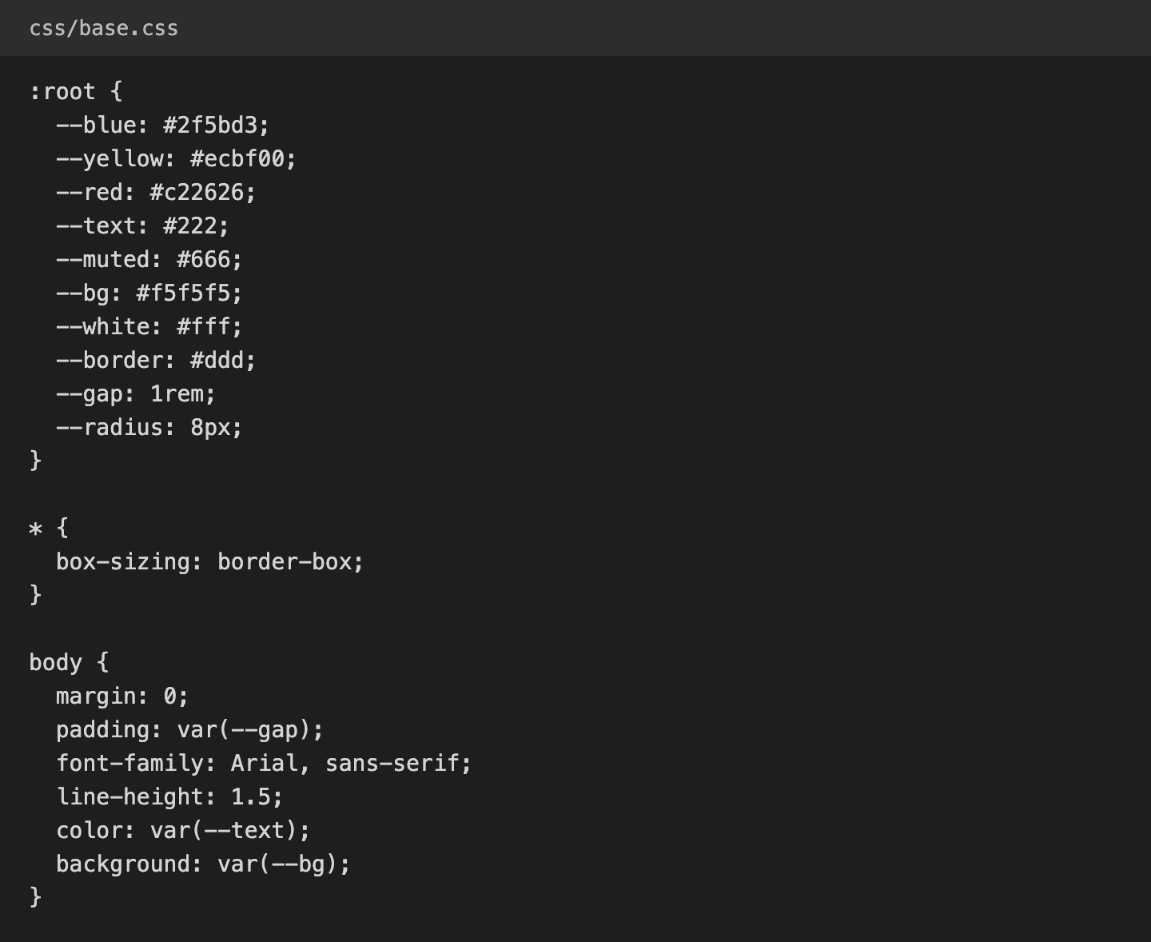
Figure 1. Shared variables and base rules in css/base.css

Task 1. Geometric composition (CSS Grid)

Result
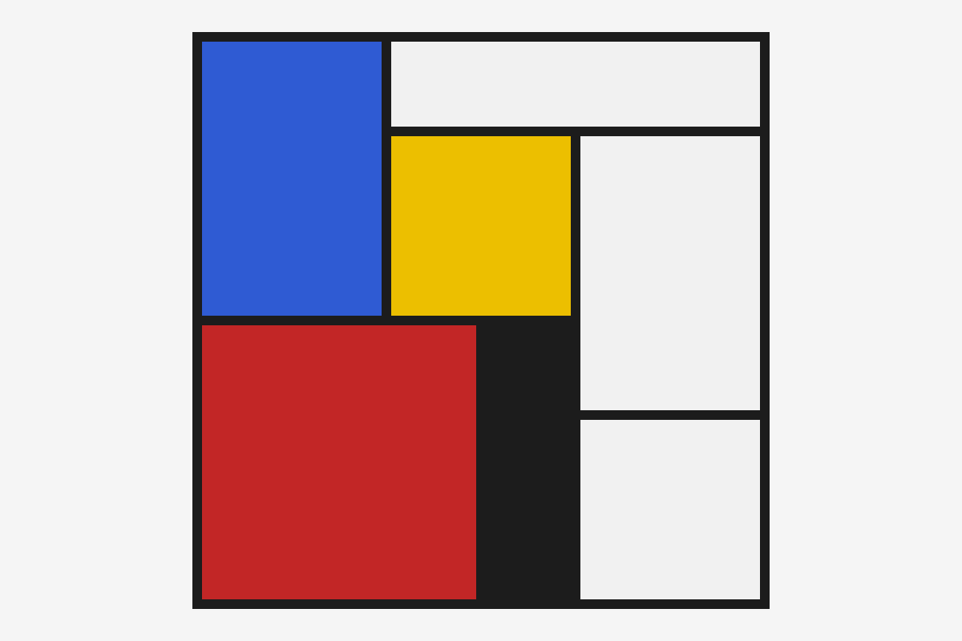  Desktop, 1200 px wide | 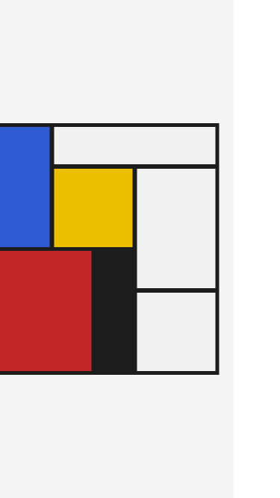  Phone, 375 px wide
Figure 2. The composition on a wide and a narrow screen

Key CSS
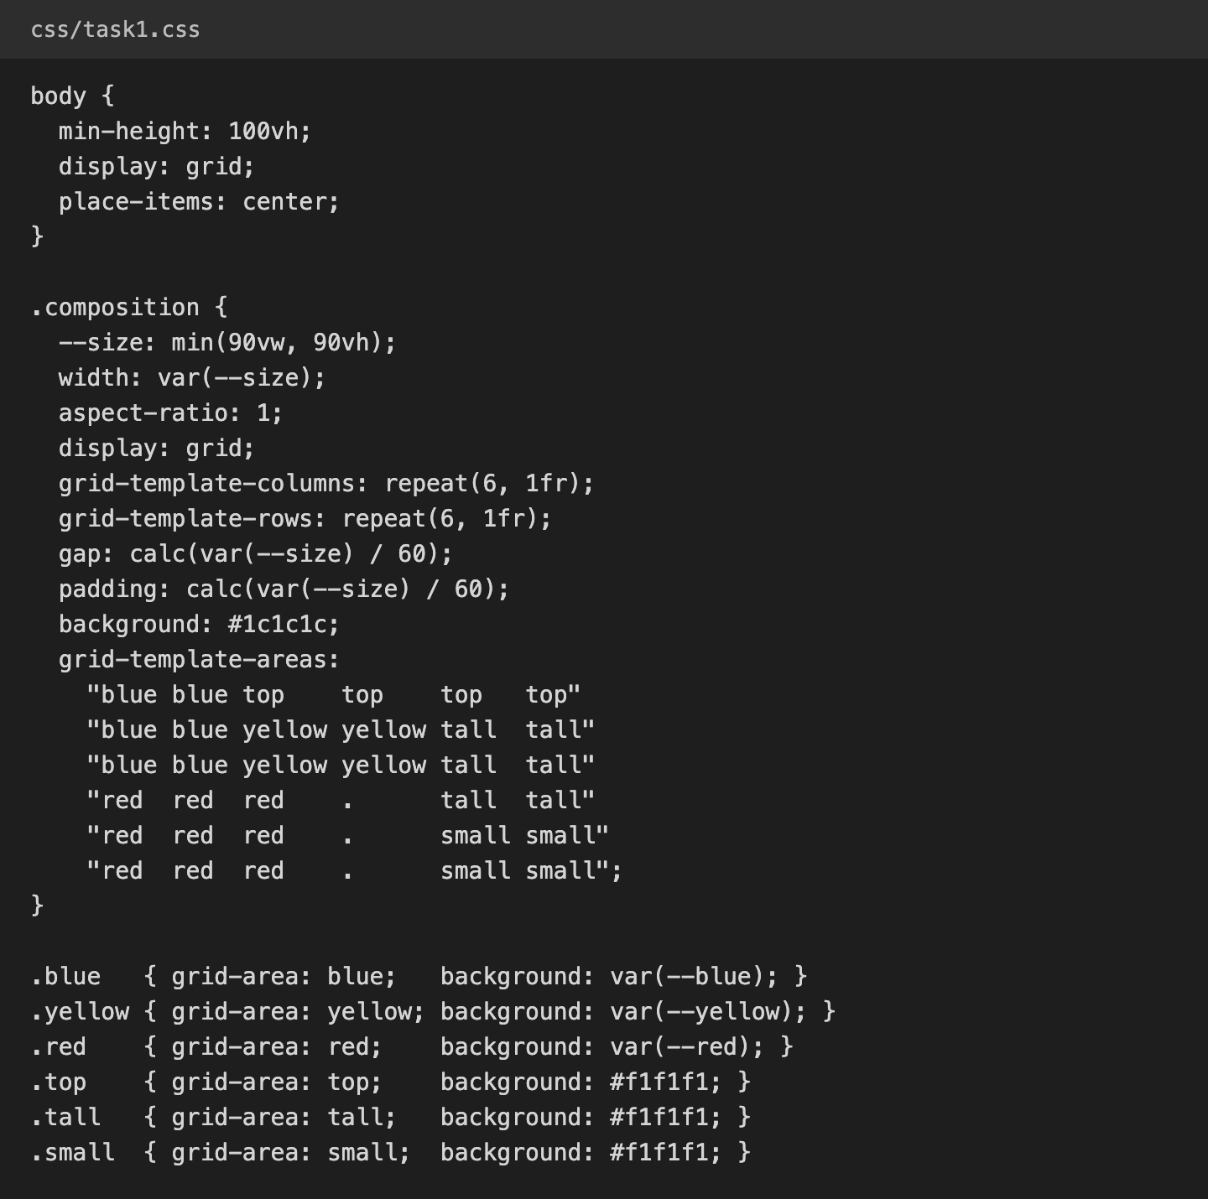
Figure 3. css/task1.css

How I solved it
First I divided the drawing into a 6 × 6 grid of equal cells and counted how many columns and rows every block takes:
Block | Columns | Rows
Blue | 1–2 (2 columns) | 1–3 (3 rows)
White top | 3–6 (4 columns) | 1 (1 row)
Yellow | 3–4 (2 columns) | 2–3 (2 rows)
White tall | 5–6 (2 columns) | 2–4 (3 rows)
Red | 1–3 (3 columns) | 4–6 (3 rows)
Black (empty) | 4 (1 column) | 4–6 (3 rows)
White small | 5–6 (2 columns) | 5–6 (2 rows)

- I made the container a grid with grid-template-columns: repeat(6, 1fr) and the same for rows, so all 36 cells are equal.
- To place the blocks I used grid-template-areas. I drew the picture as a text map and gave every block its name with grid-area. A dot (.) means an empty cell. The black strip next to the red block is just three empty cells, so I did not need an element for it.
- The black lines are made by the grid itself. The container has a dark background, and the gap between the cells lets this background show through. The padding has the same size as the gap, so it draws the outer frame. The blocks have no borders or margins.
- To keep it square and fit the screen I used width: min(90vw, 90vh) together with aspect-ratio: 1. min() takes the smaller value, so the square is never wider than the window and never taller than the screen. The gap is size / 60, so the lines also scale with the square. I did not use floats, positioning or fixed pixel sizes.

Task 2. Component library (Flexbox)

Result
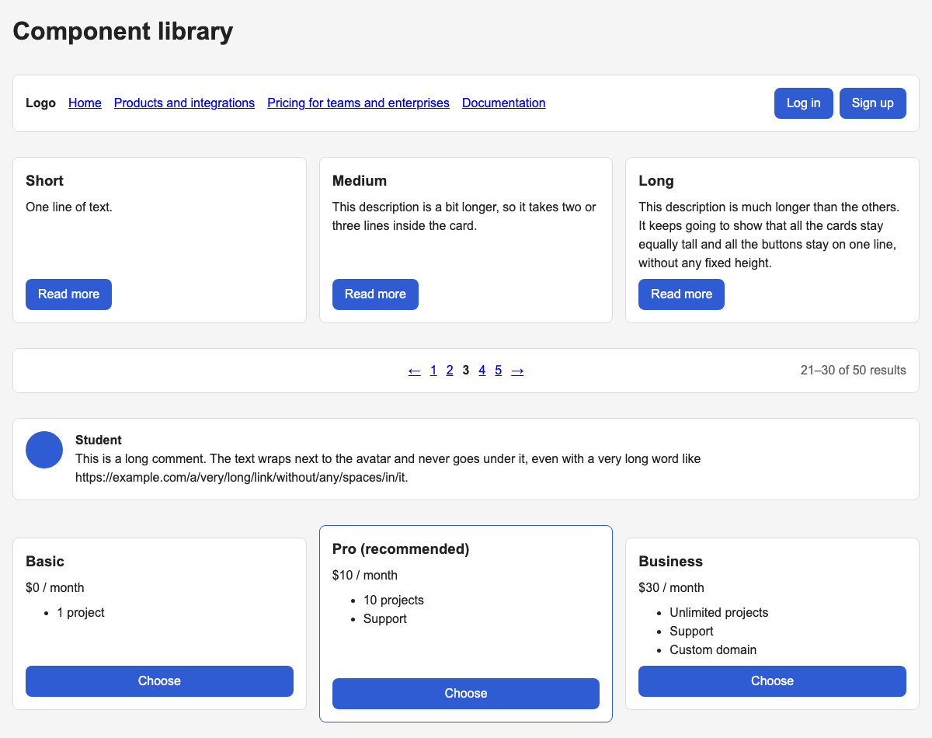
Figure 4. All five components on a desktop screen
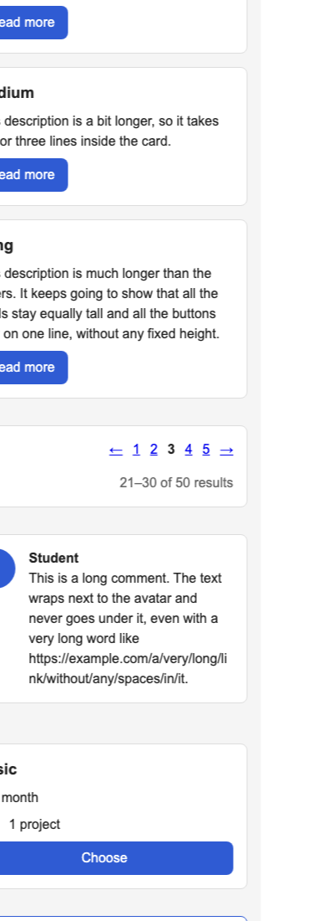
Figure 5. The same page on a 375 px phone screen: the navbar and cards wrap

Key CSS
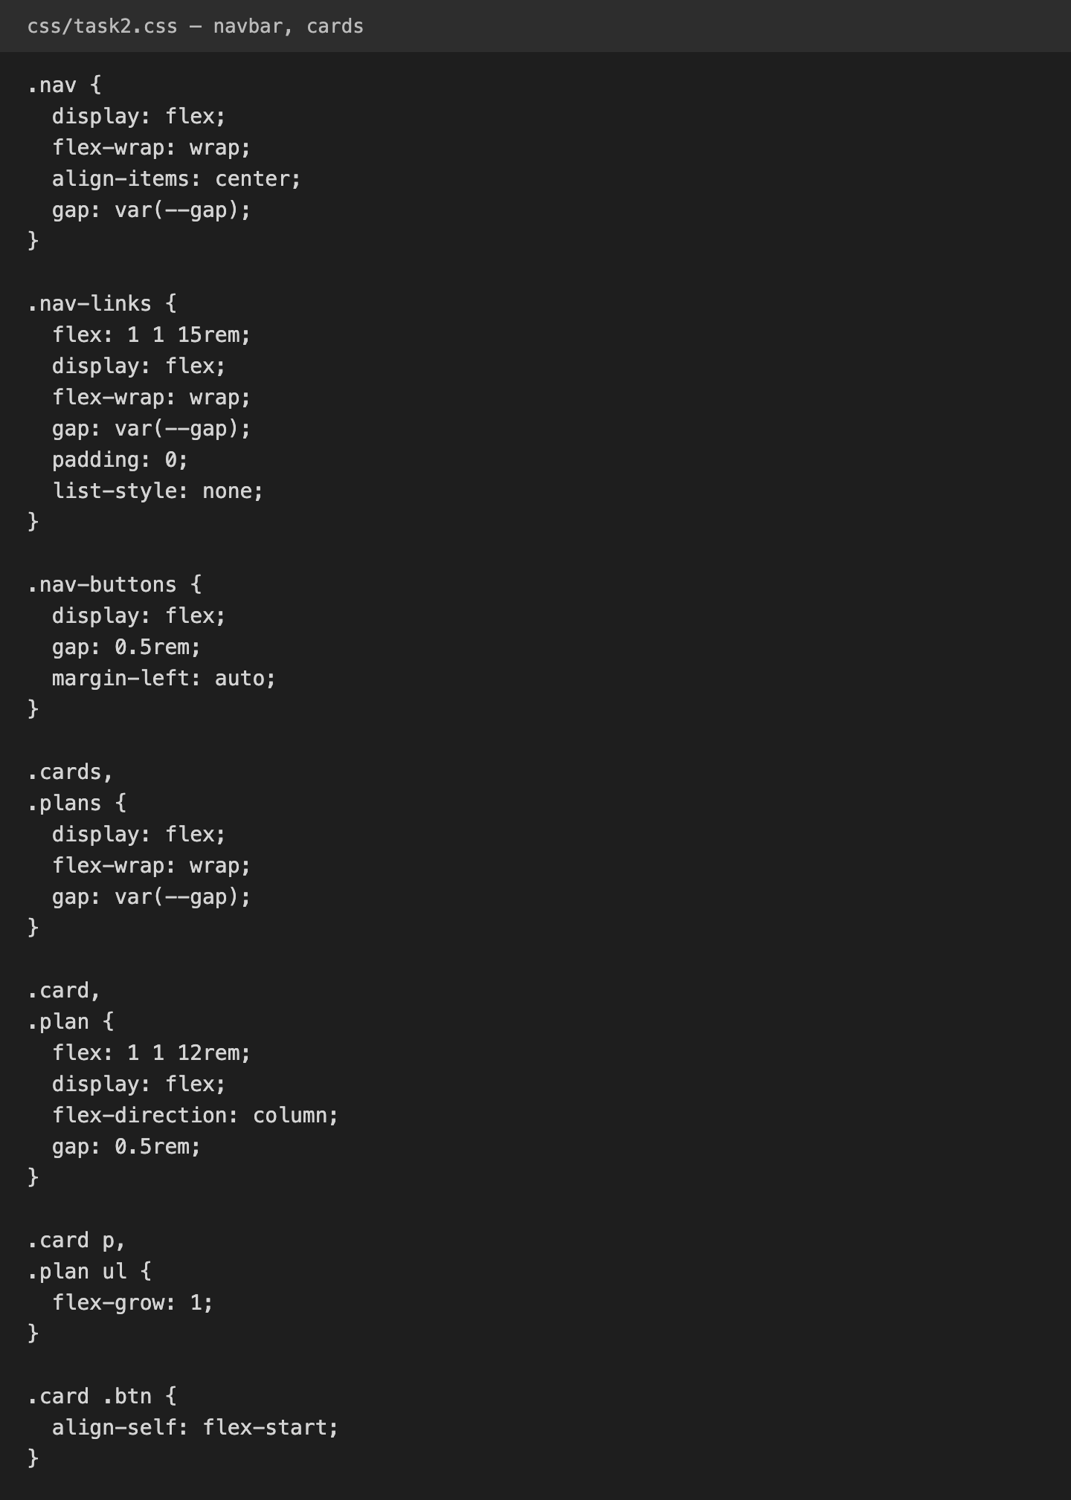
Figure 6. Navbar and cards (css/task2.css)
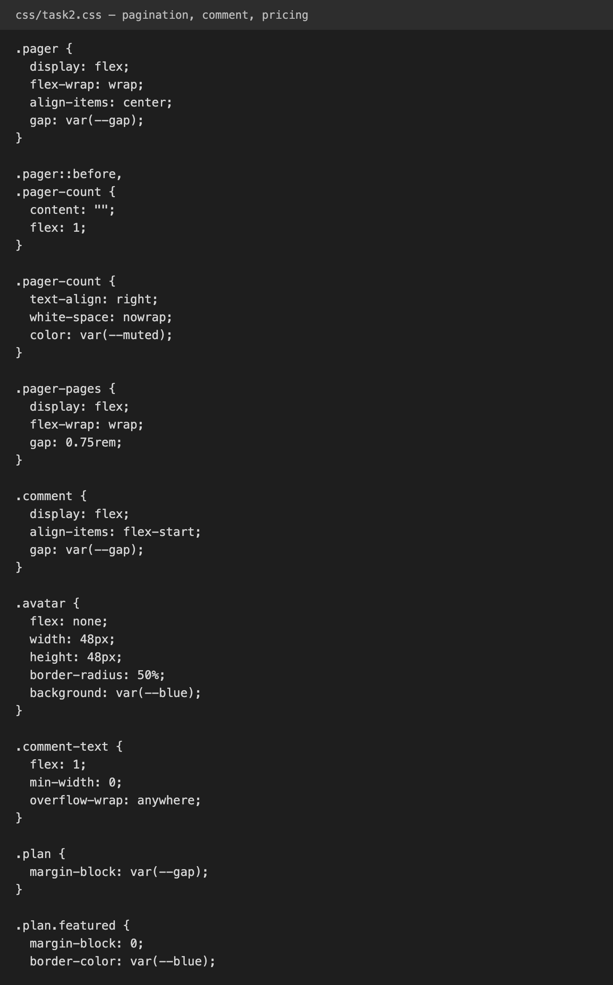
Figure 7. Pagination, comment and pricing table (css/task2.css)

How I solved it
All five components are on one page and use one stylesheet, together with the shared colors, spacing and .box / .btn classes from base.css. I used only Flexbox and did not set any fixed width or height for the layout (only the avatar has its own size).
- Navigation bar. .nav is a flex row with flex-wrap: wrap. The list of links has flex: 1 1 15rem, so it takes all the free space and the links wrap inside it when they are long. The button group has margin-left: auto, which pushes it to the right edge. So the buttons stay on the right however long the links are, and on a narrow screen they move to the next line but still stay on the right.
- Cards. .cards is a flex row with wrap, and each card has flex: 1 1 12rem. Flex items stretch by default (align-items: stretch), so all cards in a row are as tall as the tallest one. Each card is a flex column, and the description has flex-grow: 1. It takes the extra space and pushes the button down, so all buttons are on one line.
- Pagination. The bar has three parts: an invisible ::before element, the page numbers with the arrows, and the result count. The ::before and the count both have flex: 1, so they are always the same width, and the numbers end up exactly in the center. The count has text-align: right. Thanks to flex-wrap the count moves to a new line on a narrow screen.
- Comment. The avatar and the text are two flex items. The avatar has flex: none, so it keeps its size. The text has flex: 1 and min-width: 0, so it can shrink, and overflow-wrap: anywhere breaks very long links. Because they are separate flex items, the text wraps beside the avatar and can never slide under it, which happens with float.
- Pricing table. .plans is a flex row, so all plans get the same height. The two normal plans have a margin above and below them, and the recommended plan has no margin, so it is always taller than its neighbors, whatever text is inside. Inside each plan the list of features has flex-grow: 1, so all buttons are at the bottom.

Task 3. Three layouts, one markup (Grid and Flexbox)
The page has 12 news items. All of them have the same HTML: a picture (.pic), a text block (.text with a title and a description) and a date (time). The titles and descriptions have different lengths, and one title has a very long word, to test that nothing breaks.
All items are inside one container: <div class="feed grid">. To switch the layout I only change the second class to grid, list or magazine. The rest of the HTML stays the same. The container is always a CSS Grid, and every item inside is a Flexbox.

Mode 1: grid of cards
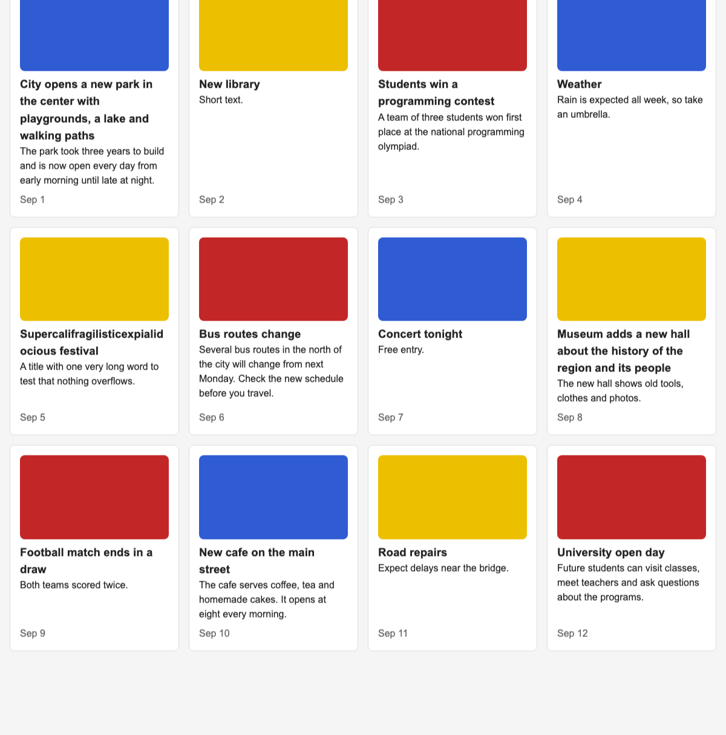
Figure 8. Grid mode (class="feed grid")
Tool: CSS Grid does the work: repeat(auto-fill, minmax(min(15rem, 100%), 1fr)) creates as many columns as fit in the window, so the number of columns follows the window width.
Inside the card, Flexbox puts the parts in a column, and flex-grow: 1 on the text keeps all dates at the bottom of the row.

Mode 2: compact list
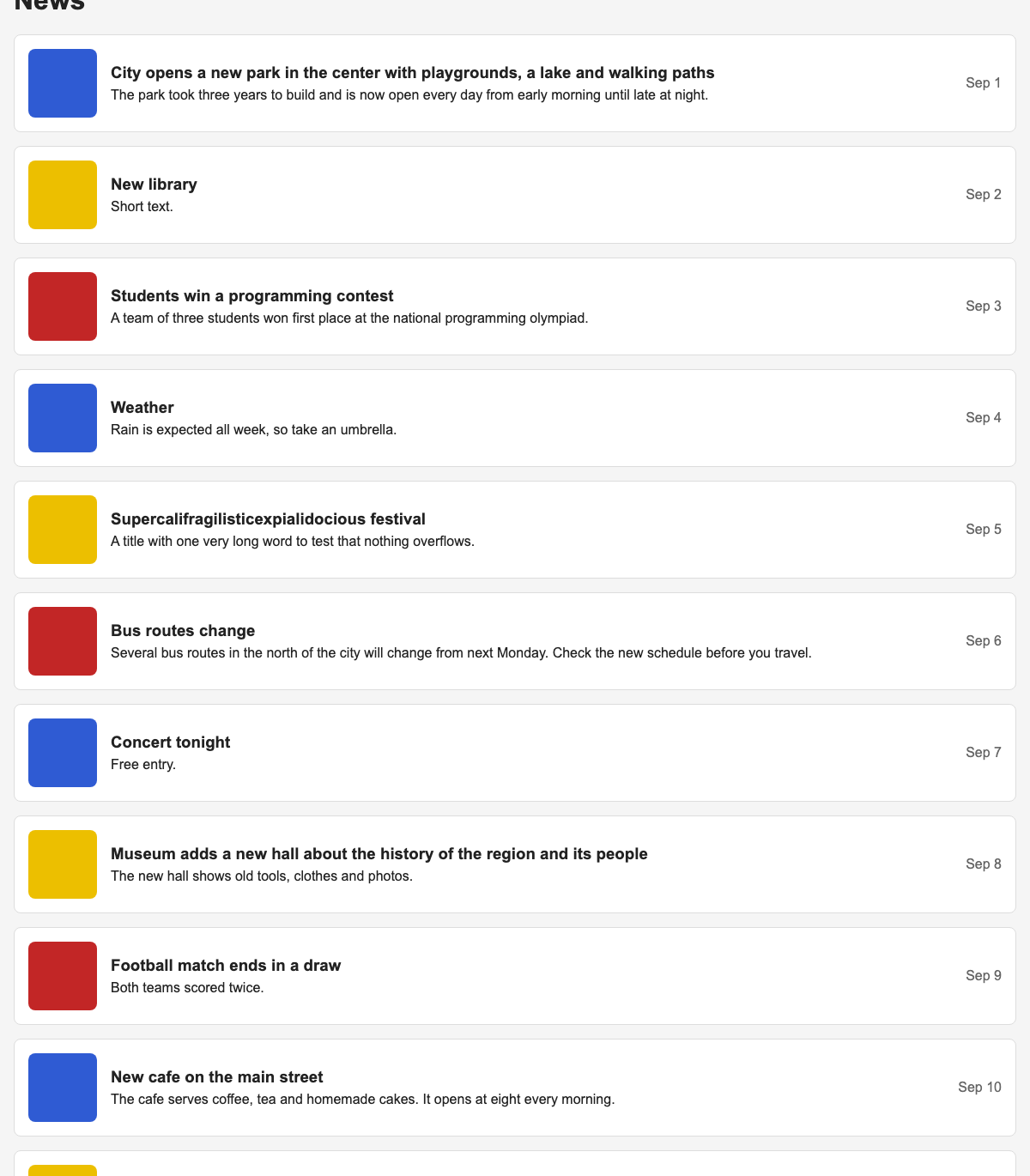
Figure 9. List mode (class="feed list")
Tool: Flexbox inside the item does the work: the grid has only one column, and each item becomes a flex row with the picture on the left, the text in the middle and margin-left: auto pushing the date to the right edge.
The text has flex: 1 1 10rem, so it takes the free space. On a very narrow screen the date moves to a new line but stays on the right.

Mode 3: magazine front page
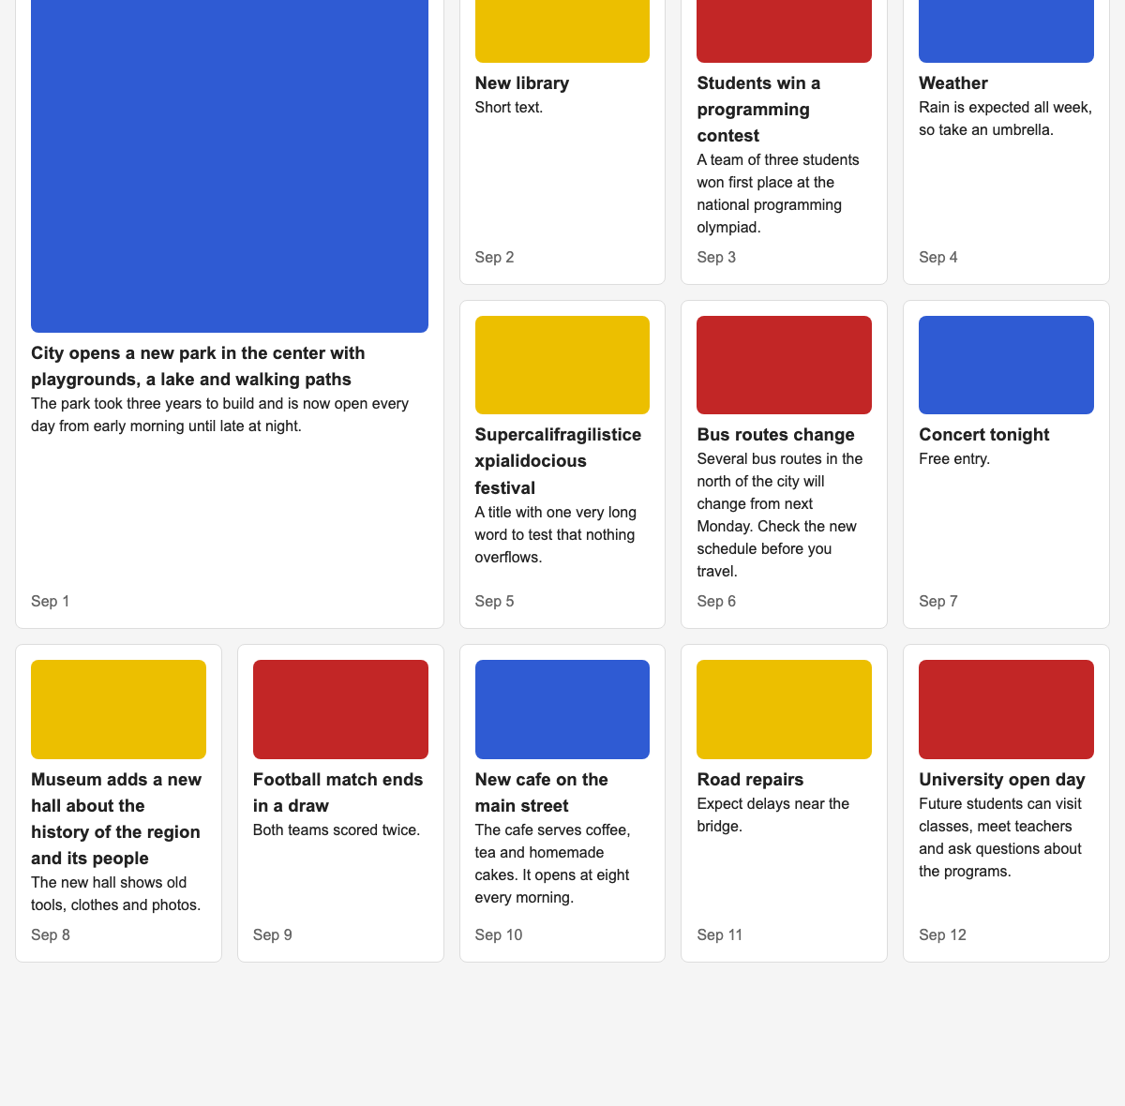
Figure 10. Magazine mode (class="feed magazine")
Tool: CSS Grid does the work: the first item gets grid-column: span 2 and grid-row: span 2, and grid-auto-flow: dense fills the other items into the free cells around it.
The minimum column width is min(12rem, 40%). Because a column can never be wider than 40%, there are always at least two columns, even on a phone, so the lead item always has two columns to span.

Narrow screen
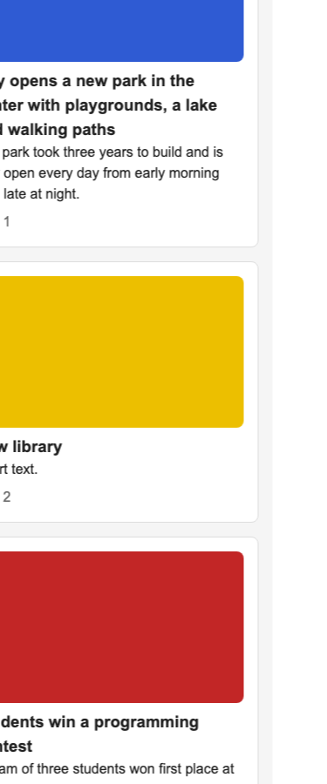  Grid | 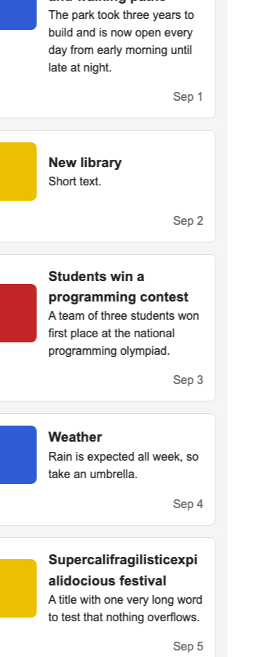  List | 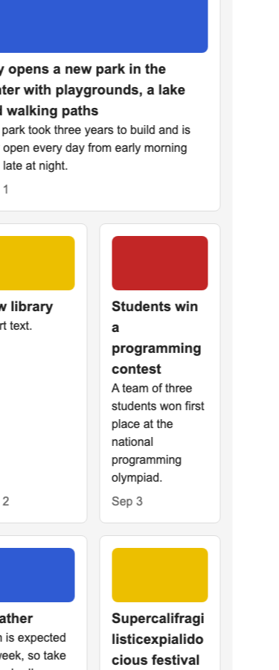  Magazine
Figure 11. All three modes on a 375 px phone screen, without media queries

Key CSS
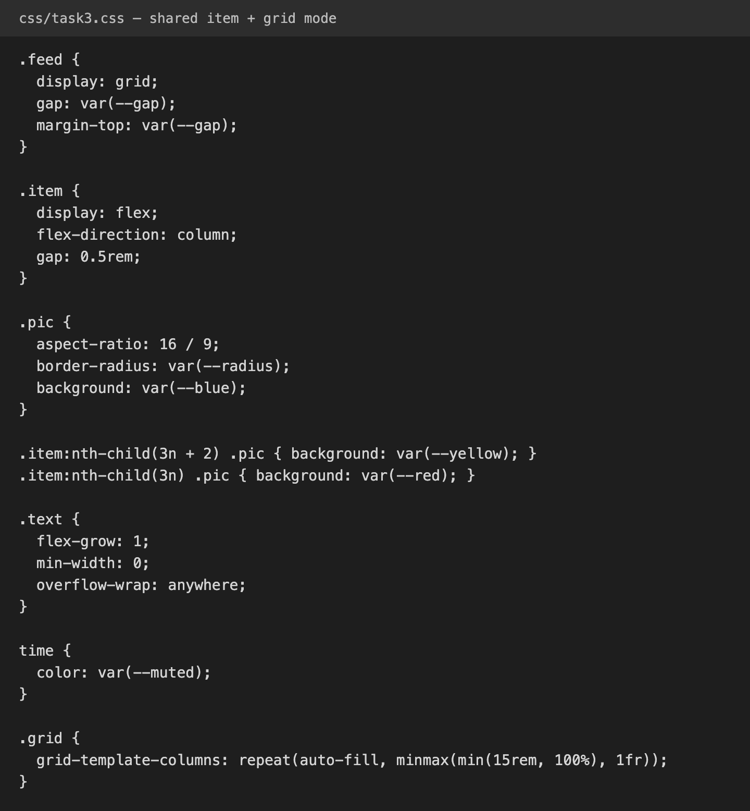
Figure 12. Shared item styles and grid mode (css/task3.css)
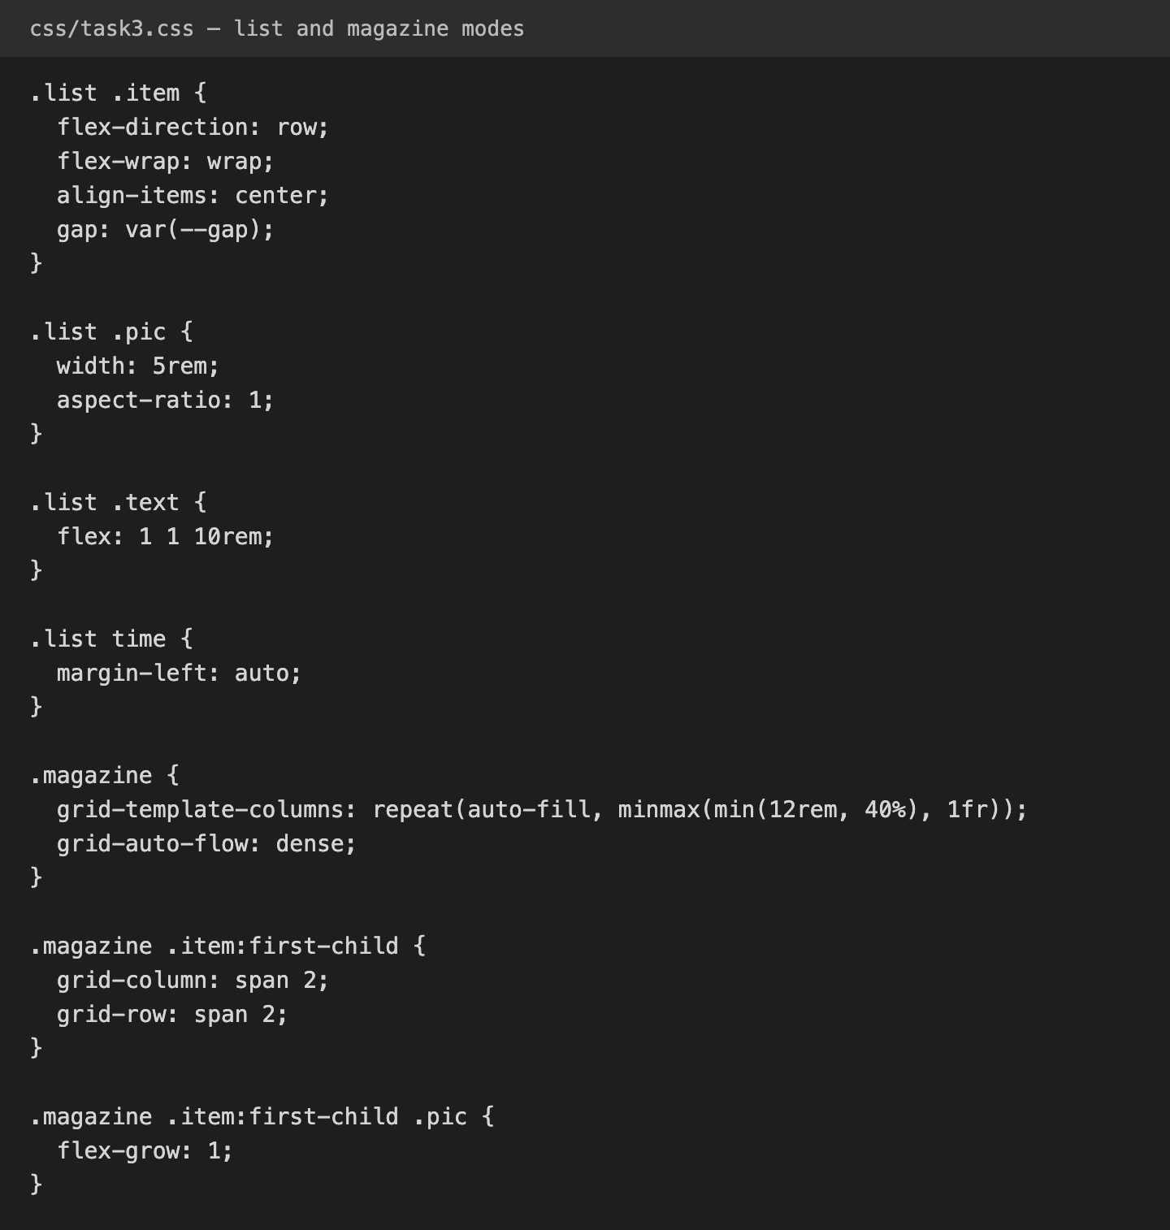
Figure 13. List and magazine modes (css/task3.css)

Conclusion
In this assignment I learned when to use CSS Grid and when to use Flexbox. Grid is best when I need to control rows and columns at the same time, like the geometric composition, the card grid and the magazine page. Flexbox is best for components that go in one direction and where the content decides the size, like the navbar, the cards, the comment and the pricing table.
I also learned some useful tricks: margin-left: auto to push an element to the edge, flex-grow: 1 to push buttons to the bottom, min-width: 0 to stop overflow, auto-fill with minmax() to make columns without media queries, and gap with a background to draw lines. Using min(), aspect-ratio and CSS variables helped me make pages that work on small and large screens and look consistent.

GitHub repository
Source code: https://github.com/your-username/your-repo

