**Javaee Assignment1测试设计与测试报告**

1. 测试目标及测试范围

本次测试主要是针对Javaee第一次作业的各项功能进行单元测试，主要是测试代码中service层的各项功能。

1. 测试案例与测试数据

我们一共测试了20轮单元测试，下面是其中一些测试用例和预期结果

OrderService:

getOrdersByUserId()

输入数据：Order实例

预期结果：返回UserId对应的Order数据

addOrder()

输入数据：Order实例

预期结果：数据库成功添加Order数据

getOrdersByAddress()

输入数据：srcAddress

预期结果： 返回srcAddress对应的Order数据

updateOrderStatus()

输入数据：Order实例

预期结果：数据库对应的Status完成更新

updateCourierIdByOrderId()

输入数据：Order实例

预期结果：数据库对应的CourierId完成更新

updateSiteIdByOrderId()

输入数据：Order实例

预期结果：数据库对应的SiteId完成更新

getOrderDetailByOrderId()

输入数据：OrderId

预期结果：返回OrderId对应的Order数据

ProductService

getAllProducts()

输入数据：无

预期结果：获取数据库所有Product数据

getProductByName()

输入数据：productName

预期结果：返回productName对应的Product数据

SiteService:

getAllSites()

输入数据：无

预期结果：获取数据库所有Product数据

UserService

getPasswordByAccount()

输入数据：Account

预期结果：返回Account对应的Password

getUserTypeByAccount()

输入数据：Account

预期结果：返回Account对应的UserType

getUserIdByAccount()

输入数据：Account

预期结果：返回Account对应的UserId

addAccount()

输入数据：User实例

预期结果：数据库成功添加对应数据

delUserByUserId()

输入数据：UserId

预期结果：数据库成功删除UserId对应数据

getUserByUserId()

输入数据：UserId

预期结果：返回Account对应的User数据

getAllUsers()

输入数据：无

预期结果：获取数据库所有User数据

1. 测试代码

OrderServiceTest.java

import org.junit.Test;

import com.hny.bean.Order;

import com.hny.service.OrderService;

import org.junit.Test;

import org.junit.runner.RunWith;

import org.springframework.beans.factory.annotation.Autowired;

import org.springframework.test.context.ContextConfiguration;

import org.springframework.test.context.junit4.SpringJUnit4ClassRunner;

import java.util.Arrays;

import java.util.List;

import static org.junit.Assert.*;

@RunWith(SpringJUnit4ClassRunner.class)

@ContextConfiguration(locations = {"classpath*:/*.xml"})

public class OrderServiceTest {

@Autowired

public OrderService orderService;

@Test

public void getOrdersByUserId() {

List<Order> orders=orderService.getOrdersByUserId(8);

System.out.println(Arrays.toString(orders.toArray()));

}

@Test

public void addOrder() {

Order order=new Order();

order.setSrcAddress("ss");

int i =orderService.addOrder(order);

System.out.println(i);

order.setOrderId(1);

i=orderService.addOrder(order);

System.out.println(i);

}

@Test

public void getOrdersByAddress() {

List<Order> orders=orderService.getOrdersByAddress("AABB");

System.out.println(Arrays.toString(orders.toArray()));

}

@Test

public void updateOrderStatus() {

Order order=new Order();

order.setSrcAddress("ss");

order.setOrderStatus("aabb");

order.setOrderId(8);

int i=orderService.updateOrderStatus(order);

System.out.println(i);

}

@Test

public void updateCourierIdByOrderId() {

Order order=new Order();

order.setSrcAddress("ss");

order.setCourierId(20);

order.setOrderId(8);

int i=orderService.updateOrderStatus(order);

System.out.println(i);

}

@Test

public void updateSiteIdByOrderId() {

Order order=new Order();

order.setSrcAddress("ss");

order.setSiteId(20);

order.setOrderId(8);

int i=orderService.updateSiteIdByOrderId(order);

System.out.println(i);

}

@Test

public void getOrderDetailByOrderId() {

Integer integer=new Integer(8);

Order order=orderService.getOrderDetailByOrderId(integer);

System.out.println(order);

}

}

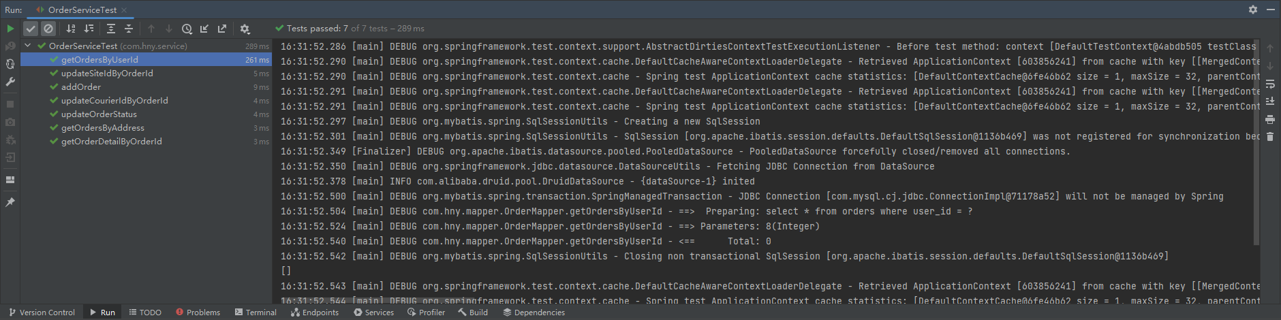

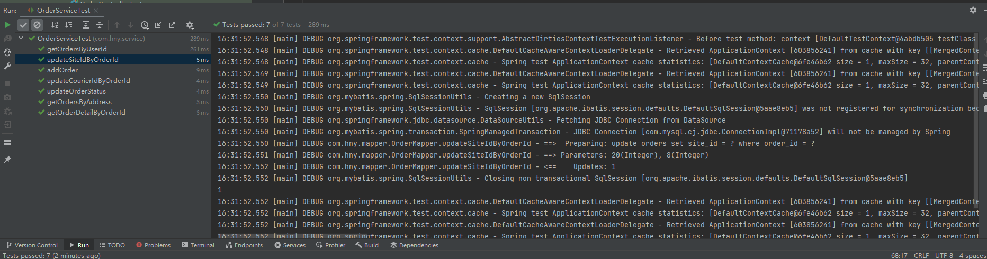

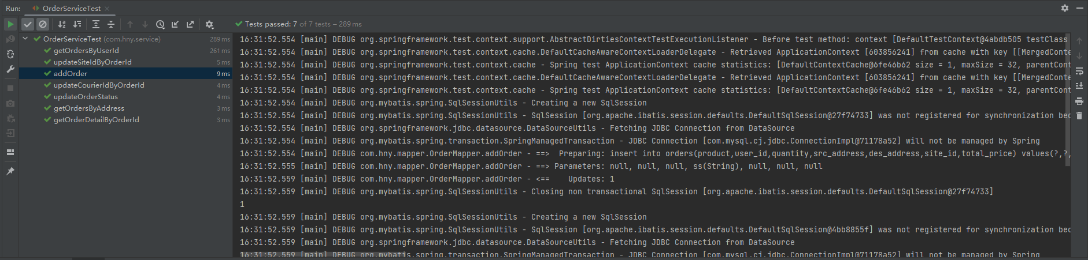

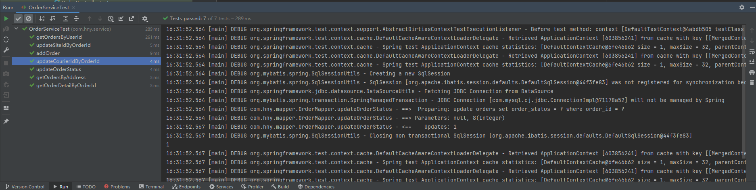

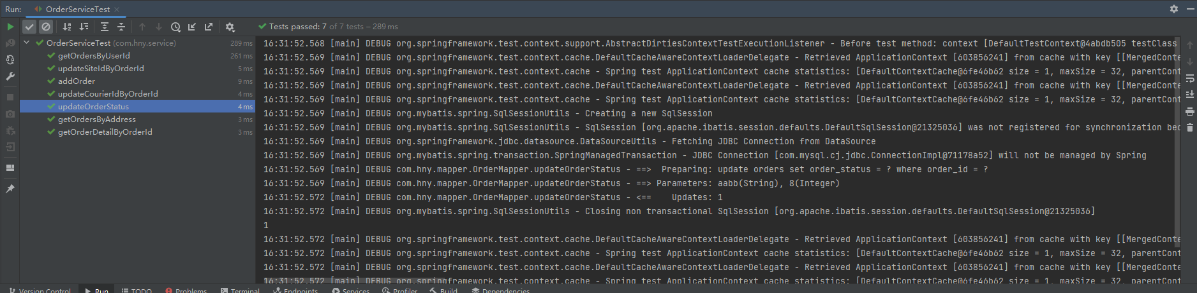

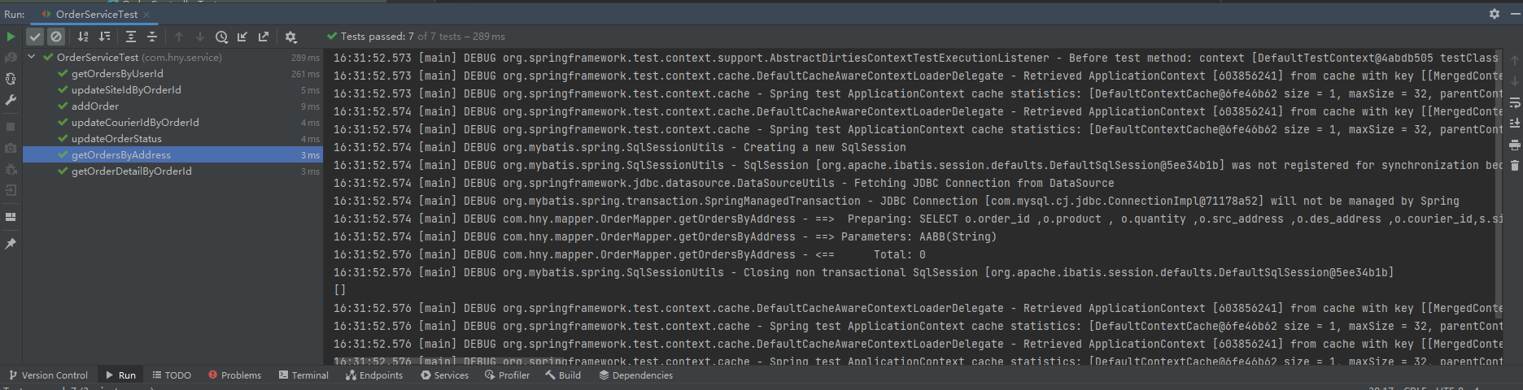

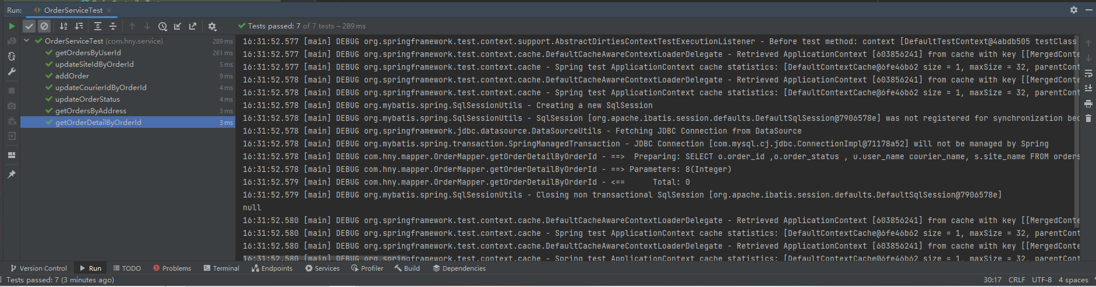

ProductServiceTest.java

import org.junit.Test;

import static org.junit.Assert.*;

import org.junit.Test;

import com.hny.service.ProductService;

import com.hny.bean.Product;

import org.junit.Test;

import org.junit.runner.RunWith;

import org.springframework.beans.factory.annotation.Autowired;

import org.springframework.test.context.ContextConfiguration;

import org.springframework.test.context.junit4.SpringJUnit4ClassRunner;

import java.util.Arrays;

import java.util.List;

@RunWith(SpringJUnit4ClassRunner.class)

@ContextConfiguration(locations = {"classpath*:/*.xml"})

public class ProductServiceTest {

@Autowired

public ProductService productService;

@Test

public void getAllProducts() {

List<Product> products=productService.getAllProducts();

System.out.println(Arrays.toString(products.toArray()));

}

@Test

public void getProductByName() {

Product product=productService.getProductByName("Apple");

System.out.println(product);

}

}

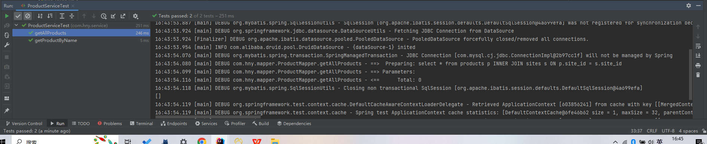

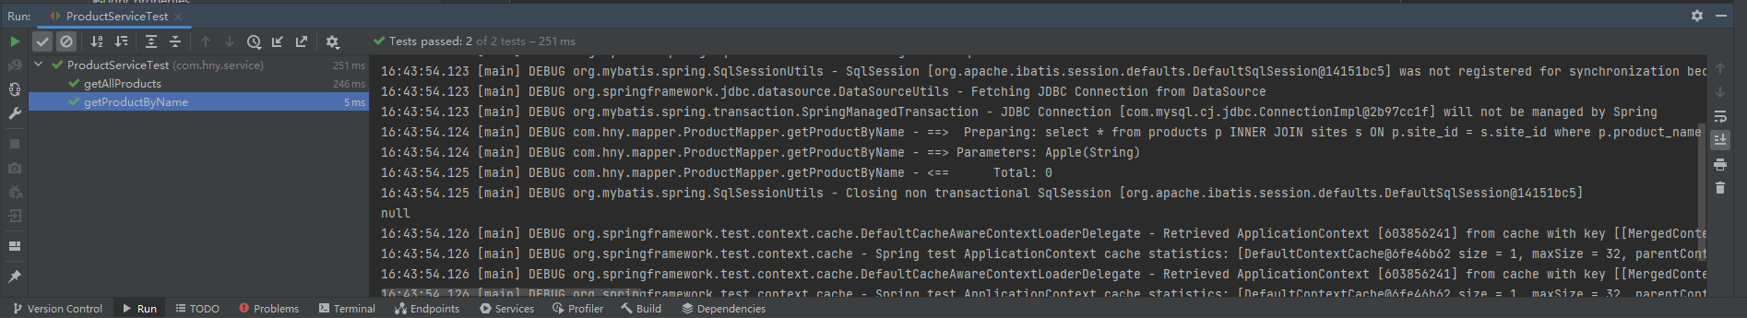

SiteServiceTest.java

import org.junit.Test;

import static org.junit.Assert.*;

import com.hny.service.SiteService;

import com.hny.bean.Site;

import org.junit.Test;

import org.junit.runner.RunWith;

import org.springframework.beans.factory.annotation.Autowired;

import org.springframework.test.context.ContextConfiguration;

import org.springframework.test.context.junit4.SpringJUnit4ClassRunner;

import java.util.Arrays;

import java.util.List;

@RunWith(SpringJUnit4ClassRunner.class)

@ContextConfiguration(locations = {"classpath*:/*.xml"})

public class SiteServiceTest {

@Autowired

public SiteService siteService;

@Test

public void getAllSites() {

List<Site> sites=siteService.getAllSites();

System.out.println(Arrays.toString(sites.toArray()));

}

}

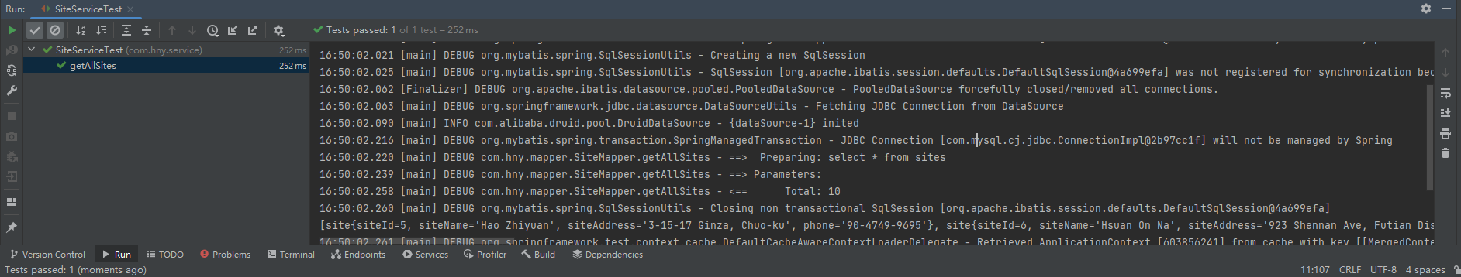

UserServiceTest.java

import org.junit.Test;

import static org.junit.Assert.*;

import static org.junit.Assert.*;

import com.hny.service.UserService;

import com.hny.bean.User;

import org.junit.Test;

import org.junit.runner.RunWith;

import org.springframework.beans.factory.annotation.Autowired;

import org.springframework.test.context.ContextConfiguration;

import org.springframework.test.context.junit4.SpringJUnit4ClassRunner;

import java.util.Arrays;

import java.util.List;

@RunWith(SpringJUnit4ClassRunner.class)

@ContextConfiguration(locations = {"classpath*:/*.xml"})

public class UserServiceTest {

@Autowired

public UserService userService;

@Test

public void getPasswordByAccount() {

String str=userService.getPasswordByAccount("RAkuovTH1p");

System.out.println(str);

}

@Test

public void getUserTypeByAccount() {

String str=userService.getUserTypeByAccount("RAkuovTH1p");

System.out.println(str);

}

@Test

public void getUserIdByAccount() {

int i=userService.getUserIdByAccount("RAkuovTH1p");

System.out.println(i);

}

@Test

public void addAccount() {

User user=new User();

user.setUserId(1);

user.setAccount("abc");

int i = userService.addAccount(user);

System.out.println(i);

}

@Test

public void delUserByUserId() {

int i=userService.delUserByUserId(1);

System.out.println(i);

}

@Test

public void getUserByUserId() {

User user=userService.getUserByUserId(23);

System.out.println(user);

}

@Test

public void getAllUsers() {

List<User> user=userService.getAllUsers();

System.out.println(Arrays.toString(user.toArray()));

}

}

