JetPMS
Technical Assignment

Content

0. About project...............................................................................
1. Scope of work & Features..................................................................................
2. Information Architecture Analysis................................................................
3. Design of content........................................................................................
4. Building and integration..............................................................................
5. Testing and quality assurance.....................................................................
6. Roles...........................................................................................................
7. Budget........................................................................................................
8. Timeline......................................................................................................
9. Business process and finite state machine automata.....................................
10. Maintenance and life cycle of development................................................

0. About project

This document describes the JetPMS - an online property management system which is designed to make the life of hostel and hotel manager's much easier. It has its own booking engine which can communicate and synchronize booking information almost simultaneously, with minimum delay, using two-way synchronization (from both ends) and send data back and forth to world-wide booking system like booking.com. JetPMS provides convenient way of doing booking and a lot of useful operation in fast and reliable manner.
Initial registration and accommodation setup takes just a few minutes.
It provides facilities to communicate with guests using email and instant messaging and also provides powerful accounting, assets and financial management such as expenses and revenues. It can generate corresponding reports.

0.1 Audience

This document will be useful for all of the project participants, like system architectors, software developers, designers, business analysts, database and server administrators.

0.2 Document revision

Revision | Date | Editor | Changes affected
0.1 | 21.11.2015 | NNuriyev | Initial draft

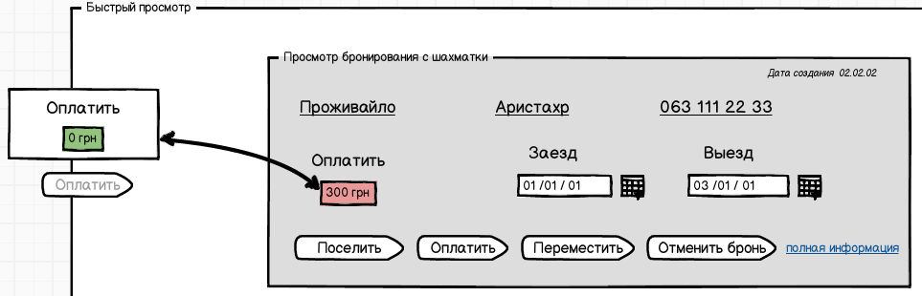
0.3 Glossary & Abbreviations

Bookers
Internal booking
External booking

1. Scope of work

The overall scope of work includes at least 5 main areas of development such as: booking engine(dashboard), communication with bookers, accommodation configuration, email/instant messages , accounting, reminder.

The priority of development features are following:

0. accommodation configuration
1. dashboard / local booking engine
2. communication with bookers
3. email & instant messaging
4. accounting
5. reminder.

Let's go through each of these functionality part.

1.1 Booking engine

The heart of the software.
1.1.1 Dashboard

This functionality includes booking from dashboard and reviewing order details from dashboard. Example of such view

There are two types of booking from dashboard: individual and group.

1.1.1.1 Individual booking

Individual booking is possible to make using two ways
by click and by dragging.

By click:
Individual click to cell to date and bed on dashboard - creates individual booking on selected date, with modal dialog windows.

Field:
Name and Surname, telephone, email,

save & close, save & check in, save & accept payment, cancel
Описать кнопки и вообще всплывающее окно????

By dragging:
We click to the cell and dragging required count of days. Modal windows appear when we release left mouse button, with possibility of outting details, modifying dates.
It's convenient, by probably it will slow down the program performance.
If the dates of booking are out of the range of the dashboard on the screen, then, when mouse comes to the egde of the screen, dashboard dates is moved to the corresponding side.

1.1.1.2 Group booking

From the left side of the screen should be a button which will show hints and instructions for group booking
In order to make group booking, it's required to press CTRL and select according cells on the dashboard. It's also possible to drag the cells.

When you release a button there will be corresponding window with group booking details.

1.1.2 Local booking engine (internal booking)

Local booking engine is the - backend part of the software which will implement main dashboard features and communication of database.

1.1.3 Communication with bookers (external booking)

Communicaton with bookers is need to intergrate service with world-wide used online booking sites, including, but not limited with booking.com, hostels.com.
This part of software requires reasearches and API analysis of booking.com.
Dashboard information must be kept consistent with online booking sites.
If the information is change and online site, that changes must be affected to the dashboard, and if the booking information on dashboard is changes it must be affected to the online booking sites. So, we speak about two-way synchronization. This can be implemented using observer pattern, by notification callbacks. When some data is changed all listeners receive the notification that some attribute has been changed, please, redraw view.

Booking from bookers automatically goes to dashboard the notification appears as hints, which is closed by clicking on it.

Option 1:

When the new booking appears, and notification comes to the application, on the email tab at the right upper corner of the email tab button appears the icon with number, which shows the number of new unread bookings.

Option 2:

Find possibilities of filter out new booking away from all other bookings (processed and archived).

The main aim is that, client may see new booking but it should not distract from his current operation.

1.1.4 Checking in
We click on booking.

Dialog window with button check in, purchase, move, cancel, review the order details.

After clicking check in, it's suggested to purchase , if refusal then it's added reminder and in dashboard, guest is iconed as "purchase reminder"

Option 1:

After that program suggest to make scan , which will be stored on local comuter's hard disk. At the guest profile there will be field: which stores address and name of this file on the local computer.

Option 2:

Button Scan is on the guest profile, and that's just an option, it's unneccesary to make this step mandatory during check in.

1.1.5 Checking out

We click on reservation, dialog window appears with buttons check out, accept payment - this option is greyed out (inactive) if the complete payment had been done, move to another accommadation, order detials

1.1.6 Booking cancellation

During cancellation it's required to specify: cancelling or editing.

If the cancellation of reservation is done beforehand (standard policy is - 3 days), program should offer return back the money and automatically add this to reminders.

1.2 Email & Instant messaging

1.2.1 Side menu
1.2.2 Main tabs
1.2.3 Search bar

1.3 Accounting

1.3.1 Standard report
1.3.2 Advanced report
1.3.3 Expenses
1.3.4 Add payment
1.3.5 Diagrams

1.4 Accommodation configuration

1.5 Reminders
2. Information Architecture Analysis

2.1 Order card info
2.2 Guest card info
2.3 Group reservation card info
2.4 Database structure information.
3. Design of content

The address of site is www.jetpms.com

4. Building and integration

5. Testing and quality assurance
6. Roles
7. Budget
7.1 Expenses
8. Timeline
9. Business process and finite state machine automata

