1. CREATE VIEW nilai_ipk AS SELECT nim, nama, (semester_1+semester_2+semester_3)/3 as IPK FROM nilai_mahasiswa;

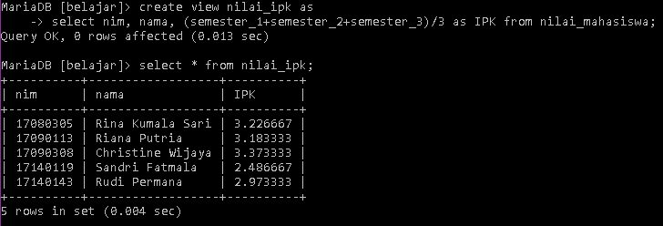

1. CREATE VIEW nilai_ipk_format AS SELECT CONCAT(nama,” (“,IPK,”)”) AS `Nama dan IPK` FROM nilai_ipk;

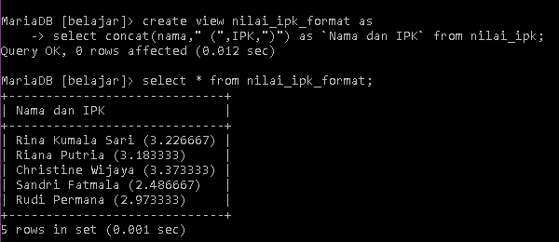

1. INSERT INTO nilai_mahasiswa VALUE(‘17441900’, ‘Robby’, 3.5, 3.24, 3.8);

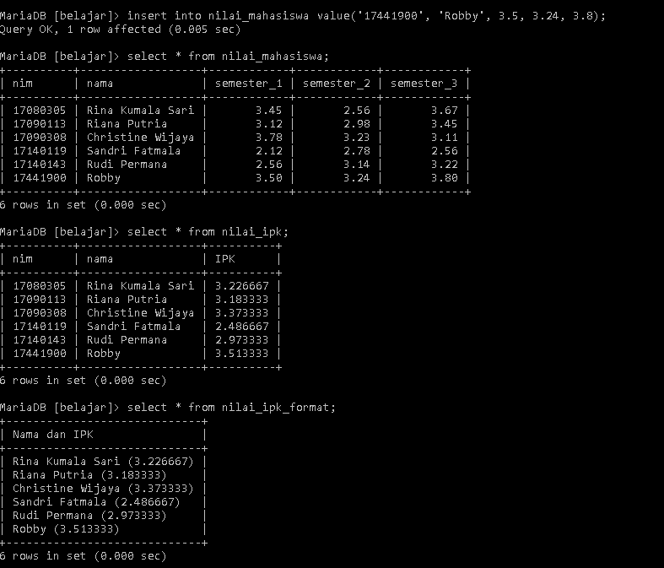

1. SELECT * FROM nilai_ipk_format WHERE `Nama dan IPK` LIKE ‘R%’;

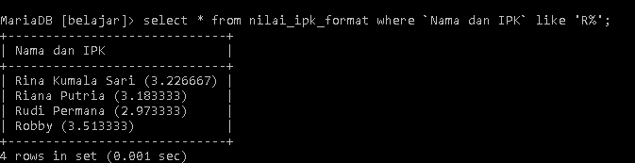

1. DROP VIEW nilai_ipk, nilai_ipk_format;

