Sequence Detector (Overlapping 1011)
State Diagram & Transition Table

1. States
This is a Moore machine: the output detected is a function of the current state alone. Detecting 1011 with a Moore output requires a dedicated final state (S1011) that the FSM occupies for exactly one cycle after the pattern completes — that is where detected is asserted.
- IDLE — no relevant progress yet (reset state) — matched ""
- S1 — most recent bits match the prefix 1 — matched 1
- S10 — most recent bits match the prefix 10 — matched 10
- S101 — most recent bits match the prefix 101 — matched 101
- S1011 — full pattern 1011 just completed → DETECT state — matched 1011

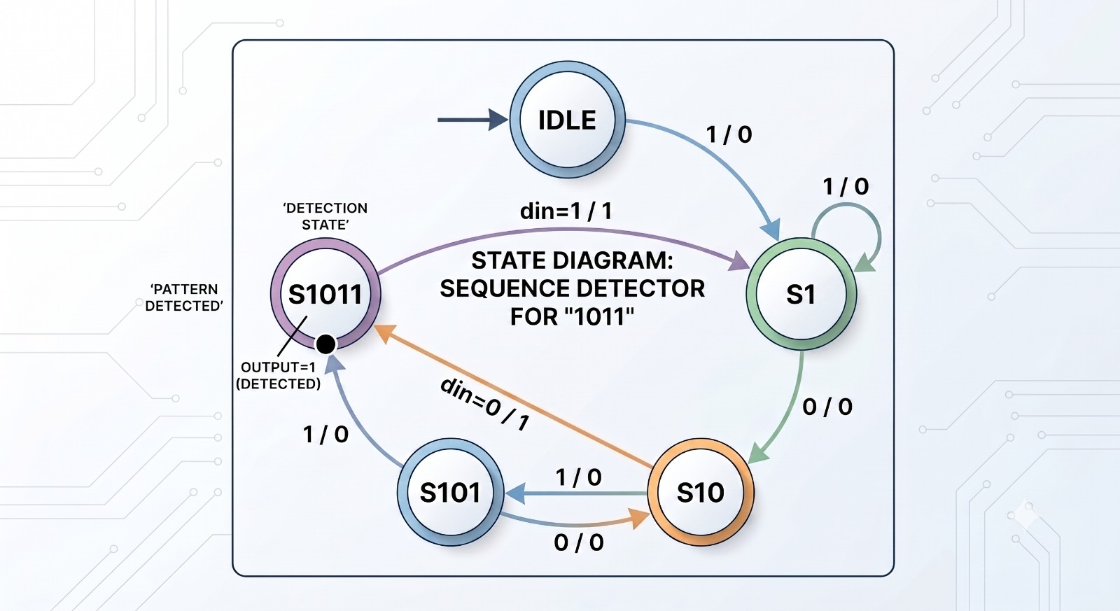
Figure 1 — ASCII reference sketch of the state diagram
din=1 din=0 din=1
+------+ -------> +------+ -------> +------+ -------> +------+
| IDLE | | S1 | | S10 | | S101 |
| "" | <------- | "1" | | "10" | |"101" |
+------+ din=0 +------+ +------+ +------+
^ self din=0 ^ self din=1 | din=0 | din=1
| (stay IDLE) | (stay S1) | (-> IDLE) v
| | +-------+
| | din=1 (overlap: acts | S1011 | detected = 1
| +-------- like S1) <------------- |"1011" | (DETECT state)
| +-------+
+-------------------------------- din=0 -------------+ (-> S10)

The ASCII picture is only a visual reference. For an FSM the transition table below is the authoritative specification.

2. Transition Table (next-state logic)
Columns: Current State | Input (din) | Next State
Current State | Input (din) | Next State | Why
IDLE | 0 | IDLE | self-loop — no progress
IDLE | 1 | S1 | first bit of a potential match
S1 | 0 | S10 | progress: 10 so far
S1 | 1 | S1 | self-loop — still just ...1
S10 | 0 | IDLE | 100 seen — no usable prefix, restart
S10 | 1 | S101 | progress: 101 so far
S101 | 0 | S10 | 1010 — trailing 10 still useful
S101 | 1 | S1011 | 4th bit arrives → full match, enter DETECT state
S1011 | 0 | S10 | 10110 — trailing 10 still useful
S1011 | 1 | S1 | overlap: trailing 1 of the match seeds the next one

3. Output Table (Moore — output is a function of state ONLY)
State | detected
IDLE | 0
S1 | 0
S10 | 0
S101 | 0
S1011 | 1

Because detected depends on state alone (not on din), it is glitch-free on din and unambiguously a Moore output.

4. Hand-Trace: input sequence 1 1 0 1 0 1 1
detected in a given cycle = ( state in that cycle == S1011 ). The pattern 1011 is completed by the 7th input bit, so the FSM enters S1011 on that edge and detected reads HIGH in the following cycle — the ordinary one-cycle latency of a clocked FSM.
Step | Input Applied | State (this cycle) | Output (detected) | State (next cycle)
1 | 1 | IDLE | 0 | S1
2 | 1 | S1 | 0 | S1
3 | 0 | S1 | 0 | S10
4 | 1 | S10 | 0 | S101
5 | 0 | S101 | 0 | S10
6 | 1 | S10 | 0 | S101
7 | 1 | S101 | 0 | S1011
8 | – | S1011 | 1 | S1 (if din=1) / S10 (if din=0)

Check: input bits 4–7 (1,0,1,1) spell 1011; the FSM reaches the DETECT state S1011 right after bit 7 is consumed, and detected is HIGH for exactly that one cycle (step 8). Verified in simulation (Icarus Verilog): against a 4-state registered-Mealy variant driven by the same stimulus, this 5-state Moore design produces an identical detected waveform over 2000 random bits (0 mismatches).

5. Overlap check (why S1011 → S1 on din=1)
For 1011, the only proper suffix that is also a prefix is the trailing 1. So after a match, a following 011 completes another match, sharing that 1 — e.g. 1011011 fires twice. The FSM captures this by making S1011 behave like S1 for the next input.

6. Moore-vs-Mealy note (resolved — KB honesty entry)
An earlier draft built a 4-state Mealy table (IDLE, S1, S10, S101) where detected depended on state and din in the S101 + din=1 row. That is Mealy by definition. Registering such a Mealy output reproduces Moore timing but is still not structurally Moore — its detected is not a function of state alone.
The genuine Moore resolution (used here) is to add the fifth state S1011, enter it when the 4th bit completes the match, and tie detected to being in that state. This is exactly what the assignment’s Day 4 goal (“Moore FSM”) asks for, and it removes the ambiguity for the RTL, the smoke test, and the spec. Logged here rather than papered over, per the assignment’s “log confusion honestly” rule.

7. Traffic Light — State Sequence (no timers yet)
Per the assignment: just the sequence, no durations. A generic single-bit advance input represents “move to the next phase,” since a transition table needs something in the input column — the real timing source (a down-counter reaching zero) is added in Day 5.
Current State | Input (advance) | Next State | Output (lights)
MAIN_GREEN | 0 | MAIN_GREEN | main = green, side = red
MAIN_GREEN | 1 | MAIN_YELLOW | main = green, side = red
MAIN_YELLOW | 0 | MAIN_YELLOW | main = yellow, side = red
MAIN_YELLOW | 1 | SIDE_GREEN | main = yellow, side = red
SIDE_GREEN | 0 | SIDE_GREEN | main = red, side = green
SIDE_GREEN | 1 | SIDE_YELLOW | main = red, side = green
SIDE_YELLOW | 0 | SIDE_YELLOW | main = red, side = yellow
SIDE_YELLOW | 1 | MAIN_GREEN | main = red, side = yellow

Design decision documented (per Day 7’s “don’t leave it implicit”): during both YELLOW phases the other road stays RED for the entire phase — there is never a moment where both roads show anything other than “one green/yellow, one red.” This is the standard safe convention and is stated explicitly rather than assumed.
Note: this 4-phase design has no dedicated all-red interphase; the Day 5 RTL keeps the opposing road red throughout each yellow, which serves the same safety purpose for this assignment’s scope.

