Progress Report
Human-Speech Anonymization in Dog Recordings: from synthetic tests to real lab recordings
Project: Dog Sound Recording Analysis, ELTE (Task 1 of 3)
Supervisor: Dr. Péter Kovács
Prepared by: Nur
Date: 5 October 2026 (covers 21 September – 4 October)

1. Summary
Since the last consultation (21 September), the work moved from a detect-and-mute prototype tested on hand-made mixtures to an evaluation on real lab recordings: the ELTE BARKS Lab “Dog play pant” dataset (30 dog–owner play sessions, 581 expert-annotated human sounds). Following your suggestion, all synthetic tests now use controlled SNR mixing. The main findings:
- Muting is not sufficient. It deletes the dog wherever speech and dog overlap, and in 31% of dog clips the speech detector fired on the dog alone at some SNR level. Subtracting a pretrained speech estimate instead removed speech by about 35 dB on synthetic mixtures while keeping the dog (+8 dB SDR in the overlap, versus about 0 dB when muting).
- Both detection and removal suffer from domain shift on real recordings. The standard detector (Silero VAD) finds only 4.5% of the annotated human-sound time. Even with perfect detection (expert annotations used as an oracle), the same speech-removal models reduce the real human sounds by only 2–4 dB, against 26–35 dB on synthetic mixtures.
- The structure of the data allows a simpler, stronger design. 71% of human-sound time does not overlap any dog vocalization. A hybrid scheme mutes those parts and subtracts speech only where human and dog overlap. With oracle detection it reduces the events in which an independent speech recognizer (Whisper) reads two or more words from 23% to 7%, against a 4% hallucination floor measured on background-only audio.
- A detector adapted to the lab's recordings helps substantially. A classifier on pretrained VGGish audio embeddings, evaluated on unseen participants, finds 50% of human-sound time while flagging 6% of dog-vocalization time (about 11× the recall of Silero VAD).
Privacy is now measured independently of the detector (with an ASR model), and every result on real data is evaluated leave-one-participant-out or against measured noise floors, to avoid over-claiming.

2. Controlled SNR mixing
Speech and dog sounds are mixed at a target signal-to-noise ratio: mixture = speech + x · dog, with x chosen so that 10·log10(P_speech / P_dog) equals the target. Because barks are mostly silence with short bursts, the dog's power is measured only over its active 20 ms frames (within 30 dB of its loudest frame); otherwise short barks would be scaled up excessively. The detector was tested on 42 dog clips (40 ESC-50 dog clips and 2 AudioSet clips) at 9 levels from +20 to −40 dB.
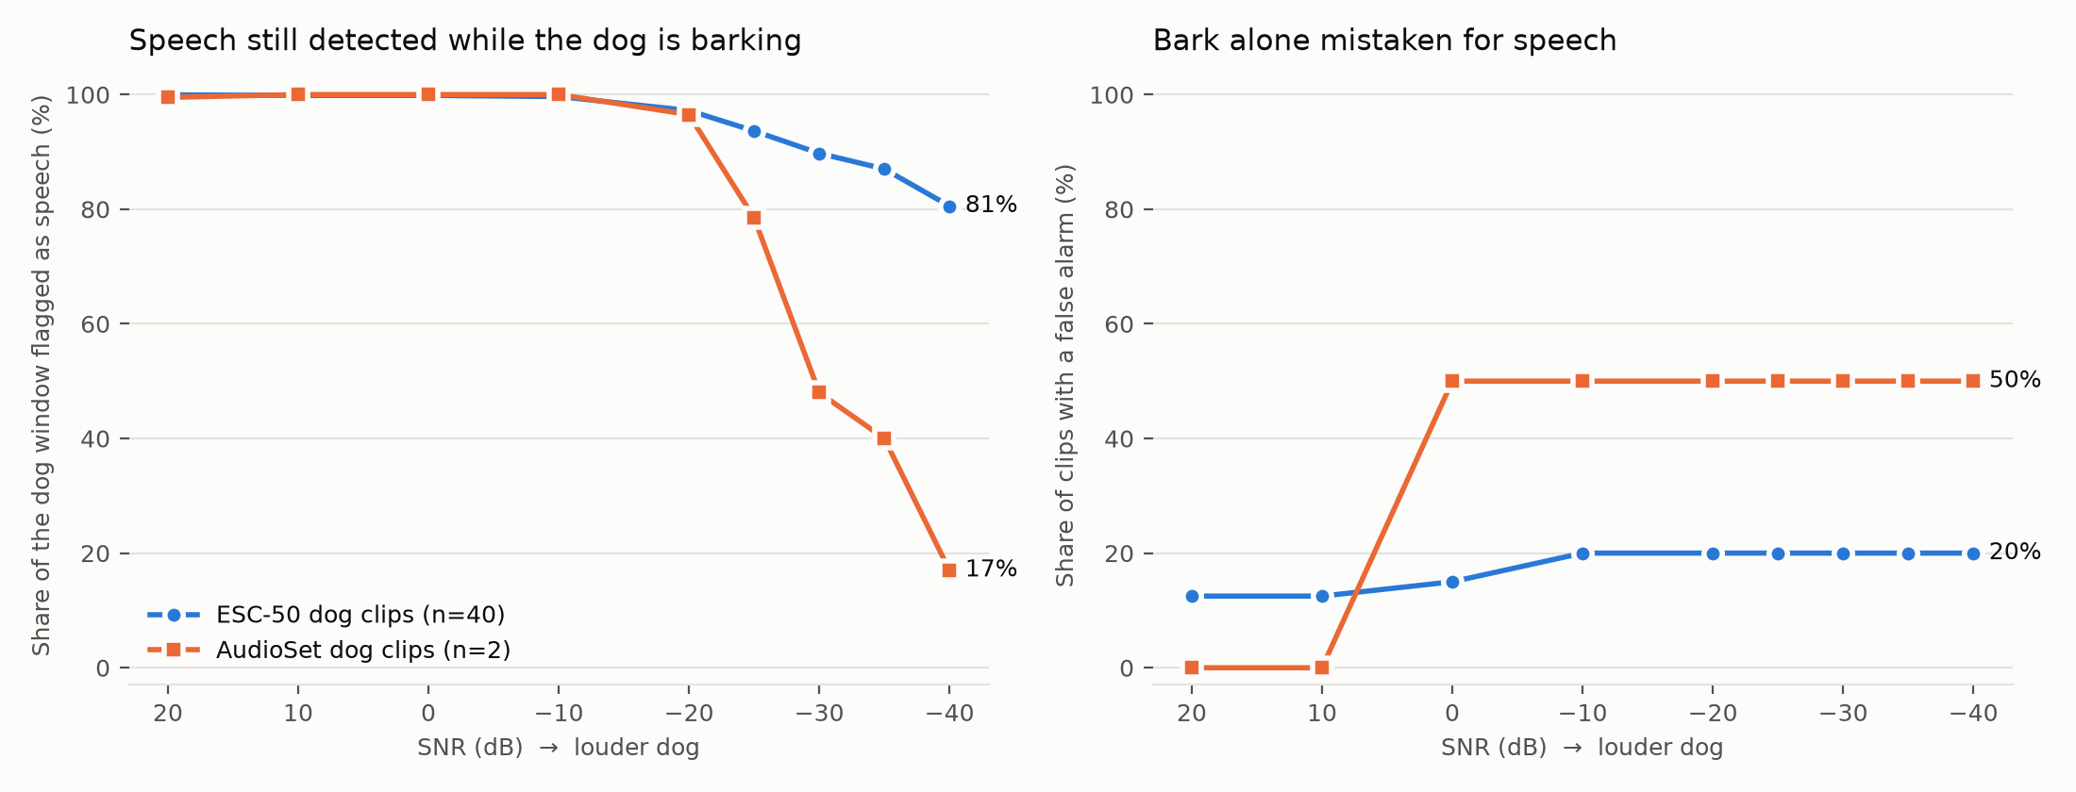
Figure 1. Left: share of speech still detected while the dog vocalizes, by SNR. Right: share of dog clips mistaken for speech when played alone (40 ESC-50 and 2 AudioSet clips).
Detection is robust down to −10 dB (mean recall 99.7%), degrades from −20 dB (97%) and reaches 78% at −40 dB; dense AudioSet barking degrades it much earlier (48% at −30 dB). More important for this task, 13 of the 42 dog clips (31%) caused false speech detections on the dog alone at some level. With detect-and-mute, those dog vocalizations would be deleted from the data.

3. From muting to speech removal
Instead of zeroing detected regions, the speech is estimated with a pretrained speech-enhancement model and subtracted from the recording (y = x − ŝ). Three models were tested, all with publicly available weights: DTLN, GTCRN and DeepFilterNet3. In the “gated” variant the subtraction is applied only inside detected speech, so dog-only passages stay bit-identical. Each 10-second test scene contains speech (0–5 s), dog (2.5–7.5 s) and silence, so speech-only, overlap and dog-only regions can be scored separately against the known clean signals (40 LibriSpeech speakers, 42 dog clips, SNR +10/0/−10 dB).
Method (0 dB SNR) | Speech left | STOI | Dog SDR in overlap
No processing | 0 dB | 0.92 | −3.0 dB
Detect + mute | −56 dB | 0.00 | 0.3 dB
Gated DTLN subtraction | −35 dB | 0.26 | 7.9 dB
Gated GTCRN subtraction | −28 dB | 0.14 | 8.0 dB
Gated DeepFilterNet3 subtraction | −24 dB | 0.63 | 8.5 dB
Table 1. Synthetic mixtures, LibriSpeech speech with ESC-50/AudioSet dog sounds, 42 scenes. Speech left: residual speech energy relative to the original. STOI: intelligibility (0–1).
On synthetic data, gated DTLN subtraction gave the best balance between removing speech and keeping the dog. DeepFilterNet3 leaves intelligible speech and was ruled out (see also Section 6). The same comparison with real dog sounds cut from the lab recordings (88 dog-only windows, mostly panting) gave the same ranking: −26.5 dB speech left with gated DTLN, and 8.4 dB dog SDR in the overlap versus 0.2 dB for muting.

4. Real recordings: ELTE BARKS Lab dataset
Dataset: “Dog play pant” (Zenodo, DOI 10.5281/zenodo.18972388), recorded at the BARKS Lab, Budapest. 30 sessions (about 125 minutes) of dog–owner play with 17 participants; one shotgun microphone (Sennheiser ME66) aimed at the dog; 48 kHz, mono. Expert annotations (Praat) mark 581 human sounds and 2,055 dog vocalizations (1,294 pants, 198 growls, 163 grunts, 48 barks/yelps and others). The raw data is kept read-only with a checksum manifest.
Silero VAD threshold | Human time found | Human events found | Precision | Dog-only time flagged
0.3 | 9.5% | 3.8% | 85% | 0.3%
0.5 (default) | 4.5% | 1.4% | 96% | 0.0%
0.7 | 2.6% | 0.9% | 100% | 0.0%
Table 2. Off-the-shelf speech detection on the real sessions, scored against the expert annotations.
The detector is precise but misses almost all human sounds. The reasons are visible in the data: 53% of human events are quieter than −60 dBFS (the microphone points at the dog, and the person is off-axis), 67% are shorter than one second, and many are not speech at all (laughs, short calls, kissing or clicking sounds). Automatic gain control did not change this materially.

5. Oracle analysis and hybrid removal
To separate detection errors from removal errors, the expert annotations were used as a perfect (“oracle”) detector, and the speech estimate was subtracted inside every annotated human event. Without a clean reference on real recordings, two measurable quantities are reported: the energy change inside each event, and the remaining level above the local background noise floor (10th percentile of 50 ms frame energies within ±5 s).
Removal (oracle detection) | Median energy change | Above noise floor (before → after) | Events reaching the floor (≤3 dB)
DTLN, human-only events | −3.8 dB | 13.9 → 9.1 dB | 16%
GTCRN, human-only events | −2.3 dB | 13.9 → 10.1 dB | 8%
DTLN, human + dog overlap | −2.0 dB | 15.4 → 12.1 dB | 6%
Table 3. Oracle removal on 579 real human events (audible events: at least 6 dB above the floor). Loudness-normalizing the input before the model did not help.
The same models that removed 26–35 dB on synthetic mixtures remove only 2–4 dB here. They were trained on close, clean, normally loud speech; the human sounds in these recordings are distant, quiet, reverberant, short, often non-verbal and partly in Hungarian, so the models do not extract them as speech. Removal therefore also suffers from domain shift.
The annotations also show that 71% of annotated human-sound time has no dog vocalization at the same moment. Muting is lossless there, since there is no dog signal to preserve. This leads to a hybrid scheme: inside human segments, mute where no dog vocalizes and subtract the speech estimate only where a dog overlaps (Figure 2). In the results below the dog/no-dog decision uses the expert annotations; this is an oracle hybrid, and Section 7 reports a first deployable version.
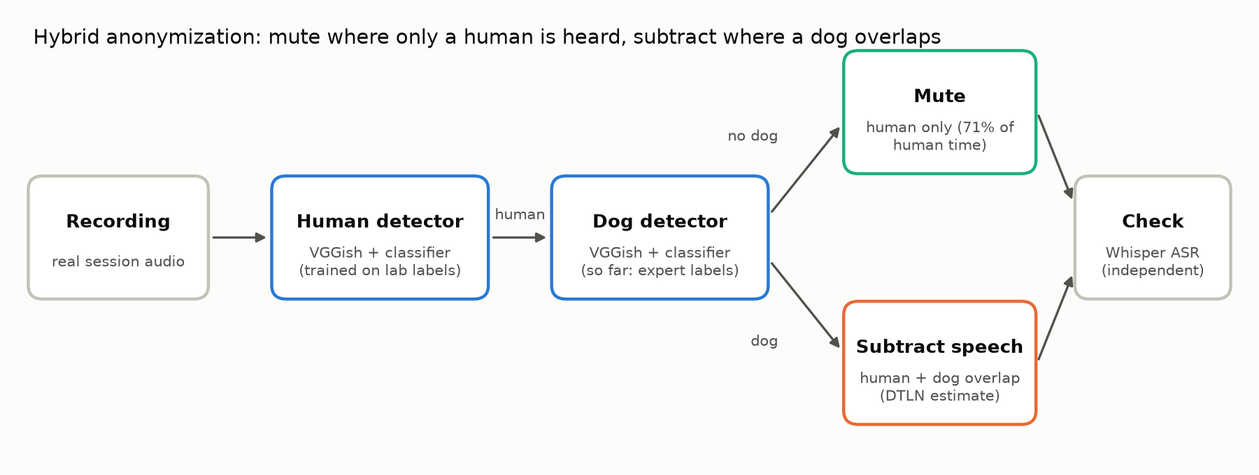
Figure 2. Hybrid anonymization pipeline.

6. Independent privacy evaluation with ASR
Earlier, success was judged by the speech detector no longer finding speech, which is circular, because a similar detector decided what to remove. Privacy is now measured with an independent and much stronger model: OpenAI Whisper (small, run locally through sherpa-onnx) transcribes the anonymized audio as an attacker would.
Synthetic scenes (ground truth known). Reference: Whisper's transcript of the clean speech; metric: share of its words that can still be read back after anonymization.
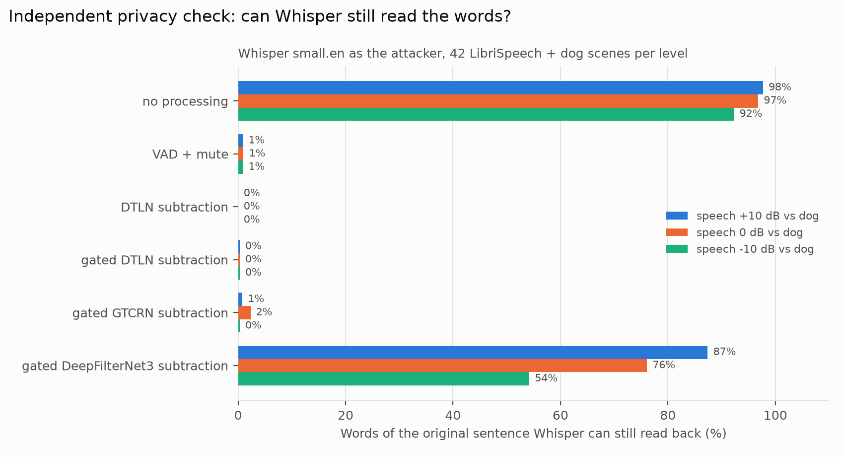
Figure 3. Words recovered by Whisper (small.en) after each method; 42 scenes per SNR level.
DTLN subtraction leaves no recoverable words in 95–100% of scenes. The isolated recovered words are either the first word before the detector onset or Whisper hallucinations. DeepFilterNet3 leaves 54–87% of the words readable.
Real recordings. Here the true transcript is unknown, so multilingual Whisper (automatic language detection) transcribes each annotated human event before and after removal, and also a background window of the same length from the same session with no annotated human or dog sound. The background windows measure how often Whisper invents words from noise, which gives a floor for the other numbers. All windows are normalized to the same loudness, as an attacker would amplify the audio.
Events with ≥2 words read | Original | Subtraction | Oracle hybrid | Background only
All events (581) | 23% | 20% | 7% | 4%
Events longer than 1 s (190) | 36% | 36% | 11% | 2%
Human only, no dog overlap (345) | 21% | 17% | 0.6% | 5%
Human + dog overlap (236) | 26% | 24% | 17% | 3%
Table 4. Whisper (small, multilingual) on real human events, with oracle detection and DTLN as the speech estimate.
On real audio, subtraction alone barely changes what can be understood (consistent with Section 5), whereas the hybrid removes recognizable speech from human-only events entirely. The remaining risk is concentrated in longer speech that overlaps a dog vocalization, where some English sentences remain recognizable. Because Whisper also hallucinates, a manual audit of the 79 remaining cases is in progress (Section 8).

7. Detection adapted to the lab recordings
Pretrained VGGish embeddings (trained on AudioSet) are extracted every 0.24 s from loudness-normalized sessions, and a logistic regression trained on the expert “Human” annotations classifies each frame (with the neighbouring frames as context). Evaluation is leave-one-participant-out (17 folds): every number comes from a model that never heard the tested person or dog.
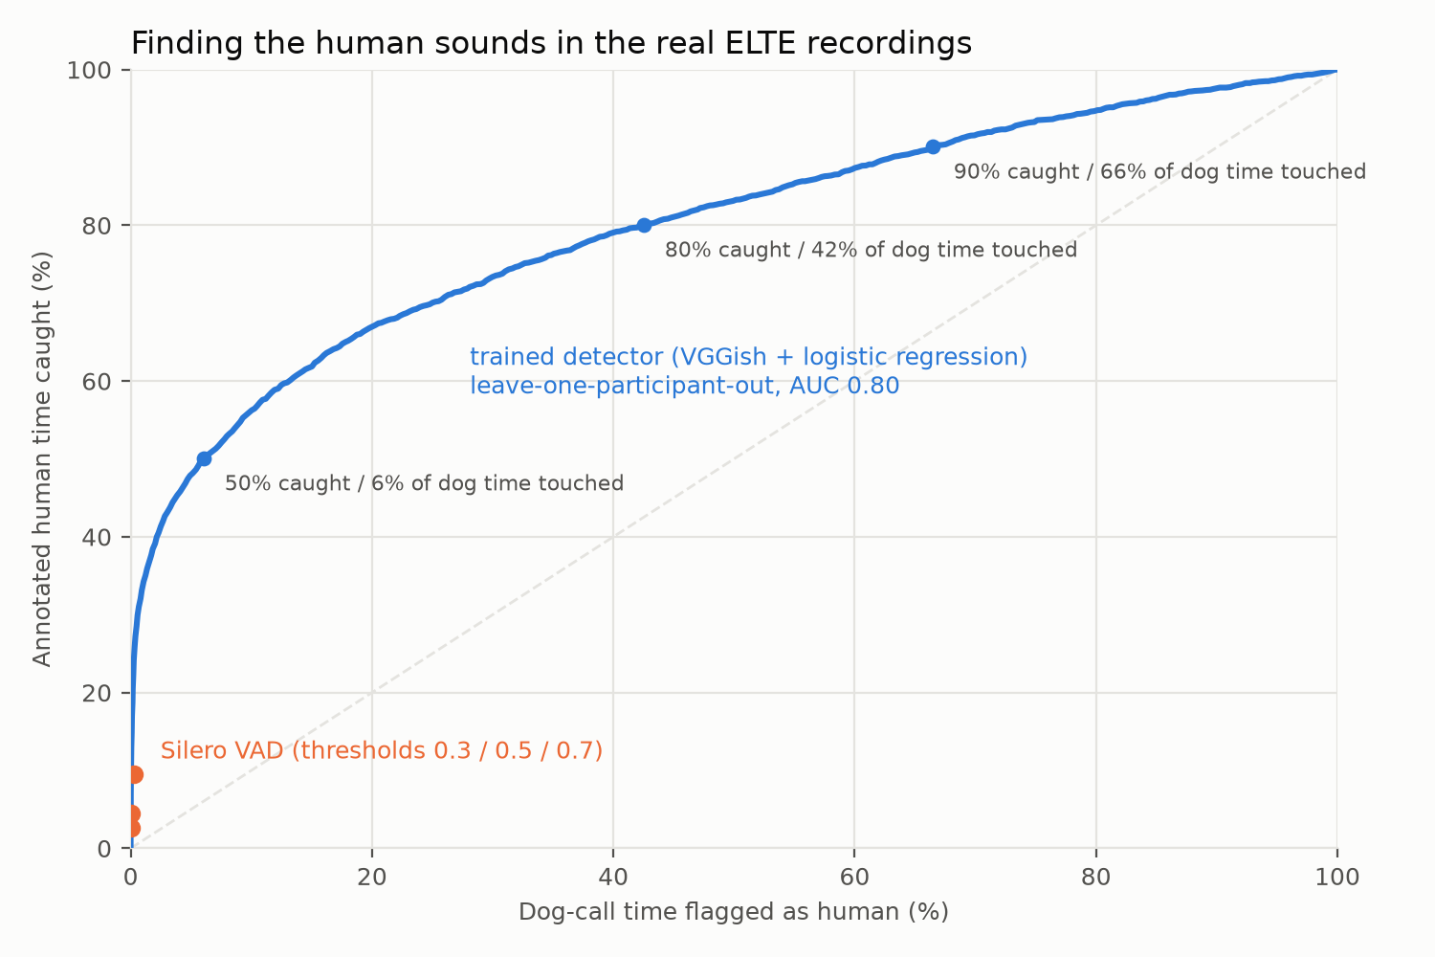
Figure 4. Human-sound time detected versus dog-vocalization time flagged, out-of-fold (ROC AUC 0.80).
Operating point | Human time found | Human events touched | Dog-vocalization time flagged
Silero VAD (0.5) | 4.5% | 1.4% | 0.0%
Trained detector, strict | 50% | 56% | 6%
Trained detector, balanced | 70% | 82% | 25%
Trained detector, high recall | 90% | 95% | 66%
Table 5. Detection on real sessions (leave-one-participant-out).
At high recall the detector also flags much of the dog's time. In the hybrid scheme a flag on dog time leads to subtraction, not deletion (about 2 dB loss for the dog in Section 3). The current target is every annotated human sound, including non-verbal ones. Retraining on intelligible speech only (Section 8) is expected to be an easier task.
Toward a deployable hybrid. The same method trained on the dog annotations gives a dog detector with ROC AUC 0.77 (most dog sounds are quiet panting). Used for routing inside human time at threshold 0.5, it sends 71% of human-only time to muting and 65% of human–dog overlap time to subtraction; a privacy-first threshold (0.7) mutes 89% of human-only time but routes only 43% of overlap time to subtraction. Deciding mute versus subtract without expert labels is therefore an open problem.

8. Target definition and labeling (in progress)
The expert annotations use a single “Human” label. For anonymization the relevant target is most likely intelligible speech. A working definition with three tiers was adopted, pending your confirmation: (A) intelligible speech — must be removed; (B) voiced non-speech such as laughter — should be removed; (C) other human noises such as clicks or claps — optional. A local listening tool was built to label the events by tier, ordered so that about 30 minutes cover all longer or word-containing events, a random spot-check of the short ones, and an audit of the 79 hybrid outputs in which Whisper still read something (real leak versus hallucination).

9. Limitations
- Results on real data use oracle (expert) annotations wherever stated; the deployable detectors are evaluated separately in Section 7.
- Whisper is a strong but imperfect proxy for a human listener: it can hallucinate (measured with background windows) and can also miss words a person would understand (hence the manual audit).
- The real-data evaluation uses one public dataset (single microphone, one lab). The lab's multi-microphone recordings have not been tested yet.
- Licensing: the dataset readme states CC BY-NC 4.0 while the Zenodo page states CC BY 4.0; the stricter NC terms are assumed.

10. Questions for discussion
- Is intelligible speech (tier A) the right primary target for anonymization, or must all human sounds be removed (tiers A–C)?
- Will the lab's own multi-microphone recordings be available, and in what form? They are also what the localization task needs.
- Is losing some dog signal where it overlaps speech acceptable (privacy-first), or must dog vocalizations be preserved as much as possible?
- Is fine-tuning a speech-removal model on simulated far-field speech mixed with real dog sounds a reasonable next research step?
- May the dataset and code be shared with Ivannova J. (localization task) via a private repository?

11. Proposed next steps
- Complete the tier labels and the leak audit; recompute detection and privacy results for the intelligible-speech target and retrain the detector on it.
- Make the hybrid routing deployable (better dog detector, or a privacy-first rule when uncertain).
- Only then address the overlap cases: fine-tune DTLN on simulated far-field, low-level, reverberant speech mixed with real lab dog sounds, evaluated on held-out participants.
- Run the full pipeline on complete sessions and summarize privacy and dog-signal preservation end to end.

Appendix: reproducibility
All experiments are scripted in the speech_anonymization repository (one script per step, documented in README.md with commands and results). Model weights are downloaded from the authors' public GitHub releases (DTLN, GTCRN, DeepFilterNet3, VGGish, Whisper via sherpa-onnx). The library code is covered by 39 automated unit tests. Real recordings, transcripts and listening clips are kept locally and are not published.

