MCQ
Module 3 – OOSAD using UML
Chapter 09: Object Interaction

Q1. Objects communicate by ___________________.
- sending messages
- firing events
- using API calls
- using objects of Control class
Answer: A

Q2. When an object sends a message to another object, ___________________in the receiving object.
Which one of the following best fit in the gap?
- an event is fired
- a transaction is started
- an operation is invoked
- only one property value is changed
Answer: C [See page 232]

Q3. How do we describe Object Interaction?
- Using use case diagram
- Using state chart
- Using the metaphor of Model
- Using the metaphor of message passing
Answer: D

Q4. '’The structure of Instances playing roles in a behaviour and their relationships “– what do we call it?
- Event
- State
- Collaboration
- Association
Answer: C

Q5. Which of the following is or are the benefits of distributing responsibilities appropriately among the classes?
- Each class does not become unduly complex and the class is easier to develop and maintain
- Each class becomes self-contained and has a much greater potential for reuse
- System becomes more resilient to changes in requirements
- System becomes more secured and isolated from malicious use
Answer: A, B, C

Q6. Which one is resilient system?
- 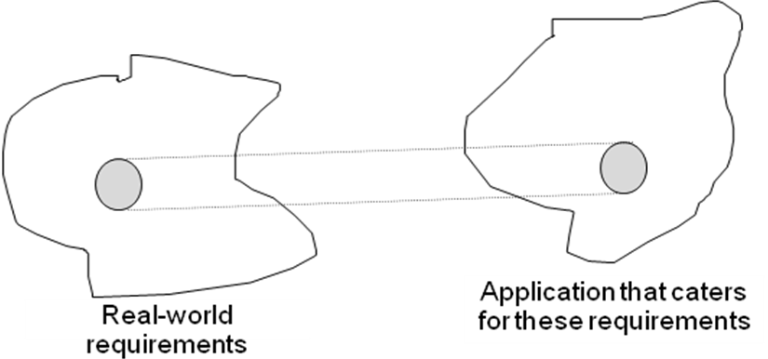
- 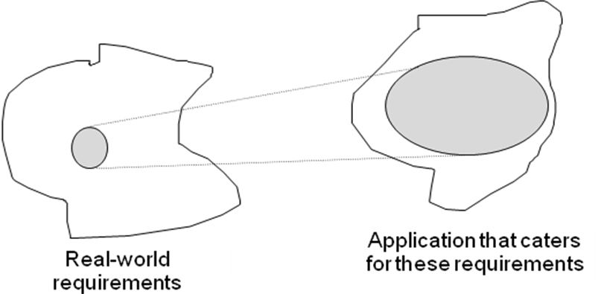
Answer: A [Any change in requirements needs change in the system. But if change in the system magnifies as compared to change in requirements, the system is not resilient. In A, change in the system due to the change in requirements is lesser than what is in B. So, A is more resilient.]
Q7. Which is the focus of a model of object interaction?
- To determine links between objects in order to support a particular user requirements
- To determine the user interface requirements in order to support a particular user requirements
- To determine the most appropriate scheme of messaging between objects in order to support a particular user requirement
- To determine the object instances those play a role to support a particular user requirement
Answer: C [See page 233]

Q8. Consider following two statements
Statement 1: A particular object instance may play different roles in different contexts or collaborations
Statement 2: A particular object instance may play more than one role in a given context or collaboration
No find out the correct combination about the above statements.
- Both Statement 1 and statement 2 are true
- Both Statement 1 and statement 2 are false
- Statement 1 is true and statement 2 is false
- Statement 1 is false and statement 2 is true
Answer: C

Q9. ____________ causes the invoking operation to suspend execution until the focus of control has been returned to it.
Which one appropriate for the blank space?
- A synchronous message
- An asynchronous message
Answer: A

Q10. ____________ does not cause the invoking operation to suspend execution until the focus of control has been returned to it.
Which one appropriate for the blank space?
- A synchronous message
- An asynchronous message
Answer: B

Q11. Collaboration diagrams differ from interaction sequence diagrams in which of the following way?
- Collaboration diagrams cannot show the design detail that can be shown on a sequence diagram.
- Collaboration diagrams only show the collaboration and not the sequence in which the messages are sent
- Collaboration diagrams show explicitly the links between the objects.
- None
Answer: B, C

Q12. An interaction diagram should he consistent with the associated class diagram in various ways. Which of the following statements is true?
- It is always correct to show a message between two objects if there is an association between their classes.
- The sending object must have the object reference of the receiving object before sending an object-scope message.
- A message should not be shown between two objects if there is no association between their classes.
- None is true
Answer: B

