**Software Requirements Specification (SRC)**

**Project Title: Train Ticket Reservation**

**Requirements:**

We need to build a software for “Train Ticket Reservation”. The application will have following features:

1. There will be different type role like Admin, Super Admin, Users etc.
2. There will be ‘Available Seat ’, ‘Train Schedule Time’, ‘Many Compartment’, ‘Seat or Cabin’, ‘Seat Details’ ,‘Route Details’,’ Train Details ’,’Reservation’, ’Fare Category ’, ‘Many Route ’, ‘Many Station’, ‘Train Class’, ‘Ticket Details ’, ‘Train Class ’, ‘ Sales ’, ‘ ’ and ‘Login page’ etc.
3. In login page admin receptionist’s views.
4. From Available Seat Passenger can find his available facilities. He/she can his suitable Seat or Cabin.
5. From Seat Details page Passenger can select his Seat details. He/she can have facility to reserve the train seat check in and check out time.
6. From Reservation page Passenger can Purchase Ticket. He/she can have facility to reserve the train seat check in and check out time.
7. In Train Schedule Time page Passenger can see schedule details. All the information about route will be presented there.
8. From Seat Train page Passenger can see train details. All the information about route will be presented there.
9. From Fair Category page Passenger can Purchase Ticket. He/she can have facility to reserve the train seat check in and check out time. And also can select seat his/her chosen.
10. Passenger can payment with ‘Visa/Master’, ‘DBBL Nexus ’, ‘DBBL Mobile Banking’, ‘American Express ’. He/she can have facility to reserve the train seat check in and check out time.
11. Passenger can visit his/her profile.
12. Passenger cancel his/her reservation seat or cabin.
13. Super admin and admin control all page without user profile
14. In about page there will be information about train details.

Analysis and Design Part:

1. Brain Storming Diagram:

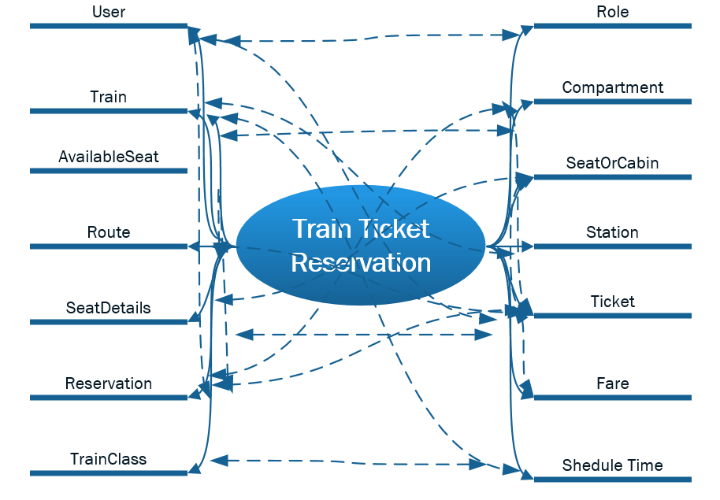

1. Use Case Diagram:

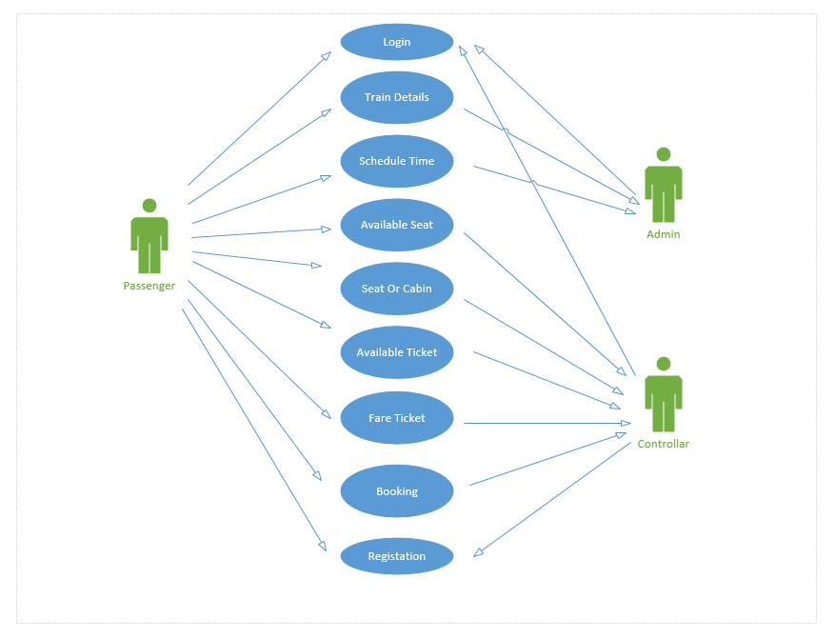

1. Class Diagram: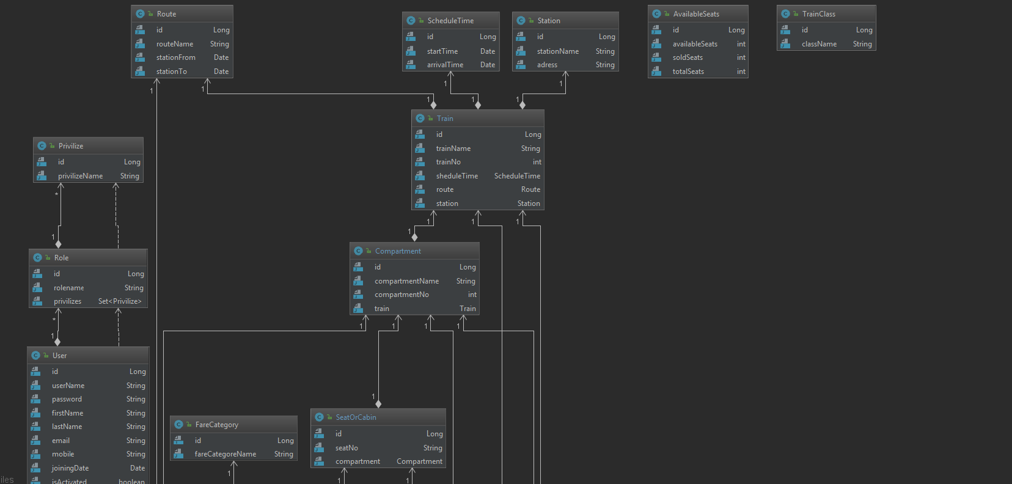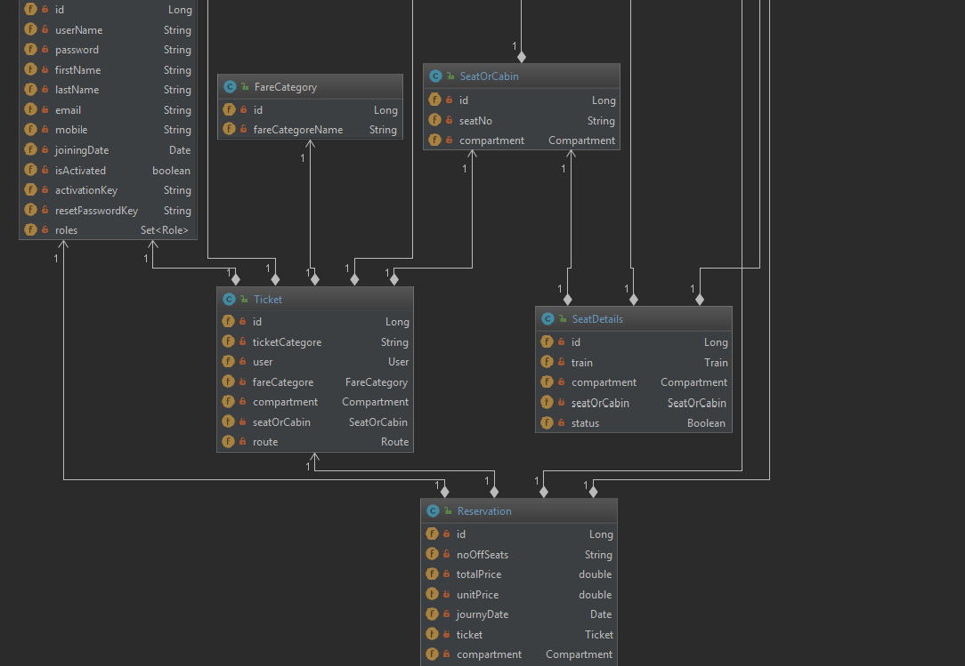
2. Entity Relationship Diagram:

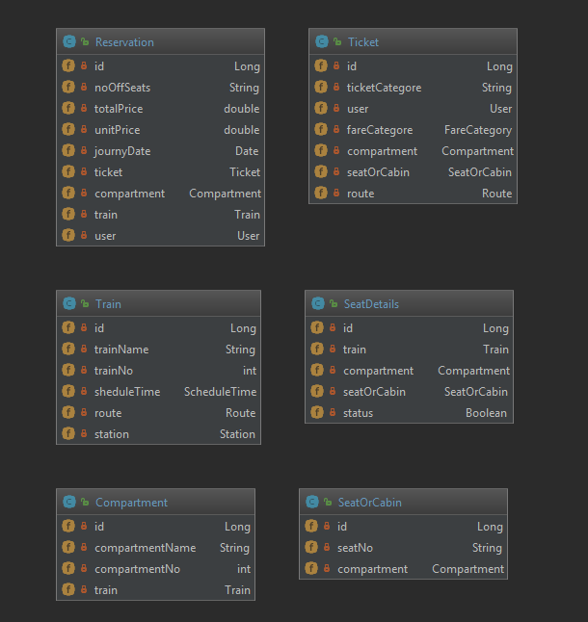

1. Front End Designs: