# SQL Запросы

1. SELECT COUNT(CustomerName) FROM Customers WHERE country='Germany'
2. SELECT * FROM Customers WHERE CustomerName LIKE '%e';
3. INSERT INTO Customers (CustomerName) VALUES('Roman') 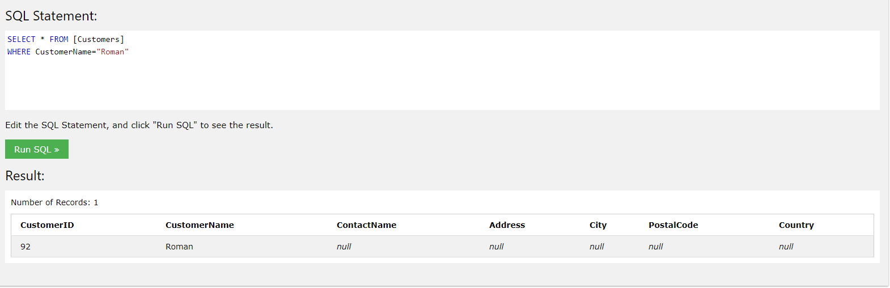
4. UPDATE Customers SET CustomerName = 'nurpix' WHERE CustomerID = 92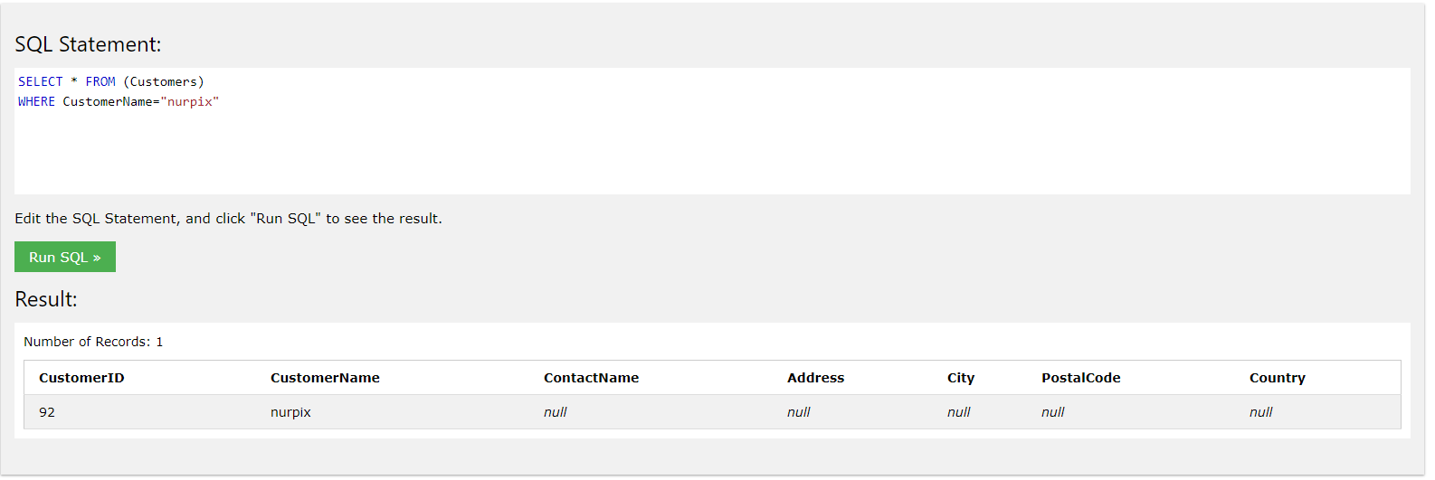
5. DELETE FROM Customers WHERE City='Nantes'; 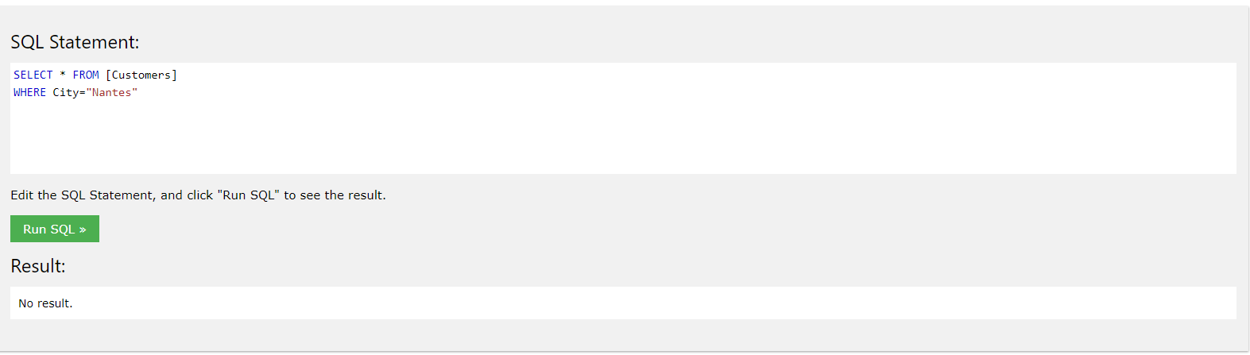
6. SELECT Orders.OrderID, Employees.EmployeeID

FROM Employees

INNER JOIN Orders ON Employees.EmployeeID = Orders.EmployeeID

WHERE Employees.FirstName='Steven'