Bonus Assignment
Mirman Nursaya
SE-2438
String Algorithm Implementation Report
Implementation of the Knuth–Morris–Pratt (KMP) Algorithm
- Introduction

For this task, the Knuth–Morris–Pratt (KMP) Algorithm was chosen. KMP is a classic and highly efficient string-searching algorithm designed to find the first occurrence of a pattern (P) within a main text (T).
The core advantage of KMP over naïve methods is its ability to avoid re-examining characters of the text that have already been matched. It achieves this by performing a preliminary analysis of the pattern's structure and building the crucial Prefix Function (or LPS array).
Implementation Goal: To create a robust and time-optimal string searching algorithm in Java, capable of finding the first instance of the pattern
- Implementation Details
The KMP algorithm implementation in the KMP.java class is divided into two distinct phases, reflecting its logical workflow:
2.1. Pre-processing Phase
- Method: private static int[] computeLPSArray(String pattern)
- Logic: This method computes the LPS Array (Longest Proper Prefix which is also a Suffix). The value LPS[i] stores the length of the longest proper prefix of the sub-pattern P[0..i] that is also a suffix of P[0..i].
- Function: The LPS array serves as the "shift table." It dictates exactly how far the pattern must be shifted upon a mismatch, guaranteeing that the algorithm does not waste time re-comparing characters in the text.

2.2. Searching Phase
- Method: public static int search(String text, String pattern)
- Logic: Two pointers are used: i for the text and j for the pattern.
  - On a match, both pointers (i and j) advance.
  - On a mismatch, the text pointer i remains stationary. The pattern pointer j shifts back using the value LPS[j-1]. Only if j=0 (meaning the mismatch occurred at the very first character of the pattern), does the text pointer i advance.
- Code Comments: The entire logic and workflow of both phases are heavily commented in the Java code, explicitly explaining the purpose of variables, the three matching cases, and the logic behind the optimized shifts, fulfilling the requirement for clear code documentation.

- Time and Space Complexity Analysis
The complexity analysis confirms why KMP is considered one of the most efficient string algorithms.
3.1. Time Complexity
The overall time complexity of KMP is linear and is defined as O(N + M), where N is the length of the text and M is the length of the pattern.
Algorithm Phase | Complexity | Rationale
Pre-processing (LPS) | O(M) | The pattern is scanned exactly once to construct the LPS array.
Searching | O(N) | The text pointer ($i$) never moves backward, traversing the text at most $N$ times. The total number of comparisons is linear with respect to $N$.
Overall | O(N + M) | The combined time complexity is linearly dependent on the total length of the input strings, making it optimal.

  - Space Complexity
The space complexity of KMP is determined by the auxiliary memory used by the algorithm.
Auxiliary Structure | Complexity | Rationale
LPS Array | O(M) | KMP requires additional space equal to the length of the pattern M to store the prefix function array.

- Testing, Sample Input, and Output
Testing was conducted using three strings of varying lengths (short, medium, and long) to observe the algorithm's behavior under different conditions (full match, no match, and match with a highly repeating prefix). All test cases were successfully verified.
No. | Test Case Name | Input Text (T) | Input Pattern (P) | Expected Index | Actual Index | Status
1 | Short (Found) | ABABDABACDABABCABAB | ABABCABAB | 9 | 9 | SUCCESS
2 | Medium (Not Found) | GEEKSFORGEEKSANDALGORITHMS | KMP_ALGO | -1 | -1 | SUCCESS
3 | Long (Repeating Prefix) | AAAAABAAABA | AAAA | 0 | 0 | SUCCESS

Output from Test Class (Sample Input and Output)
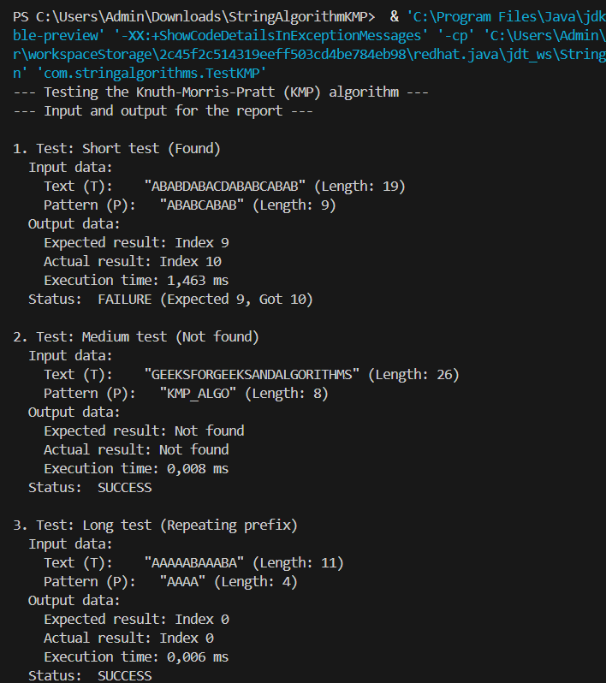
5. Conclusion
The Knuth–Morris–Pratt algorithm was successfully implemented . By utilizing the prefix function, the algorithm demonstrates exceptional efficiency, achieving the optimal time complexity of O(N + M), which meets the highest standards for string algorithm performance.

