DATABASE 1FIT

Hello everyone.My team and I have chosen the project – 1fit

1fit is a network of gyms

Our ER diagram for database of 1fit is <https://drive.google.com/file/d/1VHRK-fvT0Wo6eBamQG3iucUtgTePvIJz/view?usp=sharing>  
  
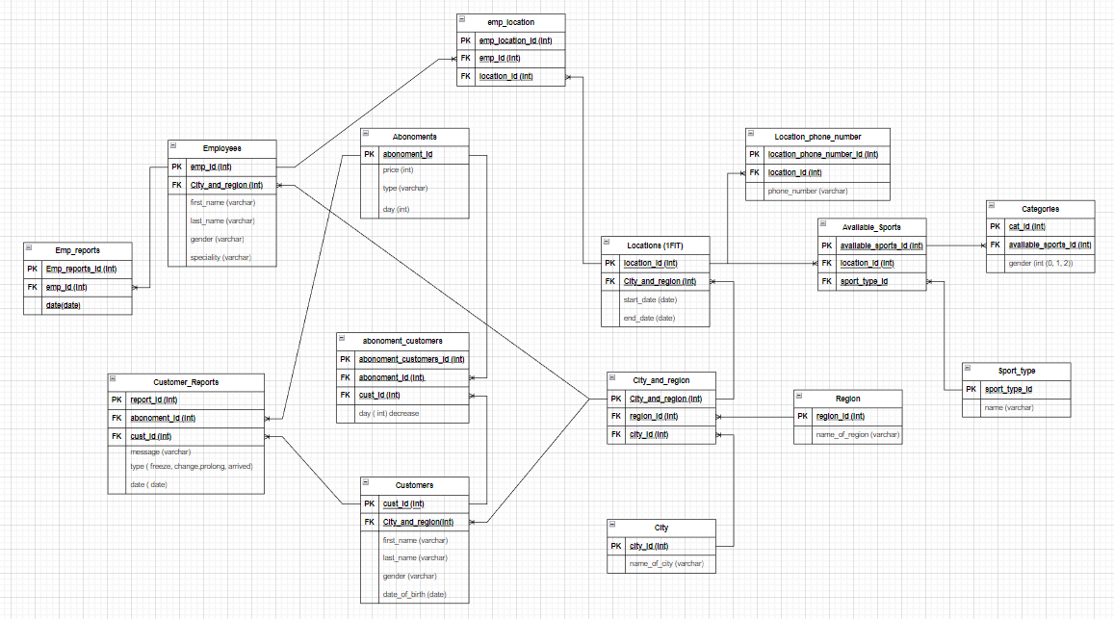

Our ER diagram follows to requirments of 1NF, 2NF, 3NF  
1NF - Each table cell should contain a single value. Each record needs to be unique.  
2NF - Be in 1NF. Single Column Primary Key that does not functionally dependant on any subset of candidate key relation  
3NF - Be in 2NF. Has no transitive functional dependencies

**Our creation of tables is following:**

create table City (

city_id int primary key,

name_of_city varchar2(32)

);

create table Region(

region_id int primary key,

name_of_region varchar2(32)

);

create table City_Region(

city_region int primary key,

city_id int references City(city_id),

region_id int references Region(region_id)

);

create table Customers(

cust_id int primary key,

city_region int references City_Region(city_region),

first_name varchar2(32),

last_name varchar2(32),

gender varchar2(32),

date_of_birth date

)

create table Locations(

location_id int primary key,

city_region references City_Region(city_region),

start_date date,

end_date date

)

create table Abonoment_customers(

abonoment_customers_id int primary key,

abonoment_id int references Abonoments(abonoment_id),

cust_id int references Customers(cust_id),

day int

)

create table Abonoments(

abonoment_id int primary key,

price int,

type varchar2(32),

day int

)

create table Location_phone_number(

location_phone_number_id int primary key,

location_id int references Locations(location_id),

phone_number varchar2(32)

)

create table Reports(

report_id int primary key,

abonoment_id int references Abonoments(abonoment_id),

cust_id int references Customers(cust_id),

message varchar2(32),

type varchar2(32),

dates date

)

create table Employees(

emp_id int primary key,

city_region int references City_region(city_region),

first_name varchar2(32),

last_name varchar2(32),

gender varchar2(32),

speciality varchar2(32)

)

create table Emp_reports(

emp_reports_id int primary key,

emp_id int references Employees(emp_id),

dates date

)

create table Emp_location(

emp_location_id int primary key,

emp_id int references Employees(emp_id),

location_id int references Locations(location_id)

)

create table Sport_type(

sport_type_id int primary key,

sport_type_name varchar2(32)

)

create table Available_sports(

available_sports_id int primary key,

location_id int references Locations(location_id),

sport_type_id int references Sport_type(sport_type_id)

)

create table Categories(

cat_id int primary key,

available_sports_id int references Available_sports(available_sports_id),

gender varchar2(32)

)

**TRIGGERS**

create or replace trigger custReportArrive

before insert on reports

for each row

begin

if :new.type like 'arrived' then

update Abonoment_customers

set day = day-1

where cust_id = :new.cust_id;

end if;

end;

create or replace trigger custReportProlong

before insert on reports

for each row

declare

temp int;

begin

select day into temp

from abonoments

where abonoment_id = :new.abonoment_id;

if :new.type like 'prolong' then

update Abonoment_customers

set day = temp

where cust_id = :new.cust_id;

end if;

end;

create or replace trigger custReportChange

before insert on reports

for each row

declare

temp int;

begin

select day into temp from abonoments where abonoment_id = :new.abonoment_id;

if :new.type like 'change' then

update Abonoment_customers

set day = temp

where cust_id = :new.cust_id;

end if;

end;

create or replace trigger CustNum

before insert on customers

for each row

declare

temp int;

begin

select count(*) into temp from customers;

dbms_output.put_line('current number of rows: '||temp);

end;

create or replace trigger reportNum

before insert on reports

for each row

declare

temp int;

begin

select count(*) into temp from reports;

dbms_output.put_line('current number of rows: '||temp);

end;

create or replace trigger employeeNum

before insert on employees

for each row

declare

temp int;

begin

select count(*) into temp from employees;

dbms_output.put_line('current number of rows: '||temp);

end;

**EXCEPTIONS**

declare

c_name customers.first_name%type := 'Abay';

c_lname customers.last_name%type := 'Baxa';

symbol_invalid exception;

begin

if c_name like '%@%' or c_lname like '%@%' then

raise symbol_invalid;

else

dbms_output.put_line('Registration successful.');

end if;

exception

when symbol_invalid then

dbms_output.put_line('First name or last name has invalid symbol');

when others then

dbms_output.put_line('Error!');

end;

declare

c_lname customers.first_name%type := 'Abay';

less_symbol_invalid exception;

begin

if c_lname not like '%____%' then

raise less_symbol_invalid;

else

dbms_output.put_line('Registration successful.');

end if;

exception

when less_symbol_invalid then

dbms_output.put_line('Less than 4 characters');

when others then

dbms_output.put_line('Error!');

end;

declare

c_id customers.cust_id%type;

c_name customers.first_name%type;

c_lname customers.last_name%type;

begin

select first_name, last_name into c_name, c_lname

from customers

where cust_id = c_id;

dbms_output.put_line('Name: '|| c_name);

dbms_output.put_line('Last name: '|| c_lname);

exception

when no_data_found then

dbms_output.put_line('No such customer!');

when others then

dbms_output.put_line('Error');

end;

declare

city_name city.name_of_city%type := 'A';

city_invalid exception;

begin

if city_name is null then

raise city_invalid;

else

select name_of_city into city_name

from city

where name_of_city = city_name;

end if;

exception

when city_invalid then

dbms_output.put_line('Fill in the fields');

when others then

dbms_output.put_line('Successfully');

dbms_output.put_line('Name of city: '|| city_name);

end;