Financial News Knowledge Graph Report

Abstract
This report presents an end-to-end automated pipeline for constructing a domain-specific knowledge graph from unstructured financial news using a large language model (LLM) and Neo4j. The system processes raw news articles from the Financial_Sentiment.csv dataset, extracts structured (subject, relation, object) triplets via few-shot prompting with Qwen (via OpenRouter), performs data cleaning, and loads the results into a Neo4j property graph. A natural language interface enables users to query the graph using plain English, which is translated into Cypher by the same LLM. In experimental runs, the pipeline processed 100 sentences in 350.8 seconds and extracted 38 valid triplets, including events such as “Home Depot Hits 16-week Low” and “Target earnings above expectations.” The results demonstrate that LLMs can effectively automate knowledge graph construction in financial domains with minimal human intervention, enabling scalable semantic data representation.
1. Introduction
1.1 Background
Financial markets generate vast volumes of unstructured textual data through news, earnings reports, and analyst commentary. Extracting structured knowledge from this data manually is infeasible at scale. Recent advances in LLMs enable zero- or few-shot information extraction, making them powerful tools for building knowledge graphs without labeled training data. Knowledge graphs, in turn, support complex querying, event tracking, and decision support in finance.
1.2 Objective
The main objectives of this experiment are:
- To design and implement an automated pipeline for knowledge graph construction from financial news.
- To evaluate the effectiveness of few-shot LLM prompting (using Qwen) for entity and relation extraction.
- To store and visualize the resulting graph in Neo4j using the Property Graph Model.
- To enable natural language querying through LLM-based Cypher generation.
1.3 Report Structure
Section 2 reviews theoretical concepts. Section 3 details the methodology. Section 4 presents results. Sections 5 and 6 discuss limitations and conclusions.
2. Related Work / Theoretical Background
2.1 Key Technologies
- Large Language Models (LLMs): Qwen is used in few-shot mode to extract structured triplets without fine-tuning.
- Property Graph Model: Represents data as nodes (e.g., Company) and relationships (e.g., HIT_LOW), both of which can carry properties (e.g., year, value).
- Natural Language to Cypher (NL2C): An LLM maps user questions to executable Cypher queries using schema-aware prompting.
2.2 Pipeline Stages
- Data Preprocessing – Clean and segment raw text.
- Entity & Relation Extraction – Use LLM to generate triplets.
- Data Cleaning – Normalize and validate outputs.
- Graph Construction – Load into Neo4j.
- Query Interface – Translate natural language to Cypher.
2.3 Justification
LLMs reduce dependency on annotated data. Neo4j’s native graph model is ideal for representing financial events as interconnected entities. The combination enables rapid, interpretable knowledge base development.
3. Methodology
3.1 Experimental Environment
- Hardware: MacBook with Apple M-series (ARM64), 16GB RAM
- Software:
  - Python 3.9
  - Neo4j 5.x (installed via Homebrew)
  - Libraries: py2neo, pandas, nltk, openai
  - LLM: Qwen (qwen/qwen-7b-chat) via OpenRouter
3.2 Dataset Description
- Source: Financial_Sentiment.csv
- Size: 15,534 valid news items after cleaning
- Structure:
  - Title: News headline
  - Tag: Category (e.g., Earnings, Stock Market)
  - Content: Full news body (contains timestamps and artifacts)
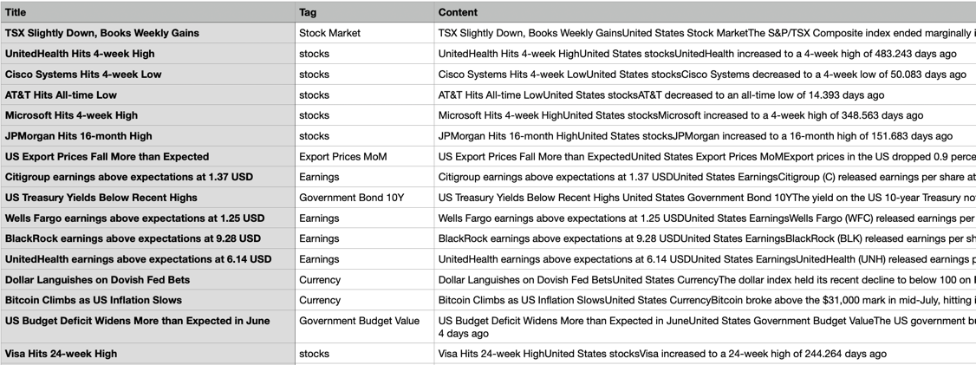
Figure 1: Sample Financial News Records

3.3 Pipeline Implementation
- Data Preprocessing
  - Load CSV with pd.read_csv(..., on_bad_lines='skip')
  - Combine Title + Content, clean special characters, split into sentences using nltk.sent_tokenize
- Entity & Relation Extraction
- Few-shot prompt with 2 examples: Text: "Home Depot Hits 16-week Low" -> {"triplets": [{"subject": "Home Depot", "subject_type": "Company", "relation": "HIT_LOW", "object": "", "object_type": "Event"}]}
- Supported relations: Acquired, Invested_in, Founded, Anounced_earnings, Hit_High, Hit_Low
- Data Cleaning
- Filter invalid relations
- Ensure non-empty subjects/objects
- Default entity type: Company
- Graph Construction
- Use py2neo to connect Neo4j
- Run MERGE with uniqueness constraints on Company.name
- Example Cypher:
MERGE (c:Company {name: "Home Depot"})
MERGE (c)-[:HIT_LOW]->(:Event)

- Natural Language to Cypher
  - Prompt includes graph schema
  - Output: executable Cypher (e.g., MATCH (c:Company)-[:HIT_LOW]->() RETURN c.name)
3.4 Analytical Approach
- Process 100 sentences for evaluation
- Manually verify extracted triplets
- Visualize in Neo4j Browser
- Test NL2C with sample questions
4. Results and Analysis
4.1 System Output
  - Processed: 100 sentences from 15,534 news items
  - Extracted: 39 raw triplets → 38 cleaned triplets
  - Examples:
(Home Depot)-[:HIT_LOW]->()
(Target)-[:ANNOUNCED_EARNINGS {value: 3.19}]->()
(AT&T)-[:HIT_LOW]->()
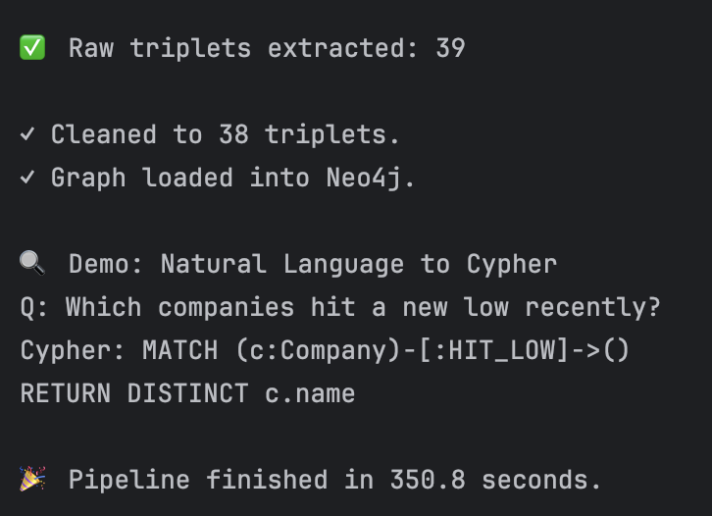
Figure 2: Pipeline Execution Log
4.2 Natural Language Query
  - Input: “Which companies hit a new low recently?”
  - Generated Cypher:
MATCH (c:Company)-[:HIT_LOW]->()
RETURN DISTINCT c.name
  - Verified correct in Neo4j Browser
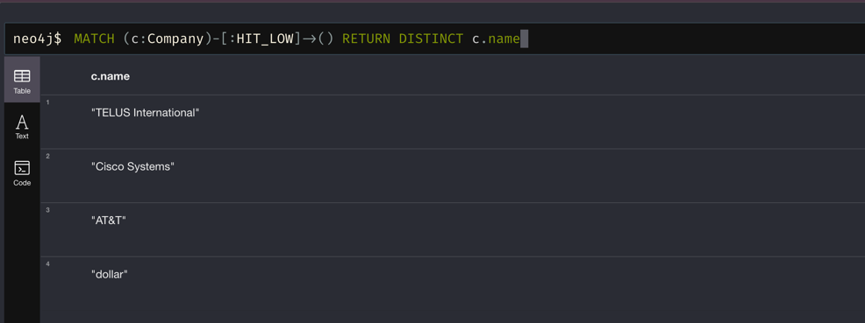
Figure 3: Natural Language Query Execution
4.3 Performance
- Runtime: 350.8 seconds (~3.5 sec/sentence)
- Success Rate: 38/100 sentences yielded valid triplets (38%)
- Graph Load: 100% success
4.4 Visualization
In Neo4j Browser (http://localhost:7474), the graph displays:
- Company nodes with name
- Relationships like HIT_LOW, ANNOUNCED_EARNINGS
- No duplicate nodes (thanks to MERGE + constraints)
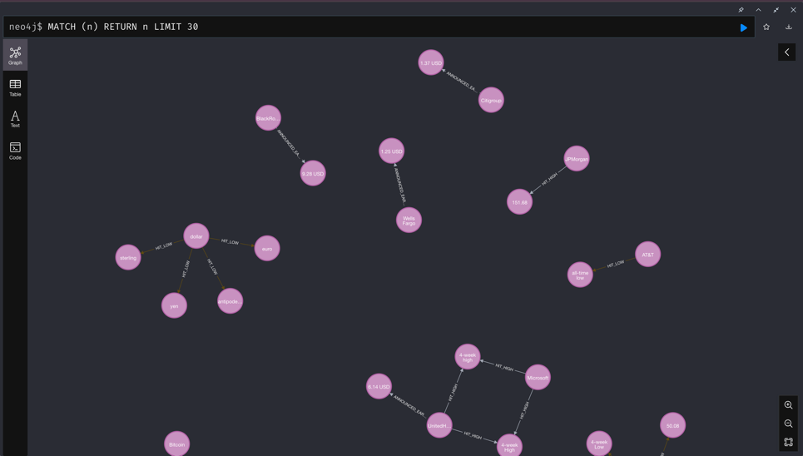
Figure 4: Knowledge Graph Visualization in Neo4j Browser
5. Discussion
5.1 Summary of Findings
- Few-shot LLM prompting successfully extracts financial events without training data.
- Neo4j provides an intuitive, queryable representation of financial knowledge.
- NL2C enables non-technical access to structured insights.
5.2 Technical Challenges
- CSV contained malformed rows → resolved with on_bad_lines='skip'
- Initial Neo4j connection failed → fixed by installing via Homebrew and setting password
- OpenRouter model name errors → resolved by using qwen/qwen-7b-chat
5.3 Limitations
- Only 100 sentences processed due to API cost and time
- No entity resolution (e.g., “Home Depot” vs “HD”)
- Relations are limited; could expand to BELOW_EXPECTATIONS, MERGER, etc.
5.4 Scalability
- For full dataset: switch to Ollama + Qwen (local) to eliminate API costs
- Add batch processing and caching for production use
6. Conclusion and Future Work
6.1 Conclusion
This experiment successfully demonstrates an automated, LLM-driven pipeline for financial knowledge graph construction. The system extracts, validates, and stores real-world events from news text, enabling semantic querying via natural language. It validates the practicality of LLMs for rapid knowledge engineering in domain-specific applications.
6.2 Future Work
- Implement entity linking using financial identifiers (e.g., ticker symbols)
- Add sentiment attributes (e.g., sentiment: negative) to relations
- Process entire dataset using local Ollama
- Deploy as a web service with FastAPI and Neo4j Browser integration
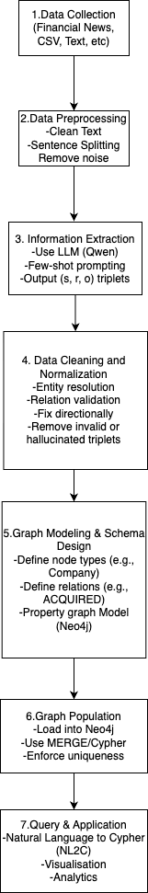
Automated Knowledge Graph Workflow

