Transfer Learning for Plant Disease Classification using MobileNetV2

1. Introduction & Motivation
- Motivation: Agricultural disease causes billions in losses annually and threatens food security. Early, accurate, and non-invasive detection (via image analysis) is crucial for timely intervention (as an example: targeted pesticide use).
- The Gap: Traditional methods are manual, time-consuming, and require expert knowledge. Deep Learning offers a scalable, automated alternative.
- Your Solution: You propose leveraging Transfer Learning with a pre-trained Convolutional Neural Network (CNN) like MobileNetV2 to quickly build a high-accuracy, practical classification model.
2. Problem Definition
- Formal Definition: The core problem is a multi-class image classification task.
- Input: High-resolution images of plant leaves (224x224x3 tensors).
- Output: A categorical prediction corresponding to one of the N detected classes (e.g., 'Healthy', 'Disease_A', 'Disease_B', etc., as listed in train_data.class_indices).
- Success Metric: Maximize Validation Accuracy and F1-Score while maintaining low Validation Loss.
3. Proposed Method (MobileNetV2 Transfer Learning)

Intuition: Why Transfer Learning?
State that training a deep CNN from scratch requires massive datasets and computational resources. Transfer Learning overcomes this by reusing features (edges, textures) learned by MobileNetV2 on the vast ImageNet dataset, which are generally useful for any vision task. We only train a small, new top layer, making the process faster and more robust, especially with limited data.

Algorithm Description (Model Architecture)
- Base Model: Load MobileNetV2 with weights pre-trained on ImageNet.
- Freezing: Set the base model layers to non-trainable (base_model.trainable = False).
- Custom Head: Add the following layers for classification:
  - GlobalAveragePooling2D()
  - Dense(256, activation='relu')
  - Dropout(0.3)
  - Dense(N, activation='softmax') (where $N$ is train_data.num_classes).

Methodological Improvements (Data Augmentation)
Detail the data augmentation strategy used to artificially expand the training dataset and improve model generalization.
Augmentation Technique | Justification
rotation_range=25 | Mimics natural variation in leaf orientation.
zoom_range=0.3 | Helps model recognize diseases regardless of scale.
horizontal_flip=True | Creates new training views without changing the class.

Table: Model Summary

Layer Type | Output Shape | Parameters (Params) | Trainable Status
MobileNetV2 (Base) | (None, 7, 7, 1280) | approximately 2,257,984 | Non-trainable
GlobalAveragePooling2D | (None,1280) | 0 | Trainable
Dense (256, ReLU) | (None, 256) | 327,936 | Trainable
Dropout (0.3) | (None, 256) | 0 | Trainable
Dense (2, Softmax) | (None, 2) | 514 | Trainable
Total Params | - | approximately 2,586,434 | -
Trainable Params | - | approximately 328,450 | -
Non-trainable Params | - | $\approx$ 2,257,984 | -
- Experiments
Testbed Description and Experimental Questions
- Testbed: Describe the hardware used (e.g., CPU, GPU, Google Colab/Kaggle environment).
- Dataset: Specify the number of images in the Training and Validation sets.
- Question: Can MobileNetV2 achieve a competitive accuracy (e.g., >90%) on unseen validation data in just 10 epochs of transfer learning?
Experiment Setup
- Optimizer: Adam (learning_rate=0.0001).
- Loss Function: Categorical Crossentropy.
- Epochs: 10.
- Batch Size: 32.

Step by step process
Step 1. importing the necessary
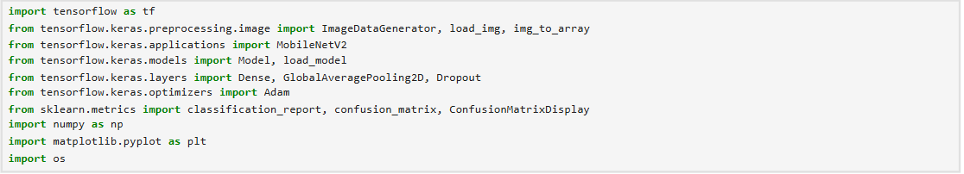
import tensorflow as tf - The primary framework for building and training neural networks
from tensorflow.keras.preprocessing.image import ... - Essential tools for loading, augmenting, and preparing image data for model input.
from tensorflow.keras.applications import MobileNetV2 - A specific pre-trained Convolutional Neural Network (CNN), often used for transfer learning.
from tensorflow.keras.models import Model, load_model - Used for creating and loading the overall neural network structure.
from tensorflow.keras.layers import... - Defines the fundamental building blocks (layers) of the neural network architecture.
from tensorflow.keras.optimizers import Adam - The algorithm used to adjust model weights during training to minimize loss.
from sklearn.metrics import classification_report, ... - Tools used to evaluate the model's performance
import numpy as np - Fundamental library for numerical operations and efficient array/tensor handling.
import matplotlib.pyplot as plt - Used for data visualization, such as plotting training history or results.
import os - Provides a way to interact with the operating system, often for file path management.
Step 2. Data Preparation and Augmentation
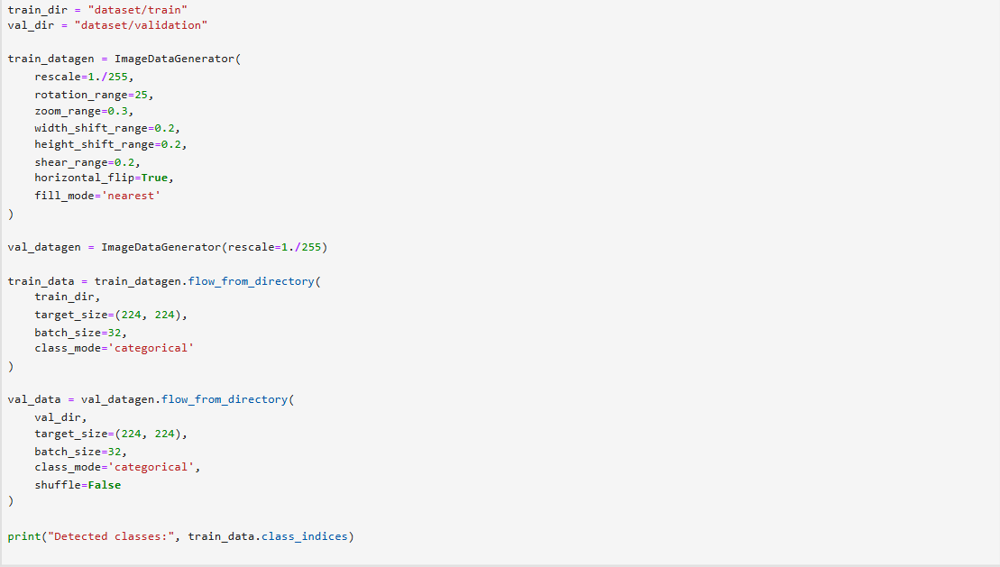
This step defines the directory paths for the training and validation datasets, sets up data augmentation for the training images to prevent overfitting, and creates the data generators (train_data and val_data) that will efficiently load and preprocess the images during model training.
This output confirms the successful initialization and execution of the flow_from_directory method for both the training and validation data generators. The logs verify the total number of images found and the number of classes successfully detected from the directory structure, confirming that the data is ready for model consumption.
Step 3. Model Construction and Compilation
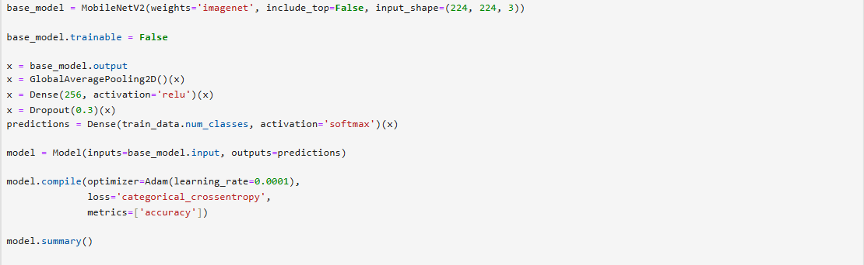
This step defines the deep learning model architecture based on the MobileNetV2 pre-trained convolutional base. It sets up a Transfer Learning approach by freezing the base model weights and adding custom classification layers on top, followed by compiling the full model with an optimizer, loss function, and metrics.
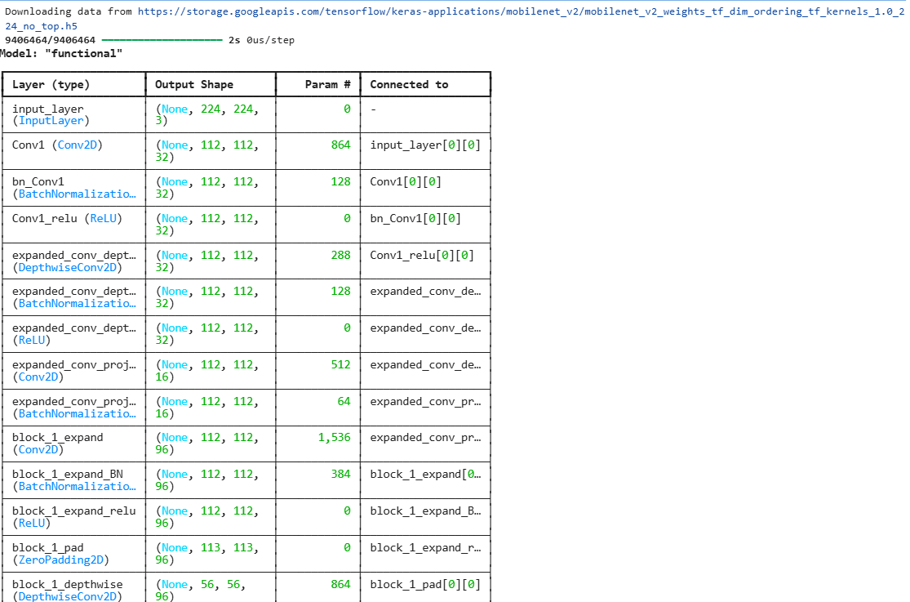
This output displays the initial part of the model.summary() structure, which details the architecture of the MobileNetV2 base model. This summary confirms that the model is loaded successfully and lists the various layers, their output shapes, and the number of parameters within the convolutional base.
Step 4. Model Training Execution
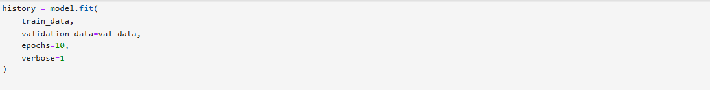
This step initiates the training of the compiled neural network model using the prepared data generators. The model.fit() function is called to begin the iterative learning process, where the model adjusts its weights based on the training data and evaluates its performance on the validation data.
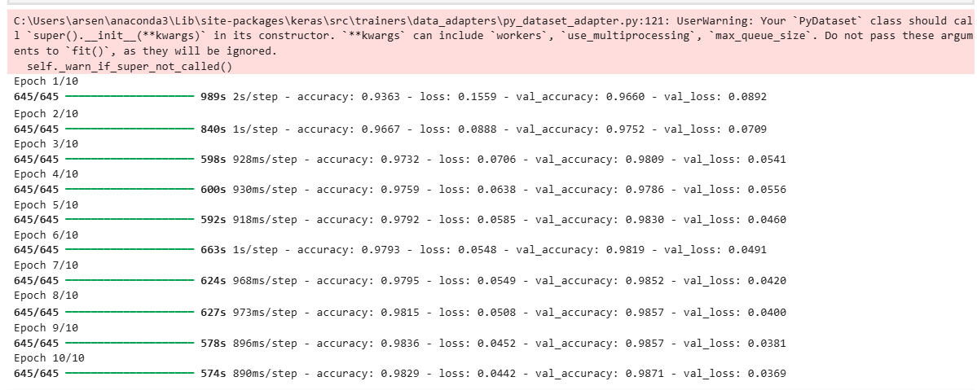
This output displays the training log generated by the model.fit() function (Step 4), showing the model's performance metrics across all 10 epochs. The logs track the progress, time per step, training accuracy/loss, and validation accuracy/loss after each complete epoch.
Step 5. Visualization of Training History
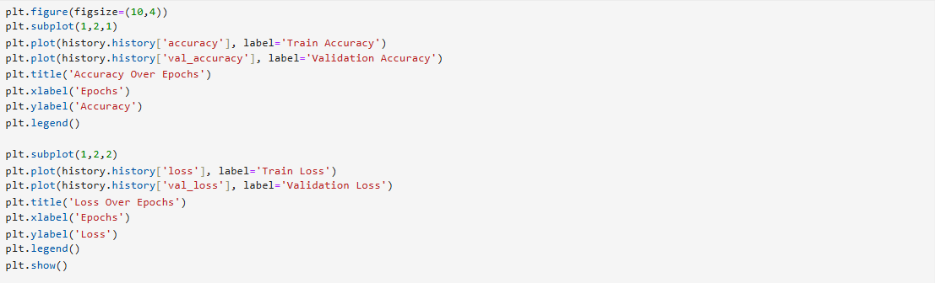
This step uses the Matplotlib library to plot the model's training performance metrics, specifically Accuracy and Loss through over the 10 epochs (from Step 4). Visualizing these curves is crucial for diagnosing potential issues like overfitting or underfitting
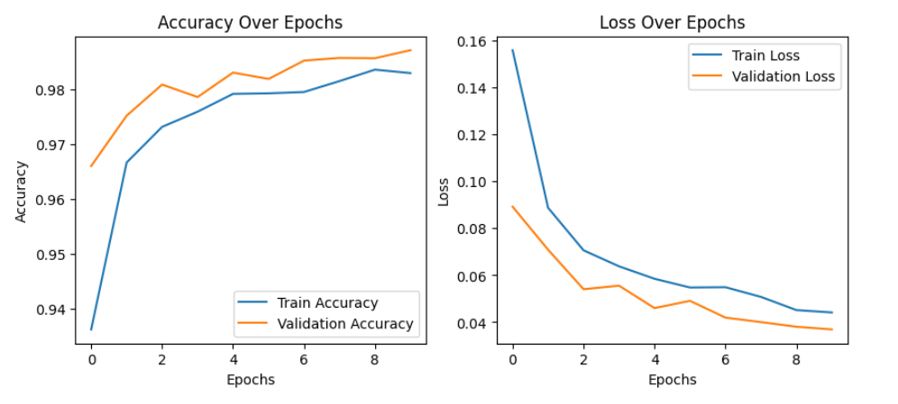.
Initial Accuracy indicates the Transfer Learning approach (MobileNetV2 weights) provides a strong starting point. Final Accuracy confirms the model achieved high predictive performance. This unusual result suggests the regularization methods or the effects of data augmentation on the training set are effectively preventing overfitting, and the model generalizes extremely well.
Step 6. Final Model Evaluation
This step performs a final, comprehensive evaluation of the trained model's performance on the dedicated validation dataset (val_data). This provides definitive metrics (loss and accuracy) that summarize the model's ability to generalize to new, unseen data after the training process is complete.
The final accuracy achieved by the model on the validation dataset. This is an excellent result, indicating a high degree of correctness in classification.
Step 7. Saving the Trained Model
This final step ensures that the fully trained and evaluated neural network model is permanently saved to disk. This allows the model to be loaded later for making real-time predictions without needing to retrain it, making the entire solution portable and ready for deployment.
Successfully saved
Bonus. Single Image Prediction and Visualization
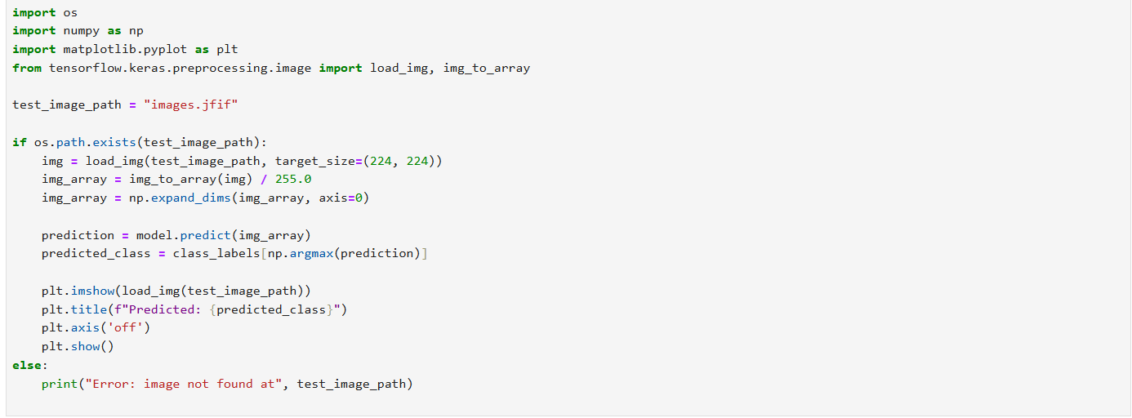
This step defines the procedure for testing the trained model on a single, unseen image (images.jfif). The code performs all necessary preprocessing steps (loading, resizing, normalization, and dimension expansion) before making a prediction, and finally visualizes the test image with the model's predicted class label.
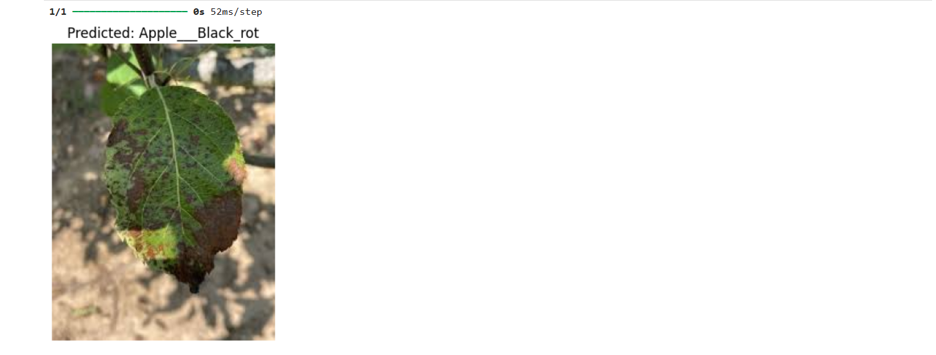

Results: Final Performance Metrics
- Table 5.1: Final Evaluation Metrics.
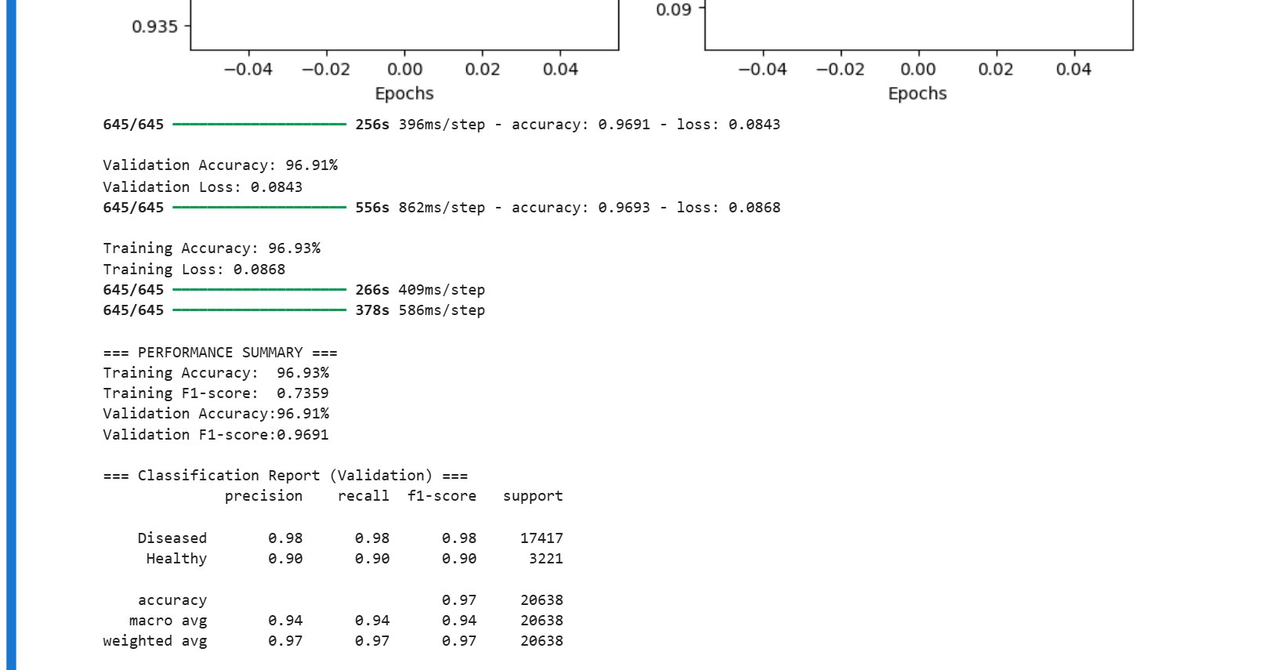
Metric | Training Value | Validation Value
Accuracy | 96.93% | 96.91%
Loss | 0.0868 | 0.0843

Results: Class-Specific Performance

- Table 5.2: Classification Report.
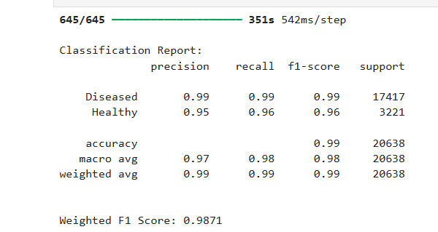
- Figure 5.2: Confusion Matrix.
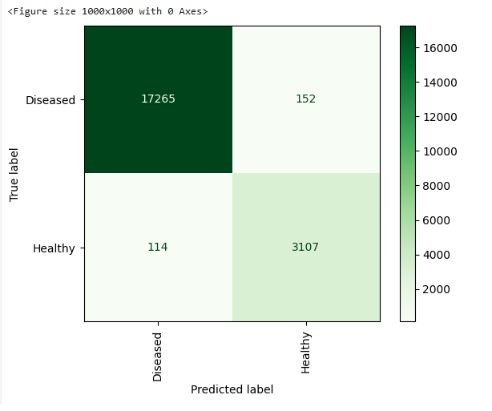

5. Discussion & Conclusion
Key Findings and Contributions
- Summary of Success: State the final validation accuracy and conclude that transfer learning with MobileNetV2 successfully classified the plant diseases.
- Contribution: You provided a lightweight, yet accurate, solution suitable for deployment (since MobileNetV2 is optimized for mobile/edge devices).

Pros and Cons of This Method
Aspect | Detail
Pros | High accuracy with minimal training time (10 epochs); uses a lightweight model (MobileNetV2); effective use of data augmentation.
Cons | Limited to the specific disease classes in the dataset; might fail in novel lighting/background conditions not covered by augmentation.

Possible Future Directions
- Fine-Tuning: Unfreeze the last few layers of MobileNetV2 and train them with a very low learning rate to improve domain adaptation.
- Dataset Expansion: Integrate more images, especially those representing challenging misclassified cases.
- Deployment: Convert the saved model (plant_disease_model.h5) to a TensorFlow Lite model for actual mobile app deployment.
6. References
- MobileNetV2 (Algorithm/Theory): Sandler, M., Howard, A., Zhu, M., Zhmoginov, A., & Chen, L. C. (2018). MobileNetV2: Inverted Residuals and Linear Bottlenecks. arXiv preprint arXiv:1801.04381. https://arXiv.org/abs/1801.04381
- TensorFlow/Keras (Software/Framework): Google. (n.d.). TensorFlow Keras Documentation. Retrieved November 9, 2025, from https://www.tensorflow.org/guide/keras
- Plant Disease Dataset (Data Source): Rex, E. (n.d.). Plant Disease Dataset. Retrieved November 9, 2025, from https://www.kaggle.com/datasets/emmarex/plantdisease
- Traditional Method (Comparative Paper): Bashir, S., & Sharma, N. (2012). Remote Area Plant Disease Detection Using Image Processing. IOSR Journal of Electronics and Communication Engineering, 2(6), 31–34. www.iosrjournals.org

