Comparative Study and Optimization of Traditional Collaborative Filtering vs. LLM-Enhanced Recommendation Systems

Part 1: Theoretical Analysis

1. Comparative Analysis

Aspect | Traditional Collaborative Filtering (CF) | LLM-Enhanced Recommendation Systems | Similarities
Data Utilization Methods | Primarily uses a User-Item Interaction Matrix (ratings, clicks, purchases). Focuses on explicit/implicit behavioral data. Sparse and ID-based. | Utilizes Unstructured Text Data (reviews, descriptions, titles), Knowledge Graphs, and User Behavior Sequences as text. Focuses on semantic/contextual data. | Both rely on a form of user/item representation derived from data to predict preferences.
Recommendation Logic | Based on Similarity (User-User, Item-Item) or Latent Factor Models (Matrix Factorization). Relies on the "homophily" assumption: similar users like similar items. | Based on Semantic Reasoning, Natural Language Understanding (NLU), and Generation (NLG). Reformulates recommendation as a language task (e.g., next-token prediction, answering a prompt). | Both aim to establish a personalized connection between the user and the item space.
Interpretability | Limited and fixed (e.g., "Users similar to you liked...", "Item features are..."). Explanations are often a byproduct of the similarity/factor calculation. | High and Personalized. LLMs can generate natural language explanations (NLG) that incorporate complex features and reasoning steps (e.g., based on genre, sentiment, or why a feature is important). | Both seek to provide a rationale for the recommendation, though the quality and style differ significantly.
Cold-Start Problem | Severe for new users/items due to lack of historical interaction data, leading to a sparse row/column in the matrix. Often requires content-based or hybrid workarounds. | Significantly alleviated. LLMs leverage their vast pre-trained world knowledge and the textual description of new items/users to generate initial representations or tags (Zero/Few-Shot Learning). | Both must address the challenge of new entities, but LLMs handle the initial information gap much better through language understanding.

Compensation for Traditional CF Shortcomings using LLM Paradigms:
- Embedding Generation (LLM as Extractor): LLMs encode item/user text (descriptions, reviews) into dense, rich semantic embeddings. This compensates for CF's reliance on sparse, simple ID-based embeddings, enriching the representation of items/users, especially for cold-start items and enabling recommendations based on deeper content understanding.
- Semantic Tag Generation (LLM for Feature Enrichment): LLMs generate high-quality, abstract tags or structured profiles (e.g., "user is an adventure-seeker, likes dark comedy") from raw data. This compensates for CF's limited feature engineering by providing interpretable, rich side information that can be directly integrated into CF models to improve accuracy and explainability.
- End-to-End Generation (LLM as Recommender): LLMs take the user history/query as a prompt and directly generate the list of recommended items and reasons as a text sequence. This compensates for CF's rigid two-stage pipeline (retrieval/ranking) and poor interpretability by offering a unified, reasoning-capable framework that naturally handles complex, conversational recommendation queries.

2. Similarity Calculation and Matrix Factorization

Similarity Measure | Formula (for vectors A and B) | Applicable Scenarios | Limitations
Jaccard Index | $$J(A,B)=\frac{\left|A∩B\right|}{\left|A∪B\right|}$$ | Best for binary implicit feedback (e.g., clicked/not clicked, purchased/not purchased). Ignores rating intensity or frequency. | Cannot handle explicit ratings (e.g., 1–5 stars).  Biased toward users with many interactions (large sets dominate).
Cosine Similarity | $$cos(θ)=\frac{A*B}{\left|\left|A\right|\right|*\left|\left|B\right|\right|}$$ | Rating data where direction/pattern of preference is more important than absolute value. High-dimensional, sparse data (e.g., user-item vectors). | Doesn't account for user rating bias (e.g., a "high rater" vs. a "low rater"). Two users could have high similarity just because both only rate 5s, even if they share few items.
Pearson Correlation | 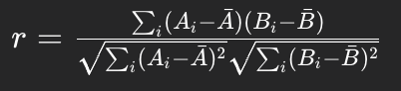 | Rating data where user/item rating bias needs to be factored out (e.g., User-Based CF). Measures the linear relationship between ratings. | Requires a sufficient number of co-rated items (co-rated pair size $i$ must be large enough to be statistically meaningful). Sensitive to outliers.

Role of SVD in Recommendation Systems and Data Sparsity:
- Role of SVD (Singular Value Decomposition): SVD is a matrix factorization technique that decomposes the large, sparse User-Item interaction matrix R into three smaller, dense matrices.
  - User Latent Factors: Each row is a user vector in a low-dimensional latent space.
  - Item Latent Factors: Each column is an item vector in the same latent space.
  - Singular Values: A diagonal matrix indicating the importance of each latent factor.
The core idea is that the unobserved ratings can be predicted by the dot product of the corresponding user and item latent factor vectors.
- Alleviating Data Sparsity: SVD helps by performing dimensionality reduction and data smoothing.
  - Dimensionality Reduction: Instead of dealing with millions of users and items (high-dimensional, sparse matrix), SVD maps them to a much smaller latent space (e.g., 50-100 dimensions). This dense, low-rank approximation captures the most important underlying patterns (e.g., genres, hidden user interests) while effectively ignoring the noise associated with individual, sparse interactions.
  - Inference/Generalization: Since the latent vectors for a user and an item are derived from all their recorded interactions, the resulting factors can predict a missing rating even if the user and item have no common neighbors. The model learns that User A and Item B are connected via a latent factor (e.g., both are associated with the 'sci-fi' factor) rather than needing a direct co-rating. This generalization across the sparse data effectively fills in the missing values.

Part 2: Algorithm Implementation and Semantic Profiling

2.1 User-Based Collaborative Filtering Algorithm
This section details the theoretical and practical application of a User-Based Collaborative Filtering (UBCF) algorithm, focusing on predicting ratings for an unrated item by a target user. The implementation leverages Cosine Similarity on overlapping item sets for neighbor identification.

1. Data Loading and Matrix Creation: The MovieLens-100K dataset is loaded using the
load_ml100k utility, and the User-Item Rating matrix R is created using user_item_matrix.

2. Similarity Calculation (Cosine Similarity): For the target user (u = 196), the Cosine
Similarity, sim(u, v), is calculated between their rating vector and every other user’s rating
vector, considering only co-rated items (cosine_on_overlap).

3. Neighborhood Selection: The K = 30 most similar users (neighbors) are selected
(topk_neighbors).

4. Rating Prediction: The predicted rating is calculated using a simple weighted sum of
the neighbors’ ratings for an unrated item i (implemented via score_items).

5. Top-5 Output and Reasoning: The top 5 unrated items are ranked by this weighted
score, and an explanation (explain_item) is provided detailing the top contributing neigh-
bors and their ratings.

2.1.1 Implementation and Results
The core UBCF recommendation logic is contained within the cf_user_based.py script. The full implementation code is provided in Appendix A. The results for the Top-5 recommendations for User 196 are shown below.
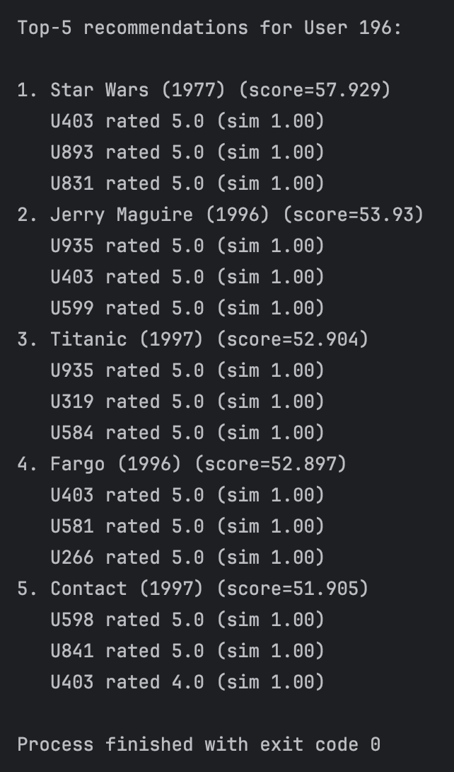
The primary reasoning for these recommendations is purely collaborative: they were highly rated by a group of users (neighbors) who have a similar taste pattern to User 196, as determined by Cosine Similarity on their co-rated items.

2.2 LLM-Generated User Profile Tags
To demonstrate the LLM’s capability as a feature enrichment tool, the llm_tags.py script was used to generate a semantic profile for User 196 based on their top genres and recent ratings. This process simulates the generation of rich side information to combat cold-start.

2.2.1 LLM Prompt and Generated Output
The LLM (using the Llama 3.1 model via Ollama in the project implementation) analyzed the user’s implicit data and generated the following profile and tag
(Full prompt in Appendix A).

Input context for LLM (derived from User 196’s data):
Top genres by count: Comedy(13), Romance(10), Drama(9), Action(8), Adven-
ture(7)
Recent ratings: Sleepless in Seattle (1993)=4, Dumbo (1941)=5, Star Wars
(1977)=5, ...
LLM Generated Profile Tags (Output from tags_user_196.txt):
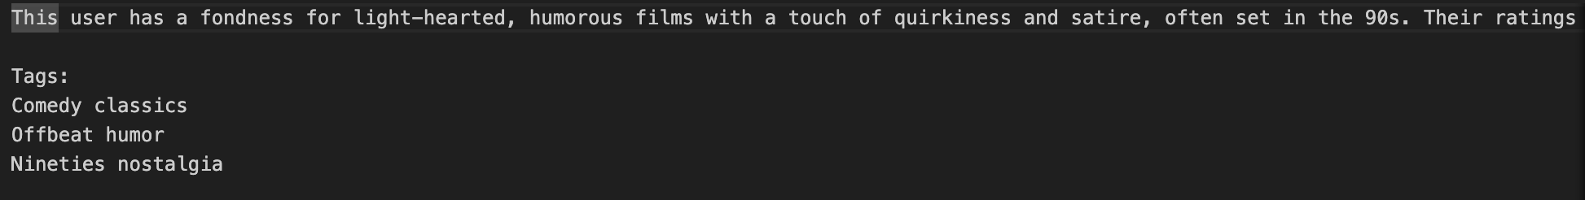
The generated tags, such as "Offbeat humor" and "Nineties nostalgia," are high-level semantic features that cannot be easily derived through standard one-hot encoding or simple counting. This semantically rich output can be immediately used to enrich item embeddings or serve as features in a deep learning recommender, thereby alleviating the cold-start problem for new users or new items that lack sufficient interaction data but have rich textual descriptions.
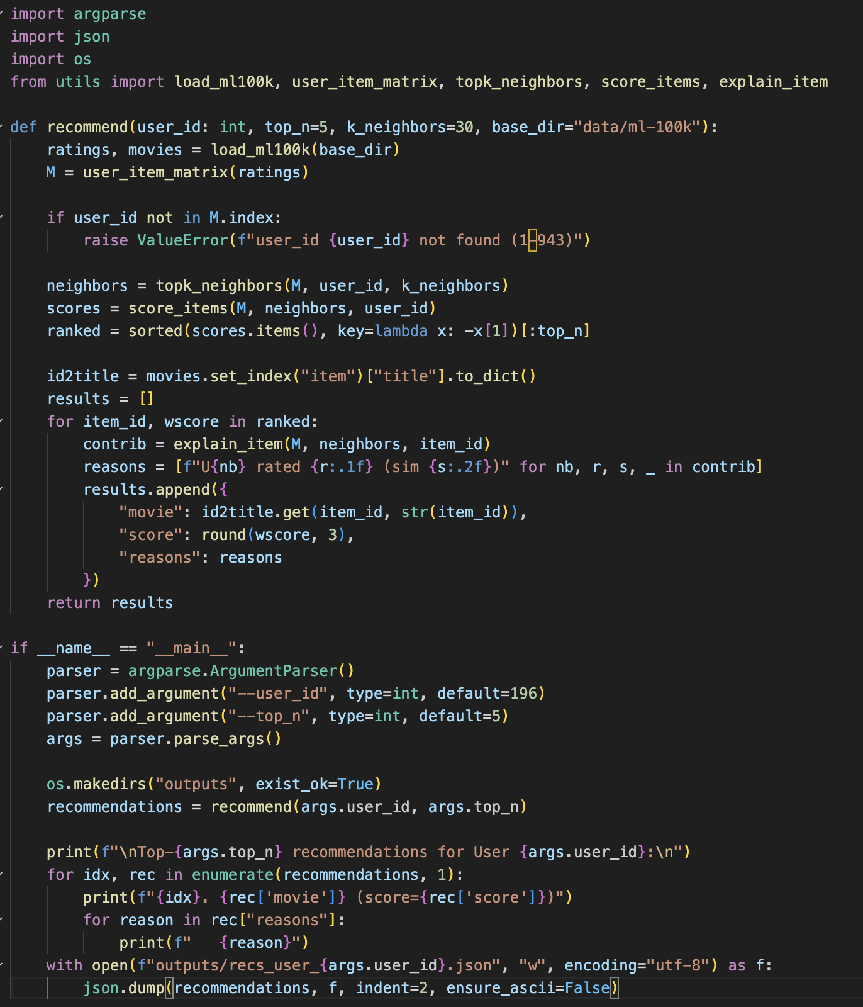

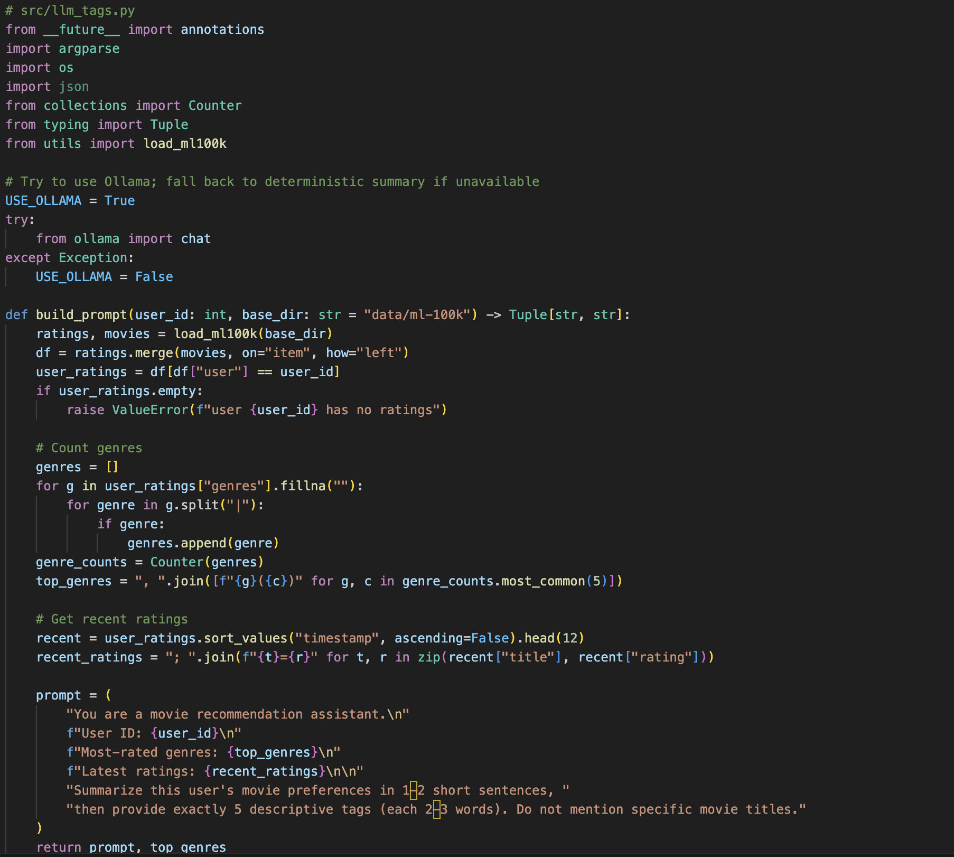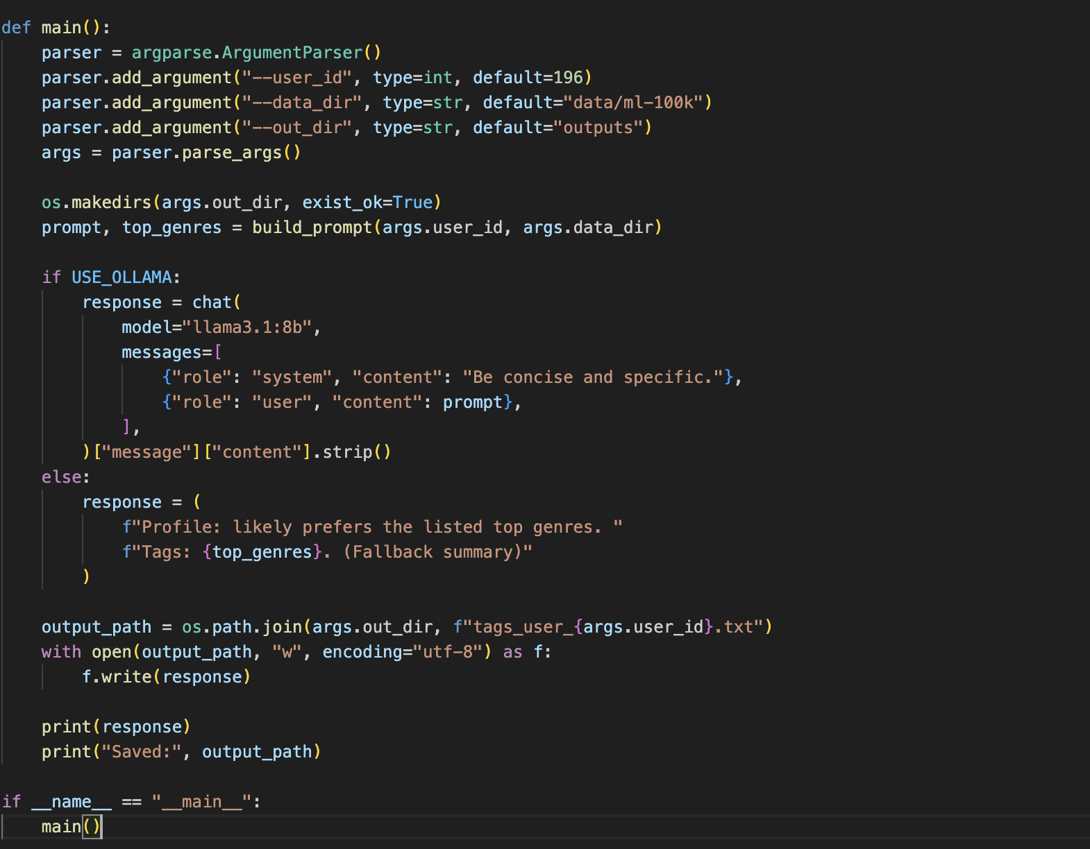
Appendix A

Part 3: Case Design and Analysis

1. Cold-Start Scenario Design for "Taobao" New Users
Scenario: New User Registration on Taobao.

Stage | Process Description | LLM Method & Data Utilization
Stage 1: Profile Initialization | User completes initial registration (age, city, occupation) and grants optional social network login. | Instruction Tuning + User Registration/Social Data
 | Process: A domain-specific LLM is Instruction-Tuned on a corpus of existing Taobao user profiles, product data, and their associated interest tags. When a new user registers, the initial text data (e.g., "35-year-old female, lives in Shanghai, works in finance, Facebook interests: hiking, indie music") is fed into the fine-tuned LLM.
 | Output: LLM generates an initial, structured set of "High-Confidence Tags" (e.g., {style: 'urban chic', category: 'outdoor gear', price_range: 'mid-high'}) and a natural language "Proto-Profile".
Stage 2: Initial Interaction Refinement | User browses a few product pages/categories (e.g., clicks on "sneakers," "smart watches," "running shorts"). | Prompting + Browsing Logs
 | Process: As the user generates 3-5 quick interaction events, the system compiles these Browsing Logs (product descriptions, categories) and appends them to the Proto-Profile. This combined text is fed into the Instruction-Tuned LLM using a Prompt that asks for a refinement of the initial tags.
 | Prompt: "Given the existing profile: [Proto-Profile], and new clicks: [product descriptions], update the user's preference tags by adding new ones and adjusting confidence."
 | Output: An updated, more accurate set of tags. This quickly moves the user from zero-shot (registration data only) to few-shot (initial browsing) without needing CF's historical matrix data.

2. Interpretability Enhancement Scheme
Scheme: LLM-Generated Personalized Explanation Module

Feature | LLM Explanation Generation | Traditional CF Explanation
Explanation Type | Content-based & Narrative. Personal, deep, and conversational. | Collaborative & Statistical. Impersonal, simple, and fixed template.
Example | "We recommend The Wandering Earth because you like sci-fi movies (Tag from your high-rated Interstellar) and we noticed you recently gave a high rating to a movie directed by a Chinese director (Shadow). This film aligns with both interests." | "We recommend The Wandering Earth because 15 of your neighbors also liked this movie." (User-Based) or "We recommend The Wandering Earth because it is often co-rated highly with Armageddon." (Item-Based)
Advantages | High Transparency & Trust: User understands why based on their own features. Richness: Incorporates multiple features (tags, item text, historical sentiment) into a coherent narrative. Handles Cold-Start: Can explain new item recommendations based on its features (semantic tags). | Simplicity & Speed: Easy to generate. Familiarity: Standard and recognizable pattern. Verifiable: The explanation is a direct result of the core algorithm's logic (similarity).
Disadvantages | Computational Cost & Latency: Generating high-quality text in real-time is expensive and slow. Potential for Hallucination: The LLM might generate a plausible but factually incorrect justification if the prompt is poorly designed. Lack of Specificity: Hard to convey the strength of the collaborative signal. | Low Informativeness: Does not explain what is similar. No Cold-Start Help: Cannot explain new items effectively. Unsatisfying: Users often find "users like you" unhelpful without knowing the 'like' criteria.

Part 4: Frontier Thinking Questions
- Is it possible for LLMs to completely replace traditional Collaborative Filtering in recommendation systems? Why or why not?
Answer: No, not completely, in the near term.
  - Why Not:
Computational Cost & Latency: Deploying LLMs as the sole engine for real-time, high-volume candidate retrieval/ranking (the core of CF) is still prohibitively expensive and slow compared to highly optimized, compact CF models (Source 8.3). E-commerce platforms require sub-50ms latency for homepage/search results, which CF models can achieve more efficiently.
Lack of Learned Collaborative Signals: Traditional CF inherently learns implicit co-occurrence patterns (e.g., users who buy product A also buy product B) directly from the interaction matrix, even if products A and B have non-similar text descriptions (Source 8.3). LLMs, relying mainly on text and world knowledge, struggle to capture these specific, complex, local behavioral patterns without extensive, expensive fine-tuning on the massive ID-based interaction data.
Stability and Reproducibility: CF predictions are deterministic. LLM outputs can be volatile, which is a major issue for industrial-scale systems requiring reliable, reproducible ranking.

- What is the future trend for recommendation systems: "LLM as the main component, CF as auxiliary," or "CF as the main component, LLM-enhanced"? Elaborate on your reasoning.
Answer: The dominant trend will be "CF as the main component, LLM-enhanced" for large-scale, industrial systems (like Taobao), but "LLM as the main component, CF as auxiliary" for niche, conversational, or small-scale systems.
  - Reasoning for "CF as Main, LLM-Enhanced" (The Hybrid Approach):
Scalability & Efficiency: The hybrid approach is the most practical for industrial deployment. Traditional CF (or deep learning variants) handles the scalable, high-throughput tasks of candidate generation and initial ranking efficiently
LLM as Enhancer: LLMs are then leveraged in high-value, low-volume roles
Feature Enrichment: Generating semantic embeddings/tags to enrich the CF model.
Re-ranking: Performing a final, nuanced re-ranking of the top 50-100 candidates with complex, prompt-based reasoning.
Interpretability: Generating natural language
Cold-Start: Initializing new user/item representations
Conclusion: This Hybrid Architecture delivers the best of both worlds: the efficiency and accuracy of CF on behavioral data and the semantic understanding and explainability of LLMs

