

**American International University- Bangladesh**

**CSC 2209: Object Oriented Programming 1 (JAVA)**

**CO1 Evaluation**

**Project Summary Report**

**Fall 2019-20**

**Group No: 02**

**Project Title: E Pharmacy**

|  |  |
| --- | --- |
| Student Name | Student Id |
| Islam, Md.Nur | **18-36856-1** |
| Marjana Akhter Jenia | **18-36907-1** |
| Farjana Khatun | **18-36875-1** |

**Introduction:**

*Now a days almost everyone in our city uses smartphones. Now-a-days online Market has become a very big place. Specially in Dhaka city almost everyone who uses internet there is a strong possibility that he/she might buy something from online. Everything is now available online. As we know Medicine is one of the most common need in our city life now-a-days. So we will sell medicine to the customer via this software.*

**User Category:**

There are two types of Users here. They are:

* User/Buyer
* Admin

**Feature List:**

* In this project the “User/Buyer” has the following features:
* Register For new account
* Login
* Search Medicine
* Add Medicine to Cart
* Remove Medicine from Cart
* Request For new Medicine
* View Purchasing history
* Buy Medicine from the cart
* Logout

In this project the “Admin” has the following features:

* Login
* Add new Medicine
* Add quantity to existing Medicine
* Remove Medicine
* Accept Orders
* Add requested Medicine
* Logout

**GUI Description:**

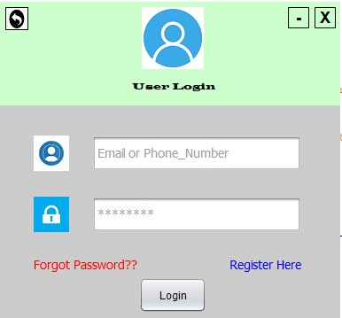

This is The User Login page. A user can Go to Register Page from Here and can login into his/her account from here.

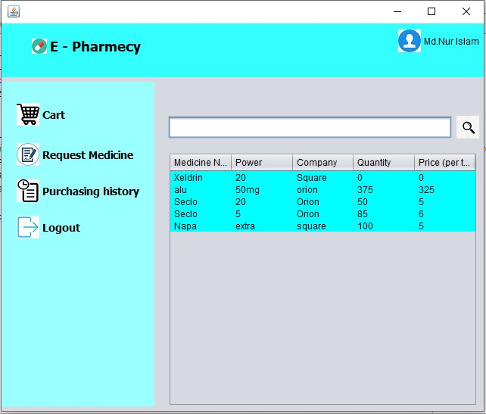

This is the User Home Page.

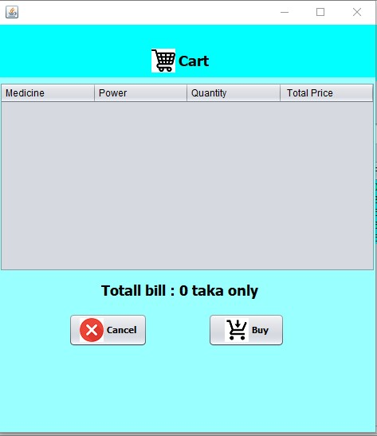

This is the Cart Where all the Medicine will added initially.

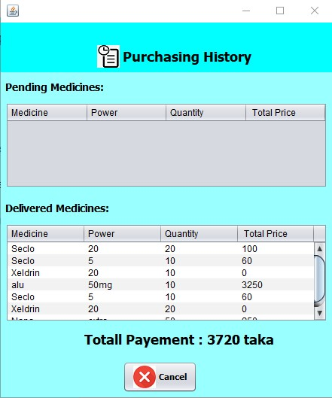

Purchasing History

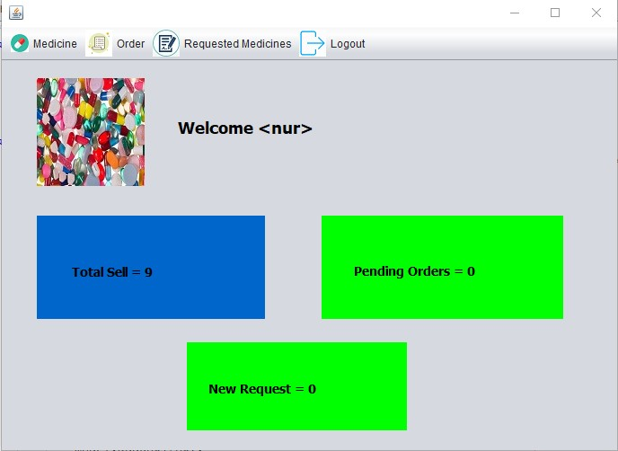

Admin Home Page

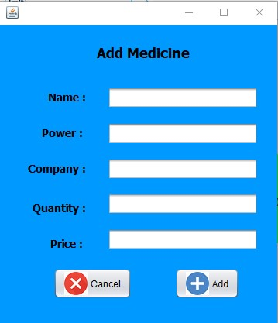

Medicine adding Panel

**Database Table Description:**

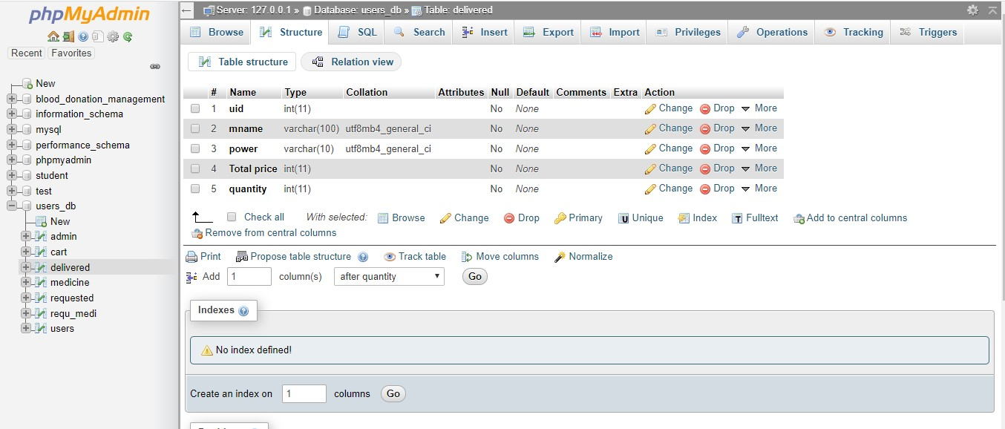

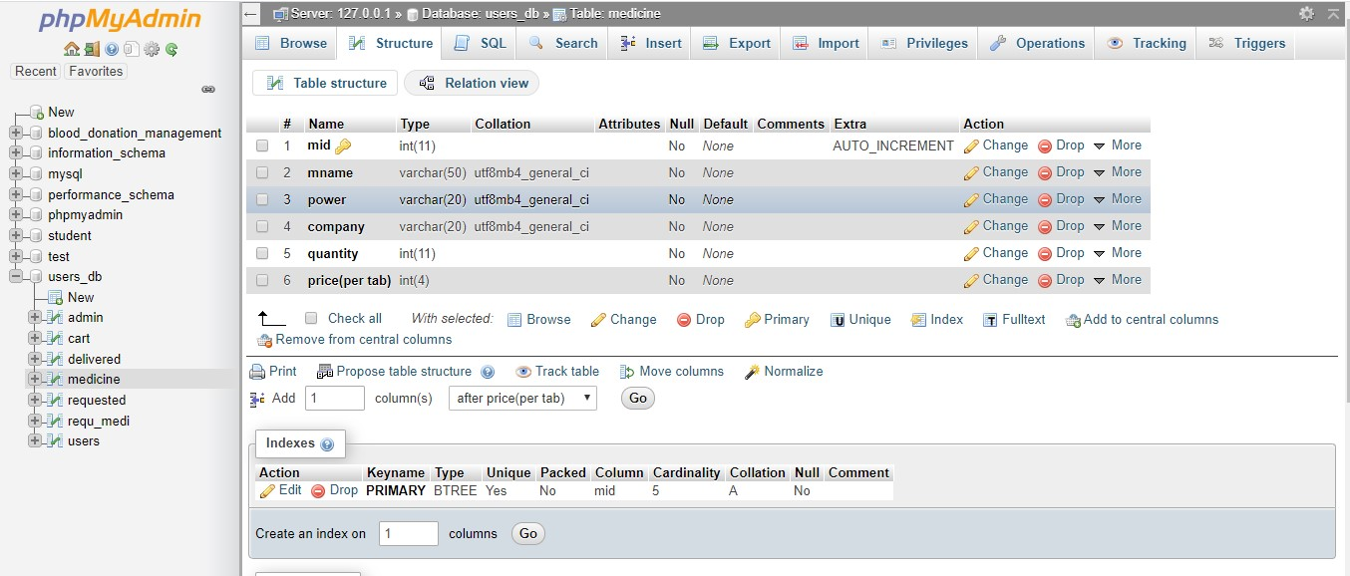

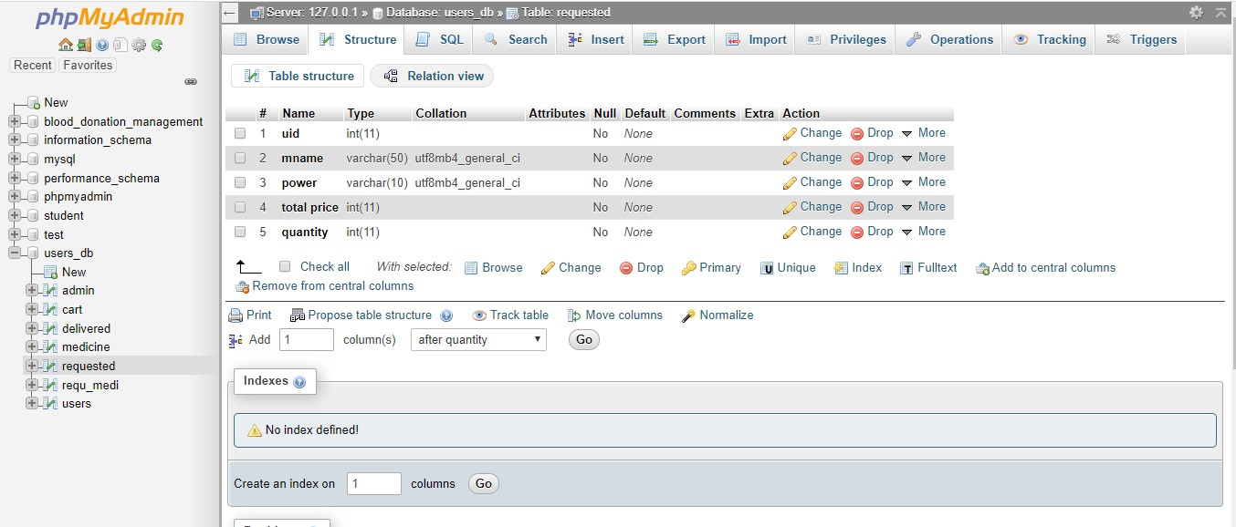

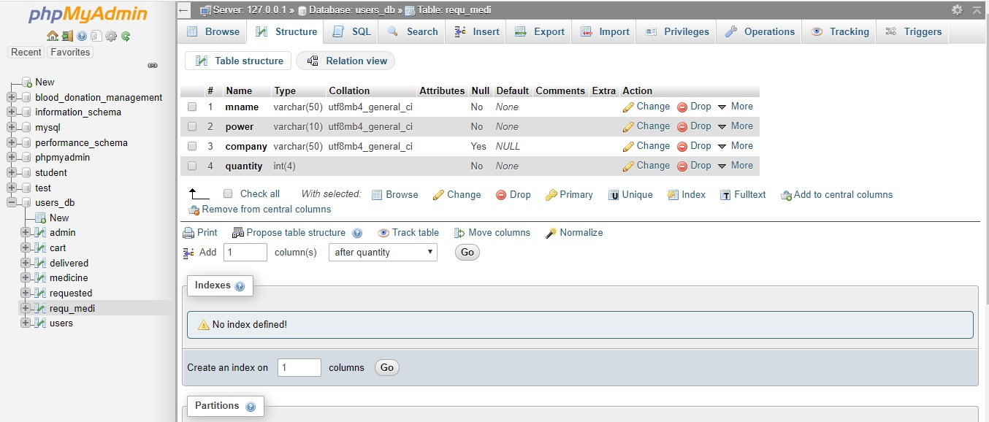

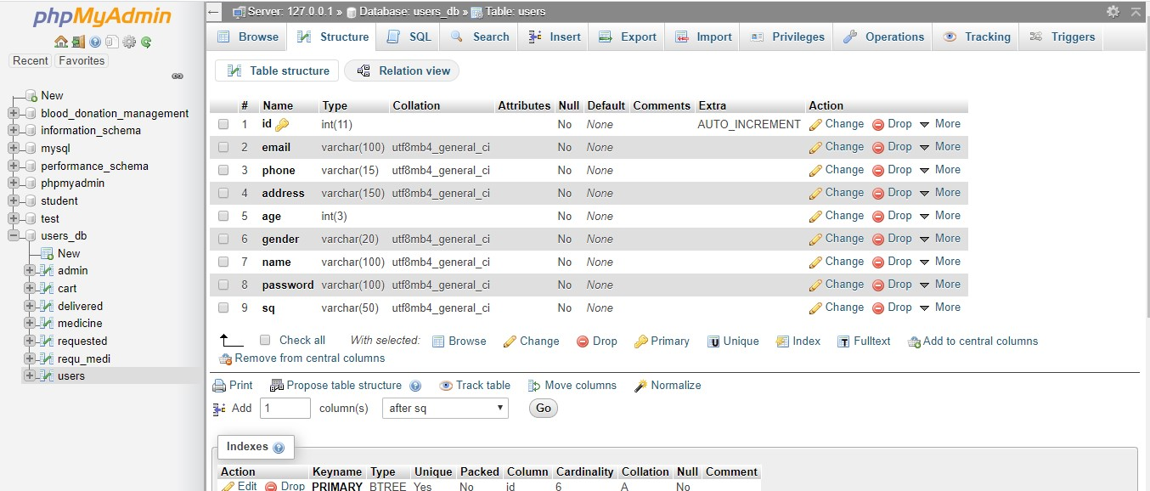

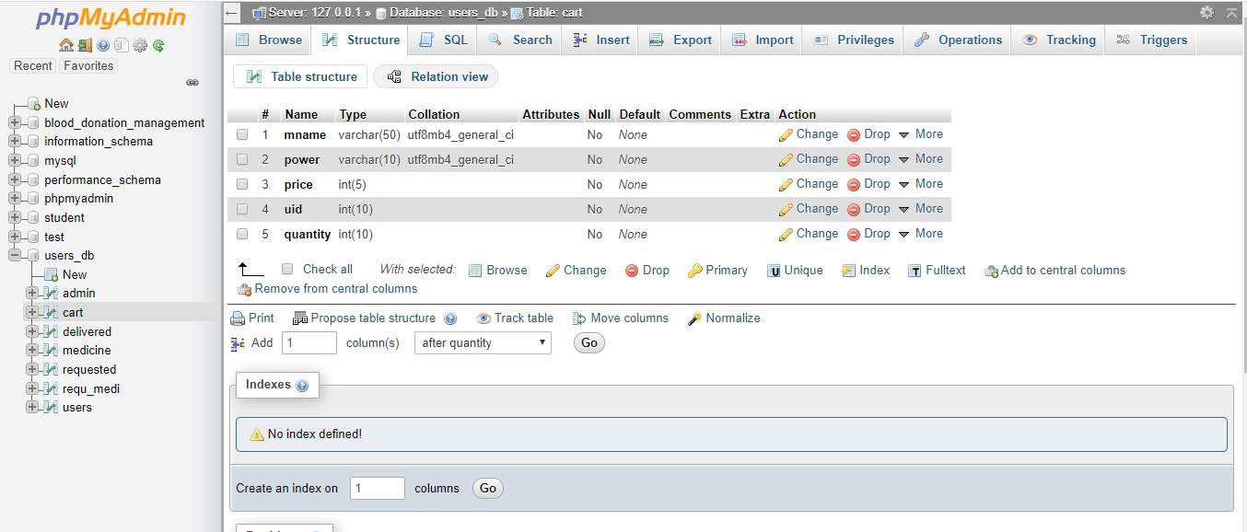

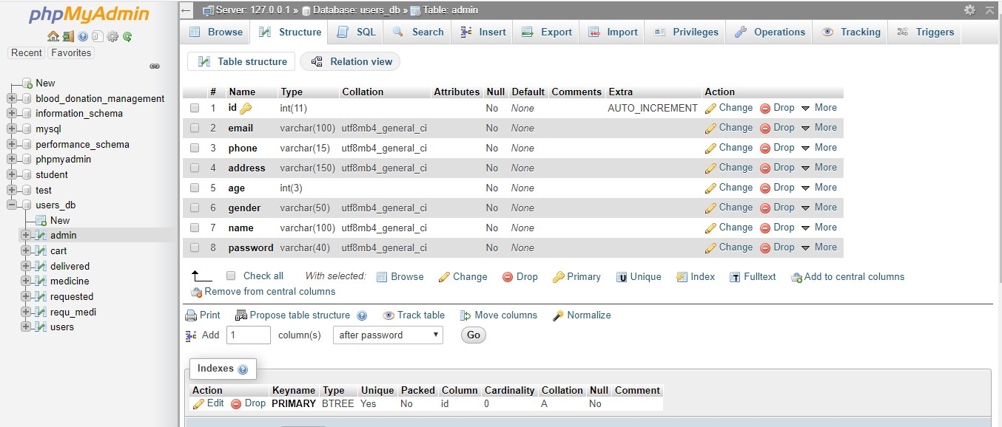

**Class Diagram:**

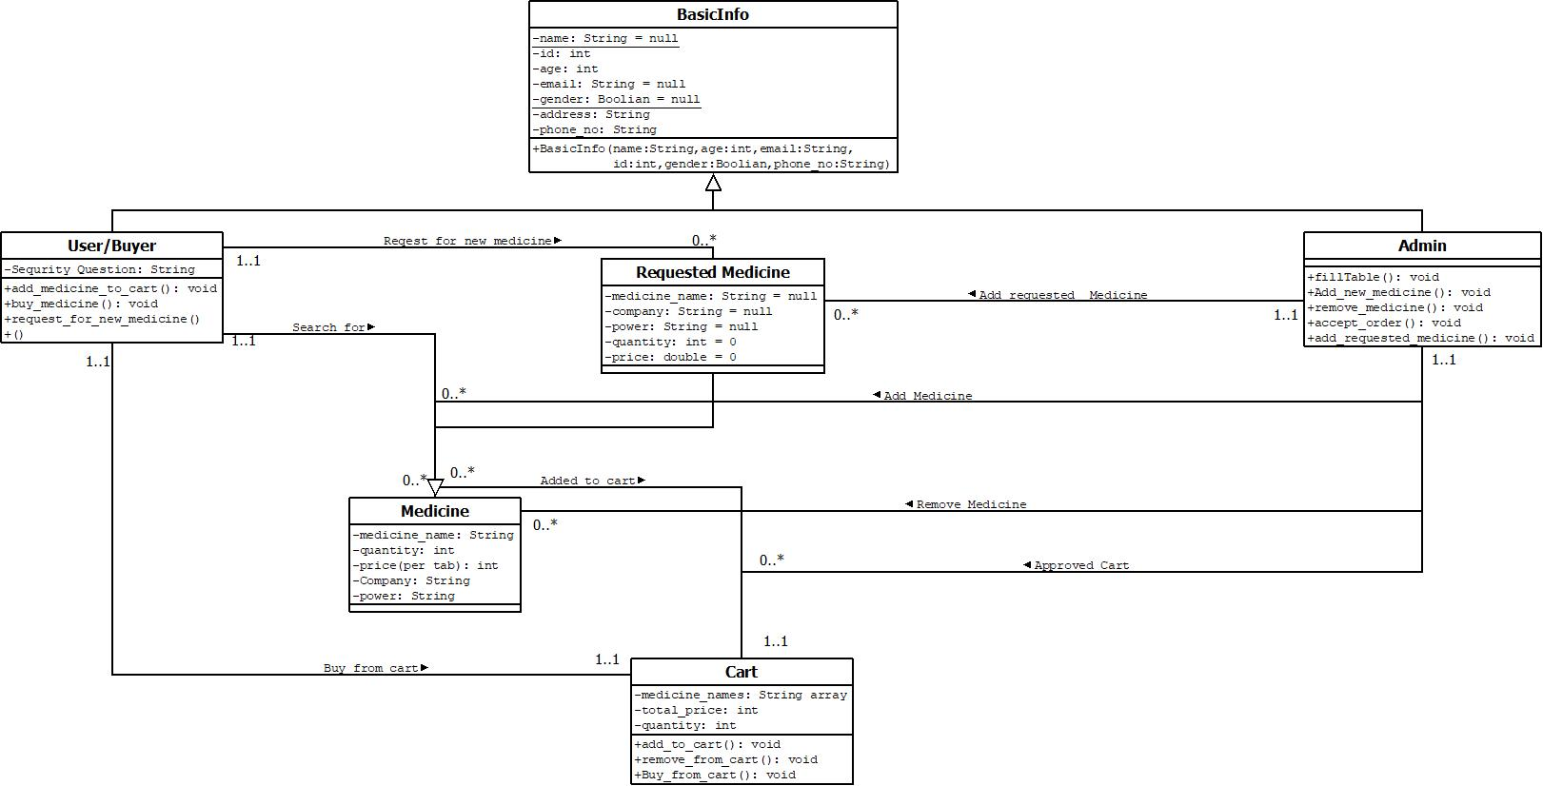

**Tools Used:**

To develop this project we have used the following:

* Netbeans 8.2
* Xmapp-Control
* PhpMyAdmin SQL server.

**OOP and Java Concepts Used:**

* Error Handling.(We connect our java program to the My SQL database sever and there we use try and catch block to handle the SQLException )
* Collection. ( We use ResultSet and Object which is a Collection and we use collection.next() function which is a subclass of Iterator).
* Encapsulation. ( In this project we created different class and Jframe for different user and field. And we Encapsulated all the value to different classes.
* Polymorphism.(We use Function Overloading in various search option. We differ the function/method() by Changing the parameter Number).
* Inheritence. (We use extends and implements in our project for the users and the admin)

**Impact of this Project:**

Impact on society:

In Dhaka city Medicine is become one of our daily need. There are so many people who has to take medicine everyday and there are some occasional user also. So its become a important need for us. There are so many pharmacy here and there and everyday they are selling a huge amount of medicines. Sometimes some pharmacy may take extra charge for the medicine from the consumer. And sometime there are no time or no one to go the pharmacy to buy medicine for you. So our software will reduce the chance of extra charge and deliver medicine to everyone’s doorstep.

How people will be benefited :

* They can buy Medicine with no extra Charge.
* Fastest Home Delivery.
* Cash on Delivery Service.
* Always will get the right medicine.

**Limitations and Possible Future Improvements:**

Limitations:

* For the Time being we are limited to some important places of Dhaka.
* Due to man power delivery is a little slow.
* Software is not so User Friendly till now.
* All the medicine is not available.

Possible Future Improvements:

* We will sell Medicine to every Corner of the country.
* Deliver will be faster in near future soon.
* More Feature will be added to the software.
* Software will be more user Friendly.
* More Medicine will be added soon.