Three types of Probability

1. Theoretical probability: For theoretical reasons, we assume that all n possible outcomes of a particular experiment are equally likely, and we assign a probability of to each possible outcome. Example: The theoretical probability of rolling a 3 on a regular 6 sided die is 1/6.

2. Relative frequency interpretation of probability: We conduct an experiment many, many times. Then we say


Relative Frequency is based on observation or actual measurements.
Example: A die is rolled 100 times. The number 3 is rolled 12 times. The relative frequency of rolling a 3 is 12/100.

3. Personal or subjective probability: These are values (between 0 and 1 or 0 and 100%) assigned by individuals based on how likely they think events are to occur. Example: The probability of my being asked on a date for this weekend is 10%.
Probability Rules

1. The probability of an event is between 0 and 1. A probability of 1 is equivalent to 100% certainty. Probabilities can be expressed at fractions, decimals, or percents.
0 ≤ pr(A) ≤ 1

2. The sum of the probabilities of all possible outcomes is 1 or 100%. If A, B, and C are the only possible outcomes, then pr(A) + pr(B) + pr(C) = 1

Example: A bag contains 5 red marbles, 3 blue marbles, and 2 green marbles. pr(red) + pr(blue) + pr(green) = 1 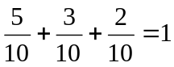

3. The sum of the probability of an event occurring and it not occurring is 1. pr(A) + pr(not A) = 1 or pr(not A) = 1 - pr(A)
.
Example: A bag contains 5 red marbles, 3 blue marbles, and 2 green marbles.
pr (red) + pr(not red) = 1 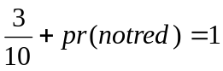 pr (not red) = 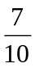
4. If two events A and B are independent (this means that the occurrence of A has no impact at all on whether B occurs and vice versa), then the probability of A and B occurring is the product of their individual probabilities.
pr (A and B) = pr(A) · pr(B)
Example: roll a die and flip a coin. pr(heads and roll a 3) = pr(H) and pr(3) 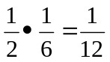

5. If two events A and B are mutually exclusive (meaning A cannot occur at the same time as B occurs), then the probability of either A or B occurring is the sum of their individual probabilities. Pr(A or B) = pr(A) + pr(B)
Example: A bag contains 5 red marbles, 3 blue marbles, and 2 green marbles. pr(red or green) = pr(red) + pr(green) 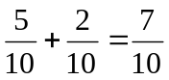

6. If two events A and B are not mutually exclusive (meaning it is possible that A and B occur at the same time), then the probability of either A or B occurring is the sum of their individual probabilities minus the probability of both A and B occurring. Pr(A or B) = pr(A) + pr(B) – pr(A and B)
Example: There are 20 people in the room: 12 girls (5 with blond hair and 7 with brown hair) and 8 boys (4 with blond hair and 4 with brown hair). There are a total of 9 blonds and 11 with brown hair. One person from the group is chosen randomly. pr(girl or blond) = pr(girl) + pr(blond) – pr(girl and blond) 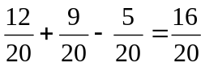

7. The probability of at least one event occurring out of multiple events is equal to one minus the probability of none of the events occurring. pr(at least one) = 1 – pr(none)
Example: roll a die 4 times. What is the probability of getting at least one head on the 4 rolls. pr(at least one H) = 1 – pr(no H) = 1 – pr (TTTT) = 1 - 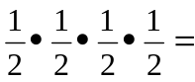 1- 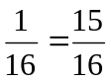

8. If event B is a subset of event A, then the probability of B is less than or equal to the probability of A. pr(B) ≤ pr(A)
Example: There are 20 people in the room: 12 girls (5 with blond hair and 7 with brown hair) and 8 boys (4 with blond hair and 4 with brown hair). pr (girl with brown hair) ≤ pr(girl) 