

CS 319 - Object-Oriented Software Engineering  
System Final Report

Iteration 2

**Farmio**

Group 2F

Nursena Kal

Demir Topaktaş

Ahmed Fuad

Eray Şahin

Context

1. Introduction 3

1.1 Implementation Process 3

1.2 System Requirements 4

2. Design Changes 4

2.1 High Level Design 4

2.2 Low Level Design 4

3. Lessons Learnt 4

3.1 What is missing and what has changed 5

4. User Guide 6

4.1 Game Menu 6

4.2 Credits 7

4.3 Help Menu 8

4.4 Game Screen 9

4.5 Store Panel 10

4.6 Inventory Panel 11

4.7 Seed Plant Game Screen 12

5. Conclusion 13

# Introduction

## Implementation Process

Our development process started after first iteration finished. We have made several meetings to discuss how to develop our game logic and how it should be interactive. Decided to separate all the work that we will have to do in the following iteration. Each member wrote and contributed to reports and one of us joined all the uploaded parts and added own parts and uploaded them on Github. Each one of us actively contributed to the project and nobody tried to run off from doing work. That was a huge plus for our project team.

After design report we started to work on our code more. Demir and Fuad has developed parts that we use on controller parts such as Manager classes. Eray and Nursena has developed on entity classes such as Trees and Seeds. View classes were distributed among all of us. We joined all our code and did debugging together. As result, we improved our project from what we have designed on first iteration and it is now better.

During we were planning how to improve our project, we were carefull about classes and how we should put their positions among each other. In addition, design patterns and their implementation were one of our priorities. We paid extra attention to MVC design and Façade design pattern. We also made researches about how we an add other patterns such as Controller design pattern and Singleton design pattern.

## System Requirements

Java Virtual Machine and Java SDK will be enough to run this game on any computer.

# Design Changes

## High Level Design

Not much of the high-level design is changed. We still use MVC and Façade design on our high-level design. We believe that MVC design is appropriate for this game beceuse abstraction between packages is clearly shown on MVC design pattern. Also combining this with Façade design pattern gives us a lot clear and understandable code. Singleton design is used on our GameEngine platform and it is

## Low Level Design

Again, we did not change much of our low-level design. We only added interfaces to let modules communicate between eachother.

# Lessons Learnt

In this iteration we learned that our team has different people with different abilities. Some of us can write code fast and good while some of us is not that good at coding but still trying their best. In this iteration we learnt more about design patterns and object-oriented approach as we design our classes and their abstraction and encapsulation. Polymorphisism was one of our priorities. We wanted to use as many methods in different classes or override them. This was a huge opportunity for us to try and learn these consepts.

Also, we learnt how architectural styles work and why they are important. We worked on making the architectural styles to be seen on each part of the game.

Another point that is learnt is graphics matter a lot in a game. Sometimes, it was not easy to find appropriate image, so we had to use photoshop and create our own images.

## What is missing and what has changed

Most of the game is finished but still there’s room for improvement. However, tree harvest is missing. Raining to the seeds is missing. We removed this ability of rain. Since it is possible for each of seeds to be used powerups on, we wanted to make it limited with that. We changed 8x8 map to 10x10. Now our game is available on a better map. Also, we changed GMC and fertilizers’ abilities. They were used to be able to update water status of seed that they are applied but now they grow each seed to food directly.

# User Guide

## Game Menu

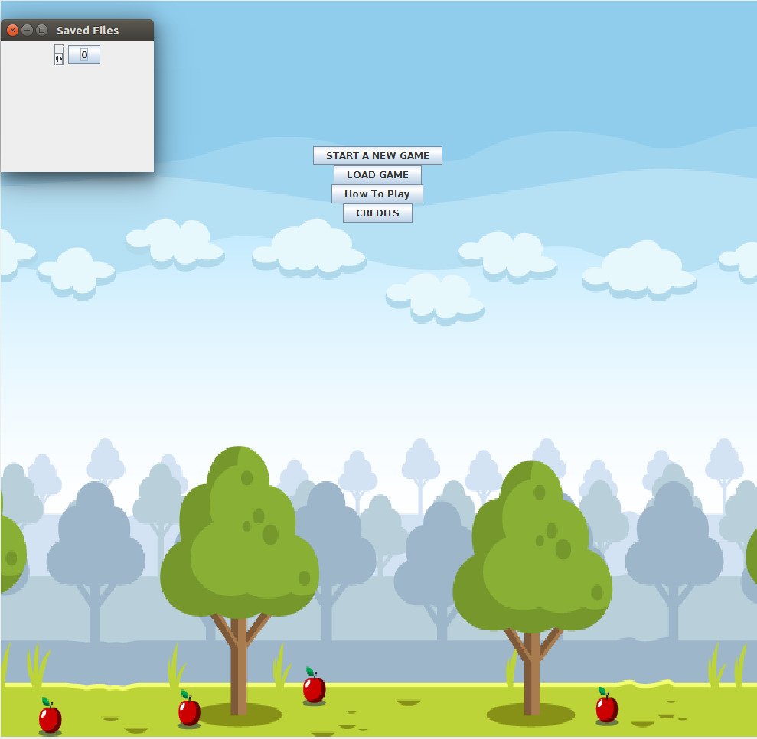

From this menu, user can select between starting a new game, how to play, credits and loading a game. Use can load the game that he/she was playing before he/she exit.

## Credits

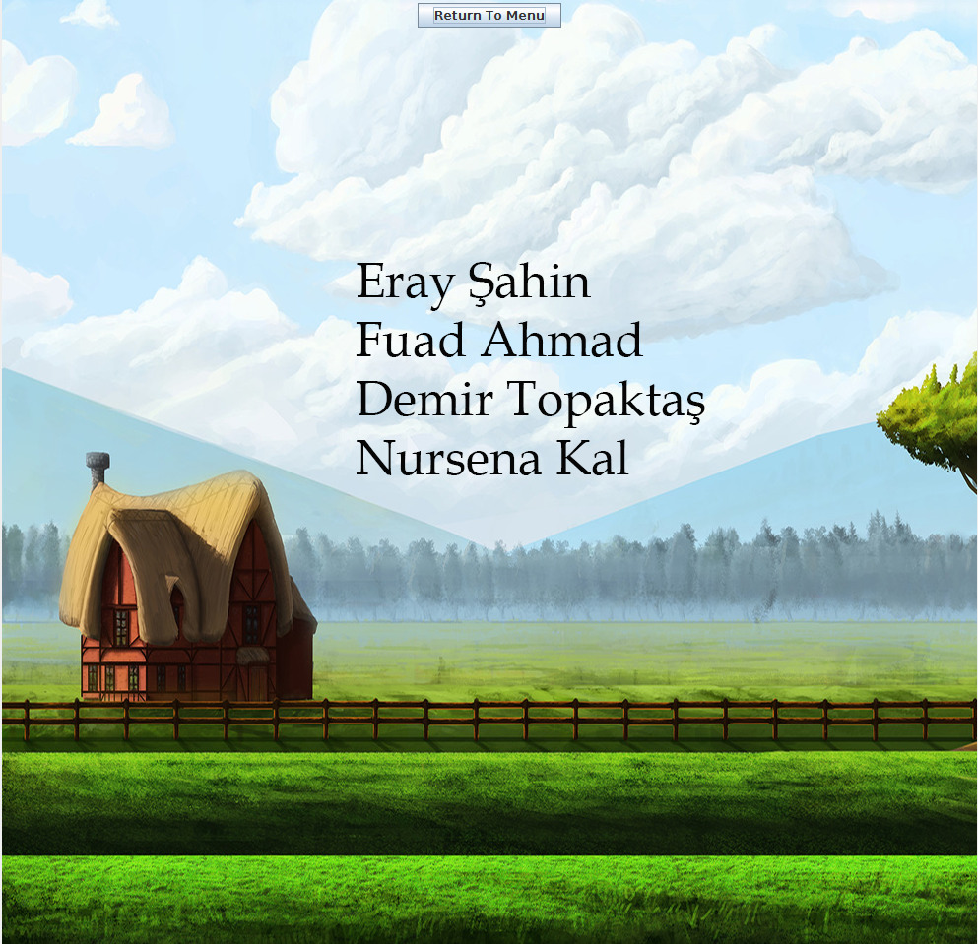

From this page, user can see developers of the Farmio. From the button above, user can return to the main menu.

## Help Menu

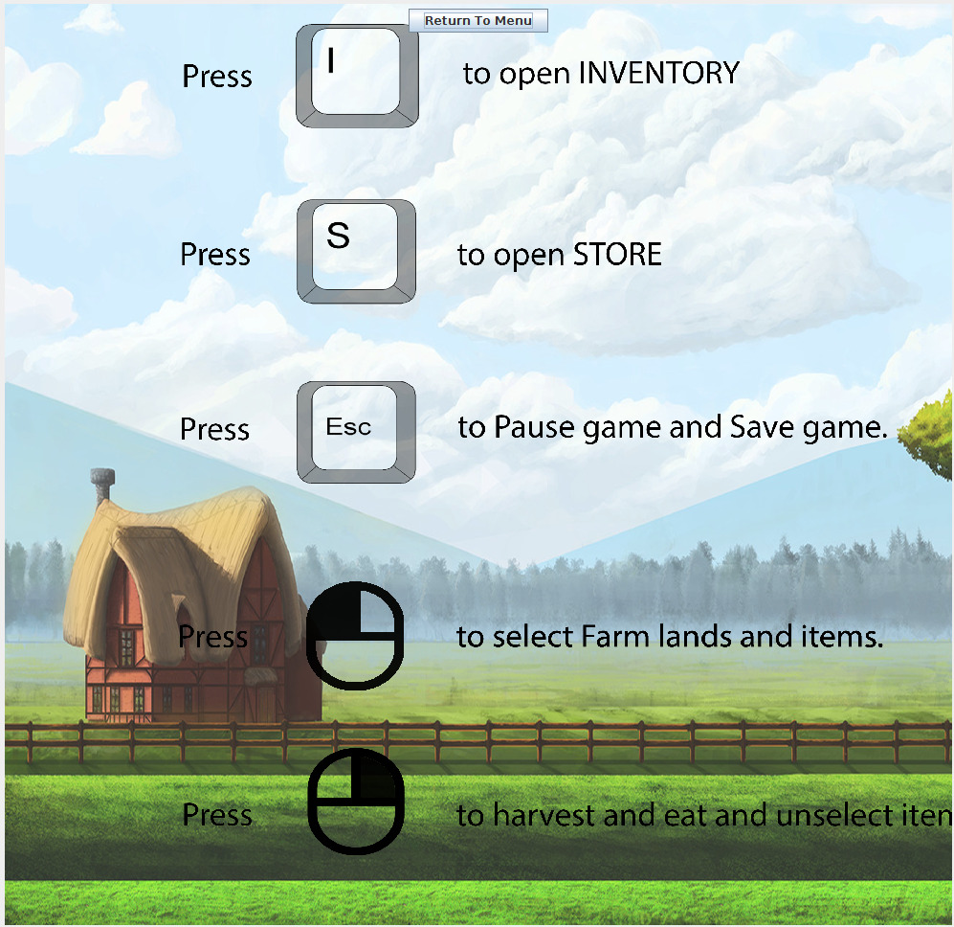

From this page, user can see controls of the game. User should press “I” to open inventory, press ”S” to open Store, click Right to select items and click Left to harvest and eat and unselect items.

## Game Screen

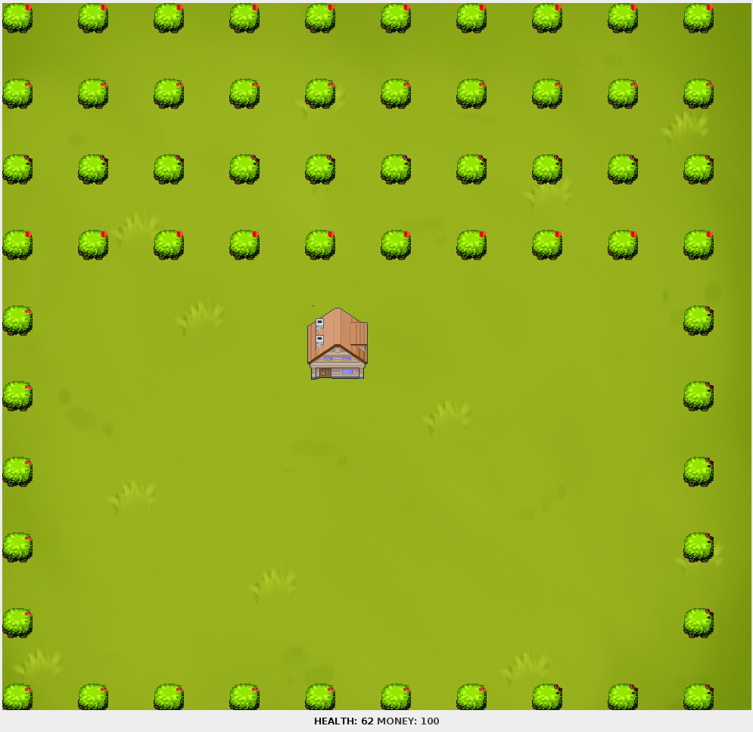

This is how our game looks like in the beginning. It can be seen on the corner of each tree that what is the kind of tree is. On the bellow of the secreen farmer’s health and money can be seen. They are updated according to the timer.

## Store Panel

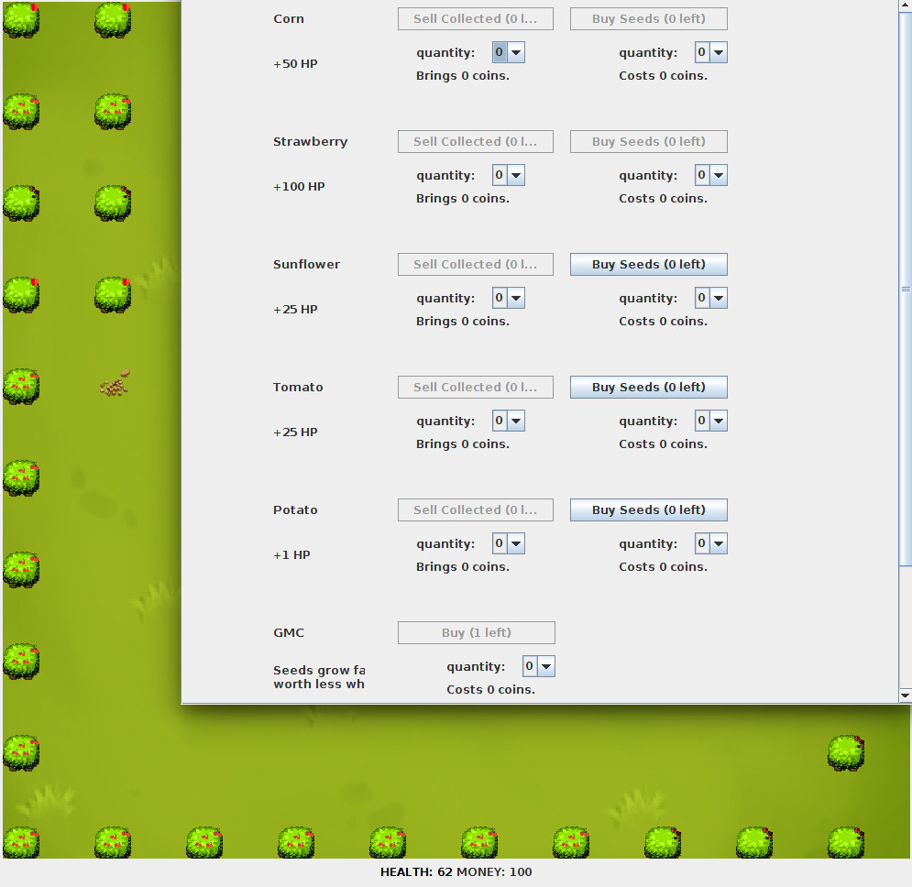

From store, user can buy seeds, sell the grown crops and see their HP, selling price and buying price of each of them.

## Inventory Panel

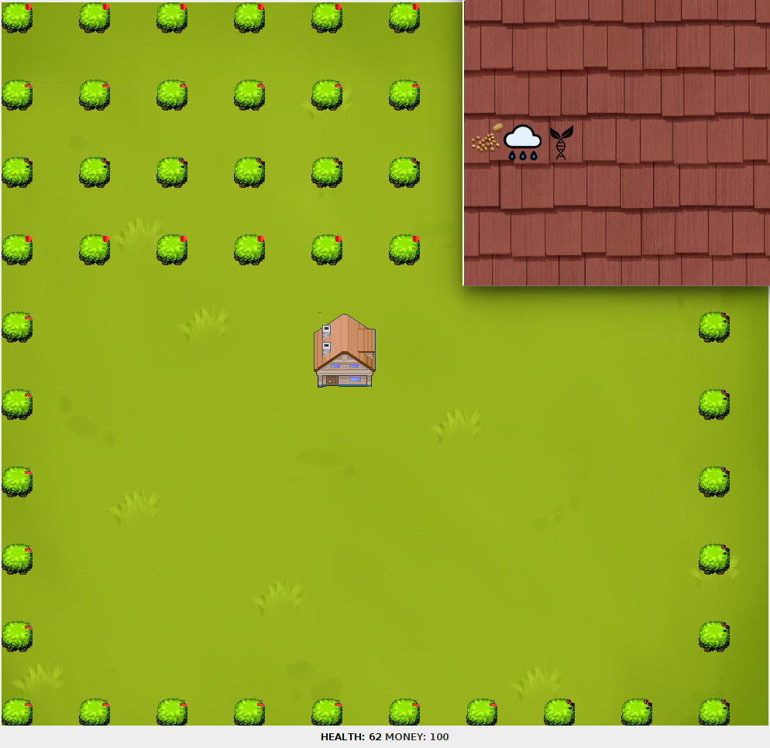

From inventory, user can see the seeds that he/she has, water can and fertilizer and all the other entities that he/she has grown or bought. He/she can select each one of the seed and then plant it on one of the available slot.

## Seed Plant Game Screen

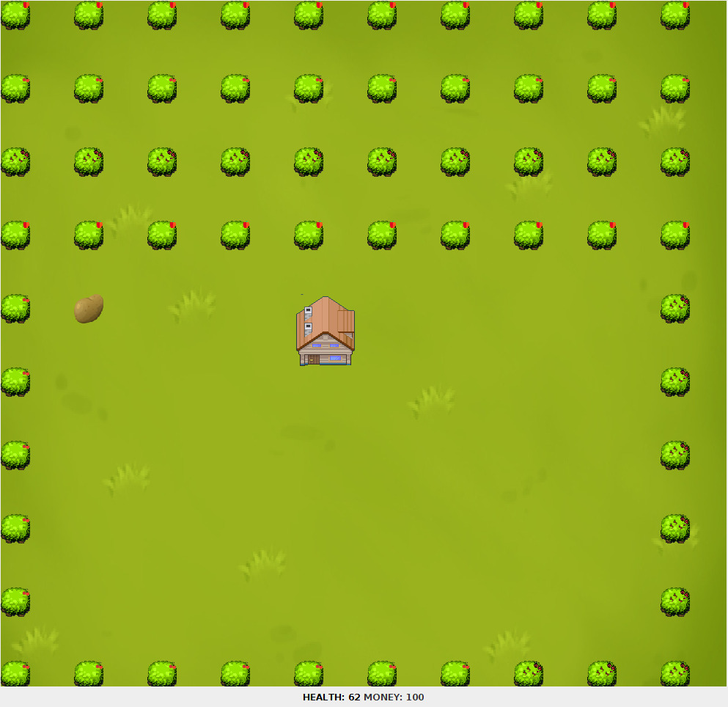

In the screenshot above, it is shown how a seed was planted and successfully grown.

# 5. Conclusion

In this final report, it is explained what has been channged and what has been added to our game after the first iteration. We decided to add new features after analysis report. Firstly, we have added new Entity objects including Potato, Tomato, Cherry, Raspberry, and Apple class as a subclass of Food class. Accordingly, TomatoSeed and PotatoSeed classes have been added. Besides, Tree class added with AppleTree, RaspberryTree, and CherryTree classes, which Tree class is superclass of these classes. In other words, we added ability to plant new trees to our farmland and new type of plants. Also, we added power-ups like GMO, Fertilizer, and Rain. These new features, will increase the entertainment level of game.  We changed the ability of being spoiled. We decided that it will be irrelevant at this stage to have an spoiled stage of each seed. It can be added on the following iteratitons of this software product.