

CS 319 - Object-Oriented Software Engineering  
Final Report

Iteration 1  
  
**Farmio**

Group 2F

Nursena Kal

Demir Topaktaş

Ahmed Fuad

Eray Şahin

**Context**

**1.Introduction** 3

**2.Game Description** 3

**3. User Manuel** 4

**4. Main Menu** 4

**5. Credits** 5

**6. Load Game and Save Game** 5

**7. Game Screen** 6

**8. Implementation Process and Lessons Learnt** 6

**9. System Requirements** 7

**10. References** 7

# **1.Introduction**

This report will talk about the implementation process of our Farmio game and will also include a how to play manual. Since our project is a game we will first give a brief description of our game. Then, we show how a player can play this game, helping about basic navigations through game. After this , we will start talking about the implementation process; challenges that we have faced and how we have dealt with them, what changes have been made different from the design of the game and the current status of the implementation.

# **2.Game Description**

Farmio is a Farmville game in which the player has a farm where he can grow different kinds of plants and different types of trees. Farmer can plant his seeds, water them and take of his growing plants. After they are grown, he can harvest them and sell them to gain coins. The farm can be shaped as the way farmer wants. The shape that is lastly given by the farmer will be saved and can be loaded when player wants.Also there will be different types of power-ups. Some will come up by system and some will be availabe on store. For example , farmer can buy GMO to grow his plants faster. It is cheap but when plants grow up, they will be sold for less coins.

# **3. User Manuel**

This section will contain explanation of each implemented panel view and their functionality.

# **4. Main Menu**

This is Main Menu of game. This part contains buttons that will lead to different panels that are required. To begin game, player should click New Game button. To load game, player should click Load Game button. To learn basics of gameplay, player should click Help. Different options are available on game. If a player wants to change these options, player should click Options.

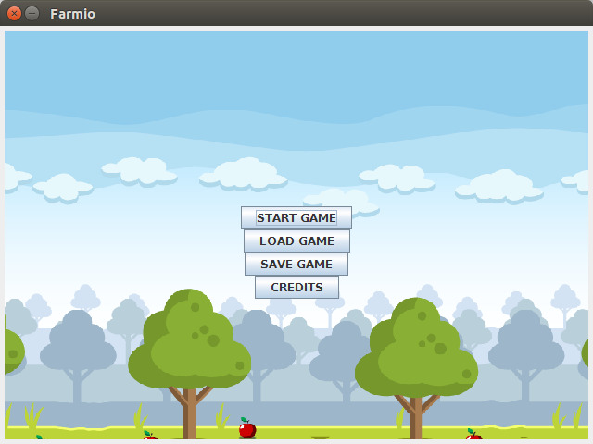

# **5. Credits**

This page contains developers of game. Player navigate through this page using buttons.

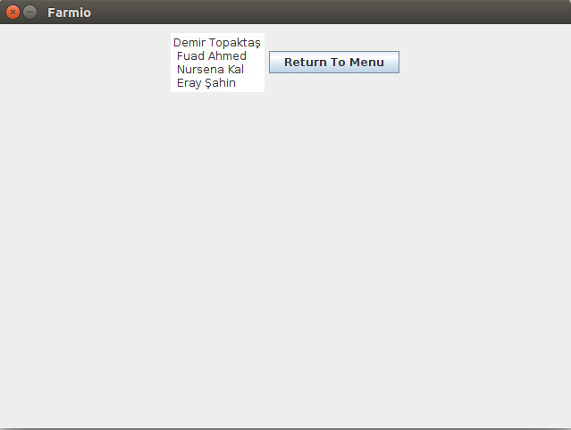

# 

# **6. Load Game and Save Game**

User will load and save game from these buttons which are placed in main menu. No screes shots have been provided because not accomplished it in first demo.

# **7. Game Screen**

This page is what is shown during gameplay. This page is still being implemented.

# 

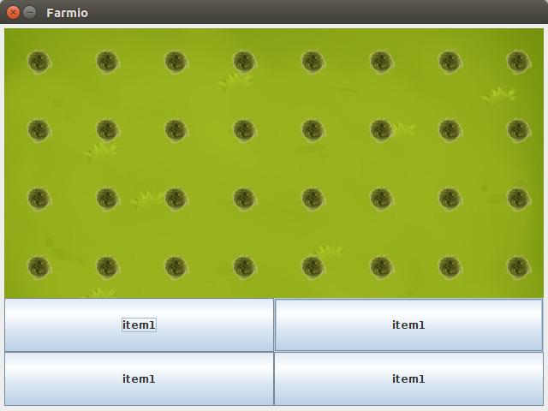

# **8. Implementation Process and Lessons Learnt**

Implementation process is a complicated process as we feel as a group. Analysis and Design reports helped us understand the problem better and as a team we can use our knowledge more efficient. Also, different than other groups, every member of this group Works and does anything that can be done. We are also lucky about that .

Now, our team has implemented Map, Inventory and Main Menu. During the implementation we found some libraries that may help us during implementin our game logic.

Still working on our gameplay and trying to get some unique parts that can be implemented.

Challenges we have seen is absolutely time. Timing between reports is little so we have no time to do enough research and make this project as we wish. We solved this problem with partioning the different layers to different member of our team. So each one of us does some research related to their part. After the researches done, we talk about our findings in meetings. This saves a huge amount of time to us.

Now we are on a research part about game logic. We are currently looking for different libraries and games that were implemented before so we can learn and maybe add them to our project to get a better designed project.

# **9. System Requirements**

We are working on Java. There is no more system required for Farmio to work.

# **10. References**

[1] Object-Oriented Software Engineering, Using UML, Patterns, and Java, 3rd Edition, by Bernd Bruegge and Allen H. Dutoit, Prentice-Hall, 2010, ISBN-10: 0136066836.

[2] FarmVille Game by Zynga : https://www.zynga.com/games/farmville