

CS 319 - Object-Oriented Software Engineering  
System Design Report

Iteration 1  
  
**Farmio**

Group 2F

Nursena Kal

Demir Topaktaş

Ahmed Fuad

Eray Şahin

İçindekiler

**1. Introduction** 3

**1.1 Purpose of the system** 3

**1.2 Design Goals** 3

**1.4. References** 5

**1.5. Overview** 5

**2. Software Architecture** 6

**2.1** **Overview** 6

**2.1.1** **Gameplay** 6

**2.1.2.** **Map** 6

**2.1.3.** **Soil** 6

**2.1.4.** **Store** 6

**2.1.5.** **Seeds** 6

**2.1.6.** **Grown Crops** 7

**2.1.7.** **Harvesting** 7

**2.1.8.** **Inventory** 7

**2.1.9.** **Selling** 7

**2.1.10 Farmer’s Health** 7

**2.1.11 Power-Ups** 7

**2.3 Architectural Styles** 12

**2.3.1 Layers** 12

**2.3.2 Model View Controller (MVC)** 12

**2.3 Hardware/Software Mapping** 13

**2.4 Persistent Data Management** 13

**2.5 Access control and security** 13

**2.6 Boundary conditions** 14

**3.Subsystem Services** 15

**3.1 Design Patterns** 15

**3.2 User Interface Subsystem Design** 16

**3.4 Game Entities Subsystem** 26

**Conclusion** 26

# **1. Introduction**

## **1.1 Purpose of the system**

Farmio is a basic 2D farming simulator video game we planned to develop. The main aim of this game is to manage a farmland by planting different types of seeds, taking care of plants, gathering their grown crops to either sell or eat. If the player chooses to sell the grown crops, this will facilitate in generating income, helping the player to invest in different types of seeds to attain more money. Alternatively, the player may also choose to eat the grown crops so that the health of the farmer can be kept at its maximum. The player has to balance these two actions properly since either running out of money or worsening health means the end of the game. In other words, the game will be over when the player loses all of his/her money -and there is no investment in plants to provide income- or when the farmer represented in the game loses his/her health.

Additionally, we will implement Farmio in Java programming language by Object-Oriented Programming principles and it will be a desktop application. This report contains the game overview, basic game objects, and the basic structure of the game. Besides, we also added the functional, non-functional requirements as well as the use-case, class, activity and state diagrams.

## **1.2 Design Goals**

Before the composing the system it is crucial to identify the design goals of the system in order to clarify the qualities that our system should focus on. In this respect many of our design goals inherit from non-functional requirements of our system that are provided in analysis stage. Crucial design goals of our system are described below.

**End User Criteria:**

Simulation of real world : Since our system is a game, it should provide good entertainment for the player. In order to provide the entertainment player should not have a difficulty in using our system. In this respect, system will provide player friendly interfaces for menus, by which player will easily find desired operations, navigate through menus and perform the desired operations. While a player is “farming” , speed will be important. If the seeds grow too slow, player might be bored or if too fast again the player might feel that what he has done is not satisfiying. Also it will be important to have great graphics to keep player interested. It is determined that our system will perform actions according to mouse input from the user, like clicking buttons, moving around the farm. This makes it easy to use the system from the point of the player.

Basic and applicable : Since player is not ought to have knowledge about how the game is played, how to plant a seed, how to water and grow a seed. Also there will be a litttle instruction set in the begining of the game so the player can learn hands on. Simple logic and observation of real farming will also help user to understand how to play game.

**Maintenance Criteria:**

Extendibility: In general, in the lifetime of game software, it is always important to add new components, features to the game in order to sustain the excitement and interest of the player. In this respect our design will be suitable to add new functionalities, entities (i.e. new brick types, new power-ups) easily to the existing system.

Portability: Portability is an important issue for a software, since it provides that the software can reach wide range of users. In this respect we are determined that the system will be implemented in Java, since its JVM provides platform independency, our system will satisfy the portability.

Modifiability: In our system it would be easy to modify the existing functionalities of the system. In order to achieve this we will minimize the coupling of the subsystems as much as possible, to avoid great impacts on system components by a desired change.

Performance Criteria:

Response Time: For the games, it is vital that users’ requests should be responded immediately in order not to distract the player’s interest and entertainment. Our system will respond player’s actions almost immediate, while also displaying animations, effects smoothly for enthusiasm.

**Trade Offs:**

Ease Of Use and Ease of Learning vs. Functionality:

Since we designed this game as a simulation game, it is important to have a game which is easy to discover. However, in this game there are huge variety of objects such as different seeds, power ups, trees and tools that are used on these crops, it is a trade-off for us to make the game a little bit complicated. We choosed to make Farmio a little bit complicated but still easy to learn and observe.

Performance vs. Memory:

In our system, it is our main purpose to make the game as close to real life as possible. Briefly, performance of our system is our primary focus. For this purpose, we sacrificed the memory in order to gain the performance. We used a huge varity of objects. Therefore, our game has a lot to store. Since the performance of this event is important in our system, instead of storing one type of game entitiy, we store the important game objects of the game map in memory to access them fast when needed.

**1.3 Definitions, acronyms, and abbreviations**

Abbreviations:

MVC: [2] Model View Controller

JDK: [1] Java Development Kit

JVM: [1] Java Virtual Machine

## **1.4. References**

[1] Object-Oriented Software Engineering, Using UML, Patterns, and Java, 3rd Edition, by Bernd Bruegge and Allen H. Dutoit, Prentice-Hall, 2010, ISBN-10: 0136066836.

[2] FarmVille Game by Zynga : https://www.zynga.com/games/farmville

## **1.5. Overview**

In this section Farmio game is briefly explained. The way it is designed and the considered actions are stated. Since this game is a simulation game, there is a huge variety of objects, it makes our game little bit complicated than we want but it is a tradeoff that we have already think is okay. The advantage of this game is that it is a simulation game, we are observing the real world relations and implementing them into computer as a game. This makes our game easier to understand eventhough it has lots of different objects.

# **2. Software Architecture**

## **2.1 Overview**

This is the explanation part of inner side of the game.

### **2.1.1 Gameplay**

The game is played using the mouse. Some actions are to be handled through right-clicking to choose one of the several possible actions.

### **2.1.2. Map**

The map initially consists of a farm house whose location is fixed (defined by the game). Surrounding the farm house are the “slots” of soil on which the player may plant and grow seeds depending on the type of the soil (see the next section 2.3. Soil for details).

### **2.1.3. Soil**

The soil slots can be considered in two different categories as “grass” and “pit”. Grasses are blocks of soil which are not suitable for planting. On the other hand, pits are the ones on which the player can plant and grow seeds.

### **2.1.4. Store**

The player is able to buy seeds of different kinds from the store. The store, which is to be made available directly on the game screen, displays the available seeds and their respective prices as small icons.

Note that, at the beginning of a new game, the player is provided with some initial money to buy some seeds to begin planting. Except this initial money, the actual income is supposed to be generated through growing crops and selling them.

### **2.1.5. Seeds**

The game represents strawberry, corn, sunflower tomato and potato seeds available for purchase at the store. These seeds differ by their growing times and prices. Having planted seeds, as long as they are watered once using the “watering can” tool, they grow continually and form grown crops.

### **2.1.6. Grown Crops**

As already mentioned above, seeds produce grown crops when treated properly. These crops need to be harvested as soon as possible, otherwise they will rot, which is indicated by the change of the color of the soil.

### **2.1.7. Harvesting**

When the seeds are grown fully and have produced grown crops, which is indicated by slots’ attaining new icons, the player is expected to harvest them. To harvest the grown crops, the player simply clicks on these new icons.

### **2.1.8. Inventory**

The purchased seeds and collected crops appear directly on the inventory, which also is continuously accessible on the game screen for ease of use. The player can switch back and forth between both the purchased seeds to plant and also between gathered crops to eat or sell.

### **2.1.9. Selling**

To sell the gathered crops and generate income, the player may right-click on the harvested items on the inventory to select “Sell”. Note that each crop will yield a different amount of money, depending on the kind of the seed from which it is grown.

### **2.1.10 Farmer’s Health**

As one of the main objectives of the game, in addition to maintaining money, the player needs to keep the health of the farmer highest so as to keep the game continuing. This involves the player’s letting the farmer eat some of the gathered crops through using the inventory.

### **2.1.11 Power-Ups**

To add different style to Farmio, there are three different power-ups designed inside it. Rain, GMC and fertalizers. Rain will be randomly gained and it is used to change the watered status of seeds’. GMC and fertalizers will be available on the store. Their difference will be the selling prices and their effects on the seeds. GMC will be cheaper than fertalizers and lower the growing time but that will also lower the value of the gathered crops that will be sold. Fertalizers will cost more than GMC and they will lower the growing time of the seed and it will not lower the selling price.

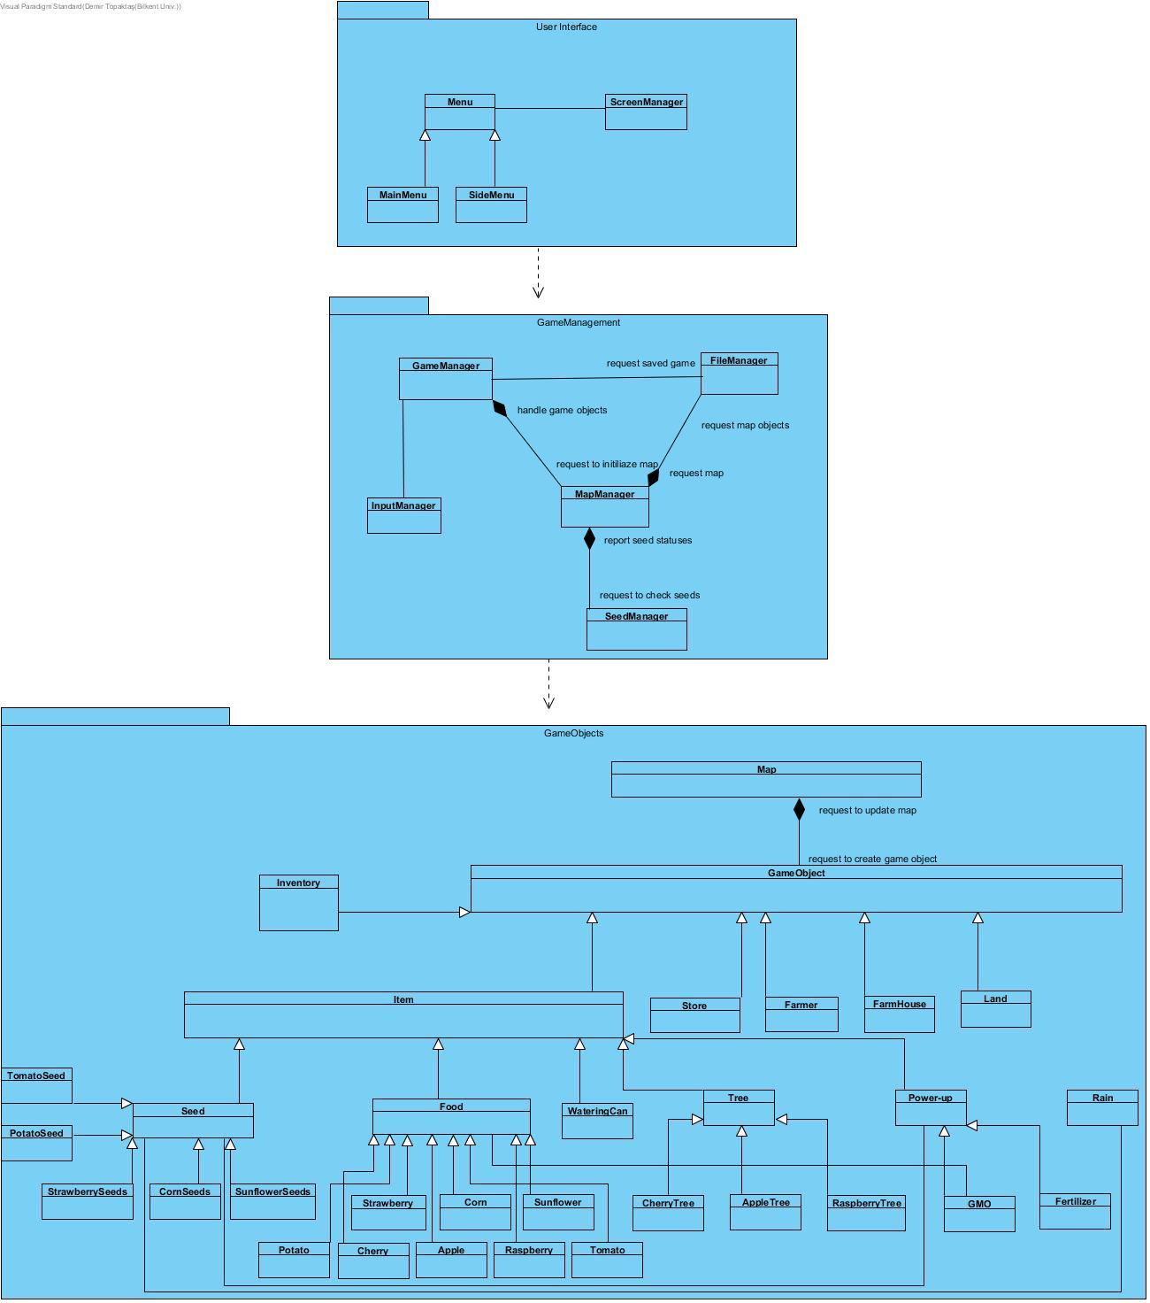**2.2 Subsystem Decomposition**

Figure 1 : Basic Subsystem Decomposition

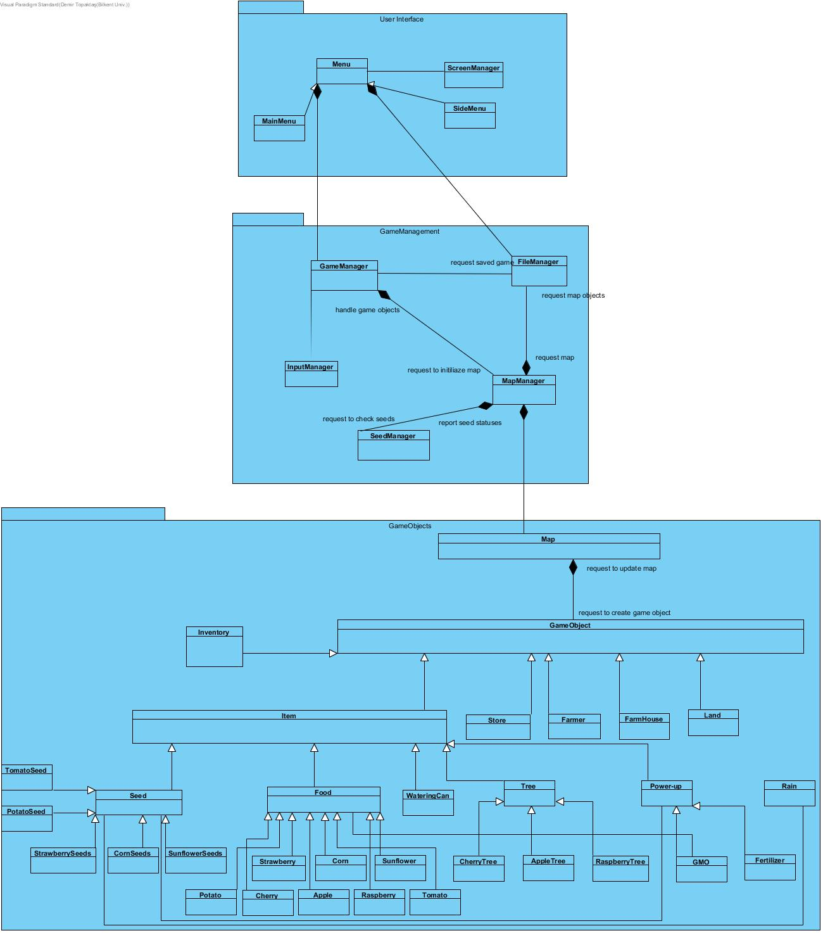Figure 2: Basic Subsystem Decomposition Detailed

In this part, we will decompose our system into three parts; User Interface, Game Management and Game Objects. With this approach, we can reduce the complexity of the game and make the system eligible to changes. We will achieve high coherency and reduce coupling.

MVC(Model-View-Controller) architectural pattern will be chosen for this system. The system will be decomposed considering this pattern. User Interface subsystem will be our view and it will provide interface to the user. It will contain Menu, Settings etc. Our Game Management subsystem will be the controller for the system. It will control the game and it will maintain communication between Model and View. For example, map controller will control the map and game engine will be responsible for controlling the game. Game objects and map will be the Model part of the system.

Subsystems will be separate from each other but they will work closely. User Interface will get the user input and transmit this information to the Game Management system. Then, Game Management will update Game Objects according to the information. Communication between User Interface and Game Objects will be happened through Game Management(Façade Design). This design principle will provide us to have reliable system.  GameManagement includes MapManager for updating the map and checking the map. Moreover, it will have SeedManager for checking the growing seed in the land and it will report seed status to the MapManager.

## **2.3 Architectural Styles**

## **2.3.1 Layers**

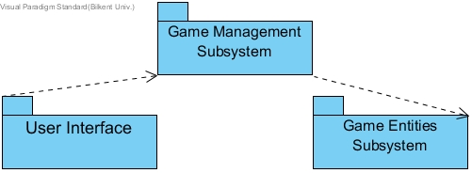

System of game will be separated to 3 different layers including UI (User Interface), Game-Map management, and game entities. It can be implied that UI system decomposition does not depend from any other subsystem unlike Game Management and Game Entities system decompositions. On the other hand, last layer Game Management subsystem depends from UI and also controls Game Entities and Game Logic. Additionally, Game Entities subsystem are composed of all entity objects which are brought together.

## **2.3.2 Model View Controller (MVC)**

Aim of this architectural style is to separate your subsystems into 3 parts including controller, model, and view. As it is implied in the layers section we have 3 different layers, which these layers will be classified for MVC. In MVC architectural style, controller responds to user’s input by updating model objects. Besides, view is the demonstration of the models in desired format. And model is to management of the objects’ data. In relation with our system, Game Management Subsystem establishes Controller. User Interface which is interaction between user and system establishes View. At last, Game Entities Subsystem makes up model of the MVC.

## **2.3 Hardware/Software Mapping**

Regarding the software aspects, Farmio is to be implemented in Java, using Java Development Kit (JDK) 8. Therefore, as long as Java Runtime Environment is installed, the game can be played on Windows, Mac and Linux platforms.

To play the game, in terms of the hardware requirements, the player will need an ordinary computer with a mouse and screen.

## **2.4 Persistent Data Management**

Farmio involves data storage in a filesystem rather than a database. More specifically, data will be stored in “text files” on the hard drive. As the player makes progress, planting new seeds or harvesting grown crops for instance, these text files will be updated. Thus, in the next run, objects can be initialized properly by reading these saved information.

Rendering the map of the game relies heavily on these data since there will be many blocks of soil (i.e. farm slots) with possibly different seeds at different conditions. Any changes to these farm slots are supposed to be reflected in these text files.

Additionally, as the player may maintain multiple games with each having a different progress, there will be separate text files for different games. Depending on the player’s choice about whether to start a new game or load an existing one, the text file(s) to read and write will vary.

Finally, the player’s preferences are kept in text files, too.

## **2.5 Access control and security**

Farmio does not have any network-related uses, meaning that there will not be any outside users other than the user(s) of the computer in which it is stored. As a result, no measurement regarding access control and security needs to be taken.

## **2.6 Boundary conditions**

***Initialization***

The game is to be launched using a “.jar” file. It will not require any prior installation.

***Termination***

To terminate the game, the player is supposed to switch to the Pause Menu. Then, after choosing whether to save the game or not, the player will be able to quit the game.

***Failure***

To prevent the unfortunate effects of any possibly failures, reading / writing the text files should be given the proper priority. In other words, in case the game fails and needs to be started again, the text files should have already been updated very recently. Therefore, when the game crashes somehow, in the next run, the most recently saved configuration of the game can be loaded.

Note that this will not cause any conflict regarding user-determined game saving. That is, regardless of the player’s choice, all the changes are constantly saved in text files. Then, when the player wants to exit the game, these information is either to be deleted or kept as a “saved game” for following use.

# **3.Subsystem Services**

In this section we will provide the detailed information about all interfaces of our subsystems and classes.

## **3.1 Design Patterns**

**Façade Design Pattern**:

We are planning to implement our system in Façade design pattern since this structural design pattern helps developers to easily manage subsystem. This design pattern has Façade class which is essential to communicate with classes of other subsystems. Also, Façade class is the only class that communicates with other classes in certain subsystem.

We designed our 2 subsystems in Façade design patterns including, game entities subsystem and game management subsystem. In game management, our Façade class is MapManager class, which controls and communicates with our subsystems and other classes through the actions of the user. Besides, our Façade class in game entities is Map which controlled and modified by the game management subsystem.

## **3.2 User Interface Subsystem Design**

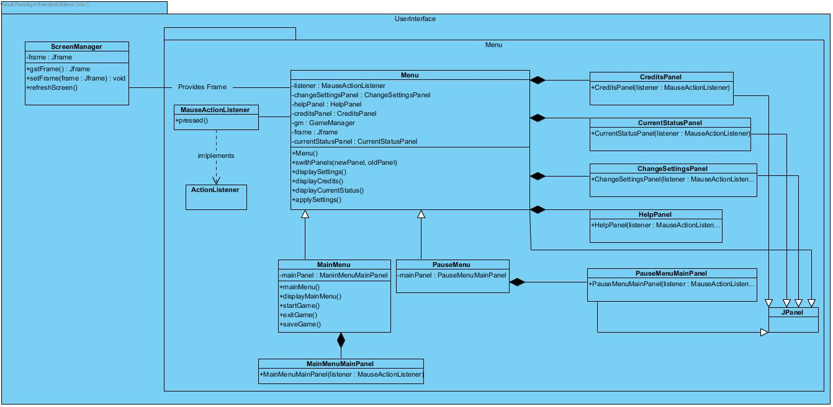

**Detailed information about the stated classes in this figure is bellow.**

**Screen Manager Class**

**Functions**

|  |  |
| --- | --- |
| Class Name : ScreenManager | Explanation of functions |
| Public getFrame(): JFrame | Returns the current frame |
| Private setFrame(frame: JFrame) : void | Sets a new frame. |
| refreshScreen() | Refreshes the frame after setting one new frame. |

Main action of this class is to provide a screen image for MainMenu. It will be provided by JFrame and it can be changed and refreshed.

**Menu Class**

Menu class is the class which has different classes that should be displayed inside of the menu. Attributes of this class is explained as following :

**Attributes**

|  |  |
| --- | --- |
| Class Name : Menu | Explanation of attributes |
| listener : MauseActionListener | To listen related user action on Menu |
| changeSettingsPanel : ChangeSettingsPanel | ChangeSettingsPanel will provide the settings of the game |
| helpPanel: HelpPanel | Include main instructions of the game |
| creditsPanel : CreditsPanel | Credits interface will also be available |
| gameManager : GameManager | Game Manager will be controlling the game |
| frame : JFrame | Provides menu frame. |
| currentStatusPanel:CurrentStatusPanel | Show the current status of game. |

These attributes will be used inside of the functions Menu class. These functions are explained as following :

**Functions**

|  |  |
| --- | --- |
| Class Name : Menu | Explanation of functions |
| Menu(): | This is the menu providing function. |
| switchPanels(newPanel, oldPanel): | If pressed to one button on the menu then this function will take the input and change the panel from the old panel. |
| displaySettings(): | This will be used when settings button is pressed |
| displayCurrentStatus(): | This function will be used when the settings button is pressed. This will navigate to the CurrentStatusPanel. |
| applySettings(): | This will send the acitons that are made by user on Settings page to GameManager to change the current settings. |

**Pause Menu**

This is the menu that will be able to be accessed from the game page. This Pause Menu will have following functions. This function will connect to the main menu so it’s actions will be done.

**Functions**

|  |  |
| --- | --- |
| Class Name : PauseMenu | Explanation of functions |
| mainPanel:PauseMenuMainPanel | This will navigate to mainPanel and will let user do main menu actions. |

**Main Menu**

Main menu is the menu that will enable the user to interact with the game with selecting new game or reloading the last saved one, saving the current status of game, exiting game. Main Menu’s functions are explained bellow :

**Functions**

|  |  |
| --- | --- |
| Class Name : MainMenu | Explanation of functions |
| mainMenu(): | Returns the current frame |
| displayMainMenu(): | Sets a new frame. |
| startGame(): | Refreshes the frame after setting one new frame. |
| exitGame(): | Exits the game. |
| saveGame(): | Saves the current status of game. |

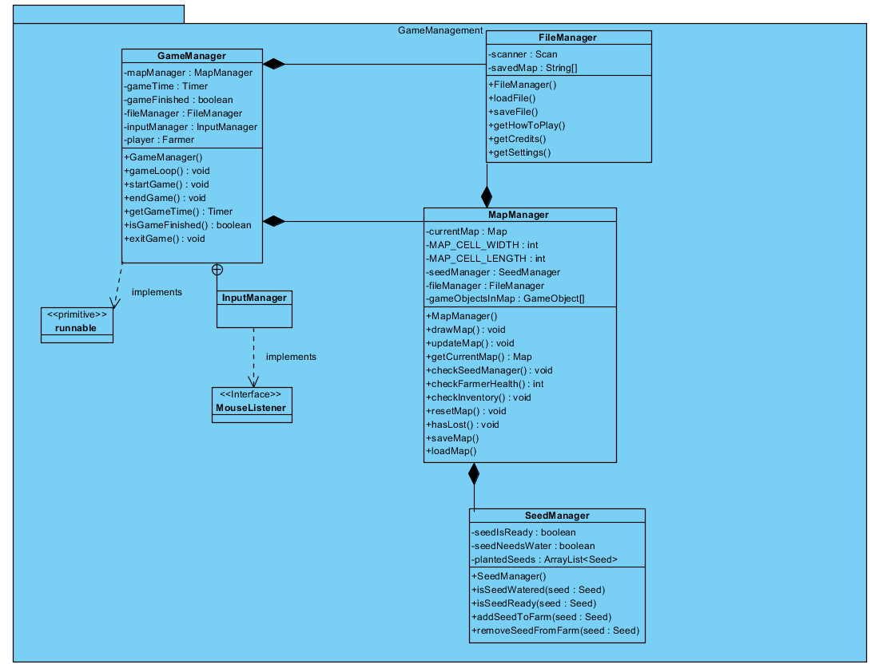**3.3 Game Management Subsystem**

**Game Manager Class**

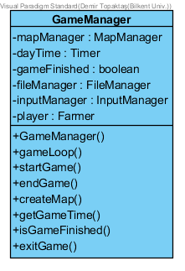

This class is to control the state of game and provides information about game state to other classes. Attributes are as following :

**Attributes**

|  |  |
| --- | --- |
| Class Name : Game Manager | Explanation of attributes |
| private MapManager mapManager: | It is the instance of MapManager. It manages Map and provides the communication between GameManager and Map. |
| private Timer gameTime | This attribute keeps track of game time and it is initiliazed when the game starts. |
| private boolean gameFinished | gameFinished attribute keeps track of whether game is finished or not. |
| private FileManager fileManager: | This instance provides files to be saved or loaded to game manager |
| private InputManager inputManager | This instance controls the user mouse actions. |
| private Farmer player | It is the instance of the Farmer object and represents the player. |

**Functions**

|  |  |
| --- | --- |
| Class Name : Game Manager | Explanation of functions |
| private void startGame(): | This method starts the game. |
| private void endGame(): | This method ends the game. |
| private void exitGame(): | This method exits the game. |
| private boolean isGameFinished(): | This method returns the game finished attribute |
| private Timer getGameTime(): | This method returns the game time timer. |
| private void saveGame(): | This method saves the game to a file |

**Constructor**

**public GameManager():** Default constructor for Game Manager. It initiliazes the GameManager object.

**MapManager Class** 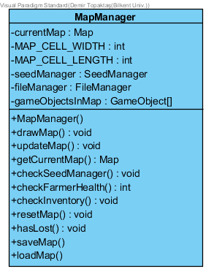

MapManager class controls, updates, and modifies the map accordingly to relations with other classes.

**Attributes**

|  |  |
| --- | --- |
| Class Name : MapManager Class | Explanation of attributes |
| private Map currentMap | This is the instance of Map object |
| private int MAP_CELL_WIDTH & MAP_CELL_LENGTH | These attributes are for dividing map equally. |
| private SeedManager seedManager | This is the instance of SeedManager. It is responsible for checking “planted” seeds status (watered or not) in the map. |
| private FileManager fileManager | It is the instance of FileManager and it provides saved files to Map Manager |

**Constructor**

**public MapManager():** Default constructor for MapManager.

**Functions**

|  |  |
| --- | --- |
| Class Name : MapManager Class | Explanation of function |
| private void drawMap(): | This method draws the initiliazed map. |
| private void updateMap() | This method updates the map |
| private void loadMap(): | This method loads the map from a file using FileManager |
| private void saveMap(): | This method saves the map to a file using FileManager. |
| private Map getCurrentMap(): | This method returns the current map object |
| private void checkSeedManager(): | This method requests SeedManager to check seeds in the farmland |
| private boolean hasLost(): | This method returns whether the game is lost or not. |
| private void resetMap(): | This method resets the map. |
| private void checkFarmerStatus(): | This method checks farmer status such as farmer’s health and money |

**SeedManager Class**

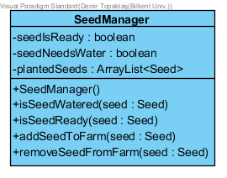SeedManager is responsible for checking planted seeds status in the map. Seeds can be planted in the map at different times and have different growth status. Some seeds might need water or ready to be harvested. Seed manager checks these attributes.

**Attributes**

|  |  |
| --- | --- |
| Class Name : SeedManagerClass | Explanation of attributes |
| private ArrayList<Seed> plantedSeeds: | This array list keeps the seeds that are planted to the map. |
| private boolean seedIsReady: | This attribute checks whether seed is ready to be harvested or not. |
| private boolean seedNeedsWater: | This attribute checks whether seed needs water or not. |

**Constructor**

**public SeedManager():** Default constructor for seed manager.

**Functions**

|  |  |
| --- | --- |
| ClassName :SeedManager Class | Explanation of functions |
| private boolean isSeedWatered(Seed seed): | This is the method for checking specific seed is watered or not. |
| private boolean isSeedReady(Seed seed): | This is the method for checking specific seed is ready for harvesting. |
| private void addSeedToFarm(Seed seed): | This method adds seed to array list of planted seeds. |
| private void removeSeedFromFarm(Seed seed): | This method removes seed from array list. |

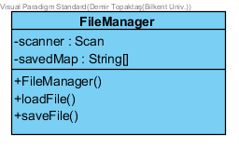**File Manager Class**

FileManager will be responsible for saving or loading the game. It will save game to file or it will load game from file.

**Attributes**

|  |  |
| --- | --- |
| ClassName :FileManager Class | Explanation of attributes |
| private String[][] map: | This attribute holds the map in 2d string array |
| private Scanner scan: | This attribute is for scanning. |

**Constructor**

**public FileManager():** Default constructor for Game Manager. It initiliazes the GameManager object.

**Functions**

|  |  |
| --- | --- |
| ClassName :FileManager Class | Explanation of attributes |
| private loadFile(): | This methods reads from the saved map from file and loads. |
| private saveFile(): | This method saves the map to the file. |

**InputManager Class**

This class will be responsible for user inputs. It will implement MouseListener to detect mouse clicks

**Constructor**

**public InputManager():** Default constructor for Game Manager. It initiliazes the GameManager object.

**Methods**

**public void mouseClicked():** This method initiates when mouse clicks**.**

## **3.4 Game Entities Subsystem**

# **Conclusion**

In this design report, we decided to add new features, classes after analysis report. Firstly, we have added new Entity objects including Potato, Tomato, Cherry, Raspberry, and Apple class as a subclass of Food class. Accordingly, TomatoSeed and PotatoSeed classes have been added. Besides, Tree class added with AppleTree, RaspberryTree, and CherryTree classes, which Tree class is superclass of these classes. In other words, we added ability to plant new trees to our farmland and new type of plants. Also, we added power-ups like GMO, Fertilizer, and Rain. These new features, will increase the entertainment level of game.