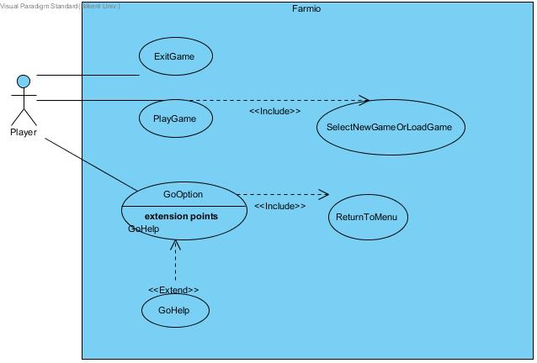

Use Case #2

**Use case name:** GoHelp

**Participating actors:** Player

**Entry condition:** Player firstly opens the game and goes to Options page.

**Exit condition:** Player returns to main menu.

**Main Flow of Events:**

1. “Help” button is chosen by Player.
2. Player gets informed about the instructions of the game.
3. Player returns to the Option menu.

Use Case #1

**Use case name:** PlayGame

**Participating actors:** Player

**Entry condition:** Player has to open main Menu and has to select “Play” button

**Exit condition:**

1. Player has to lose game by finishing his money, OR
2. Player has to exit the game by clicking the exit button.

**Main Flow of Events:**

1. Player clicks the "Play Game" Button
2. System comes up with selection page that asks if player wants to load game or start a new game
3. Player plays the game and returns to main menu at the time player wants.
4. Player returns to the main menu of the game.

**Alternative Flow of Event:**

1. Player loses all of his/her money and system comes up with pop-up message that “Game Over” and game returns to Main Menu
2. Player can exit the game any time.

Use Case #4

**Use case name:** ExitGame

**Participating actors:** Player

**Entry condition:** Player is on main menu.

**Exit condition:** Program is closed.

**Main Flow of Events:**

1. Player clicks "Exit" button from main menu.
2. Program is closed.

Use Case #3

**Use case name:** ReturntoMenu

**Participating actors:** Player

**Entry condition:** Player firstly opens the game and goes to Options page.

**Exit condition:** Player returns to main menu.

**Main Flow of Events:**

1. Player chooses "Return Menu" from Options menu.
2. Player returns to main menu.

Use Case #5

**Use case name:** SelectNewOrLoadGame

**Participating actors:** Player

**Entry condition:** Player chose “Play” button from main menu.

**Exit condition:** Player returns to main menu.

**Main Flow of Events:**

1. Player clicks "Play Game" button from main menu.
2. Player chooses to play new game or load game.
3. Player returns to the main menu of the game after playing game.

**Alternative Flow of Event:**

* Player returns to main menu without playing the game.