GameManager Class

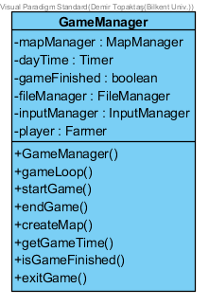

- GameManager class is the one of the main game management class that is also can be evaluated as Façade class since it hides complexities of other classes and collects all the operations here for the ease of use.
Attributes:
private MapManager mapManager: It is the instance of MapManager. It manages Map and provides the communication between GameManager and Map.

private Timer gameTime: This attribute keeps track of game time and it is initiliazed when the game starts.

private boolean gameFinished: gameFinished attribute keeps track of whether game is finished or not.

private FileManager fileManager: This instance provides files to be saved or loaded to game manager.

private InputManager inputManager: This instance controls the user mouse actions.

private Farmer player: It is the instance of the Farmer object and represents the player.

Constructors:
public GameManager(): Default constructor for Game Manager. It initiliazes the GameManager object.

Methods:
private void startGame(): This method starts the game.

private void endGame(): This method ends the game.

private void exitGame(): This method exits the game.

private boolean isGameFinished(): This method returns the game finished attribute

private Timer getGameTime(): This method returns the game time timer.

Private void saveGame(): This method saves the game to a file.

MapManager Class
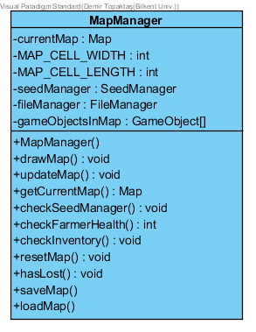

- MapManager class controls, updates, and modifies the map accordingly to relations with other classes.

Attributes:

private Map currentMap: This is the instance of Map object.

private SeedManager seedManager: This is the instance of SeedManager. It is responsible for checking “planted” seeds status(watered or not) in the map.

private FileManager fileManager: It is the instance of FileManager and it provides saved files to Map Manager

private int MAP_CELL_WIDTH & MAP_CELL_LENGTH: These attributes are for dividing map equally.

Constructors:

public MapManager(): Default constructor for MapManager.

Methods:

private void drawMap(): This method draws the initiliazed map.

private void updateMap(): This method updates the map.

private void loadMap(): This method loads the map from a file using FileManager

private void saveMap(): This method saves the map to a file using FileManager.

private Map getCurrentMap(): This method returns the current map object.

private void checkSeedManager(): This method requests SeedManager to check seeds in the farmland

private boolean hasLost(): This method returns whether the game is lost or not.

private void resetMap(): This method resets the map.

Private void checkFarmerStatus(): This method checks farmer status such as farmer’s health and money

SeedManager Class

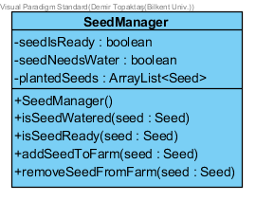

- SeedManager is responsible for checking planted seeds status in the map. Seeds can be planted in the map at different times and have different growth status. Some seeds might need water or ready to be harvested. Seed manager checks these attributes.

Attributes:

private ArrayList<Seed> plantedSeeds: This array list keeps the seeds that are planted to the map.

private boolean seedIsReady: This attribute checks whether seed is ready to be harvested or not.

private boolean seedNeedsWater: This attribute checks whether seed needs water or not.

Constructors:
public SeedManager(): Default constructor for seed manager

Methods:

private boolean isSeedWatered(Seed seed): This is the method for checking specific seed is watered or not.

private boolean isSeedReady(Seed seed): This is the method for checking specific seed is ready for harvesting.

private void addSeedToFarm(Seed seed): This method adds seed to array list of planted seeds

private void removeSeedFromFarm(Seed seed): This method removes seed from array list.

FileManager Class
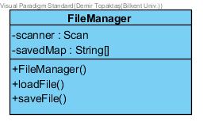

Attributes:
private String[][] map: This attribute holds the map in 2d string array

private Scanner scan: This attribute is for scanning.

Constructors:
public FileManager(): Default constructor for Game Manager. It initiliazes the GameManager object.

Methods:
private loadFile(): This methods reads from the saved map from file and loads.

private saveFile(): This method saves the map to the file.

InputManager Class

Constructors:
public InputManager(): Default constructor for Game Manager. It initiliazes the GameManager object.

Methods:
public void mouseClicked(): This method initiates when mouse clicks.

