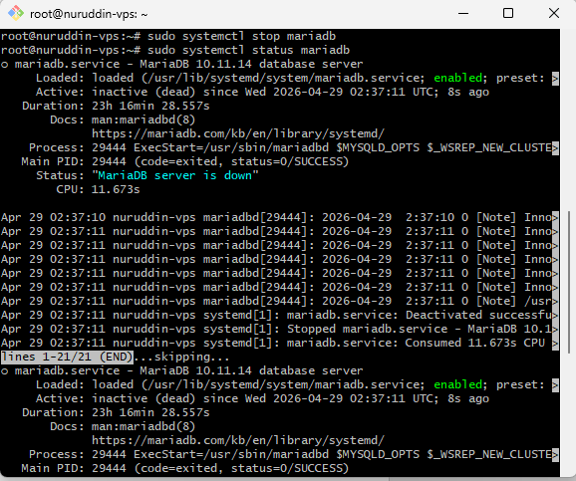
1. Stop Database

2. Bukti Database Sudah Hilang
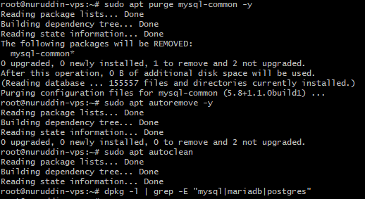

3. Pastikan RAM Lebih Lega
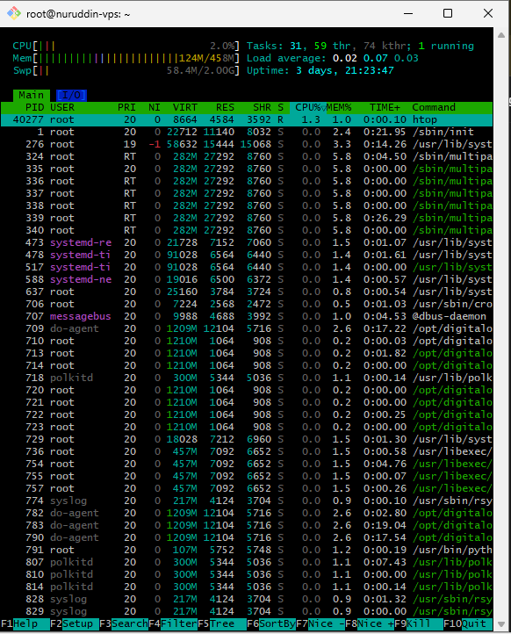

4. Evidence DNS
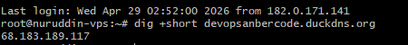
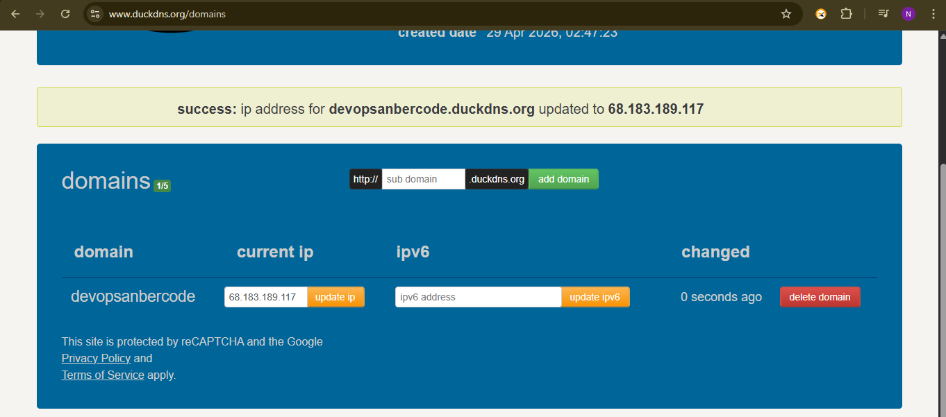
5. NGINX SETUP (FINAL CHECK)
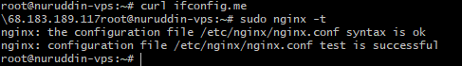
6. Firewall
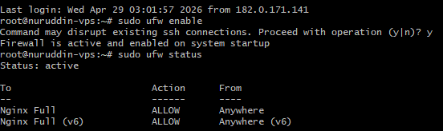

7. INSTALL SSL (Certbot)
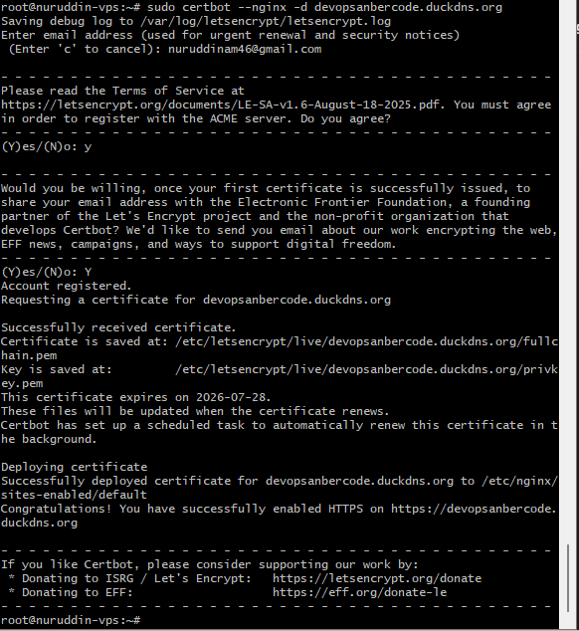

8. TEST HTTPS
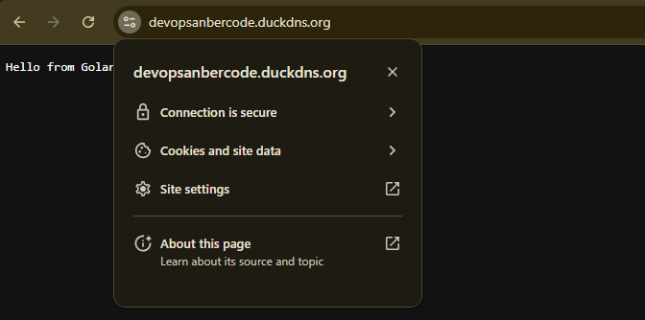

9. Evidence Config Nginx
root@nuruddin-vps:~# cat /etc/nginx/sites-available/*
##
# You should look at the following URL's in order to grasp a solid understanding
# of Nginx configuration files in order to fully unleash the power of Nginx.
# https://www.nginx.com/resources/wiki/start/
# https://www.nginx.com/resources/wiki/start/topics/tutorials/config_pitfalls/
# https://wiki.debian.org/Nginx/DirectoryStructure
#
# In most cases, administrators will remove this file from sites-enabled/ and
# leave it as reference inside of sites-available where it will continue to be
# updated by the nginx packaging team.
#
# This file will automatically load configuration files provided by other
# applications, such as Drupal or Wordpress. These applications will be made
# available underneath a path with that package name, such as /drupal8.
#
# Please see /usr/share/doc/nginx-doc/examples/ for more detailed examples.
##

# Default server configuration
#
server {
listen 80 default_server;
listen [::]:80 default_server;

# SSL configuration
#
# listen 443 ssl default_server;
# listen [::]:443 ssl default_server;
#
# Note: You should disable gzip for SSL traffic.
# See: https://bugs.debian.org/773332
#
# Read up on ssl_ciphers to ensure a secure configuration.
# See: https://bugs.debian.org/765782
#
# Self signed certs generated by the ssl-cert package
# Don't use them in a production server!
#
# include snippets/snakeoil.conf;

root /var/www/html;

# Add index.php to the list if you are using PHP
index index.html index.htm index.nginx-debian.html;

server_name _;

location / {
proxy_pass http://localhost:9090;
proxy_http_version 1.1;

proxy_set_header Host $host;
proxy_set_header X-Real-IP $remote_addr;
proxy_set_header X-Forwarded-For $proxy_add_x_forwarded_for;
}

# pass PHP scripts to FastCGI server
#
#location ~ \.php$ {
# include snippets/fastcgi-php.conf;
#
# # With php-fpm (or other unix sockets):
# fastcgi_pass unix:/run/php/php7.4-fpm.sock;
# # With php-cgi (or other tcp sockets):
# fastcgi_pass 127.0.0.1:9000;
#}

# deny access to .htaccess files, if Apache's document root
# concurs with nginx's one
#
#location ~ /\.ht {
# deny all;
#}
}

# Virtual Host configuration for example.com
#
# You can move that to a different file under sites-available/ and symlink that
# to sites-enabled/ to enable it.
#
#server {
# listen 80;
# listen [::]:80;
#
# server_name example.com;
#
# root /var/www/example.com;
# index index.html;
#
# location / {
# try_files $uri $uri/ =404;
# }
#}

server {

# SSL configuration
#
# listen 443 ssl default_server;
# listen [::]:443 ssl default_server;
#
# Note: You should disable gzip for SSL traffic.
# See: https://bugs.debian.org/773332
#
# Read up on ssl_ciphers to ensure a secure configuration.
# See: https://bugs.debian.org/765782
#
# Self signed certs generated by the ssl-cert package
# Don't use them in a production server!
#
# include snippets/snakeoil.conf;

root /var/www/html;

# Add index.php to the list if you are using PHP
index index.html index.htm index.nginx-debian.html;
server_name devopsanbercode.duckdns.org; # managed by Certbot

location / {
proxy_pass http://localhost:9090;
proxy_http_version 1.1;

proxy_set_header Host $host;
proxy_set_header X-Real-IP $remote_addr;
proxy_set_header X-Forwarded-For $proxy_add_x_forwarded_for;
}

# pass PHP scripts to FastCGI server
#
#location ~ \.php$ {
# include snippets/fastcgi-php.conf;
#
# # With php-fpm (or other unix sockets):
# fastcgi_pass unix:/run/php/php7.4-fpm.sock;
# # With php-cgi (or other tcp sockets):
# fastcgi_pass 127.0.0.1:9000;
#}

# deny access to .htaccess files, if Apache's document root
# concurs with nginx's one
#
#location ~ /\.ht {
# deny all;
#}

listen [::]:443 ssl ipv6only=on; # managed by Certbot
listen 443 ssl; # managed by Certbot
ssl_certificate /etc/letsencrypt/live/devopsanbercode.duckdns.org/fullchain.pem; # managed by Certbot
ssl_certificate_key /etc/letsencrypt/live/devopsanbercode.duckdns.org/privkey.pem; # managed by Certbot
include /etc/letsencrypt/options-ssl-nginx.conf; # managed by Certbot
ssl_dhparam /etc/letsencrypt/ssl-dhparams.pem; # managed by Certbot

}
server {
if ($host = devopsanbercode.duckdns.org) {
return 301 https://$host$request_uri;
} # managed by Certbot

listen 80 ;
listen [::]:80 ;
server_name devopsanbercode.duckdns.org;
return 404; # managed by Certbot

}server {
listen 443 ssl;
server_name devopsanbercode.duckdns.org;

ssl_certificate /etc/letsencrypt/live/devopsanbercode.duckdns.org/fullchain.pem;
ssl_certificate_key /etc/letsencrypt/live/devopsanbercode.duckdns.org/privkey.pem;

location / {
proxy_pass http://localhost:8080;
}
}

server {
listen 80;
server_name devopsanbercode.duckdns.org;

return 301 https://$host$request_uri;
}

10. PertanyaanTechLead
"Kenapa sih kita harus rajin melakukan apt purge atau menghapus servis yang nggak kepakai kayak MySQL/Postgres tadi sebelum kita instal SSL dan rilis ke publik? Apa hubungannya sama keamanan dan performa server?"
Berikan jawaban analisis kalian secara singkat dan tepat…

Menurut saya, kita perlu menghapus service yang tidak dipakai seperti MySQL atau PostgreSQL supaya server tidak menjalankan aplikasi yang sebenarnya tidak dibutuhkan.
Kalau service dibiarkan tetap terinstall, service tersebut masih bisa berjalan di background dan memakai RAM serta resource server. Ini bisa membuat server menjadi lebih berat, apalagi jika spesifikasi VPS kecil.
Dari sisi keamanan juga berisiko, karena semakin banyak service aktif maka semakin besar peluang adanya celah keamanan yang bisa diserang dari internet.
Jadi dengan melakukan apt purge, server menjadi lebih ringan, lebih aman, dan lebih siap digunakan ketika aplikasi sudah online menggunakan SSL dan diakses publik.

