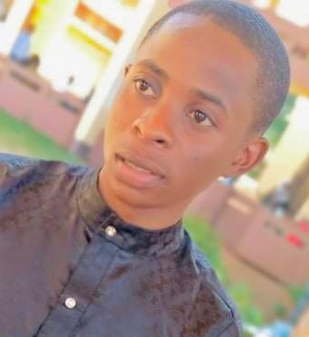++

Detailed-oriented Frontend Developer with 2 years experience working with HTML, CSS, JavaScript, React. Highly adept at both independent and collaborative projects, with an emphasis on landing page and website development.

***SUMMARY***

***DEDICATED CERTIFICATION AND PROJECT***

**I4G x Zuri Training Full Stack Developer**

**Remote| May 2022 – Present|**

**Handling of numerous tasks like**:

* Recreating a responsive landing page website
* Python fundamental
* Use of version controls like git and github
* Django (CRUD, REST API, user authentication, making request to a server)
* JavaScript fundamentals (Functions, loops, array, object-oriented JavaScript)

**Udacity certification for JavaScript programming foundation| June 2022|**

* JavaScript Fundamentals
* DOM Manipulation
* Async method to check for errors when making a request to an API
* I used React to create a blog website using React hook, router and also the fetch method to request data from an API

DUROWADE NURUDEEN

Frontend-Developer

* HTML
* CSS
* JavaScript
* React
* Website or App implementation
* DOM Manipulation
* Version Control (git)
* Problem solving skills
* Communication skills
* National Youth Service Corps Discharge certificate (Sep 2022)
* University of Ilorin

Bachelor of Science degree in Mathematics

C.G.P.A of 4.26 on a scale of 5.0 2016-2021

* Olayinka Grammar school (S.S.C.E) June 2015

***EDUCATION***

Tel : 08102308366

[nurudeendurowade@gmail.com](mailto:nurudeendurowade@gmail.com)

Lagos -Nigeria

SKILLS