Problem

"It is time to reflect on the kind of society we want to build in the future... We must continue to build a more inclusive society, valuing everyone and promoting active citizenship."

-Prime Minister Lee Hsien Loong

The total exact number of wheelchair-bound people in Singapore is unknown. In fact, statistical data on disabled people in Singapore is difficult to obtain. There is a need for a fair and just society which respects every person, especially persons with disabilities. How does the city development plan contribute to the pattern of accessibility and mobility for the physically disabled?

Motivation

Our study aims to visualize and spatially analyse the accessibility of services in a neighbourhood for the physically disabled. It aims to find a relationship in the existing footpath network and its distribution of public amenities in the neighbourhood so we can get an accurate perception about its spatial and accessibility coverage.

Approach

**The interactive user interface** will enable the user to display the types of information data regarding the mobility of the physically disabled while the other panel will display the results of any significance pattern based on the variable chosen. There will be statistics displayed from the analysis such as relevant **histograms** and **scatterplots**.

Results <4 screenshots>

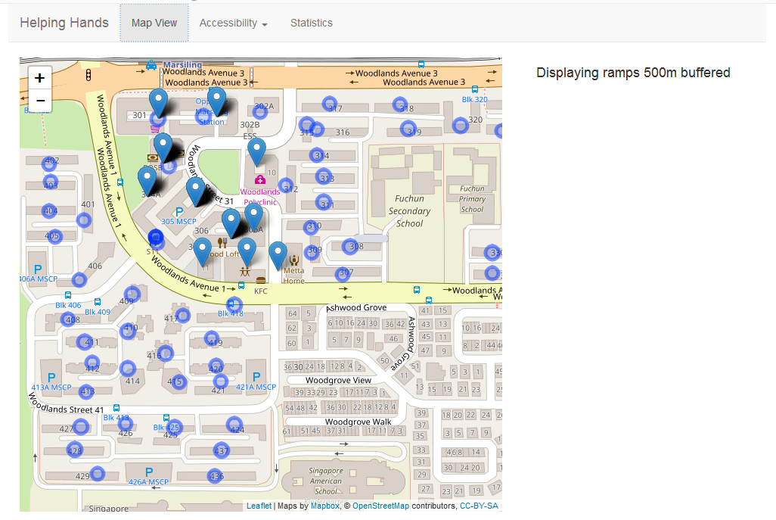

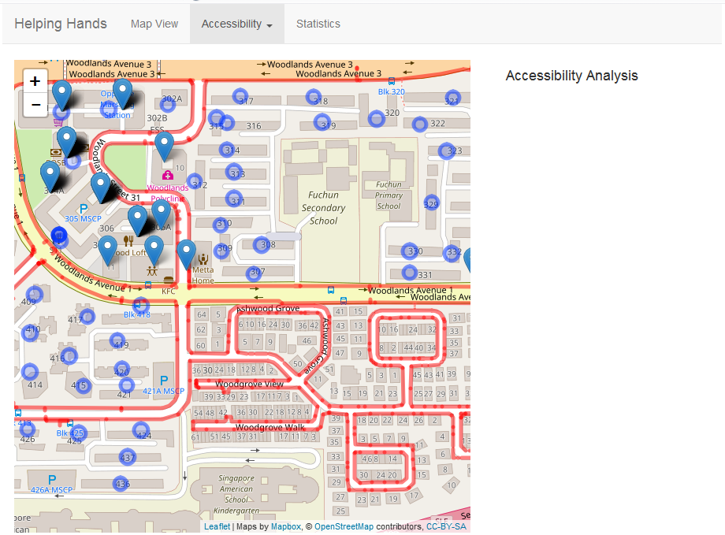

Future work

Further improvisation could be possible by enabling user to upload any type of data e.g (school/sports facilities) and the application would be able to scope the information to the limitation of the neighbourhood and provide further analysis on it.

Increased area to instead of different zones instead of subzones