**Overview**

The purpose of the geospatial analytics project is to provide students first hand experience on building web-based geospatial analytics tool by integrating open source web mapping API(s), data visualisation API(s) and geospatial analysis libraries. You will also learn how to collecting, processing and analysing spatially related issues using real world data. Students are encouraged to focus on research topics that are relevant to their field of study.

The project is to be done in a team. You are required to form a project team of 2-3 members by the second week of the academic term. Each project team must start thinking about their project ideas after the first lesson. You are expected to discuss your project topic and scope of works with the instructor during the second or third week of the academic term. A project website must be prepared and uploaded to the course wiki page by the end of week 4.

**Project Theme**

Students are required to choose one of the following theme to develop the GeoSpaital Analytics Project:

* GeoProcessing on the Web

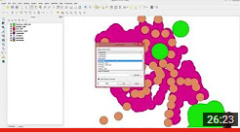

* Web-based 3D Visualisation, Analysis and Modelling

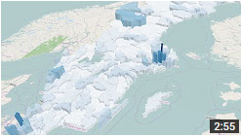

* GeoSpatial Data Analysis on the Web
* Web-based Geographically Weighted Modelling

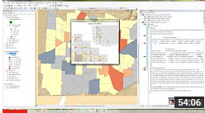

* Web-based Spatial Network and Interaction Models

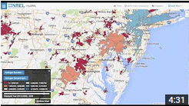

* GeoSimulation on the web   
  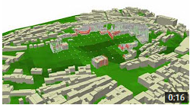

Please feel free to approach me for more details.

**Project Milestone**

* Formulation of project ideas: by week 3 before lesson
* Create project wiki page: by week 4 before lesson
* Update project wiki and interim project presentation: week 8 before the interim presentation
* Submission of project poster: 19th April 2016, at 9.30am
* Final project poster presentation: 20th April 2016 (Wednesday),
* Submission of final project paper, artifacts and update project wiki: 24th April 2016 at 11.59pm (mid-night)

**Grading**

The geospatial analytics project will count for 45% of your final grade in the course. The distribution of marks for each stage of the project are as follows:

* project wiki 5%
* Project poster 5%
* Poster presentation 10%
* Application solution 15%
* Project report 10%

The course instructor will consider strongly the novelty of the idea (If it has never been done before, you will get lots of credit!), how it addresses the problem at hand, the methodology you employ in doing the research, and your technical skill in implementing the idea.

In small group projects, each person will be graded individually. A good group project is a system consisting of a collection of well defined subsystems. Each subsystem should be the responsibility of one person and be clearly identified as their project. A good criteria for whether you should work in a group is whether the system as a whole is greater than the sum of its parts!

**Project Presentation**

**Interim Project Presentation**

A good way to assess the strengths and weaknesses of your project proposal is to present your ideas to your classmates for feedback. Thus, each group will be expected to initially present their project on week 8. The presentation should expand on the project proposal and include, but not limited to the following material:

* description of the problem and motivation, explaining why it is worth addressing.
* a background survey of related work and a list of references. Include the 2-3 most relevant pieces of prior work in your presentation.
* post your full list of references to your wiki page.
* a list of the key technical challenges your group expects to face and a description (or storyboard) of the approach you plan to use to address the challenge.
* a list of milestones breaking the project into smaller chunks and a description of what each person in the group will work on.

The project teams should take advantage of this presentation as an opportunity to get feedback on the direction of the project from their peers.

Note: Before giving your presentation, you should update the project wiki page for your presentation submission, linked from your final project page. Be sure to include a [Comments](https://wiki.smu.edu.sg/1516t2is415g1/index.php?title=Comments&action=edit&redlink=1) directive at the bottom of the page so that your classmates can share feedback. After giving your presentation, you should add a link to your slides and other presentation materials to this wiki page.

**Townhall Poster Presentation**

We will organise a public presentation of the final projects. The presentation will be in the form of a poster session and live demo. You are required to bring a laptop with a working demo of your system. You should set up the laptop near your poster and use it to explain your project. During the presentation session, visitors and course instructor will view the various posters that are put up and pose questions to find out more details of the project. Be prepared to give a short 5-10 minute oral explanation and demo of what you did.

**Deliverables**

**Project Wiki Page**

As a first step, you should create a project page (in the form of a wiki page) that includes the names of the members in your group and a short (1 to 2 paragraphs) description of the geospatial analytics issues or problems you would like to address. Please refer to the last section of this page for instructions on making the wiki page for the geospatial analytics project.

**Poster**

The final poster should provide an overview of your project. It should include, but not limited to the following information:

* Issues and problems - A clear statement of the issues or/and problems your project addresses.
* Motivation - An explanation of why the issues and/or problems are interesting and what make them difficult to solve.
* Approach - A description of the techniques or algorithms you used to solve the problem.
* Results - Screenshots and a working demo of the system you built.
* Future Work - An explanation of how the work could be extended.

The poster will be in **ANSI A1 size (22" × 34" or 559mm × 864mm)**. It has to be in **jpeg** format. Please ensure that the poster is in high resolution (**at least 300 dpi**).

The poster will be considered a final deliverable, so don't forget to apply good visual design principles to your poster as well as your project.

Note: The course instructor will be responsible for printing your poster. You are required to upload your posters to the **wiki** page of your project one week and your project **Dropbox** before the poster presentation.

Below are sample posters for your reference:

* Interactive Area Hotspot Detection [[1]](https://wiki.smu.edu.sg/1213t2is415g1/Team3_ProjectPoster)
* A City's Heartbeat[[2]](https://wiki.smu.edu.sg/1213t2is415g1/UP_ProjectPoster)
* BussStop[[3]](https://wiki.smu.edu.sg/1213t2is415g1/Team1_ProjectPoster)
* Decrypting The Housing Prices In Singapore [[4]](https://wiki.smu.edu.sg/1112t2is415g1/Jaesan_Project_Poster)

**Final Deliverable**

**General**

The final deliverable will include:

* artifact, an implementation of your system (source code and executable)
* an 8-12 page paper written in the form of a conference paper submission. The paper should present related work, a detailed description of your system and a discussion of your design.
* updated the geospatial analytics project wiki including all the links.

**Project Report**

The paper should include content that is typical of papers that appear at ACM SIGSPATIAL[[5]](http://www.acm.org/sigs/publications/proceedings-templates).

In particular it should contain:

* Introduction - An explanation of the problem and the motivation for solving it.
* Related Work - A description of previous papers related to your project.
* Methods - A detailed explanation of the techniques and algorithms you used to solve the problem.
* Results - How the geospatial analytics tool developed help to discover new understanding from the data.
* Discussion - What has the audience learned from your work? What new insights or practices has your system enabled? A full blown user study is not expected, but informal observations of use that help evaluate your system are encouraged.
* Future Work - A description of how your system could be extended or refined.

Below are sample papers for your reference:

* "DIVAD: A Dynamic and Interactive Visual Analytical Dashboard for Exploring and Analyzing Transport Data" [[6]](http://www.waset.org/publications/13394)
* Tailor-made Exploratory Visualization for Statistics Sweden[[7]](http://www.computer.org/csdl/proceedings/cmv/2005/2396/00/23960133.pdf)

**Paper format**

The final paper should be in the style of a conference paper submission. It should be formatted using the 2 column formatting of papers that appear at ACM SIGSPATIAL[[8]](http://www.acm.org/sigs/publications/proceedings-templates). A sample of the research paper template is available [here‎](https://wiki.smu.edu.sg/1516t2is415g1/img_auth.php/1/1d/Geospatial_Analytics_Project_research_paper_template.doc) for your use.

**Sample Projects**

Note that the following examples are for references purposes. You are urged to use your own creativity and innovation to design the application.

**Past Year IS415 Projects**

**Year 2010/2011 term 2 Projects:**[**[9]**](https://wiki.smu.edu.sg/1011t2is415g1/Geospatial_Analytics_Project)

**Year 2011/2012 term 2 Projects:**[**[10]**](https://wiki.smu.edu.sg/1112t2is415g1/Geospatial_Analytics_Project_Group)

**Year 2012/2013 term 2 Projects:**[**[11]**](https://wiki.smu.edu.sg/1213t2is415g1/Geospatial_Analytics_Project_Group)

**Year 2013/2014 term 2 Projects:**[**[12]**](https://wiki.smu.edu.sg/1314T2is415/Geospatial_Analytics_Project_Group)

**Year 2014/2015 term 2 Projects:**[**[13]**](https://wiki.smu.edu.sg/1415T2is415/Geospatial_Analytics_Project_Group)

**External Sites**

* Department of Geography, NUS [[14]](http://www.fas.nus.edu.sg/geog/undergrads/minor_gis_stu_projs.htm)

**Q&A**

[Link to Q&A/Project Discussion](https://wiki.smu.edu.sg/1516t2is415g1/index.php?title=Talk%3AGeospatial_Analytics_Project&action=edit&redlink=1)

Project Theme: GeoSpatial Data Analysis on the Web

Project Milestone:

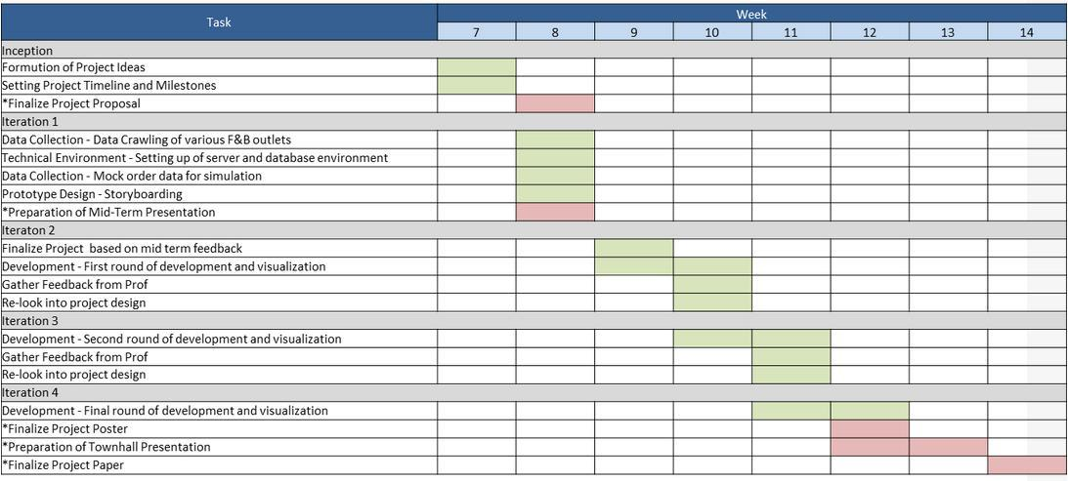

Background Survey: Level of Satisfaction from Special Needs Sector

Research articles and studies about problems and difficulties of Special Needs People in the world & Singapore:

References list:  
 <https://data.gov.sg/dataset/27de4b39-fccd-4bfe-910a-86076edaae92/resource/9285c1a1-ac49-495c-b9cf-3189611cff04> -Residents by subzone age group

<https://www.ncss.gov.sg/GatewayPages/Social-Services/Children-and-Youth-with-Special-Needs>

<https://www.moe.gov.sg/education/special-education/list-of-sped-schools>

<https://www.msf.gov.sg/research-and-data/Research-and-Statistics/Pages/Programmes-for-Persons-with-Disabilities.aspx>

<https://data.gov.sg/dataset/secondary-schools-with-special-needs-facilities-resources>

<https://www.msf.gov.sg/Pages/default.aspx>

<https://www.sgenable.sg/pages/content.aspx?path=/for-youths/vocational-training/>

Key Technical Challenges:

Addresses Solution:

Layers :

(use case- ppl w walking disabilities/wheelchair community & how friendly our current public transport system toward them)  
(base data) MRT Stations- look at how many mrt with disabled facilities

(base data) Busstops – look at how many busstops have the facilities  
Seondary School—look at how many with Special Needs Facilities – how many ss w transportation places w/without disabled facilities

(generic application) Allow user to upload relevant data/layers in the app -- with disabled facilities/disabled ppl .

Aged ppl- what is the average walking speed? What is the confortable speed that they shld have…

(application modification- pppl who walk slower than normal)Allow to analyse every road segment (road segment data—e.g. 10m width, what is the recommended timing to have.) 🡪 traffic planner can analyse and come out w the proper timing for each road segment (recommend) 🡪 take two ends of the road(traffic lights) and split them and get the distance

Road shoulder data—hands on1 (downtown area)

Jaywalking

How accessible locations are from the transport systems 🡪 e.g. getting into the MRT (don’t have many places for wheelchair bound ppl)

Traffic lights 🡪 aged ppl cannot make across in time.

20 SPED schools, early intervention programme for Infants & Children, Development Support Programme  
Community Integration locations  
Age group density  
Vocational training location

# Summary