Nurul Inayah

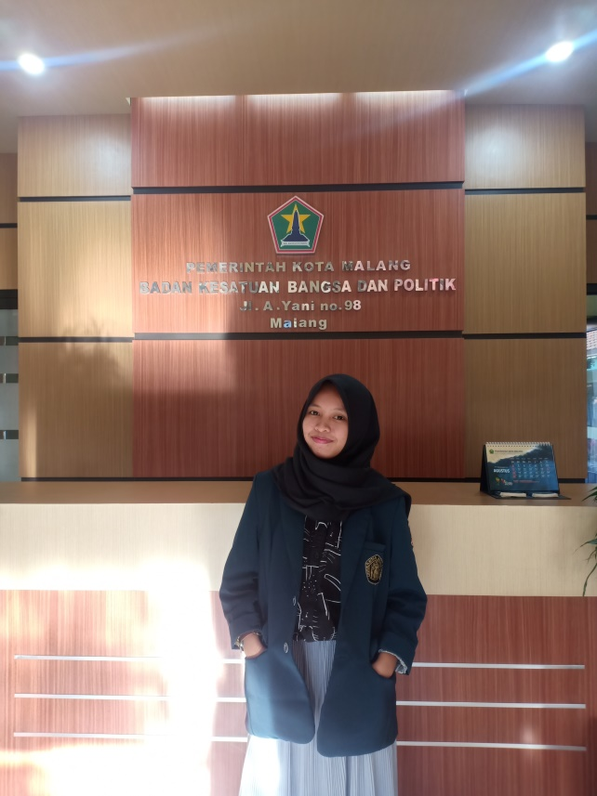

**PROFILE**

# 

I am a last year student of Brawijaya University majoring in informatics engineering. Have experience and skills in UI/UX, front-end web and management time through internship, competition, organization and volunteer opportunities. Looking for internship opportunities to increase my potential as well as deepen my interests in the UI/UX field.

# PERSONAL

**Phone number**

081230233174

**Address**

**WORK EXPERIENCE**

**UI/UX Design**

*Badan Inkubator Wirausaha UB, Malang*

* Joining in a webinar to improve soft skills
* Creating UI for lecturer guidance apps

March - May 2020

Jln. Andi Parenrengi, No.50, Sengkang

**Email**

nurulinayah.a@gmail.com

**LinkedIn**

[linkedin.com/in/nurul-inayah21](mailto:voorbeeld@hotmail.com)

Jun – Aug 2019

# SKILLS

UI/UX, Administration,

front-end web programing,

manage time

**Organizational Experience**

**INTERESTS**

UI/UX Design

System Analyst

Project Manager

**LANGUAGES**

English

Indonesia

**Achievement**

**Laboratoy Assistant of Database System**

*Faculty of Computer Science (FILKOM) UB, Malang*

* Responsible to deliver all material both theory and practice based on module
* Evaluating the practicum reports
* Manage practicum scores

Aug - Dec 2019

Apr 2018 - Jan 2019

Mar - Des 2019

Feb - Apr 2020

**Subdivision of Program Plans**

*Badan Kesatuan Bangsa dan Politik, Malang*

* Collected archives of each department to create accountability report
* Check the suitability of programs that have been implemented

**Speaker**

*Youth Sharing Center (YSC)*

* Sharing tips how to pick a university and department
* Sharing tips to pass SNMPTN of dream university

**IT Volunteer**

*Youthoffers*

* Identifying problems that can be resolved through the youthoffers apps
* Helps in making good application designs
* Follow the sharing session every week

**Staff of Public Relation Department**

*Poros Organization of Open Source FILKOM UB, Malang*

* Manage twitter account
* Manage OSI (Open Source Info) of OS department
* Coordinate with open source communities in Malang

**Secretary**

*Poros Organization of Open Source FILKOM UB, Malang*

* Manage incoming mail and create invite delegation
* Responsible for submitting LPJ / Proposals
* Create meeting minutes

**Finalist**

*Vocational Computer Festival (VOCOMFest), UGM Yogyakarta*

* As a UI/UX to create mounesia apps
* Selected as the top 10

## Coordinator

February 2020

April 2018

**Volunteer Experience**