#### **[[logo](https://doc.wemaxdevs.com/wecourier-saas)](https://doc.wemaxdevs.com/wecourier-saas)**

**Documentation**

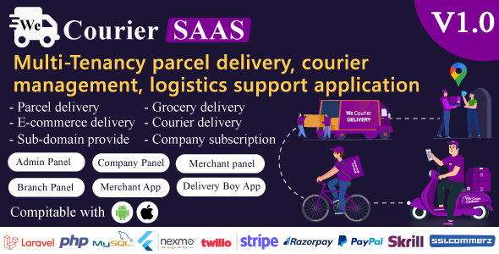

▶ **App Documentation**

#### **We Courier SAAS - Multi-Tenancy courier and logistics management - merchant, delivery app with admin panel**

Thank you so much for purchasing our item from codecanyon.

**WeCourier (SAAS)** is a complete multi-tenancy **(sub-domain)** wise parcel delivery solution for the most common courier platforms. It has a lot of build-in futures which are needed for every courier management site. It is designed for those who want to start their courier business or parcel delivery website. There are many courier scripts, many of them are very expensive, and have very complex interfaces for admin and user. **Wecourier (SAAS)** is designed with user friendly interface and simple interface. Any non-technical person can use this software.

**Version:** 1.0

**Author:** WemaxDevs

**Created:** Feb 2024

## **Recommendation**

We recommend using the latest Android Studio And Flutter SDK , which can be downloaded from here.

[**Android**](https://developer.android.com/studio?hl=en)[**Studio**](https://developer.android.com/studio?hl=en), [**Flutter**](https://developer.android.com/studio?hl=en)[**SDK**](https://developer.android.com/studio?hl=en), [**Cocoapods**](https://developer.android.com/studio?hl=en)

Recommended Version

* Android Studio 2021.2.1 or later
* Flutter 3.3.10 or later (Expect beta and alpha version).
* Dart SDK 2.18.6 or later.
* Latest Version (for iOS only).

**Installation**

* Android Studio Installation (Windows) - **video link:** <https://youtu.be/0zx_eFyHRU0>
* Android Studio Installation(Mac) - **video link:** <https://youtu.be/rNUoFXxT30U>

**Flutter Environment**

* Flutter Installation on Windows - video link : https://youtu.be/fDnqXmLSqtg
* Flutter Installation on Mac - **video link:** https://youtu.be/Dak3912YhYk
* If you have updated you mac to Catalina from mojavi or earlier version then you may fetch some issues. Please follow bellow video to fix it - **video link:** <https://youtu.be/ZwUGHiroGBo>

## **Change API Server**

**Select Project > go to lib folder > services folder > api-list.dart>** then change the root url with your url now if your Sever is **http://www.abc.com** so your service url like that [**http://www.abc.com**](http://www.abc.com/)

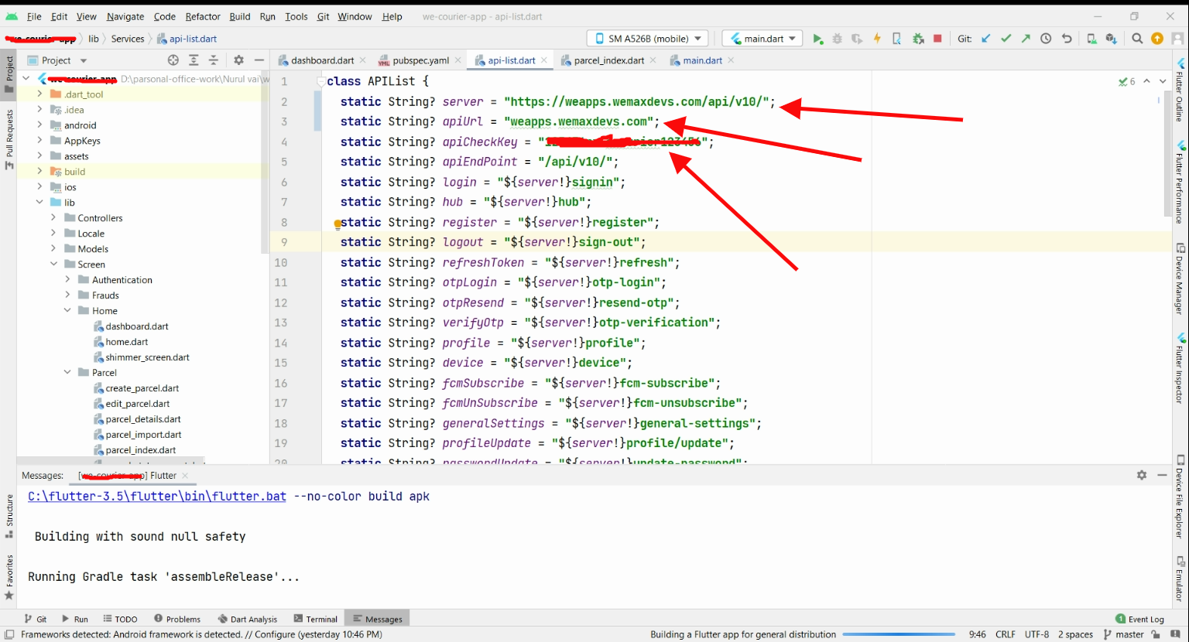

## **Change app logo**

* Rename your splash to splash1.png then copy/paste into directory location: Project » assets » images
* Re commanded logo size 512x512

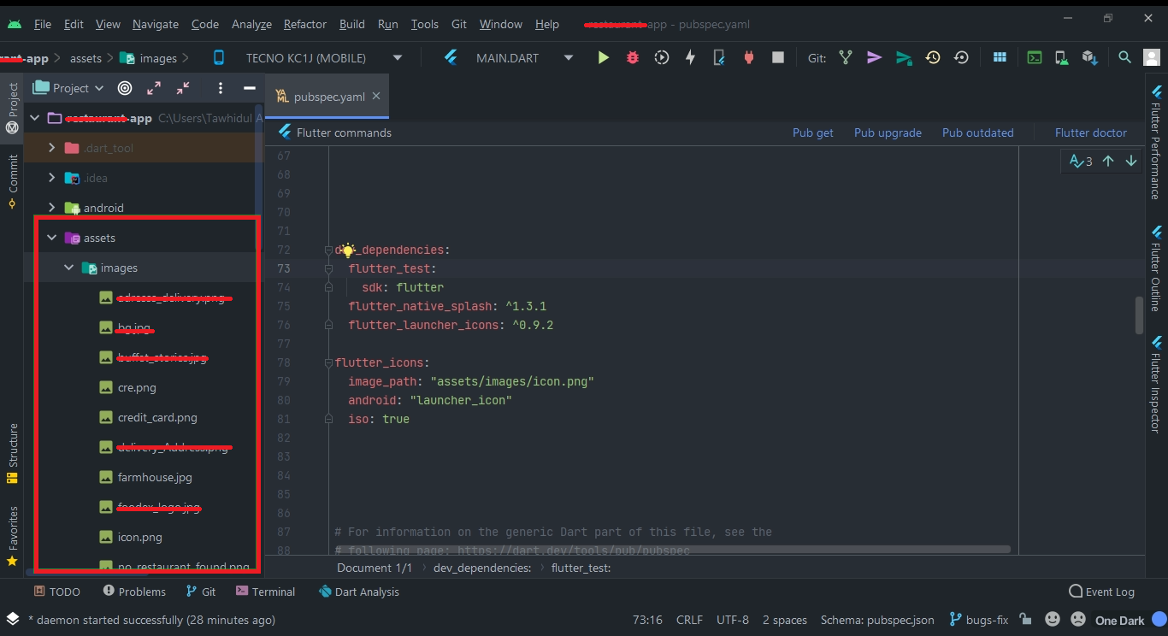

## **Change app name**

Select Project > go to android folder > app folder > src folder > main folder > AndroidManifest.xml then change the android:label name

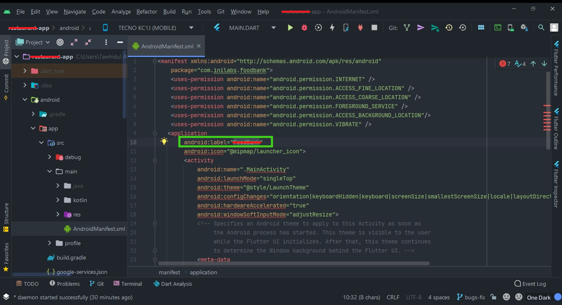

## **Change android luncher icon**

* Open this [link](https://romannurik.github.io/AndroidAssetStudio/icons-launcher.html#foreground.type=clipart&foreground.clipart=android&foreground.space.trim=1&foreground.space.pad=0.25&foreColor=rgba(96%2C%20125%2C%20139%2C%200)&backColor=rgb(68%2C%20138%2C%20255)&crop=0&backgroundShape=circle&effects=none&name=ic_launcher) from your browser.
* Create your desired launcher icon and download.

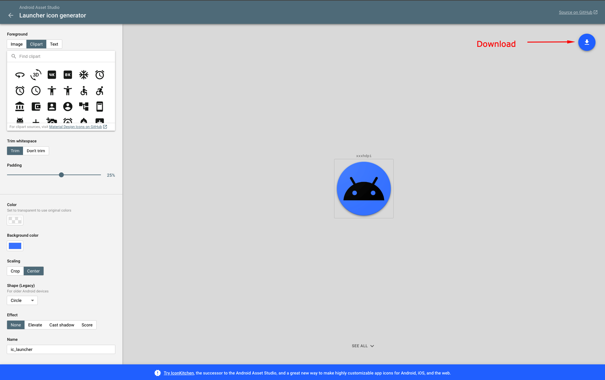

* Extract the downloaded zip file. Go to Project » android » app » src » main » res and replace existing files with your extracted files.

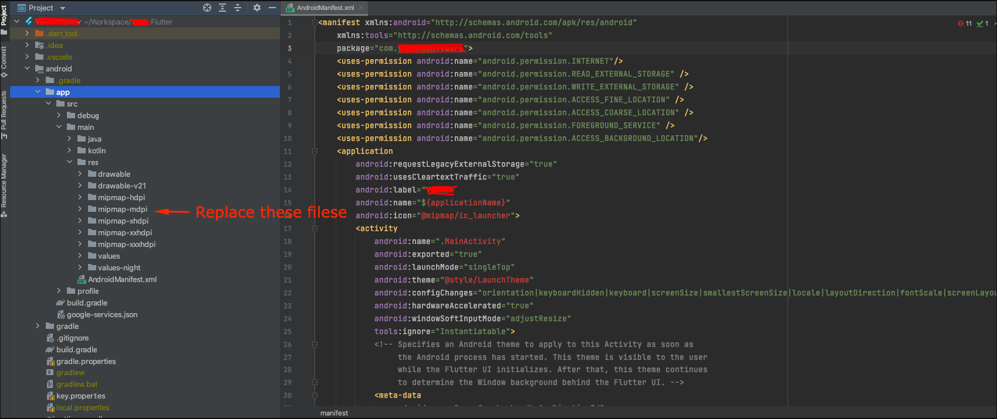

## **Change android packagee name**

* **Open** terminal from your android studio.
* Write flutter pub run change\_app\_package\_name:main com.new.package.name and replace com.new.package.name with your desired package name and press enter.

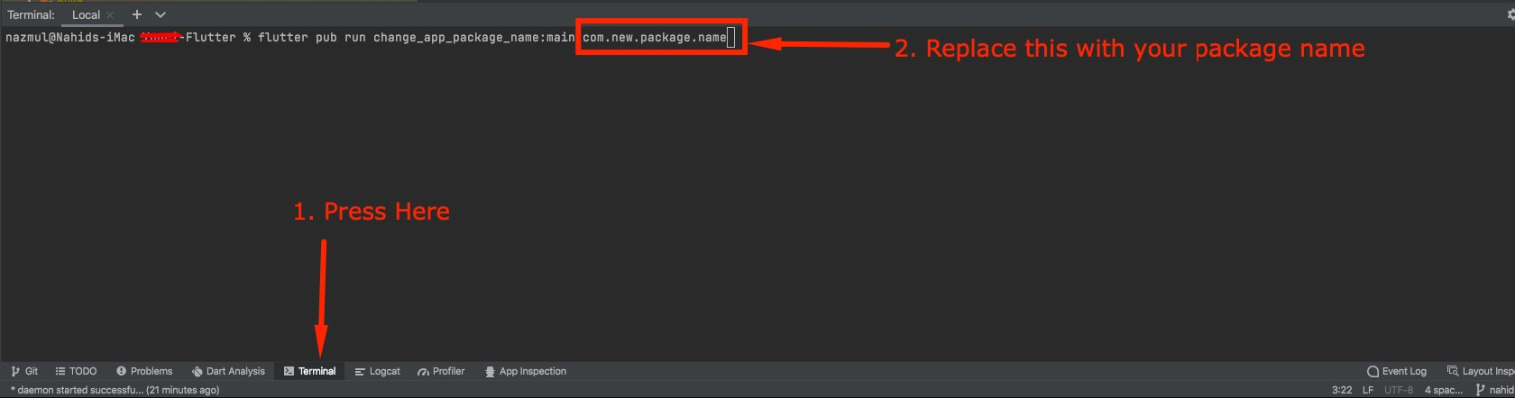

## **Generate Debug Apk**

● Open Android studio terminal then write command flutter build apk –debug

● An APK will be build.

## **Generate Signed Apk**

* First create a key-store file by following this link
* Then Copy your key.jks file to Project » keys » key.jks

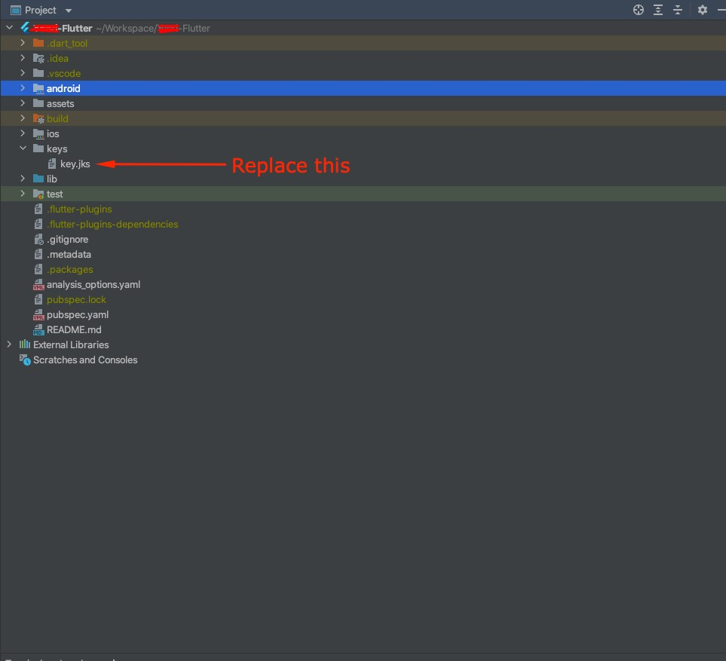

## **Preliminaries**

* Xcode is required to build and release your app. You must use a device running macOS to follow this guide.
* Before beginning the process of releasing your app, ensure that it meets Apple's [App](https://developer.apple.com/app-store/review/) [Review](https://developer.apple.com/app-store/review/) [Guidelines](https://developer.apple.com/app-store/review/).
* In order to publish your app to the App Store, you must first enroll in the [Apple](https://developer.apple.com/programs/) [Developer](https://developer.apple.com/programs/) [Program](https://developer.apple.com/programs/). You can read more about the various membership options in Apple’s [Choosing](https://developer.apple.com/support/compare-memberships/) [a](https://developer.apple.com/support/compare-memberships/) [Membership](https://developer.apple.com/support/compare-memberships/) guide.

## **Register your app on App Store Connect**

* Manage your app's life cycle on [App](https://developer.apple.com/support/app-store-connect/) [Store](https://developer.apple.com/support/app-store-connect/) [Connect](https://developer.apple.com/support/app-store-connect/) (formerly iTunes Connect). You define your app name and description, add screenshots, set pricing, and manage releases to the App Store and

TestFlight.

* Registering your app involves two steps: registering a unique Bundle ID, and creating an application record on App Store Connect.
* For a detailed overview of [App](https://developer.apple.com/support/app-store-connect/) [Store](https://developer.apple.com/support/app-store-connect/) [Connect](https://developer.apple.com/support/app-store-connect/), see the App Store Connect guide.

## **Register a Bundle ID**

Every iOS application is associated with a Bundle ID, a unique identifier registered with Apple. To register a Bundle ID for your app, follow these steps:

1. Open the [App](https://developer.apple.com/account/ios/identifier/bundle) [IDs](https://developer.apple.com/account/ios/identifier/bundle) page of your developer account.
2. Click + to create a new Bundle ID.
3. Enter an app name, select Explicit App ID, and enter an ID.
4. Select the services your app uses, then click Continue.
5. On the next page, confirm the details and click Register to register your Bundle ID.

## **Create an application record on App Store Connect**

Register your app on App Store Connect:

1. Open [App](https://appstoreconnect.apple.com/login) [Store](https://appstoreconnect.apple.com/login) [Connect](https://appstoreconnect.apple.com/login) in your browser.
2. On the App Store Connect landing page, click **My Apps** .
3. Click + in the top-left corner of the My Apps page, then select **New App**.
4. Fill in your app details in the form that appears. In the Platforms section, ensure that iOS is checked. Since Flutter does not currently support tvOS, leave that checkbox unchecked. Click Create.
5. Navigate to the application details for your app and select App Information from the sidebar.
6. In the General Information section, select the Bundle ID you registered in the preceding step.
7. For a detailed overview, see [Add](https://help.apple.com/app-store-connect/#/dev2cd126805) [an](https://help.apple.com/app-store-connect/#/dev2cd126805) [app](https://help.apple.com/app-store-connect/#/dev2cd126805) [to](https://help.apple.com/app-store-connect/#/dev2cd126805) [your](https://help.apple.com/app-store-connect/#/dev2cd126805) [account](https://help.apple.com/app-store-connect/#/dev2cd126805).

# **Review Xcode project settings**

This step covers reviewing the most important settings in the Xcode workspace. For detailed procedures and descriptions, see [Prepare](https://help.apple.com/xcode/mac/current/#/dev91fe7130a) [for](https://help.apple.com/xcode/mac/current/#/dev91fe7130a) [app](https://help.apple.com/xcode/mac/current/#/dev91fe7130a) [distribution](https://help.apple.com/xcode/mac/current/#/dev91fe7130a).

**Navigate to your target's settings in Xcode:**

1. Open the default Xcode workspace in your project by running this command in a terminal window from your Flutter project directory.

open ios/Runner.xcworkspace

1. To view your app’s settings, select the Runner target in the Xcode navigator.

**Verify the most important settings.**

In the Identity section:Display Name

1. The display name of your app.

Bundle Identifier

1. The App ID you registered on App Store Connect.

In the Signing section:Automatically manage signing

1. Whether Xcode should automatically manage app signing and provisioning. This is set true by default, which should be sufficient for most apps. For more complex scenarios, see the [Code](https://developer.apple.com/library/content/documentation/Security/Conceptual/CodeSigningGuide/Introduction/Introduction.html) [Signing](https://developer.apple.com/library/content/documentation/Security/Conceptual/CodeSigningGuide/Introduction/Introduction.html) [Guide.](https://developer.apple.com/library/content/documentation/Security/Conceptual/CodeSigningGuide/Introduction/Introduction.html)

Team

1. Select the team associated with your registered Apple Developer account. If required, select Add Account…, then update this setting. In the Deployment section of the Build Settings tab iOS Deployment Target:

1. The minimum iOS version that your app supports. Flutter supports iOS 8.0 and later. If your app includes Objective-C or Swift code that makes use of APIs that were unavailable in iOS 8, update this setting appropriately.

The General tab of your project settings should resemble the following:

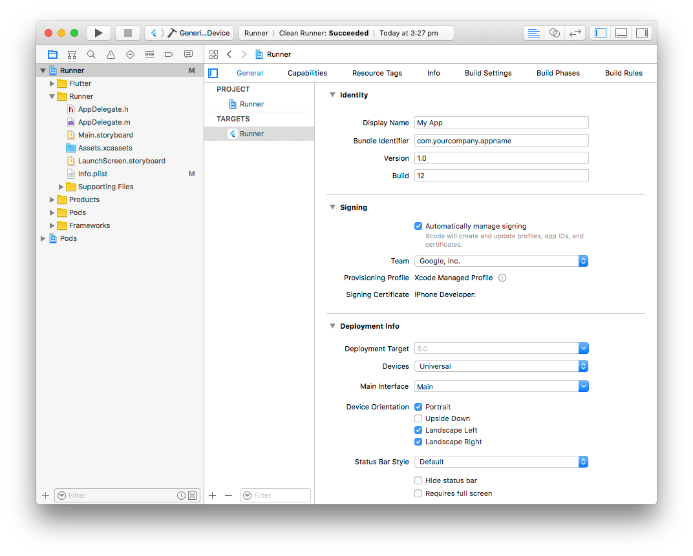

## **Updating the apps deployment version**

If you changed Deployment Target in your Xcode project, open ios/Flutter/App frameworkInfo.plistin your Flutter app and update the MinimumOSVersion value to match.

## **Add an app icon**

When a new Flutter app is created, a placeholder icon set is created. This step covers replacing these placeholder icons with your app’s icons:

1. Review the [iOS](https://developer.apple.com/design/human-interface-guidelines/foundations/app-icons#ios-ipados/) [App](https://developer.apple.com/design/human-interface-guidelines/foundations/app-icons#ios-ipados/) [Icon](https://developer.apple.com/design/human-interface-guidelines/foundations/app-icons#ios-ipados/) guidelines.
2. In the Xcode project navigator, select Assets.xcassets in the Runner folder. Update the placeholder icons with your own app icons.

|  |
| --- |
| flutter run |

1. Verify the icon has been replaced by running your app using.

## **Create a build archive and upload to App Store Connect**

During development, you’ve been building, debugging, and testing with debug builds. When you’re ready to ship your app to users on the App Store or TestFlight, you need to prepare a release build.

## **Update the app’s build and version numbers**

The default version number of the app is 1.0.0. To update it, navigate to the pubspec.yaml file and update the following line: version: 1.0.0+1

The version number is three numbers separated by dots, such as 1.0.0 in the example above, followed by an optional build number such as 1 in the example above, separated by a +.

Both the version and the build number may be overridden in Flutter's build by specifying --build-name and --build-number, respectively.

## In iOS build-name uses CFBundleShortVersionString while build-number  uses CFBundleVersion. Read more about iOS versioning at [Core Foundation Keys](https://developer.apple.com/library/archive/documentation/General/Reference/InfoPlistKeyReference/Articles/CoreFoundationKeys.html)on the Apple Developer’s site.

## **Create an app bundle**

Run flutter build ipa to produce an Xcode build archive .xcarchive file in your project  build/ios/archive/directory and an App Store app bundle (.ipa file) in build/ios/ipa .

Consider adding the --obfuscate and --split-debug-info flags to [obfuscate](https://docs.flutter.dev/deployment/obfuscate) [your](https://docs.flutter.dev/deployment/obfuscate) [Dart](https://docs.flutter.dev/deployment/obfuscate) [code](https://docs.flutter.dev/deployment/obfuscate) to make it more difficult to reverse engineer.

If you are not distributing to the App Store, you can optionally choose a different [export](https://help.apple.com/xcode/mac/current/#/dev31de635e5) [method](https://help.apple.com/xcode/mac/current/#/dev31de635e5) **--export-method ad-hoc, --export-method development or --export-method enterprise**.

## **Release your app on TestFlight**

[TestFlight](https://developer.apple.com/testflight/) allows developers to push their apps to internal and external testers. This optional step covers releasing your build on TestFlight.

1. Navigate to the TestFlight tab of your app's application details page on [App](https://appstoreconnect.apple.com/) [Store](https://appstoreconnect.apple.com/) [Connect](https://appstoreconnect.apple.com/).
2. Select Internal Testing in the sidebar.
3. Select the build to publish to testers, then click Save.
4. Add the email addresses of any internal testers. You can add additional internal users in the Users and Roles page of App Store Connect, available from the dropdown menu at the top of the page.

## **Release your app to the App Store**

When you’re ready to release your app to the world, follow these steps to submit your app for review and release to the App Store.

* Select Pricing and Availability from the sidebar of your app’s application details page on App Store Connect and complete the required information.
* Select the status from the sidebar. If this is the first release of this app, its status is Save
* Add the email addresses of any internal testers. You can add additional internal users in the 1.0 Prepare for Submission Complete all required fields.
* Click Submit for Review.

▶ **Web Documentation**

#### **Requirements**

**Most current web servers with PHP & MySQL installed will be capable of running WeCourier (SAAS).**

**Minimum Requirements**

* Linux or Windows OS
* PHP Version 8.0.2+
* MySQLi Support
* Rewrite Module (Apache)
* BCMath PHP Extension
* Ctype PHP Extension
* Fileinfo PHP extension
* JSON PHP Extension
* Mbstring PHP Extension
* OpenSSL PHP Extension
* PDO PHP Extension
* Tokenizer PHP Extension
* XML PHP Extension

#### **Installation Step**

**Step 01: Login to your cpanel and go to > MySQL® Database Wizard**

#### **Create database**

Step 02: Create Database

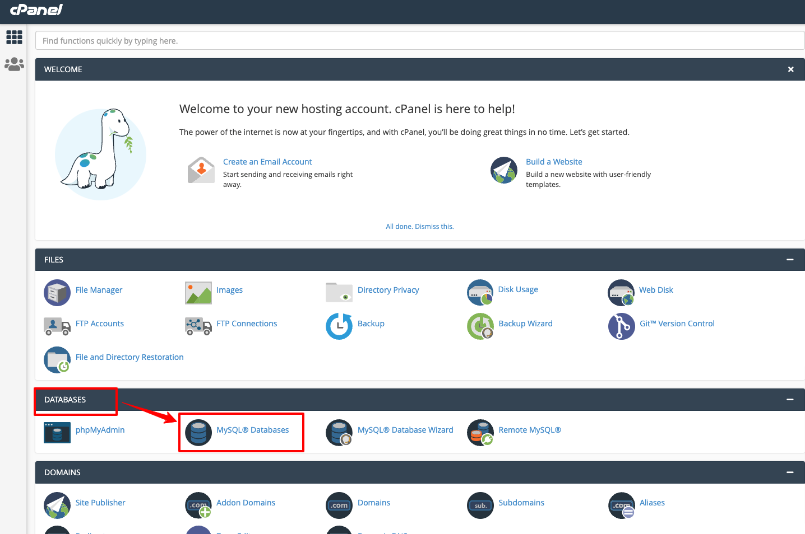

#### **Create Database Users**

Step 03: Create Database Users, do not forget to keep your database user password, we will need this while we run installation wizard.Create Database Users, do not forget to keep your database user password, we will need this while we run installation wizard.

#### **Add user to the database**

Step 04: Add user to the database. check all privileges and click make changes. then click a next step Database create is done, keep database user, database name, database password in a note.

* **1.** Give your database a name e.g **wecourier**
* **2.** Create a database user and set up a password
* **3.** Add the user to the database and give the user All privileges to the database

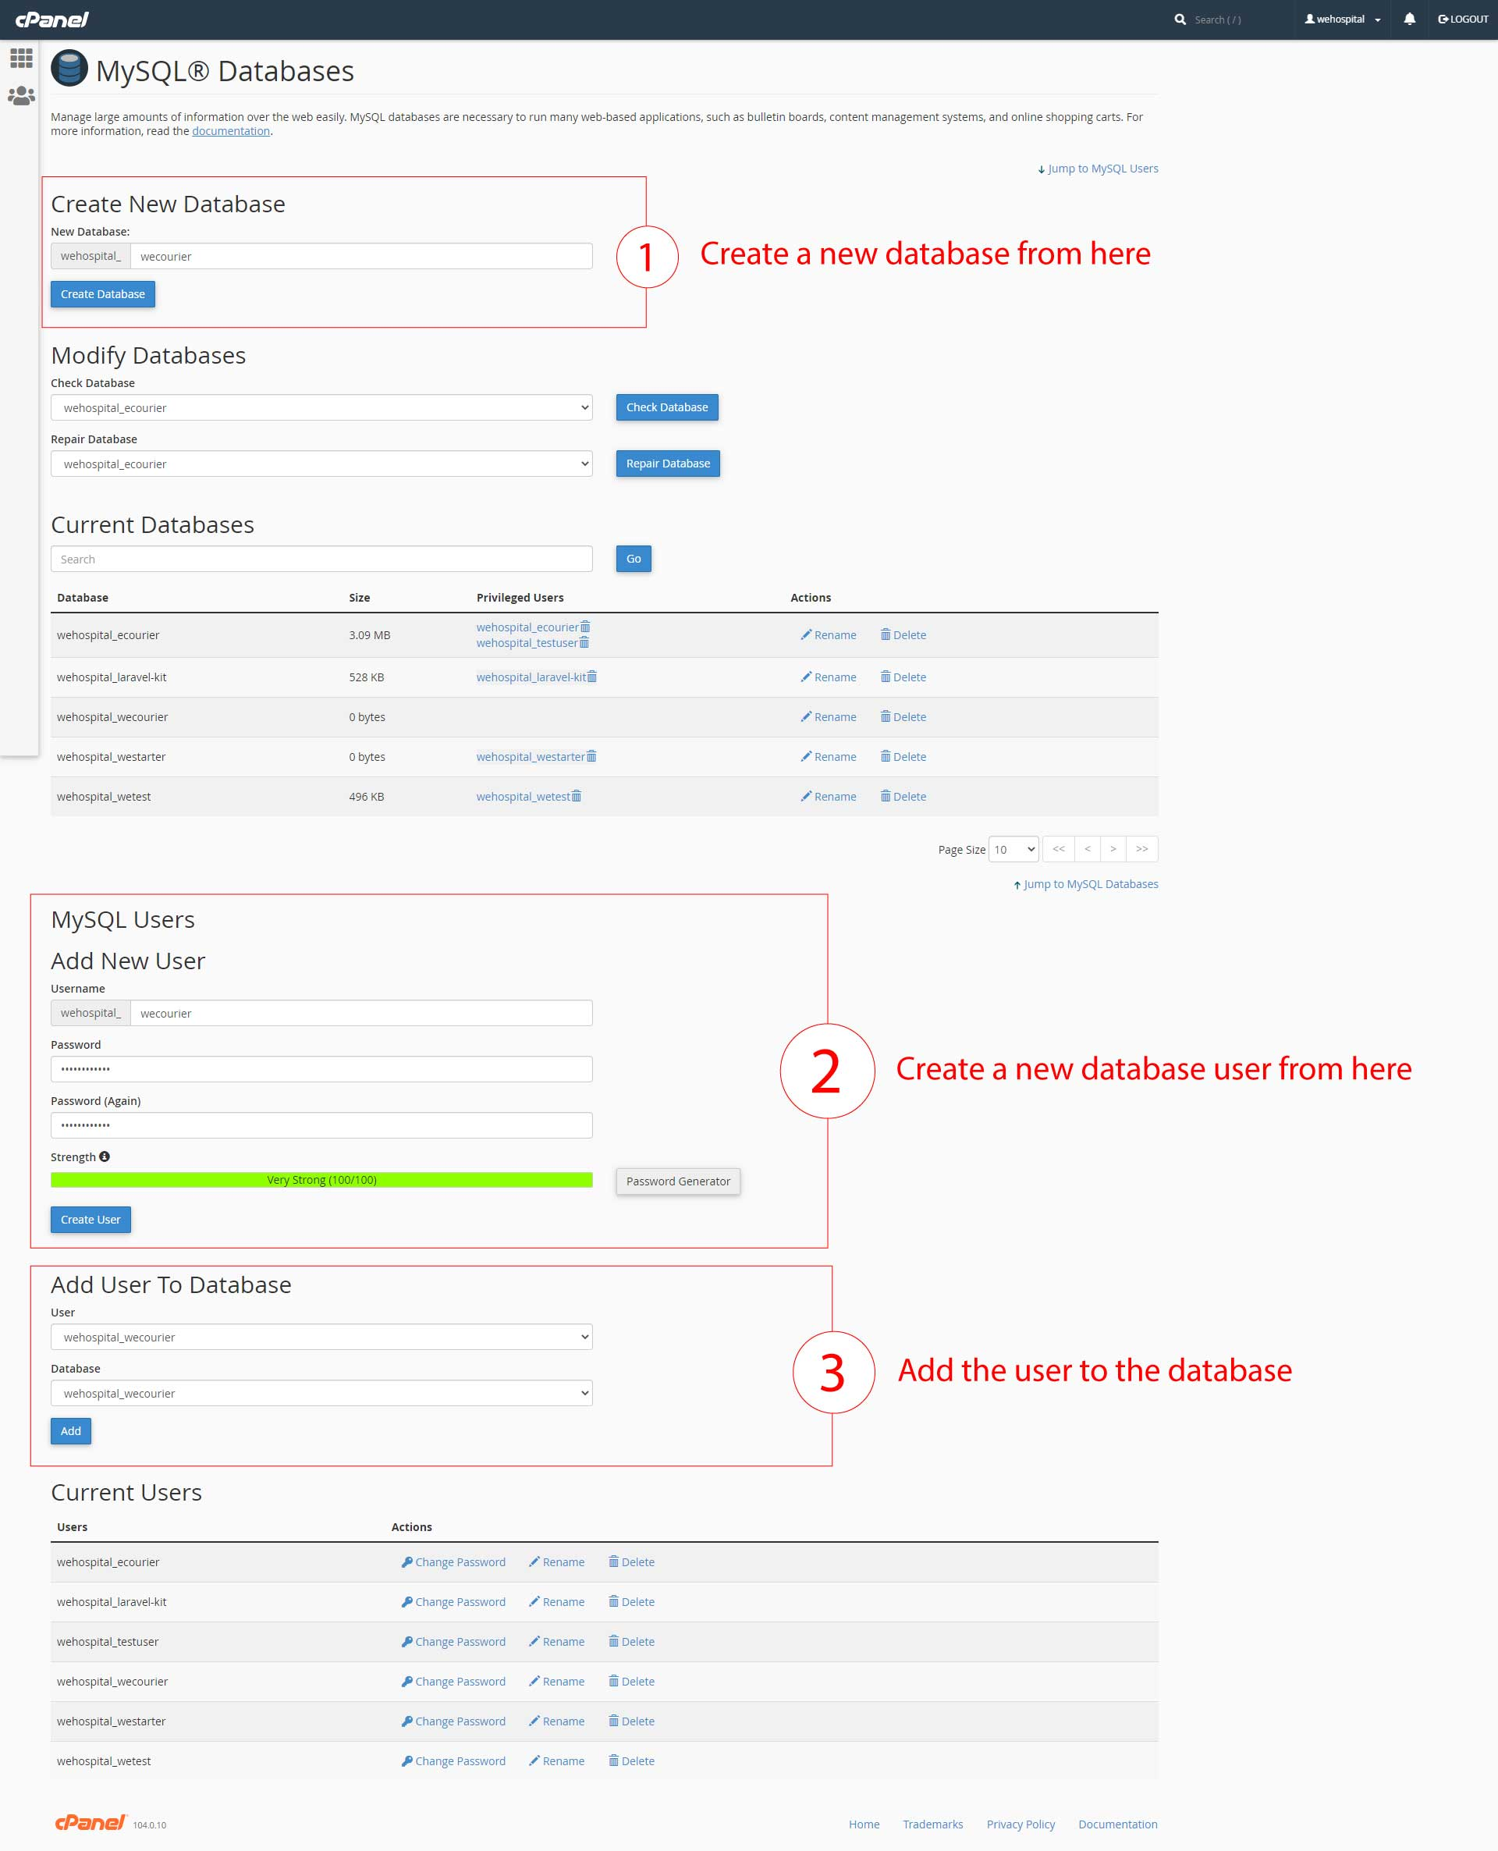

After add user to database , click on all privileges and then click on make changes button.

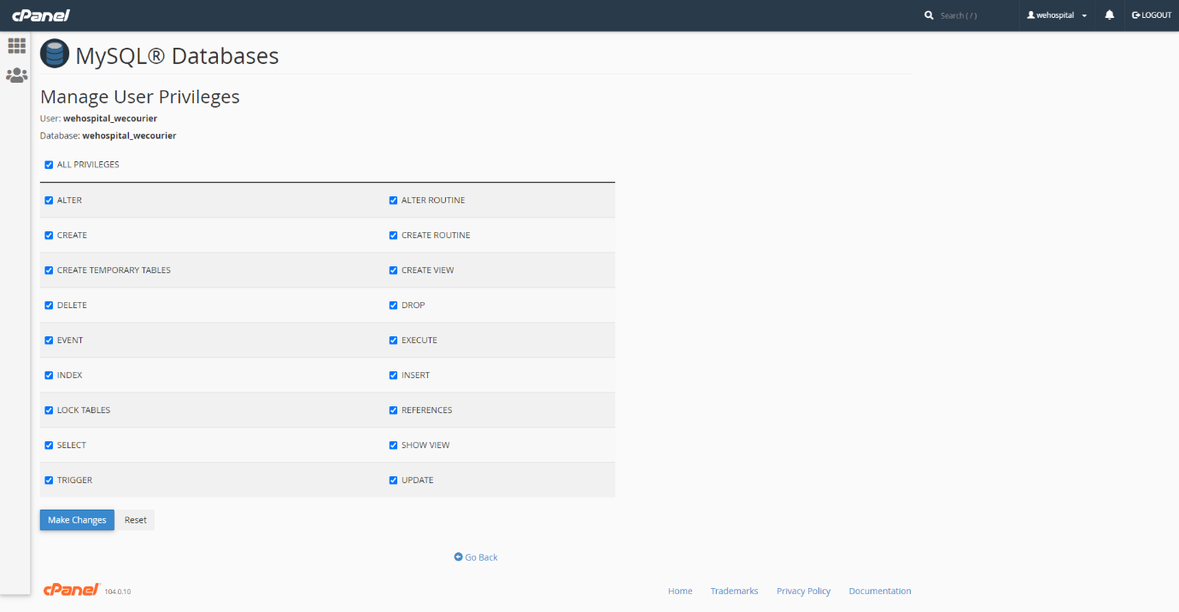

**Then copy your database user name , database name and database password.**

#### **Upload File**

Step-5:Download Main\_Files.zip from CodeCanyon

Step-6:Extract Main\_Files.zip

Step-7: Go to inside "SourceCode" folder and make zip all files & folders

Step-8:Upload zip file to your server public\_html or www or root directory.

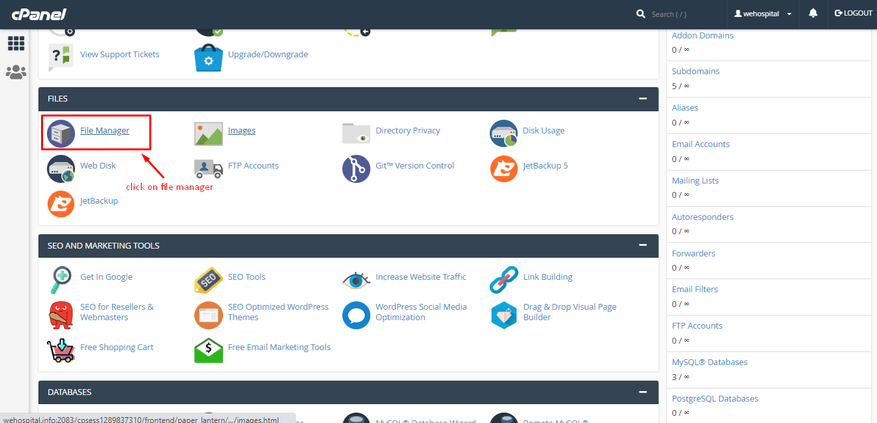

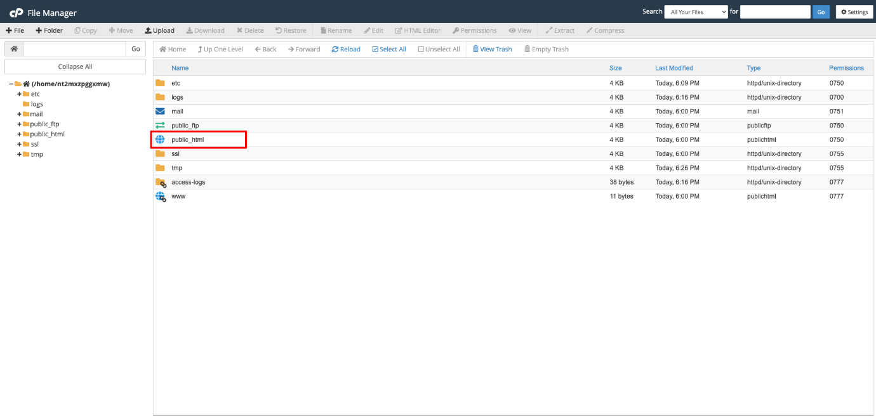

#### 

#### **Open Browse URL**

Step 08: Open browser and hit you server URL. Example: https://example.com/

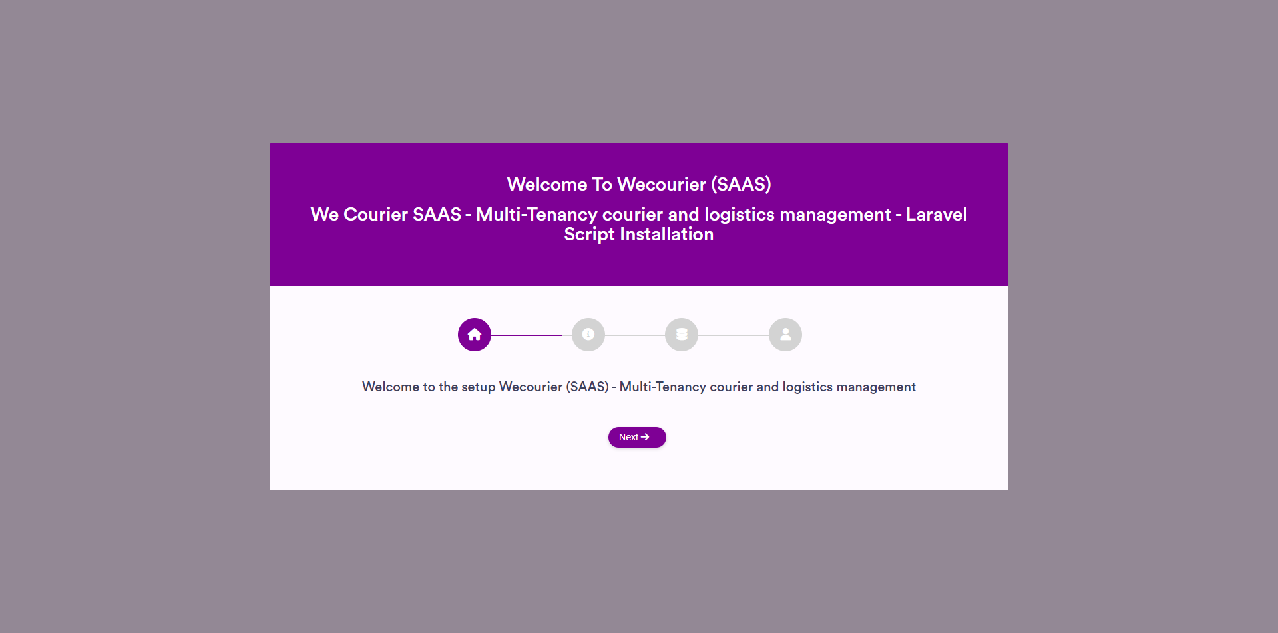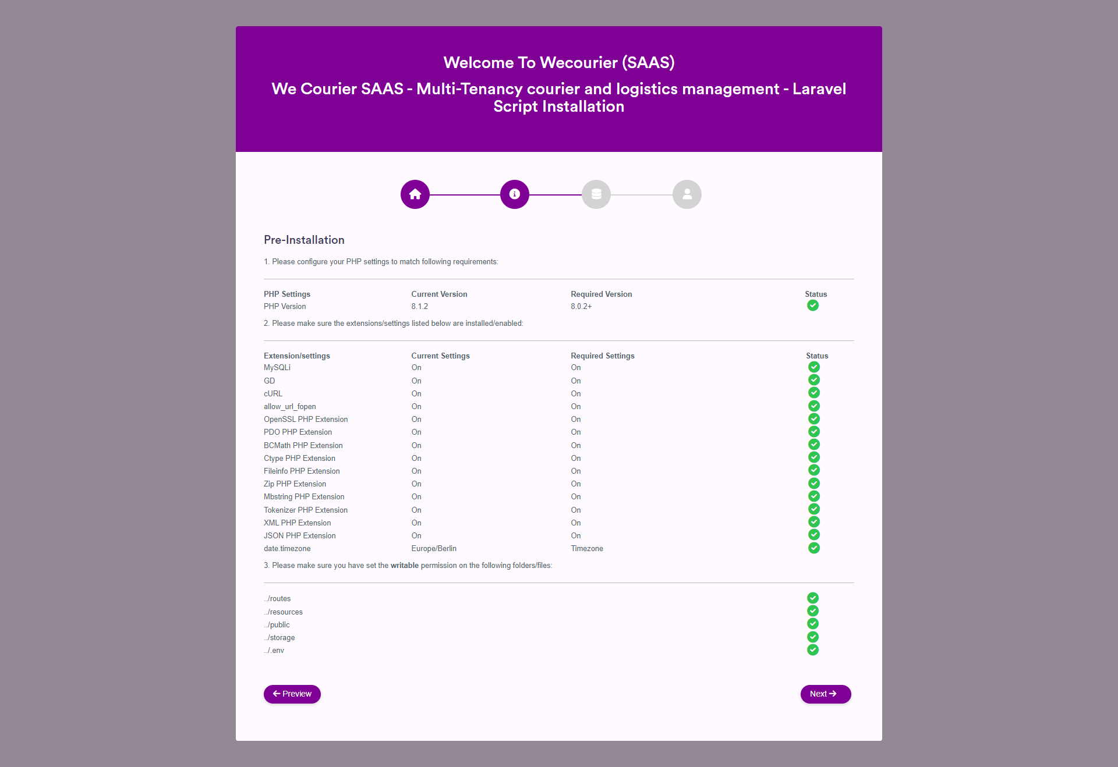

Step 09:Your database connection details:

* **Database Host:** your hosting name, e.g localhost
* **Database User:** the username that you have created with all privileges.
* **Password:** that user password.
* **Database Name:** your database name for e.g wecourier\_db.

### If all the requirements are fulfilled then click on Next.

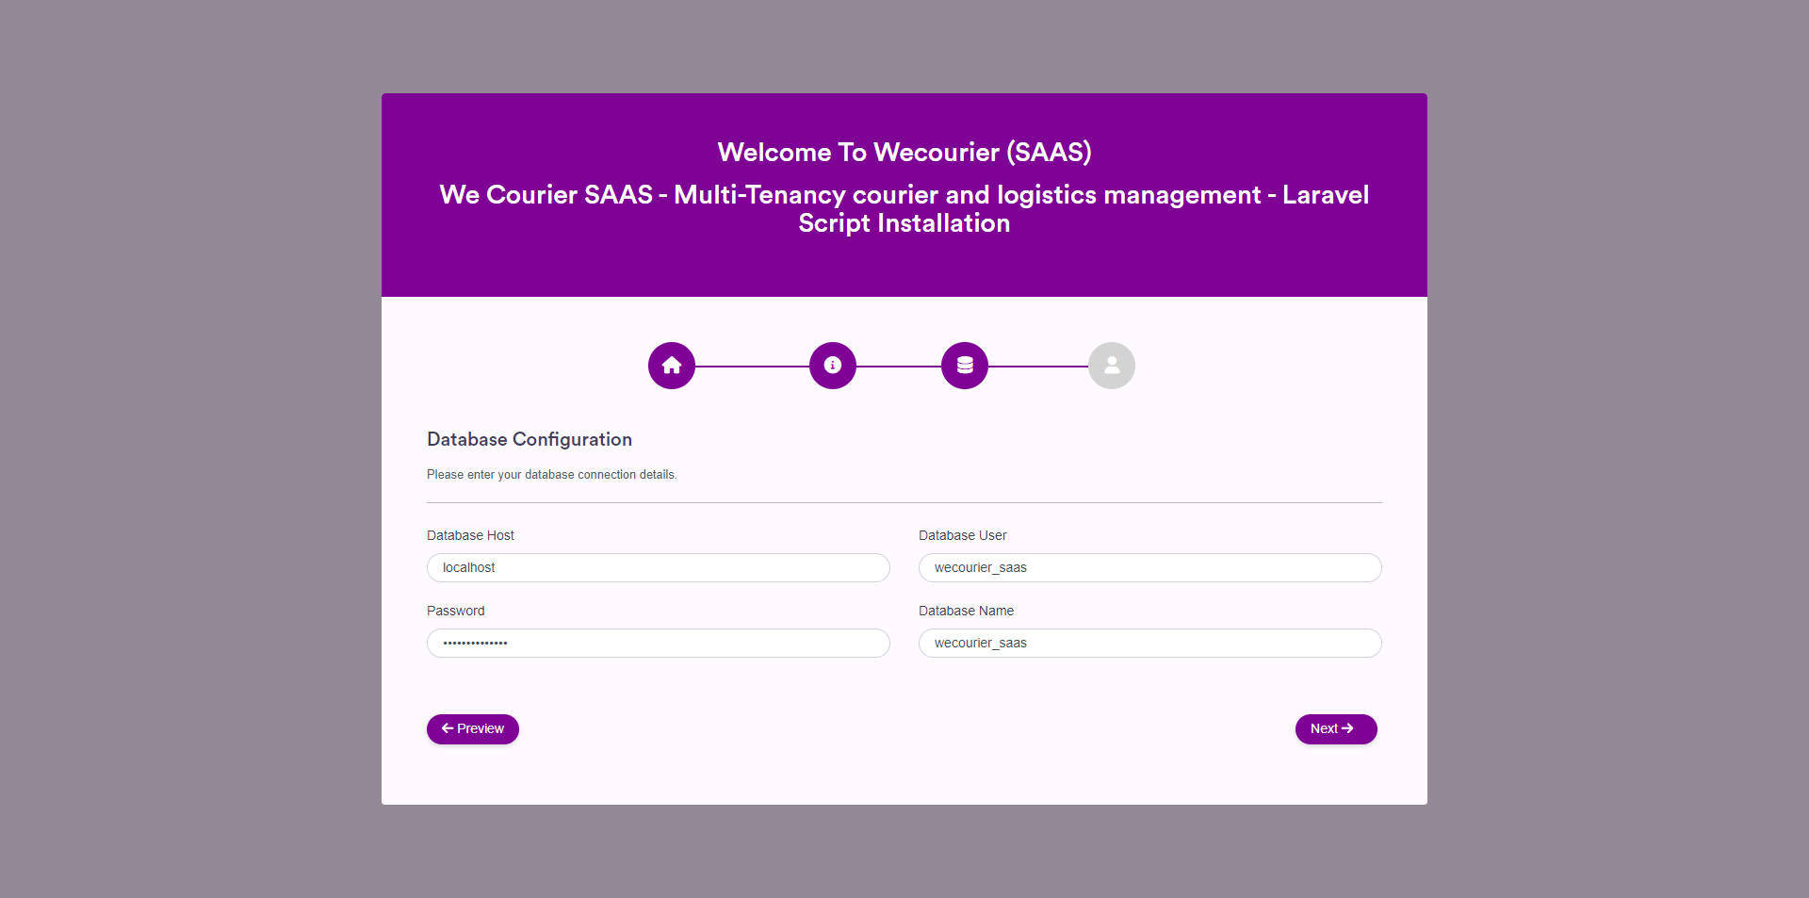

Step 10: Your account details for administration:

* **First Name:** that will be the Administrator first name
* **Last Name:** that will be the Administrator last name
* **Email:** email for login and you can't change this email.
* **Password:** password for admin login.

After successful installation, system will redirect you to the home page.

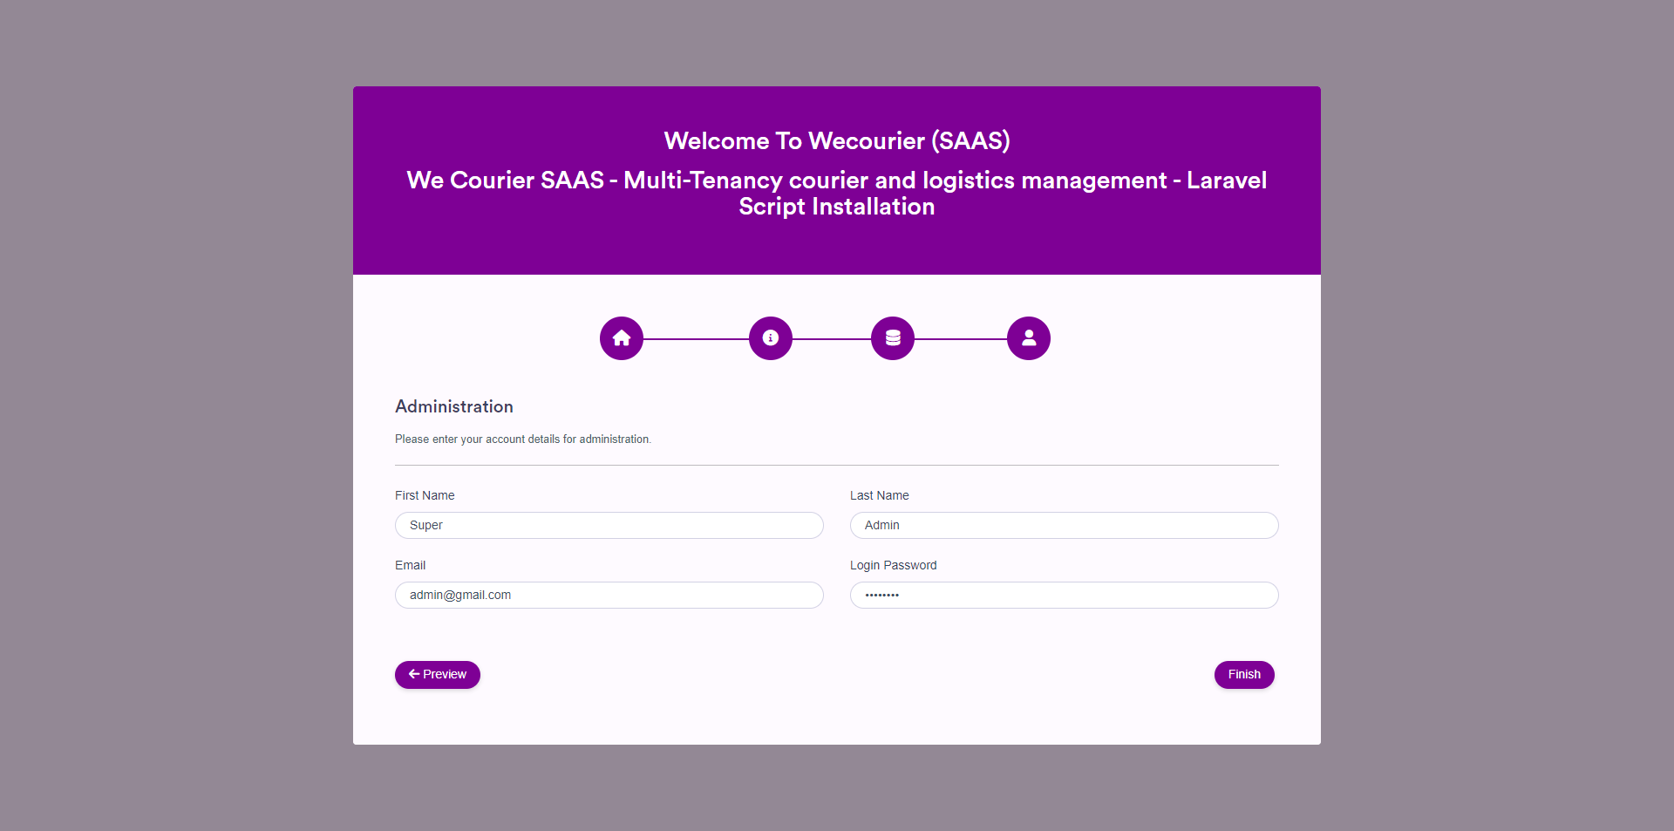

### Info: Given Administrator credentials will be serve as the Super Admin email and password for accessing admin dashboard

### Wildcard

### Note: Now you have to setup wildcard for subdomain. so that system can connect with subdomain automatically. here is few article that help you to setup wildcard subdomain

1. Setup Wildcard Subdomain in [DirectAdmin](https://docs.directadmin.com/webservices/apache/customizing.html" \l "wildcard-domain-com" \t "_blank)
2. Setup Wildcard Subdomain in [Cpanel](https://support.cpanel.net/hc/en-us/articles/4416167771543-How-to-create-wildcard-subdomains" \t "_blank)
3. Setup Wildcard Subdomain in [AaPanel](https://forum.aapanel.com/d/94-add-subdomain" \t "_blank)
4. Setup Wildcard Subdomain in [Plesk](https://docs.directadmin.com/webservices/apache/customizing.html#wildcard-domain-com)
5. Setup WildCard Subdomain in [DigitalOcean](https://www.digitalocean.com/community/questions/how-do-i-set-up-wildcard-domain-on-my-droplet" \t "_blank)

### Authentication

#### **Login**

Merchant can login in 3 ways. Merchant can access through email and password or via Facebook or Google account. Merchant must sign up first to login with email and password.

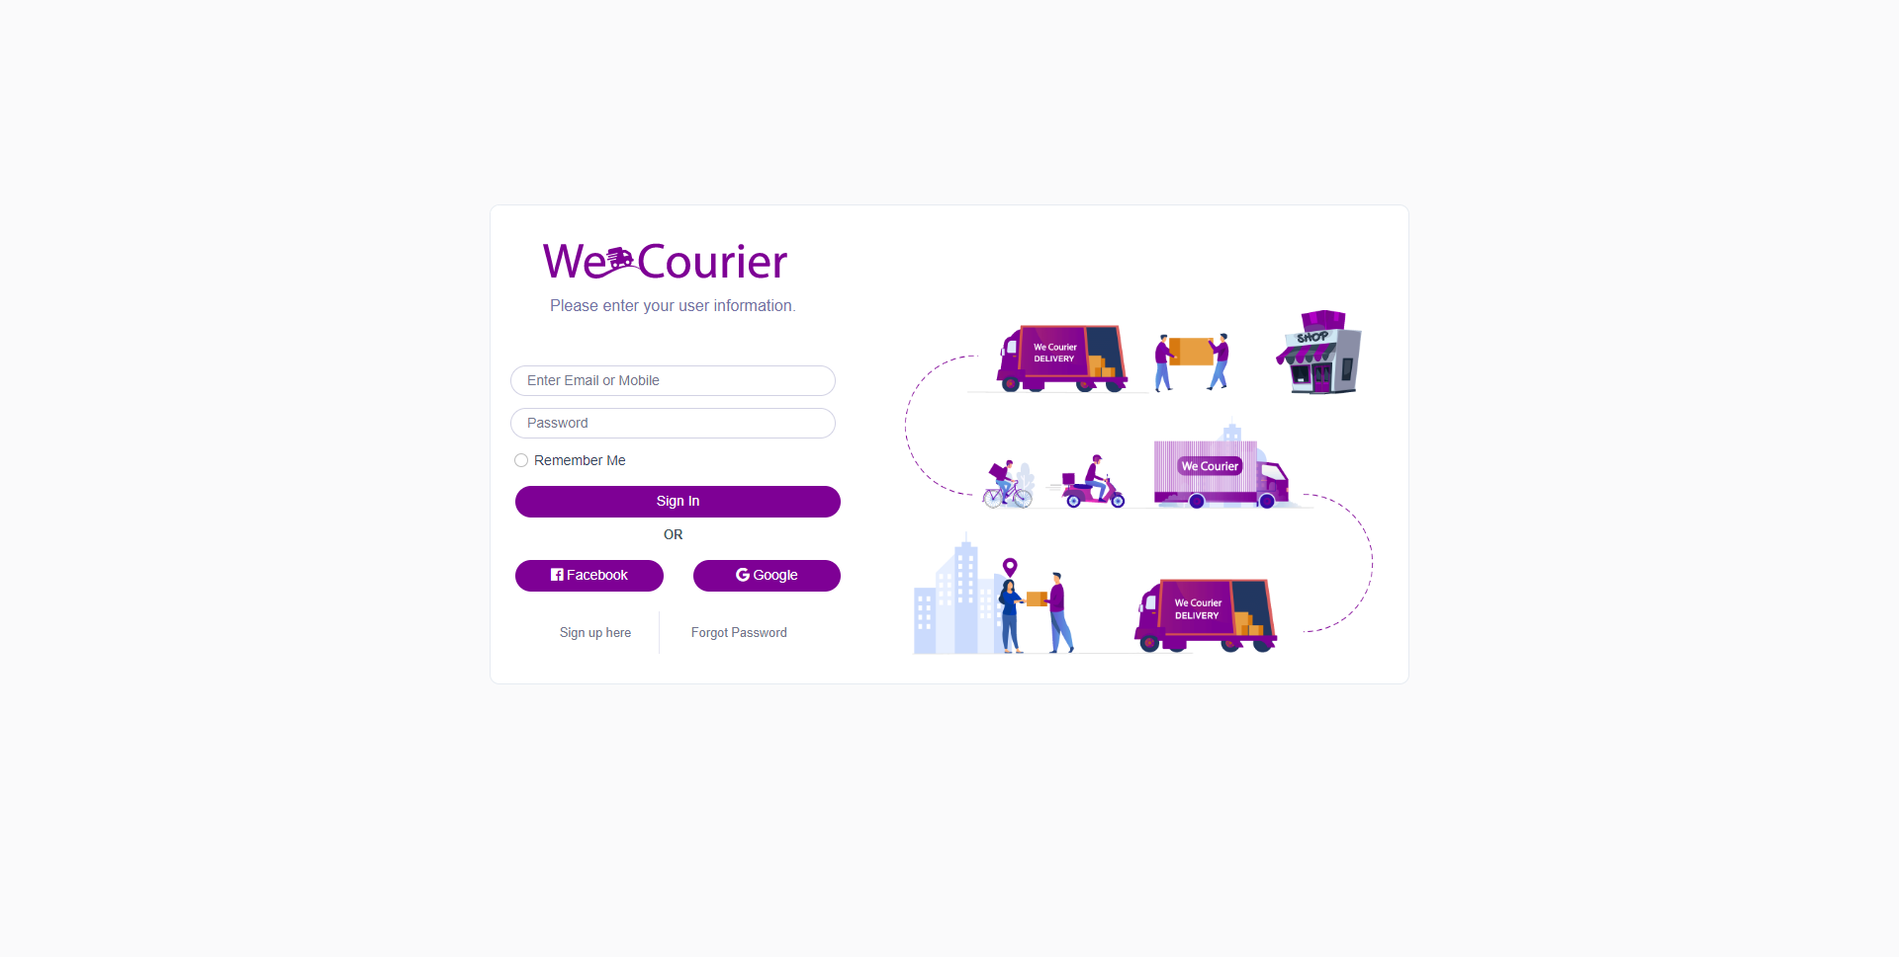

#### **Comapny signup**

Company has to sign up from main domain to open panel with its domain. And take subscription.  
Example: [**https://wecourier.com/company/sign-up**](https://wecourier.com/company/sign-up)

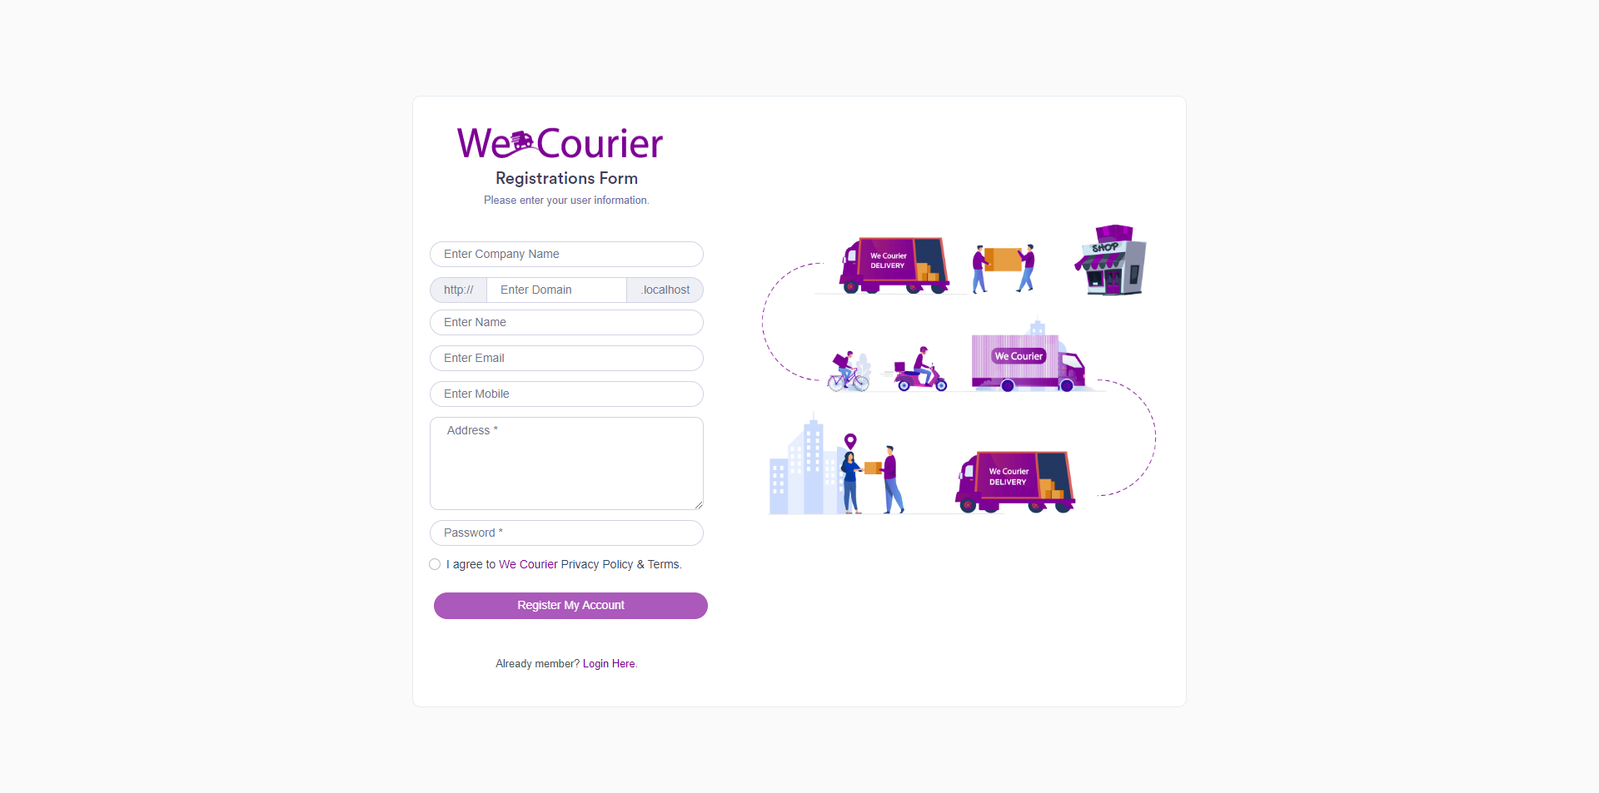

#### **Merchant signup**

Merchant should sign up from company's domain for example: **https://company.wemaxdevs.com/merchant/sign-up** . A merchant must signup as a merchant to login. After going to the sign up page, a form will appear to sign up, fill that form. All the blanks that must be filled are - Business name, Full name, select hub, Mobile, Password, Address and click on register. Once the account is created, you can login.

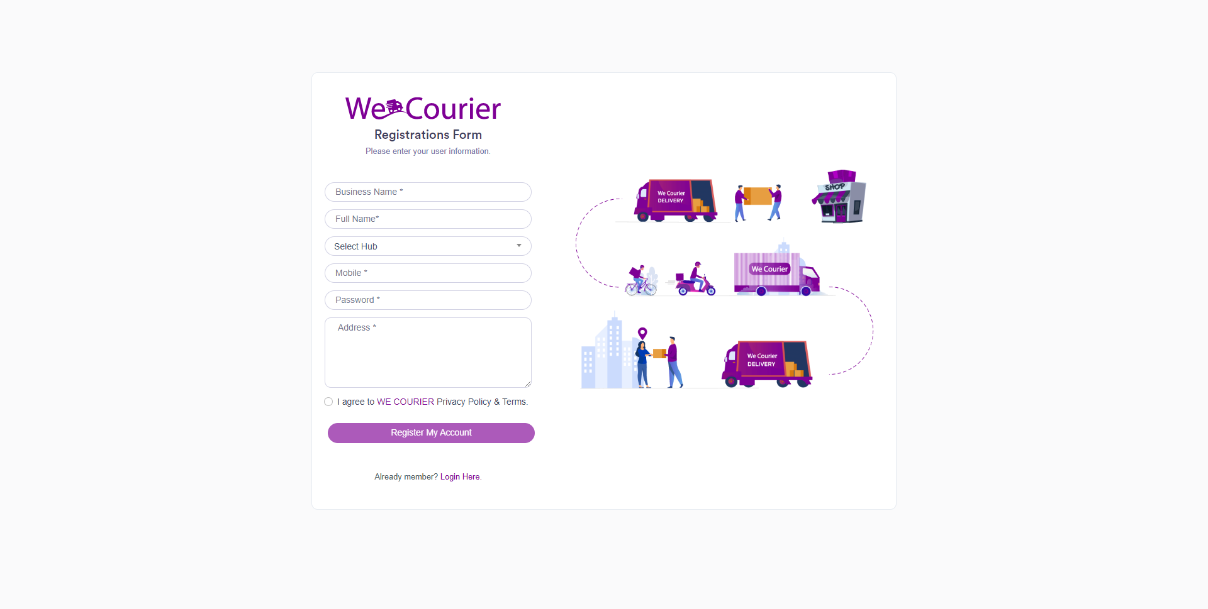

#### **Forgot password**

If the login password of the account is forgotten, the merchant can change the password again. Therefore the merchant must know his email address. To reset the password, click on Forgot Password from the login page. In the form that will be displayed, enter the registered email of the merchant and click on the reset link. Now a link will go to that email. If you click on that link, you will get a form to add a new password. If the merchant submits his new password in that form, his password will be reset. Later merchant can login.

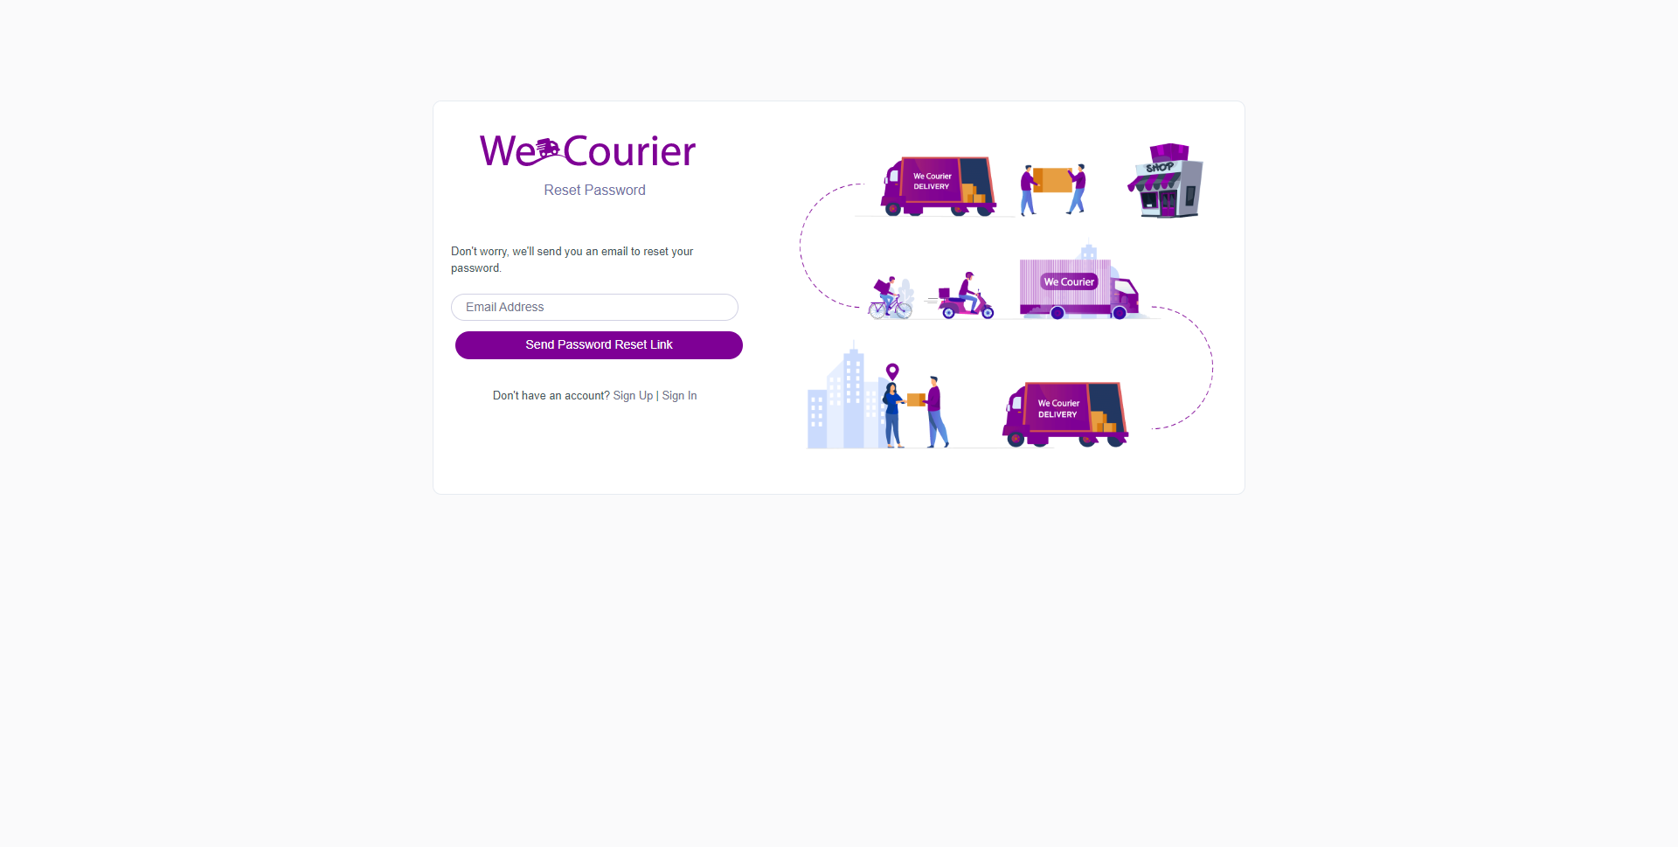

#### **Super Admin Dashboard**

When admin login he will be sent to admin dashboard. The dashboard contains a total summary of the full system.For example - total companies, total plans, total subscription, total subscription price, recent companies and recent subscriptions and etc.

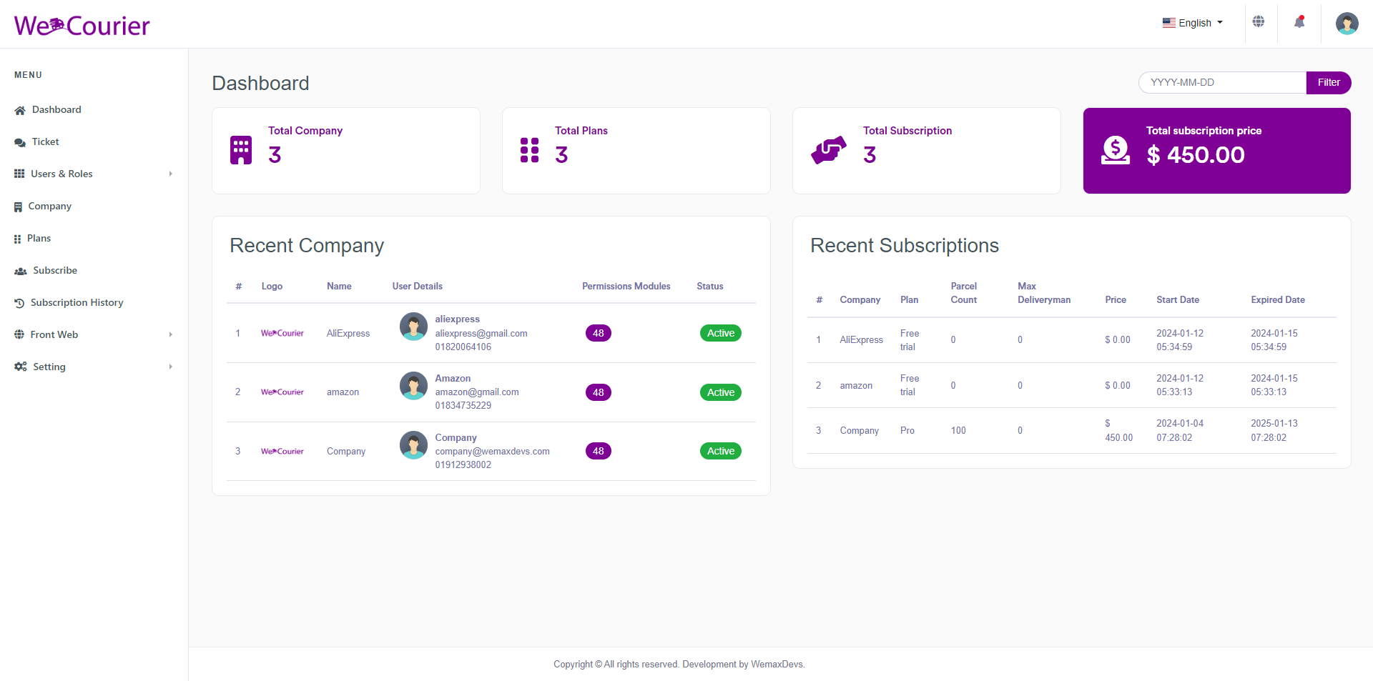

Thank you so much.