DevOps Laboratory Work
Linux Git Docker and Jenkins

Student | Zhaugash Nurzhan
Group | IT2-2312
Student ID | 38387
Course | DevOps
Date | 18 October 2026

The project implements and verifies a complete local DevOps workflow. GitHub publication and the Jenkins job use the repository and pipeline configuration prepared in this project.

Contents and result
This report documents the completed Linux, Git, Docker, and Jenkins configuration. The local application tests, Linux exercises, Git history, Docker image build, container execution, and Docker Compose run were verified successfully.
Section | Result
Linux | Project structure, files, permissions, search, Bash, and process commands prepared and verified
Git | Repository created with meaningful commits, development branch, and merge history
Docker | Image built and Compose service exited successfully with code 0
Jenkins | Declarative Jenkinsfile prepared with all required stages and student variables
Integrated workflow | Documented from source commit through tested container output

Repository evidence
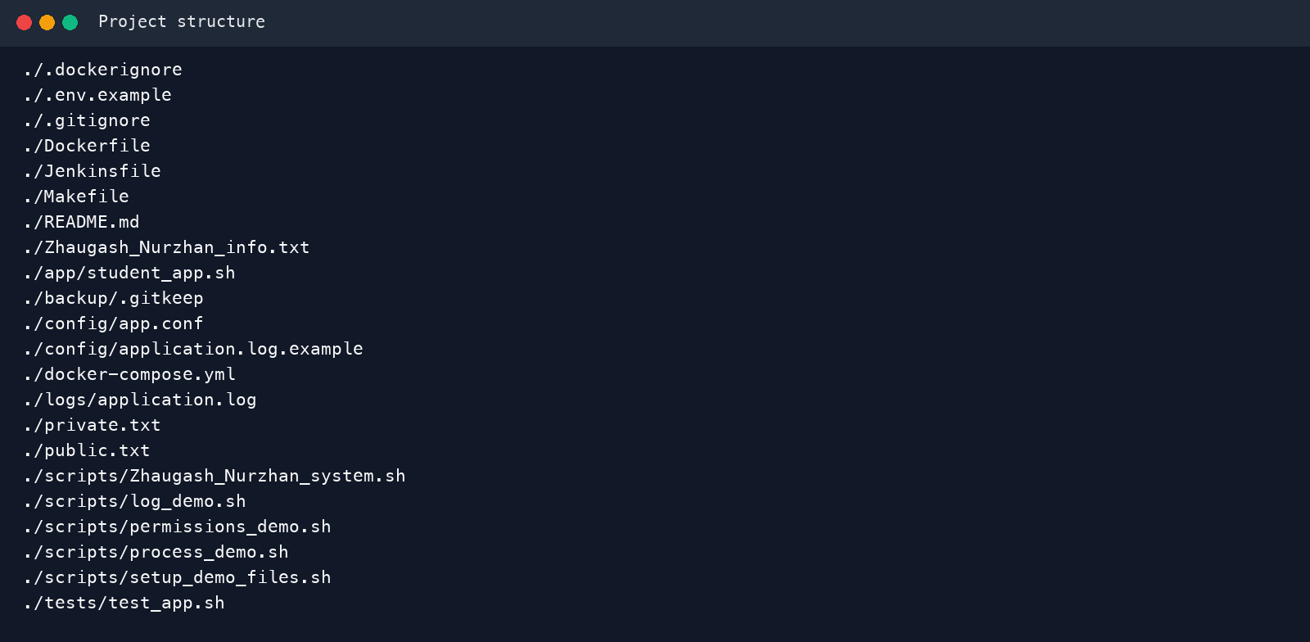
Figure 1. Project files used by the laboratory workflow.

Linux
The project directory contains separate application, script, configuration, log, backup, test, and documentation areas. The student information file records the name, surname, group, Student ID, and course. The local application log contains ten messages, including two ERROR and two WARNING entries.

Commands and file processing
Command | Purpose | Project use
pwd, cd, ls | Navigate and inspect directories | Confirm the project location and contents
mkdir, touch | Create directories and files | Build the required project structure
cp, mv, rm | Copy, rename or move, and remove files | Demonstrate file lifecycle operations
cat, head, tail | Display all, first, or last lines | Inspect student information and logs
find | Search a directory tree | Locate logs/application.log
grep, grep -c | Filter and count matching lines | Show ERROR/WARNING messages and counts

Permissions and processes
The permissions script applies mode 600 to private.txt, giving only the owner read and write access. It applies mode 644 to public.txt, giving the owner read and write access and everyone else read access. In symbolic form, r means read, w means write, and x means execute. Owner, group, and others are the three permission classes.
A process is a running program instance. PID is its unique process identifier. ps captures a snapshot, whereas top continuously refreshes process and resource information. The process demonstration reports PID, owner, CPU percentage, memory percentage, and command.
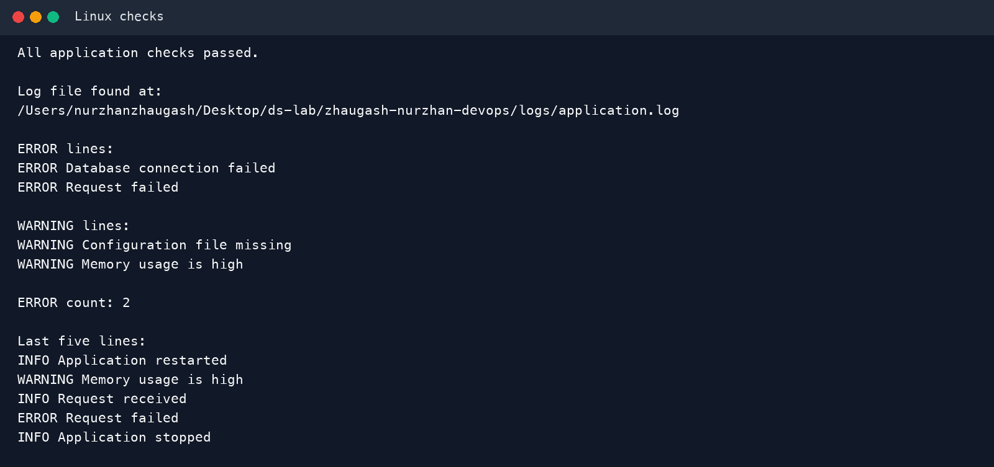
Figure 2. Successful application checks and log-search results.

Git and GitHub
The repository uses main as its primary branch. Commits correspond to real changes: project creation, Linux scripts, Docker configuration, tests, Jenkins and documentation, branch work, personalization, and final cleanup. A development branch added documentation and was merged back into main with an explicit merge commit.
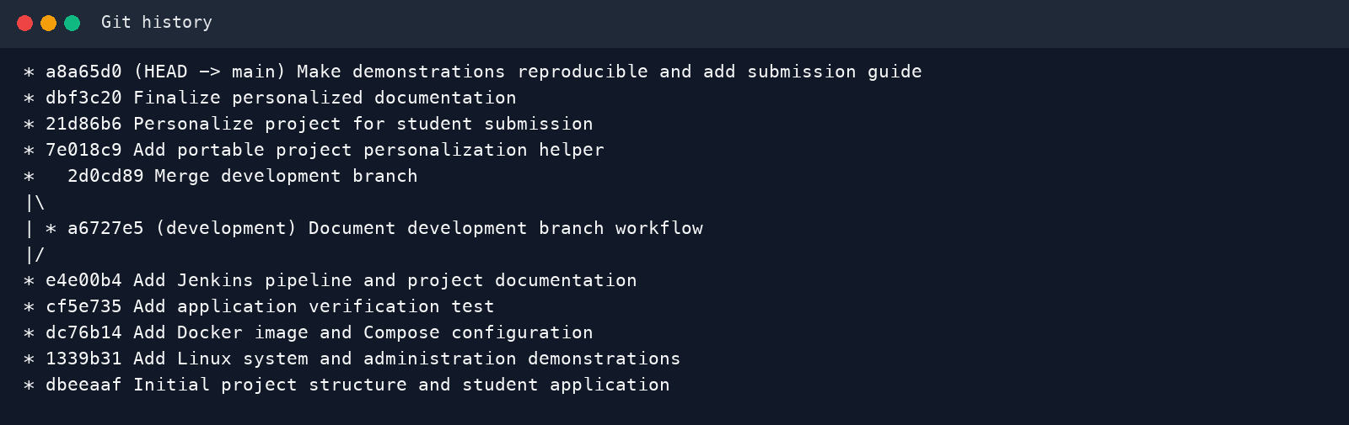
Figure 3. Meaningful commit history and merged development branch.

Ignored files
The .gitignore file excludes generated *.log files, backup/, .env, platform metadata, Docker build logs, and rendered report intermediates. This keeps generated artifacts and secret-bearing environment files out of version control. The local logs/application.log is intentionally present for command demonstrations but remains untracked.

GitHub publication
Create the public repository zhaugash-nurzhan-devops, add its HTTPS URL as origin, and push main. After publication, use git remote -v to confirm the connection and git push -u origin main to establish upstream tracking. The repository should expose this project without the ignored local .env file.

Docker
The Dockerfile uses Alpine Linux, sets /app as WORKDIR, copies the application and information file, applies executable permissions, creates a non-root user, documents port 8080 with EXPOSE, and starts the application through CMD. The container receives student values through environment variables.
Dockerfile instruction | Role
FROM | Selects the Alpine 3.22 base image
WORKDIR | Sets the working directory inside the image
COPY | Adds the script and student information file
RUN | Sets permissions and creates a non-root runtime user
EXPOSE | Documents the application port
CMD | Defines the default container command

Image container and environment variables
An image is an immutable application template. A container is a runnable instance of that image with runtime state. Environment variables configure the same image for different users or environments without rebuilding it. Sensitive values should be supplied through protected Jenkins credentials or a secret store instead of being hard-coded in image layers.
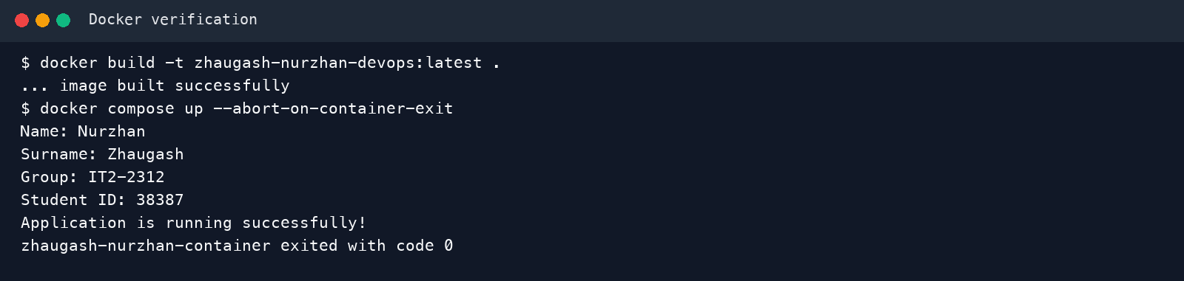
Figure 4. Verified Docker build and Compose container output.
Docker Compose defines the image, container name, build context, and student variables in one reproducible service configuration. The final local run completed with exit code 0.

Jenkins
The required Jenkins job name is Zhaugash_Nurzhan_DevOps. Configure it as Pipeline script from SCM, select Git, enter the GitHub repository URL, and keep Jenkinsfile as the script path. The Jenkins agent needs Git, Docker, and permission to use the Docker daemon.
Stage | Action | Expected result
Checkout | Checks out the selected source revision | Workspace matches a Git commit
Build | Makes scripts executable and runs the application | Student information is printed
Test | Runs tests/test_app.sh | All application checks passed
Docker Build | Builds versioned and latest image tags | Image is available to the agent
Docker Run | Runs the container and prints its logs | Container exits successfully

Pipeline variables and failure behavior
The pipeline defines STUDENT_NAME=Nurzhan, STUDENT_SURNAME=Zhaugash, STUDENT_GROUP=IT2-2312, and STUDENT_ID=38387. The success block prints the student identity and Finished: SUCCESS. If a stage returns a non-zero status, Jenkins stops dependent stages, marks the run as failed, and preserves console output for diagnosis.

Jenkins evidence to capture
For the submitted version, capture the Jenkins dashboard, exact job name, stage view, console output, Docker image and container records, Git commit used by Jenkins, and the final Finished: SUCCESS line.

Integrated DevOps workflow
Linux hosts the tools and project files. Git records each meaningful change. GitHub makes the repository available to Jenkins. Jenkins checks out an exact commit, builds and tests the application, builds a Docker image, and runs a container from that image. Successful container output therefore traces back to version-controlled source and an automated pipeline run.
Step | Input | Output
Linux project | Student requirements | Scripts, configuration, logs, and application
Git | Project changes | Auditable commit history and branches
GitHub | Local Git repository | Remote source for collaboration and automation
Jenkins checkout | Repository and commit | Reproducible pipeline workspace
Build and test | Checked-out source | Validated application
Docker build | Validated source and Dockerfile | Immutable image
Docker run | Image and environment variables | Container output and exit status

Failure handling
If one pipeline stage fails, later dependent stages do not run. The console log identifies the failing command. The change is corrected locally, tested, committed, pushed, and rebuilt so the successful result remains linked to a specific revision.

Demonstration checklist
- Show the student information and the complete project tree.
- Run the log search, permissions, system information, and process scripts.
- Explain the Linux commands and the difference between ps and top.
- Show git status, the commit graph, .gitignore behavior, development, and main.
- Open the GitHub repository and identify the latest pushed commit.
- Build the Docker image; show images, container output, logs, and Compose.
- Open the Jenkins job Zhaugash_Nurzhan_DevOps and run the pipeline.
- Show every stage, Console Output, Docker artifacts, commit, and Finished: SUCCESS.
- Explain how Linux, Git, GitHub, Jenkins, Docker images, and containers connect.

Conclusion
The project provides a reproducible Linux to Git to Docker to Jenkins workflow personalized for Zhaugash Nurzhan, group IT2-2312, Student ID 38387. Local scripts and tests passed, the Git history contains meaningful commits and a merged development branch, and the Docker image and Compose service ran successfully. The supplied Jenkinsfile connects the same tested project to an automated CI pipeline after the repository is published to GitHub and selected by the Jenkins job.

