1 – PART. INTRODUCTION TO THE SYSTEM.

Our database based on SDU Store. Which is helps to us to make orders online.

CLOTH

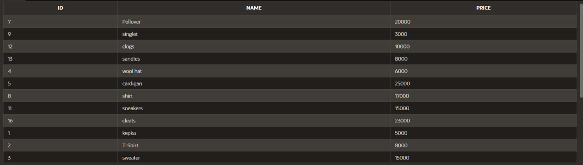

CHARACTERISTICS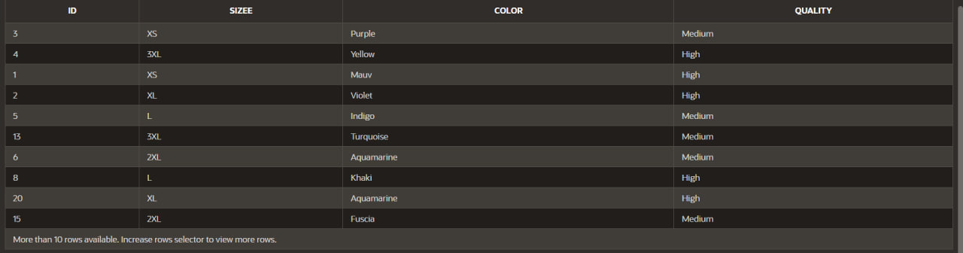

CUSTOMER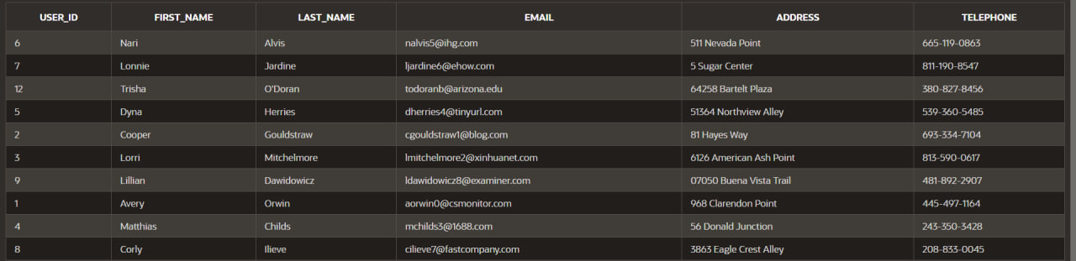

CUSTOMER_ACC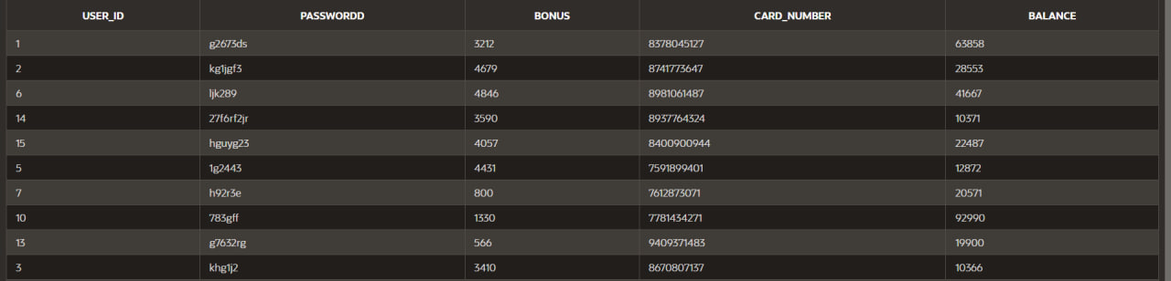

ORDERS

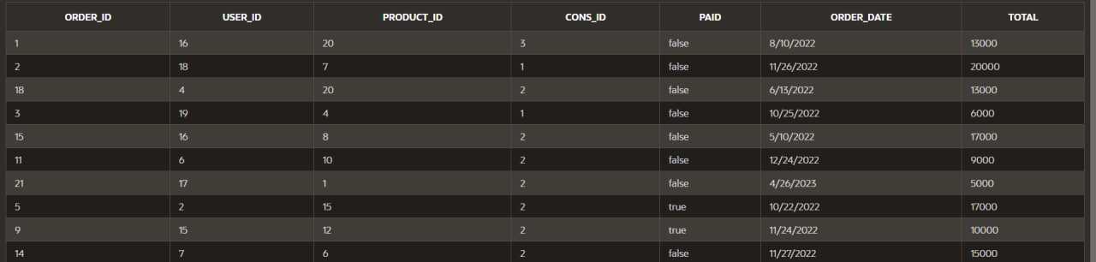

FEEDBACK

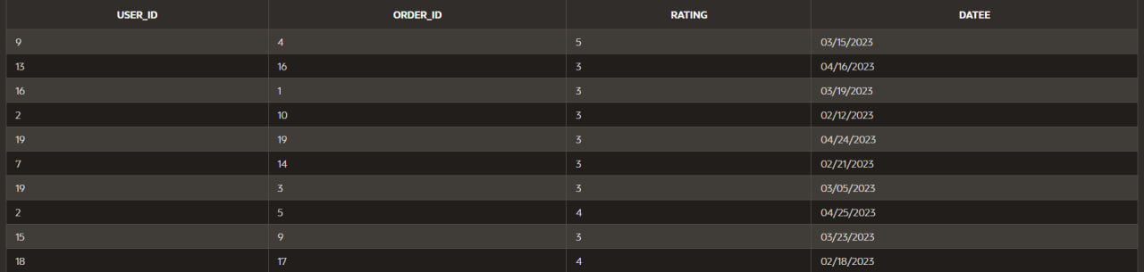

LOGISTICS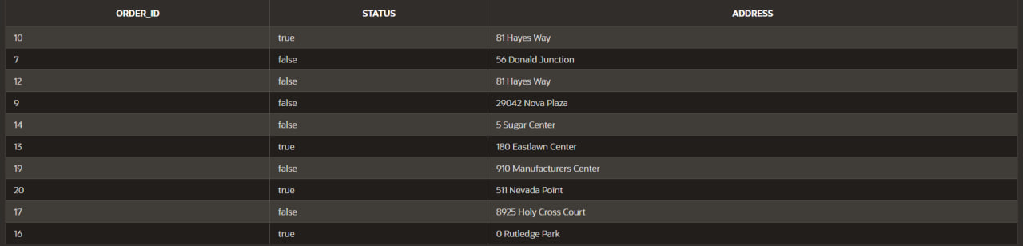

CONSULTANT

WORKING_TIME