**CS2101 / CS2103T**

Effective Communication for Computing Professionals & Software Engineering

**ABSTRACT**

This developer guide is a comprehensive document for all avid software engineers that are contributing to our to-do list application "Do-*er* List". We welcome all of you on board, to be a contributor of this awesome, life-changing application.

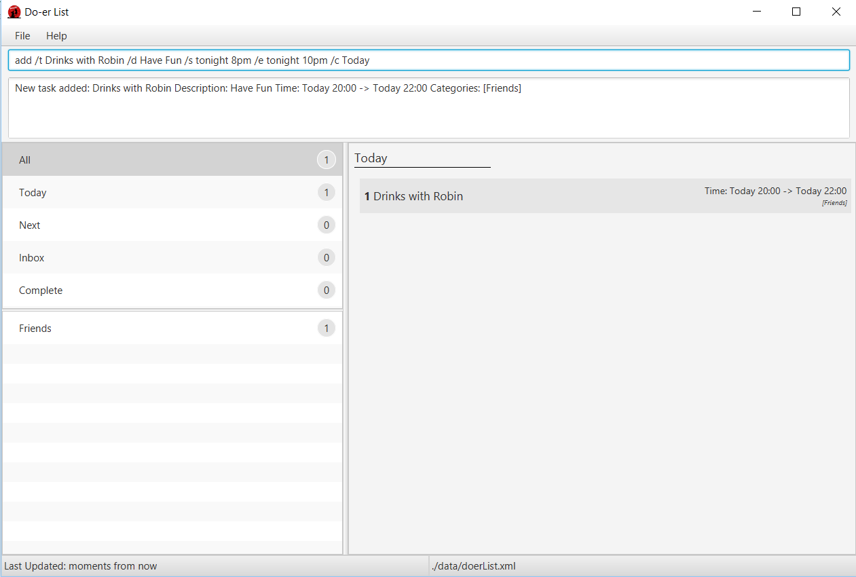

TEAM PGP

**DEVELOPER GUIDE**

**Contents**

I. Purpose Statement and Overview 2

II. Quick Start 3

1. Prerequisite Software 3

2. Importing this project 3

III. Design 4

1. Overall Architecture 4

2. UI component 7

3. Logic component 9

4. Model component 11

5. Storage component 12

6. Common classes 12

IV. Implementation 13

1. Logging 13

2. Configuration 13

V. Testing 14

1. Running Test in *Eclipse* 14

2. Using *Gradle* 14

VI. Dev Ops 15

1. Build Automation 15

2. Continuous Integration 15

3. Making a Release 15

4. Managing Dependencies 15

VII. Appendix A: User Stories 16

VIII. Appendix B: Use Cases 18

IX. Appendix C: Non Functional Requirements 27

X. Appendix D : Glossary 28

XI. Appendix E : Product Survey 29

Review of TickTick: 29

Review of WunderList: 29

Review of Trello: 30

Review of Google Calendar: 30

# Purpose Statement and Overview

This developer guide is a comprehensive document for all avid software engineers that are contributing to our to-do list application "Do-*er* List". We welcome all of you on board, to be a contributor of this awesome, life-changing application.

This guide is maintained by the 4 original developers, Xiaopu, Jason, Benedict and Hai Long.

Do-er List is the next revolutionary to-do list application that is designed so extraordinarily where every command is so deceptively short yet so functionally powerful. So get ready to immerse yourself into our application!

# Quick Start

Here are the basic steps needed to get started with your first contribution.

### 1. Prerequisite Software

Make sure you have the following software installed:

1. JDK 1.8.0_60 or later
2. ***Eclipse*** IDE
3. ***e(fx)clipse*** plugin for ***Eclipse***
4. Buildship ***Gradle*** Integration (from the ***Eclipse*** Marketplace)

### 2. Importing this project

Do the following steps to successfully import this project into your workspace and work on our program:

1. Fork the repo at https://github.com/CS2103AUG2016-W09-C4/main, and clone the fork to your computer
2. Open ***Eclipse*** (Note: Ensure you have installed the ***e(fx)clipse*** and buildship plugins as given in the prerequisites above)
3. Click File > Import
4. Click Gradle > Gradle Project > Next > Next
5. Click Browse, then locate the project's directory
6. Click Finish
   * If you are asked whether to keep or overwrite configuration files, choose keep.
   * Depending on your connection speed and server load, it can even take up to 30 minutes for the setup to finish (This is because ***Gradle*** downloads library files from servers during the project set up process).
   * If ***Eclipse*** changes any settings files during the import process, you can discard those changes.

And that is it! You are now officially part of our program!

# Design

### 1. Overall Architecture

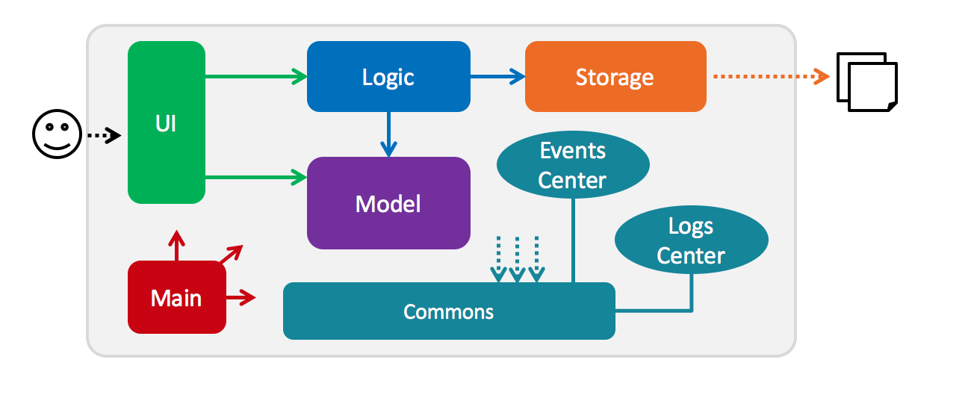

*Figure 1: Architecture Diagram of high-level design*

The *Architecture Diagram* above explains the high-level design of the application. Below is a quick overview of each component.

**Main** has only one class called MainApp. It is responsible for:

1. **At application launch**: Initializing the components in the correct sequence, and connect them up with each other.
2. **At shut down**: Shutting down the components and invoke clean-up method where necessary.

**Commons** represents a collection of classes used by multiple other components. Two of those classes play important roles at the architecture level. They are:

1. **EventsCenter**: This class (written using *Google*'s Event Bus library) is used by components to communicate with other components using events (i.e. a form of *Event Driven* design)
2. **LogsCenter**: Used by many classes to write log messages to the application's log file.

The rest of the App consists of the following 4 elements:

1. **UI**: The user interface of the application.
2. **Logic**: The command executor.
3. **Model**: Holds the data of the application in-memory.
4. **Storage**: Reads data from, and writes data to, the hard disk.

Then each of the above-mentioned four elements does the following:

1. Defining its *API* in an interface with the same name as the *Component*.
2. Exposing its functionality using a {Component_Name}Manager class.

For example, the **Logic** component (see *Figure 2* given below) defines its API in the Logic.java interface and exposes its functionality using the LogicManager.java class.

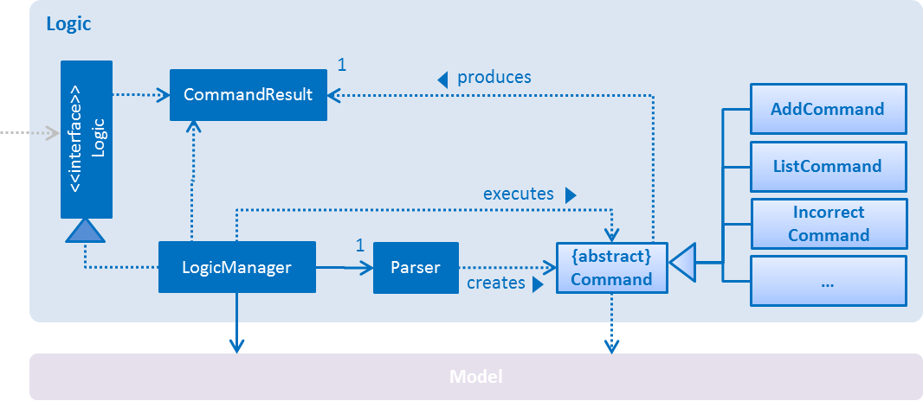

*Figure 2: Architecture Diagram of the* ***Logic*** *Component*

When a user issues a command, each component in the architecture diagram works together to deliver the result. *Figure 3* (*Sequence Diagram*) shows how the components interact with each other when the user issues the command delete 1.

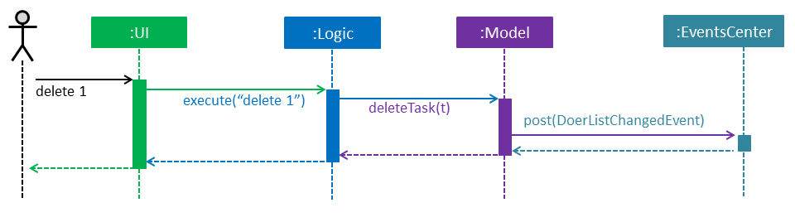

*Figure 3: Sequence Diagram when user issues the command delete 1*

Note how **Model** simply raises a DoerListChangedEvent when the Do-er List data are changed, instead of asking the **Storage** to save the updates to the hard disk.

*Figure 4* shows how **EventsCenter** reacts to that event, which results in the updates being saved to the hard disk and the status bar of the **UI** being updated to reflect the Last Updated time.

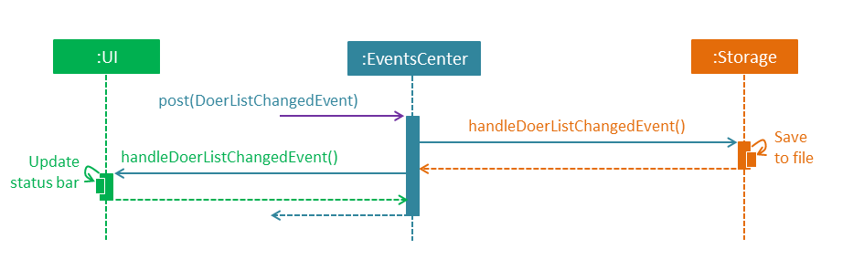

*Figure 4: How the* ***EventsCenter*** *react to a change in event*

Notice how the event is propagated through the **EventsCenter** to the **Storage** and **UI** without having **Model** to be coupled to either of them. This is an example of how this *Event Driven* approach helps us reduce direct coupling between components.

In the following sections, we will explore the four components, namely the **UI**, **Logic**, **Model** and **Storage**. We will be exploring their class diagrams and their APIs to understand how they work and interact with each other to deliver a result. It is important that you study the following section carefully, as our software is written in the *Object-Oriented Paradigm*, so it is crucial to know how various parts work together.

### 2. UI component

The **UI** component (Ui.java) is responsible for displaying user interface. *Figure 5* is its architecture diagram, displaying its smaller components and how they relate to each other.

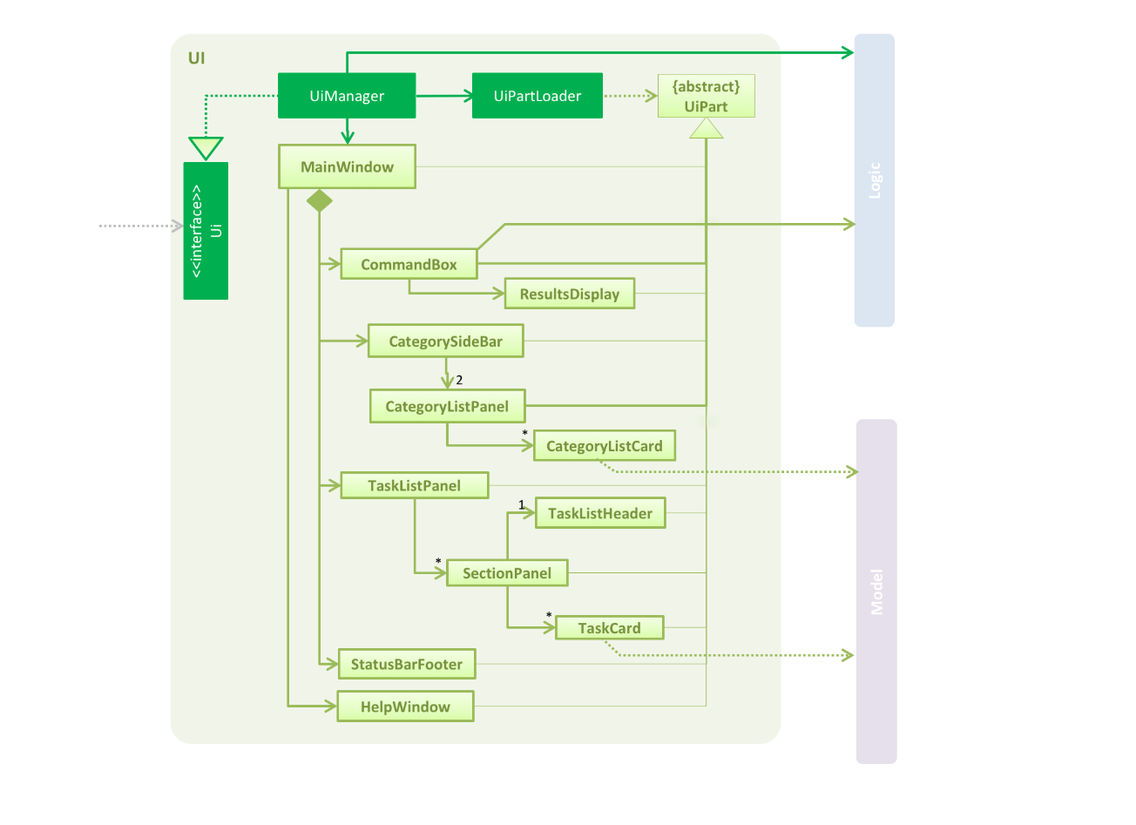

*Figure 5: Architecture Diagram of the* ***UI*** *Component*

From the diagram above, the **UI** consists of a MainWindow that is made up of various parts that are responsible for displaying the **UI**. For example, CommandBox, ResultDisplay, TaskListPanel, StatusBarFooter, BrowserPanel, TaskCard and HelpWindow. All these, including the MainWindow, inherit from the abstract UiPart class and they can be loaded using the UiPartLoader.

The **UI** component uses ***JavaFx******UI*** framework. The layout of these **UI** parts are defined in matching .fxml files that are in the src/main/resources/view folder.

For example, the layout of the MainWindow is specified in MainWindow.fxml.

The crucial roles of the **UI** component are:

1. Executes user commands using **Logic** component.
2. Binds itself to some data in **Model** so that the **UI** can auto-update when data in **Model** change.
3. Responds to events raised from various parts of the application and updates the **UI** accordingly. *Figure 6* shows the interactions between the **UI** and JumpToIndexedTaskRequestEvent event.

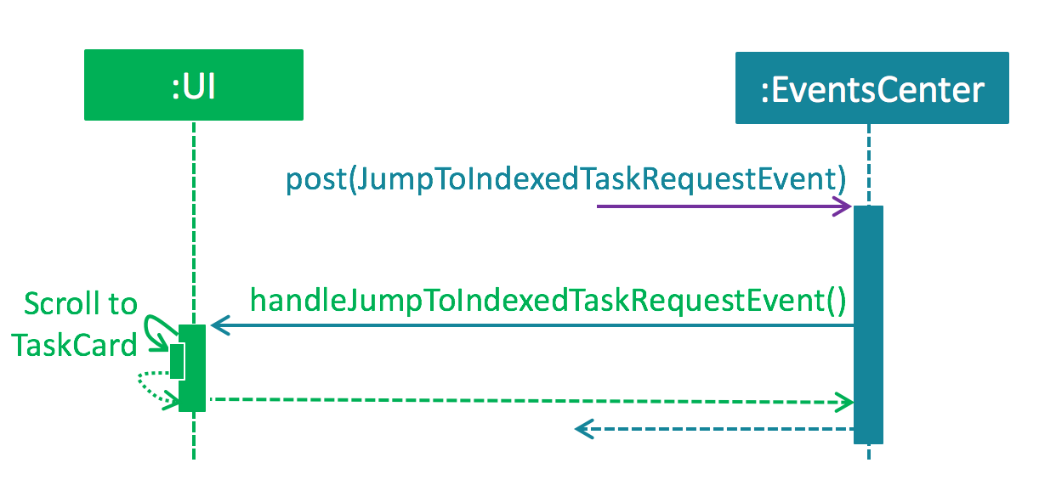

*Figure 6: Interactions between* ***UI*** *and* ***EventsCenter*** *components diagram*

### 3. Logic component

The **Logic** component is responsible for the logical functionalities in the application that includes all the possible commands and the parsing of users’ inputs. *Figure 7* below shows the architecture diagram of the **Logic** component.



*Figure 7: Architecture Diagram of the* ***Logic*** *component*

This is what happens when a user types in a command:

**Logic** uses the Parser class to parse the user’s command. This creates a Command object which will be executed by the LogicManager. The command execution can affect **Model** (i.e. adding a task) and/or raise events. The result of the command execution is encapsulated as a CommandResult object which is passed back to the **UI**.

To give you a concrete example, *Figure 8* (*Sequence Diagram*) shows the interactions within the **Logic** component when the API cal**l**s execute("delete 1").

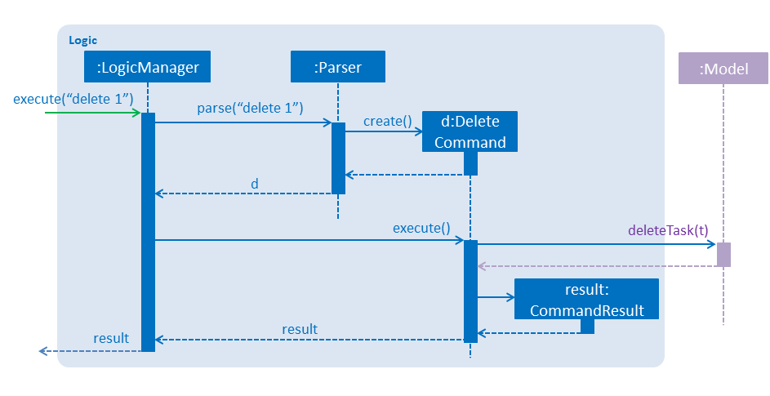*Figure 8: Sequence Diagram when delete 1 is called.*

### 4. Model component

The **Model** component stores the Do-er List's data into specific components. *Figure 9* gives an overall view of the architecture diagram of the **Model** component.

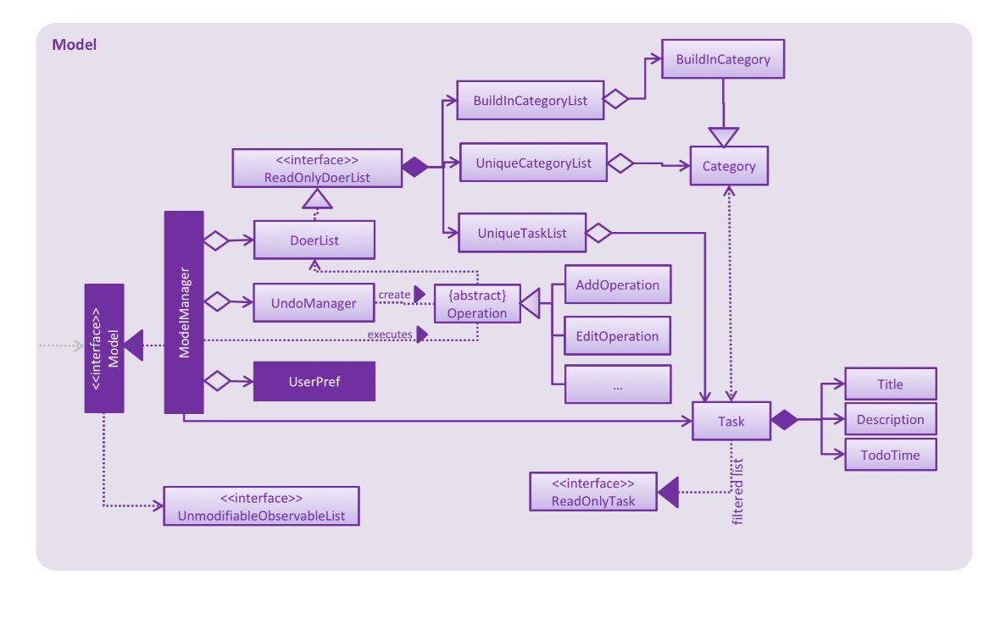

*Figure 9: Architecture Diagram of the* ***Model*** *Component*

**Model** stores a UserPref object that represents the user's preferences besides storing the Do-er List data. It also stores an UndoManager object that records the execution of all commands in the data.

More importantly, it exposes an UnmodifiableObservableList<ReadOnlyTask> and UnmodifiableObservableList<Category> that can be *observed*. It means that the **UI** can be bounded to this list so that it automatically updates when the data in the list changes, thus reflecting real-time changes.

**Model** does not depend on any of the other three components.

### 5. Storage component

The **Storage** component, as its name suggests, stores various data. It can save the Do-er List data in xml format and read it back. Additionally, it saves the UserPref objects in json format and reads it back.

Refer to *Figure 10* for the complete architecture diagram of this component.

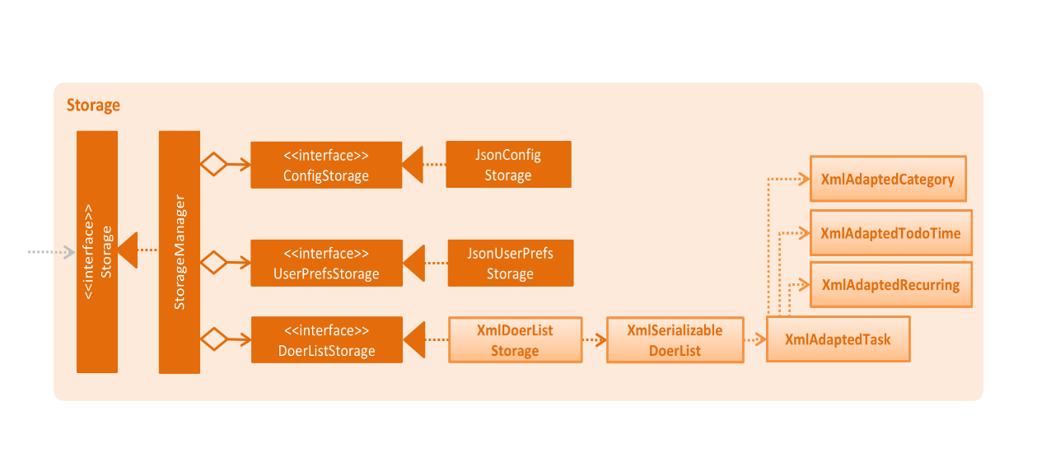

*Figure 10: Architecture Diagram of* ***Storage*** *component*

### 

### 6. Common classes

Classes used by multiple components are in the seedu.doerList.commons package.

# Implementation

### 1. Logging

We are using java.util.logging package for logging. The **LogsCenter** class is used to manage the logging levels and logging destinations.

1. The logging level can be controlled using the logLevel setting in the configuration file (See Configuration).
2. The **Logger** for a class can be obtained using LogsCenter.getLogger(Class) which will log messages according to the specified logging level.
3. Currently log messages are output through: Console and to a .log file.

There are 4 logging level in total. They are:

1. **SEVERE**: Critical problem detected which may possibly cause the termination of the application.
2. **WARNING**: Proceed with caution.
3. **INFO**: Information showing the noteworthy actions by the application.
4. **FINE**: Details that are usually not noteworthy but may be useful in debugging (print the actual list instead of just its size).

### 2. Configuration

Certain properties of the application can be controlled (i.e. application name, logging level) through the configuration file (default:config.json).

# Testing

Tests can be found in the ./src/test/java folder.

### 1. Running Test in *Eclipse*

If you are not using a recent version of ***Eclipse*** (i.e. ***Neon*** or later), enable assertions in ***JUnit*** tests as described in this link:

[*http://stackoverflow.com/questions/2522897/eclipse-junit-ea-vm-option*](http://stackoverflow.com/questions/2522897/eclipse-junit-ea-vm-option)

If you want to run all tests, right-click on the src/test/java folder and choose Run as > JUnit Test. If you want to run a subset of tests, you can right-click on a test package, test class, or a test and choose to run as a JUnit test.

### 2. Using *Gradle*

Please see UsingGradle.md that comes together when you download the project to run tests using ***Gradle***.

We have two types of tests:

1. **GUI Tests** - These are *System Tests* that test the entire application by simulating user actions on the GUI. These are in the guitests package.
2. **Non-GUI Tests** - These are tests not involving the GUI. They include,
   1. *Unit tests* targeting the lowest level methods or classes.

- seedu.doerList.commons.util.UrlUtilTest

* 1. *Integration tests* that are checking the integration of multiple code units (those code units are assumed to be working).

- seedu.doerList.storage.StorageManagerTest

* 1. Hybrids of unit and integration tests. These tests checks multiple code units as well as their connectedness.

- seedu.doerList.logic.LogicManagerTest

Headless GUI Testing: Thanks to the [***TestFX***](https://github.com/TestFX/TestFX) library, our GUI tests can be run in *headless* mode. In the headless mode, GUI tests do not show up on the screen. That means the developer can do other things on his computer while the tests are running.

See UsingGradle.m[d](https://github.com/TeamPGP/main/blob/DeveloperGuide/docs/UsingGradle.md#running-tests) to learn how to run tests in headless mode.

# Dev Ops

### 1. Build Automation

See UsingGradle.md to learn how to use ***Gradle*** for build automation.

### 2. Continuous Integration

We used ***Travis******CI*** to perform *Continuous Integration* on our projects. See UsingTravis.md that comes together when you download the project for more details.

### 3. Making a Release

Here are the steps to create a new release:

1. Generate a JAR file using ***Gradle***.
2. Tag the repository with the version number. (i.e. v0.1)
3. Create a new release using ***GitHub*** and upload the JAR file your created.

### 4. Managing Dependencies

A project often depends on third-party libraries. For example, Do-er List depends on the ***Jackson*** library for XML parsing. Managing these dependencies can be automated using ***Gradle***. For example, ***Gradle*** can download the dependencies automatically, which is better than manually downloading them from their respective libraries.

# Appendix A: User Stories

Priorities:

* High (must have) - * * *
* Medium (nice to have) - * *
* Low (unlikely to have) - *

| Priority | As a | I want to ... | So that I can... |
| --- | --- | --- | --- |
| * * * | new user | see the usage format of all commands | use various commands in the application |
| * * * | user | create a task with title and description | summarise my task into a title and provide details in its description |
| * * * | user | create a task without start or end time | record tasks that need to be done without a deadline |
| * * * | user | create a task with start and end time or deadlines | prepare for the task that is happening or due at certain time |
| * * * | user | edit the task's title, description, start time, end time and categories | update my task in the event a mistake is made |
| * * * | user | view all tasks | have an overview of all tasks |
| * * * | user | view a specific task | get more details of the specific task |
| * * * | user | find a task by title and description | quickly locate the task with certain keywords in the event I forget |
| * * * | user | delete tasks | remove unwanted tasks |
| * * | user | add tasks to different categories | organise my tasks more effectively |
| * * | user | view the tasks under a certain category | examine different tasks under different categories |
| * * | user | view the tasks that are going to happen or due today, tomorrow or in the next 7 days. | remind myself about the upcoming tasks |
| * * | user | undo the most recent operations | revert back to my unmodified data |
| * * | user | redo the most recent operations | revert to my modified data |
| * * | user | specify a storage location for data storage | synchronise with online data servers in the event I lose my data locally |
| * * | user | mark or unmark the task as [done](https://github.com/CS2103AUG2016-W09-C4/main/blob/master/docs/DeveloperGuide.md#done) or undone | choose to only keep track of the tasks which are needed to be done and archive them when completed. |
| * | user | type command parameters in arbitrary order | choose not to remember the order of parameters but still able to use the command properly |
| * | user | add external ical file to the to do-lists | keep track of other events created by others |
| * | user | create recurring tasks | be reminded to do the same task at every fixed-time-interval |
| * | user | view events in Google Calendar | have a pictorial view of my schedule. |

# Appendix B: Use Cases

(For all of the use cases below, the **System** is the Do-er List and the **Actor** is the user, unless specified otherwise)

#### Use case: Add task

**MSS**

1. User requests to add in a task.
2. To-Do List creates a task with title, description, start date and end date.
3. The task is moved into the categories according to the parameters.
4. System displays the details of the created task.  
   Use case ends.

**Extensions**

1a. add command is followed by the wrong parameters.

1a1. System indicates the error and display the correct format for user.

Use case ends.

1b. TITLE is an empty string.

1b1. System indicates the error that TASK_NAME is empty.

Use case ends.

1c. User does not supply START or END parameters.

1c1. Event is created and categorized to INBOX.

1c2. System displays the created task.

Use case resumes from steps 2.

1d. User does not supply START parameter.

1d1. Event is created with START as today.

Use case resumes from steps 2.

1e. System is able to parse START or END which is not in standard format.

Use case resumes from steps 2.

1f. System is not able to parse START or END which is not in standard format.

1f1. System will create the task without START and END date.

1f2. System indicates the error to user.

Use case resumes from steps 2.

#### Use case: Edit task

**MSS**

1. User types in the command.
2. To-Do List finds the task at that index.
3. The task's details are changed accordingly.
   * title, description, start time, end time, category
4. System displays the details of the newly edited task.   
   Use case ends.

**Extensions**

1a. edit command is followed by the wrong parameters.

1a1. System indicates the error and display the correct format for user.

Use case ends.

1b. edit command is followed by the non-existent INDEX

1b1. System indicates the error that the INDEX is non-existent.

Use case ends.

1c. TITLE is an empty string.

1c1. System indicates the error that TASK_NAME is empty.

Use case ends.

1d. System is not able to parse START or END which is not in standard format.

1d1. System will create the task without START and END date.

1d2. System indicates the error to user.

Use case resumes from steps 2.

#### Use case: Delete task

**MSS**

1. User types in the command.
2. System finds the task at that index.
3. System confirms with the user if he wants to delete the task.
4. User confirms.
5. System deletes the task.   
   Use case ends.

**Extensions**

1a. delete command is followed by the wrong parameters

1a1. System indicates error and display the correct format to user.

Use case ends.

1b. delete command is followed by a non-existent INDEX

1b1. System indicates the error in the INDEX is non-existent.

Use case ends.

4a. User rejects the confirmation

4a1. System indicates that the delete order was not carried out.

Use case resumes from step 1.

#### Use case: List task by category

**MSS**

1. User types the list command with specific category name as parameter.
2. System displays all the tasks under CATEGORY.   
   Use case ends.

**Extensions**

1a. User does not supply CATEGORY.

1a1. System displays all the tasks.

Use case ends.

2a. The category does not exist in the system.

2a1. System indicates the error.

Use case ends.

#### Use case: Undo Command

**MSS**

1. User types in the undo command.
2. System tries to find the last operation which involves change of data.
3. System undoes the operation.
4. System indicates the change to user.   
   Use case ends.

**Extensions**

2a. The last operation which involves the change of the data does not exist.

2a1. System indicates the error.

Use case ends.

#### Use case: Clear Command

**MSS**

1. User types in the command.
2. System confirms if user wants to clear the entire all of the tasks.
3. User confirms.
4. System deletes all the tasks.   
   Use case ends.

**Extensions**

3a. User rejects the confirmation

3a1. System indicates that the clear order was not carried out.

Use case resumes at step 1.

#### Use case: Help Command

**MSS**

1. User types in the command.
2. System finds with the details of a command in its parameters.
3. System displays the details.   
   Use case ends.

**Extensions**

1a. help command is followed by the wrong parameters.

1a1. System indicates the error and display the correct format for user.

Use case ends.

1b. help command is followed by no parameters.

1b1. System displays all the commands available with all the details.

Use case ends.

#### Use case: View a task

**MSS**

1. User types in the view command.
2. System retrieves the task list based on the index parameter in the recently displayed list.
3. System displays the detail of the task.   
   Use case ends.

**Extensions**

2a. There is no recently displayed list.

2a1. System indicates the errors to user.

Use cases ends.

2b. INDEX is not valid.

2b1. System indicates the errors to user.

Use cases ends.

#### Use case: Find keywords

**MSS**

1. User requests to find keyword.
2. To-Do List shows the requested keywords in all categories.   
   Use case ends.

**Extensions**

2a. Keyword does not exist in the list.

Use case ends.

#### Use case: Task Due Command

**MSS**

1. User requests to find all tasks due by end date.
2. To-Do List shows all of the tasks due by end date.   
   Use case ends.

**Extensions**

2a. No tasks are due by END date.

Use case ends.

#### Use case: Redo Command

**MSS**

1. User types the command
2. To-do List reverses the most recent undo.   
   Use case ends.

**Extensions**

1a. No recent undo is called.

1a1. System indicates the error and shows the error message.

Use case ends.

#### Use case: Mark Command

**MSS**

1. User marks the task of TASK_NUMBER done.
2. To-Do List shows if the specific task could be marked as done.   
   Use case ends.

**Extensions**

2a. No such task of TASK_NUMBER.

2a1. To-Do List shows an error message.

Use case ends.

2b. Task of TASK_NUMBER is already marked as done.

Use case ends.

#### Use case: Unmark Command

**MSS**

1. User marks task of TASK_NUMBER undone.
2. To-Do List shows if task could be marked as undone.   
   Use case ends.

**Extensions**

2a. No such task of TASK_NUMBER.

2a1. To-Do List shows an error message.

Use case ends.

2b. Task of TASK_NUMBER is already marked undone.

Use case ends.

#### Use case: Save Command

**MSS**

1. User attempts to save his data in a specified location.
2. To-Do List shows if the data could be save in that location.   
   Use case ends.

**Extensions**

2a. Invalid SAVE_LOCATION specified.

2a1. To-Do List shows an error message.

Use case ends.

# Appendix C: Non Functional Requirements

1. The program should work on any [mainstream OS](https://github.com/CS2103AUG2016-W09-C4/main/blob/master/docs/DeveloperGuide.md#mainstream-os) as long as it has Java 1.8.0_60 or higher installed.
2. It should be able to hold up to 1000 tasks.
3. Automated unit tests and open source code for this program should be readily available.
4. Every operation executed should be logged to the log file.
5. The program should favour DOS style commands over Unix-style commands.
6. The product should have no dependency on other packages.
7. The software can be launched, without installing, by clicking on the executable file.

# Appendix D : Glossary

##### Mainstream OS

Windows, Linux, Unix and OS-X

##### Deadline

A time interval with the start day as the day the task created day and the end day represents the date of the deadline.

##### Done or Undone

The build-in category in the To-Do list which store all the tasks that are marked as done or undone respectively.

# Appendix E : Product Survey

### Review of [TickTick](https://ticktick.com/):

#### Strengths:

* Desktop software is provided, so we can launch it quickly without using browser.
* Shortcuts for opening the software is provided, so the To-Do lists can be opened quickly to those who prefer using the keyboard.
* Users can create their own category for tasks and allocate tasks to different categories.
* Elegant GUI is provided, the UI is not wordy and icons are quite intuitively.

#### Weaknesses:

* A constant network connection is required. If there is no network connection, the software cannot be opened.
* The parser for input text can only deal with simple command.
  + Adding the start time of event. If the command cannot be recognized, it will be automatically added as task title.

### Review of [WunderList](https://www.wunderlist.com/zh/):

#### Strengths:

* Ease of usage is its biggest strength. A user can easily add multiple items just by entering his desired items.
* Apple Watch integration is a nice bonus for Apple Watch owners.
* Slick user interface that allows background customization.

#### Weaknesses:

* The free version is seriously limited. Users only get 25 assigns per shared to-do list and 10 background choices
* A constant network connection is required. If there is no network connection, the software cannot be opened.
* Wunderlist lacks IFTTT integration compared to other To-Do list applications.

### Review of [Trello](https://trello.com/):

#### Strengths:

* Cloud-based (Online) program that allows it to be transferrable to other computers.
* Ease to add notes and descriptions into the Trello cards.
* Customizable looks.

#### Weaknesses:

* It cannot link up with other calendar software like Google calendar which makes it hard to keep track of tasks done.
* The free version is much more limited than the paid version, making certain customisation features is hard

### Review of [Google Calendar](https://calendar.google.com/):

#### Strengths:

* Add different kinds of colouring to the schedule.
* Undo addition or deletion of events.
* Create multiple calendar for different purposes.
* GUI is quite intuitive. The formatting is clear and it does not require guidelines.
* Able to use calendar in offline mode.

#### Weaknesses:

* Unable to view all deleted events or reminders.
* It does not have command-line inputs to modify the calendar; most operations require a user to click, which can be time-consuming and troublesome.
* Only accessible via browsers; no desktop application available