DO-*er* LIST

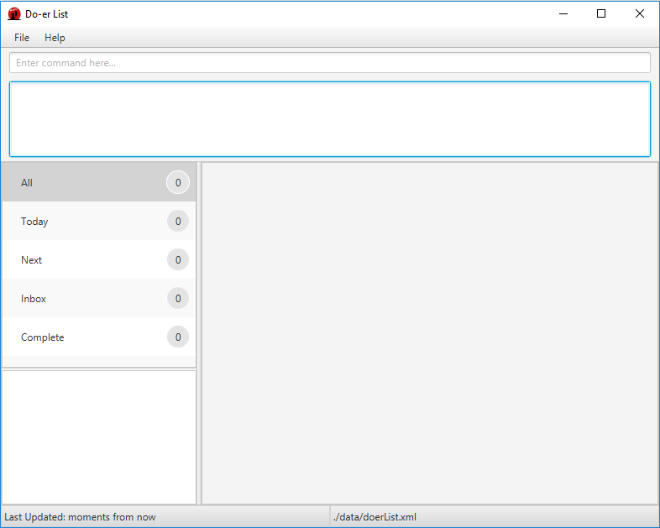

|  |  |  |  |
| --- | --- | --- | --- |
| jason-passport  **Ng Yong Sheng** | xiaopu-passport  **Xiao Pu** | benedict-passport  **Chan Jing Hui Benedict** | hailong-passport  **Vu Hai Long** |