**Sample Progress Report 1: Student project**

|  |  |
| --- | --- |
| DATE: | April 10, 2001 |
| TO: | Jim McWard, Instructor |
| FROM: | Joan Beckett |
| SUBJECT: | PROGRESS REPORT FOR STUDENT WEB SITE |

**INTRODUCTION**

I decided to create a web site for people interested in European travel. This Web site will increase consumer awareness of the company and provide travelers with valuable information on several European countries. Objectives of the web site include:

1. Increasing awareness of travel opportunities in Europe
2. Providing links to low cost airfares and hotels.
3. Providing a page of news related to European current events and issues.

**DISCUSSION**

Work Accomplished

In the last two weeks I have accomplished the following:

1. *Project Planning*: I have created a navigation tree that organizes all the pages for the entireweb site. The project management plan of mine also details the amount of time it is expected to take me to develop each part of the web site.
2. *Requirements Gathering*: To better help me determine what users would expect from a website focused on European travel, I created a survey form that members in the technical writing class completed. The results of the survey have given me a clearer idea as to the perceptions a lay reader has toward Europe. Because of this survey, I have had to modify the material on the web site significantly. I now have more space devoted to geographical and political information for European countries.
3. *Design*: I have compiled most of the drawings and photographs that I hope to use on the webpages. I have also created a company logo that will be featured on each page.

Work Remaining

To complete the web site project I need to complete the following:

1. *Page construction*: I have completed rough drafts of four of the pages on my web site, but Ihave to revise those and still create three more pages.
   1. *Testing*: Once the first version of my web site is completely finished, I will havemembers in the technical writing class test it for usability. On the basis of their recommendations, I will revise the site further.
   2. *Submission*: When I have completed my final revision after the usability test, I will submit myweb project for evaluation. I plan to upload it to the network by the due date and to print out hard copies for you as well.

The project schedule shown below indicates project deadlines and milestones for each of the above-mentioned phases. It clearly separates the work accomplished from the work remaining.

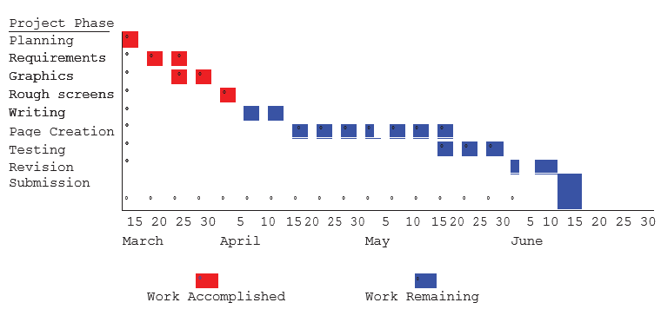

Problems Encountered

The most significant problem encountered was the loss of several graphic files when the computer network crashed on April 2, 2001. The survey I conducted also showed me that I did not have a clear concept of audience, so I needed to revise my original plans for my web site.

**CONCLUSION/RECOMMENDATION**

My web site project is approximately 30% complete. I expect to have it done by the due date if the computer network does not pose further problems.

I appreciate the amount of class time we have been given for working on our web projects. I hope that this continues. When my first draft is completed next week, I look forward to receiving your comments on how I can make my web site better.

**Sample Progress Report 2: Training project**

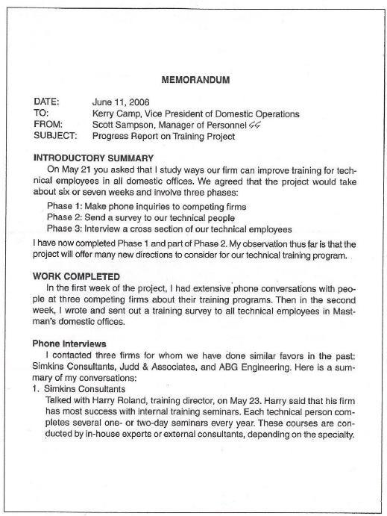

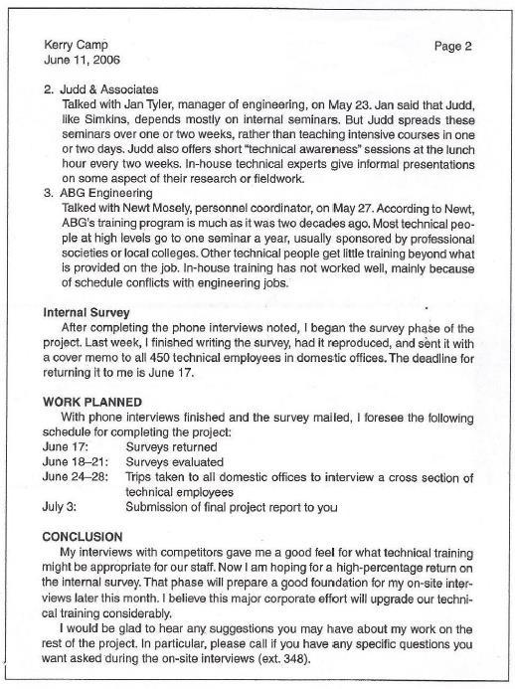

**PROGRESS REPORT CHECKLIST**

**Aims:**

This progress report checklist aims to:

* help you examine the essential sections of the progress report
* critically assess the effectiveness of the report, recognising its strengths as well as areas for improvement;
* help you scrutinize the progress report in terms of format, mechanics and clarity.

**Instructions:**

*Use the following questions to guide your evaluation of the report samples and your own reports.*

|  |  |
| --- | --- |
| **Quality characteristics and guidelines** | **Comments** |
| **ORGANISATION & PRESENTATION**   * Does the overall organisation reflect the purpose of the report? * Are the relationships between main sections and sub-divisions logical? * Is there a balance between sections? Do the most important items have the most space? * Are the headings and subheadings informative and concise? Do they capture accurately the content of the commentary that follows? Is the layout appealing and professional? * Have mechanics been used effectively to differentiate headings of different levels? * Have the pages of the report been numbered? |  |
| **CONTENT**  INTRODUCTION   * Is the purpose of the report clearly stated? * Is there an overview of the work and its objectives? * Is a short status summary provided?   DISCUSSION   * Are the following aspects provided, i.e. Scope of work/ Work completed/ Work to be completed/ Problems encountered? * Has all relevant information been included? * Is the information presented objective and convincing? * Are the problems presented effectively without being exaggerated or understated? * Has all redundant information been excluded?   RECOMMENDATIONS   * Do the recommendations follow logically from the discussion section? * Have all problematic areas been accurately identified and addressed? * Are the recommendations specific? Are they feasible? * Is it clearly stated who is expected to take the recommended action(s) – writer or reader? * Are the recommendations persuasive? Have positive outcome(s) that could result from the implementation of the recommendations proposed been highlighted?   CONCLUSION   * Is there a brief restatement of work done within the reporting period? * Is there any evaluation of the discussion section, e.g. highlighting the seriousness of problems by articulating the possible negative consequences that could result if problems are not addressed? * Is there an expression of confidence or concern about the work status? * Does the report end with a ‘call to action’ from the reader, and/or indication of writer’s willingness to make adjustments to work? |  |
| **LANGUAGE**   * Is grammar correct and spelling/punctuation accurate? * Are transitional devices used appropriately to provide coherence to the whole report? * Is the writing clear, direct and easy to read? * Is the writing concise? Can unnecessary words/phrases be deleted? * Is an appropriate level of formality and tone used? For example, this report should not read like a reflection. |  |