

A Game Developed by



*Wong Hong Wei.Wu Xianqun.Hue Zi Xian.Ng Sok Cheng Priscilla*

[Manual]

# Setup Server

1. Open command prompt
2. Change directory to where game folder is located
3. Start server by typing node loginServer.js

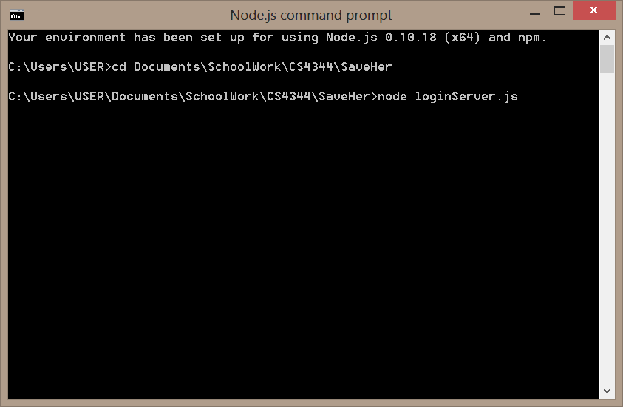

# Setup Clients

1. Open browser (either on PC or mobile device)
2. Enter as url as http://localhost:4000/SaveHer.html (or replace localhost with IP address if server is hosted on a different host machine in the network)

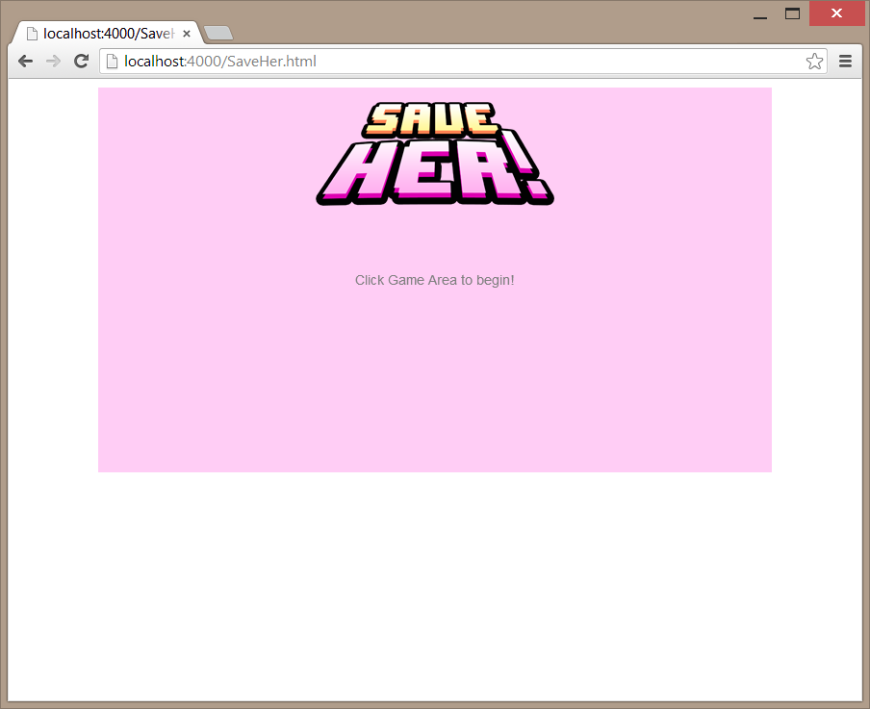

1. Click anywhere within the pink box

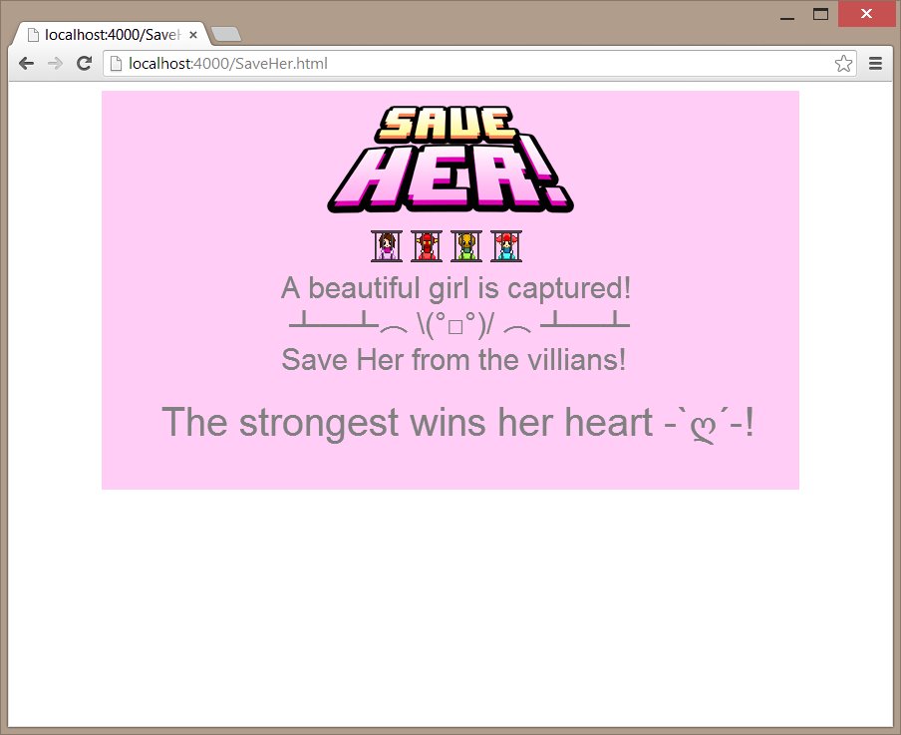

1. Click again anywhere within pink box. There may be a “sluggish” response after you click. Just wait awhile, the next screen will load. (This sluggish behavior may be caused by the Zebra UI library) 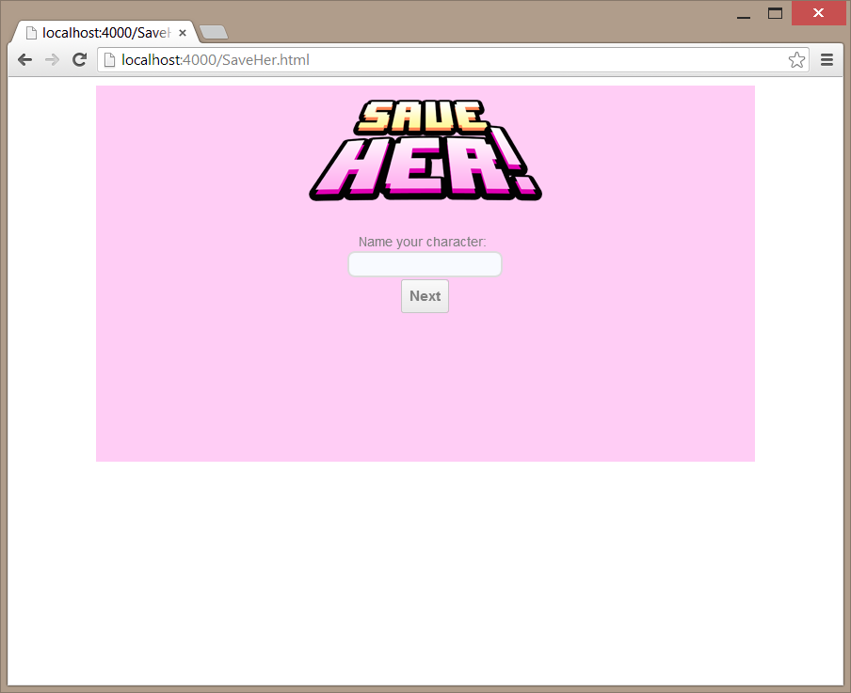
2. Enter your name

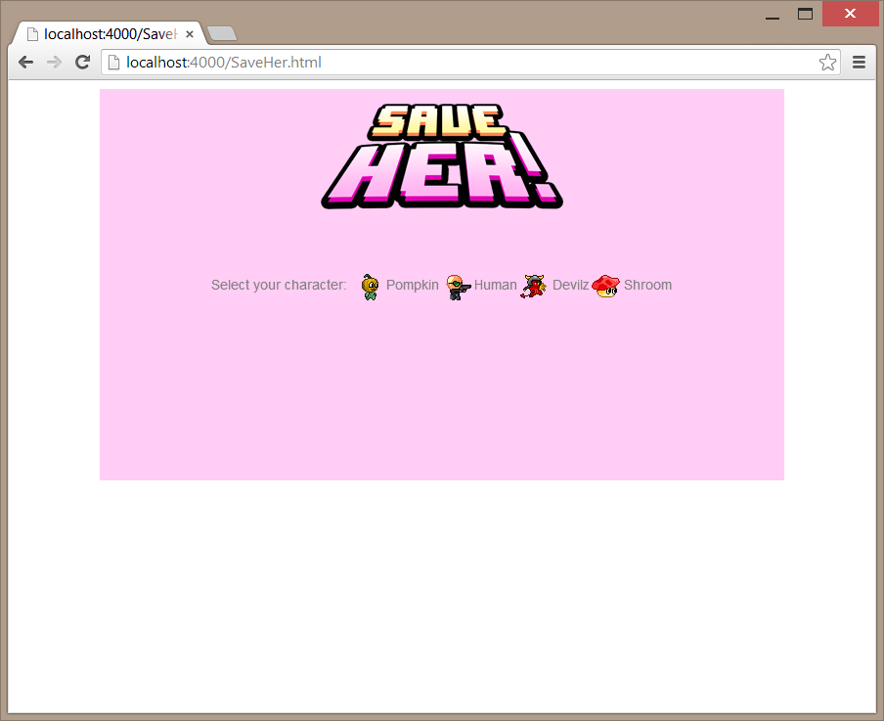

1. Choose your character

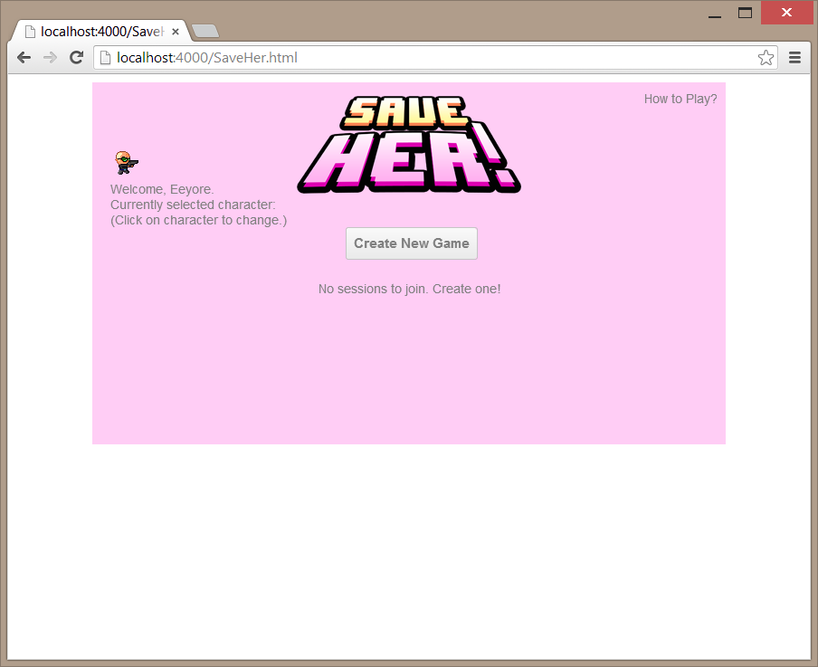

1. This is the main lobby screen. You can change character by clicking on the character avatar on the top left corner. You can view the tutorial by clicking on “How To Play” on the top right corner. The sessions will take some time to load (because it is constantly refreshing and retrieving the latest session list). If after 1-2seconds, it still says No Sessions to Join, means there really is no session. Create one by clicking the “Create New Game”!

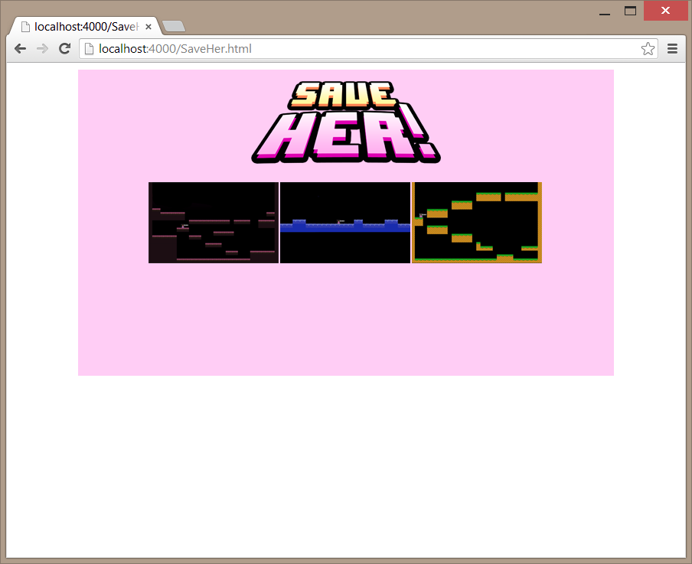

1. There are 3 maps to choose from, just click on the map to select it. After this step, the game will load.

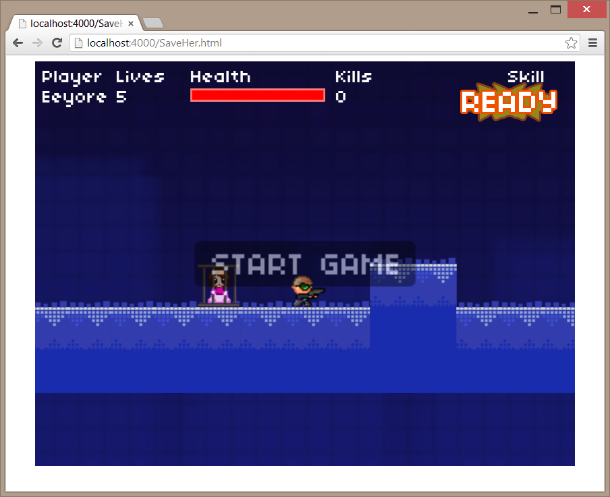

1. The player that starts a new game will be the host for the game, and needs to click on Start Game to start the fight. After this step, just wait for other players and click start! Go Save Her!