**Project Report**

**Waves Propagation and Antennas**



**6th Semester**

(B.E. Electrical Engineering)

|  |  |  |
| --- | --- | --- |
| **Lab No. 1** |  | |
| **S.No.** | **Name** | **Registration No.** |
| 1. **1** 2. **2** 3. **3** 4. **4** | Umair Ejaz  Ahmad Daud  Ummaima Nadeem  Ahmed Maqbool | 375418  367195  393460  375118 |
| **Syndicate** | C | |

# 1. Introduction

## 1.1 Objective

The goal of this project is to design a coaxial-to-waveguide adapter/transition for a WR-75 waveguide, operating within the 10-15 GHz frequency range. The main objective is to minimize the S11 (reflection coefficient) and maximize the S21 (transmission coefficient) near the center frequency of 12.5 GHz. This will ensure efficient microwave signal transmission with minimal reflection and optimal power transfer.

## 1.2 Background

Waveguides are widely used in microwave communication systems because they can carry high-frequency signals with low loss efficiently. The WR-75 waveguide, a standard rectangular waveguide, is employed in various applications such as radar, satellite communications, and microwave relay systems. It has internal dimensions of 19.05 mm by 9.525 mm and is designed to operate within the 10-15 GHz frequency range. Conversely, coaxial cables are typically used for lower frequency signals, offering flexibility and ease of connection. To transition from coaxial to waveguide transmission, an adapter is necessary. This adapter ensures efficient energy transfer from the coaxial cable to the waveguide with minimal loss and reflection.

## 1.3 Design Goals

The specific design goals for this project are:

- Minimize S11 (reflection coefficient) to ensure minimal signal reflection.

- Maximize S21 (transmission coefficient) to ensure maximum signal transmission.

- Maximize the bandwidth where S11 is less than or equal to -10 dB around the center frequency of 12.5 GHz.

# 2. Calculations

## 2.1 Waveguide Dimensions

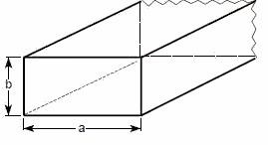The WR-75 waveguide has the following internal dimensions:

Width: 19.05 mm

Height: 9.525 mm

## 2.2 Coaxial Cable Specifications

The coaxial cable used in this design has the following specifications:

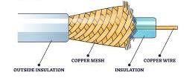Inner diameter: 1.27 mm

Outer diameter: 4.1 mm

Dielectric material: Teflon

## 2.3 Cutoff Frequency Calculation

The cutoff frequency (fc) for the dominant mode (TE10) in a rectangular waveguide is given by:

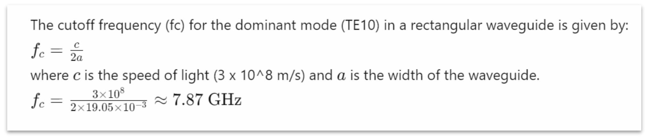

## 2.4 Upper and Lower Cutoff Frequencies

The WR-75 waveguide is designed to operate between 10 GHz and 15 GHz. These are the lower and upper cutoff frequencies for practical operation.

## 2.5 Guided Wavelength Calculation

The guided wavelength (*λg*) in a waveguide is given by:

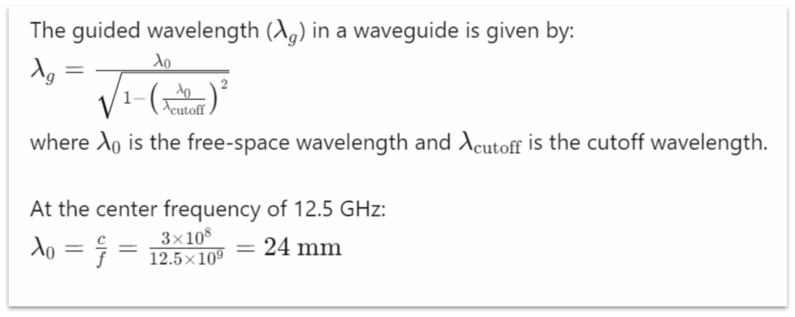

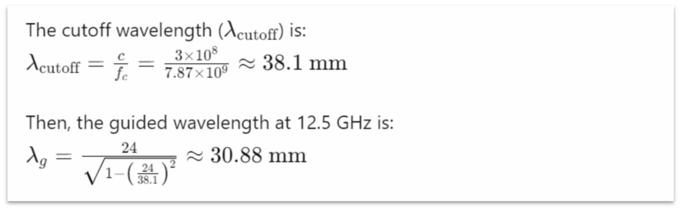

## 2.7 Initial Dimensions

Initial dimensions for the probe and other elements of the adapter are determined based on standard design practices and will be refined during the simulation and optimization process.

# 3. Procedure

## 3.1 Design in HFSS

**Model Creation:** The geometry of the coaxial to waveguide transition was created in

HFSS. The coaxial cable was modeled with its inner and outer conductors and the Teflon dielectric. The waveguide section was modeled according to the WR-75 dimensions.

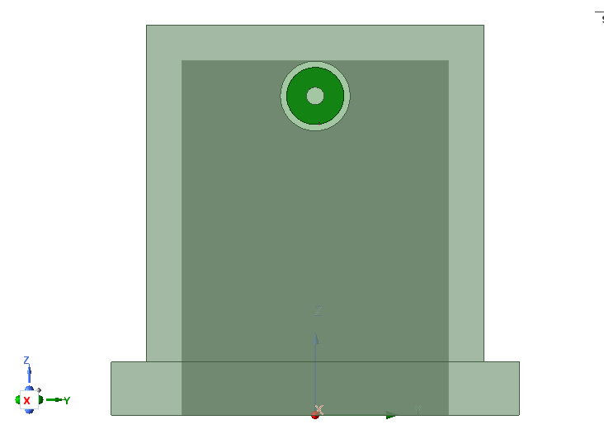

## 3.2 Simulation Setup

**Frequency Range:** The simulation was run over the frequency range of 10-15 GHz.

**Boundary Conditions:** Appropriate boundary conditions were applied to simulate the waveguide walls and the coaxial boundaries.

**Mesh Settings:** A fine mesh was used in the simulation to ensure accurate results, especially around the probe and the transition regions.

# 4. Results

## 4.1 S-Parameter Results

S11 and S21 Plots: The magnitude of S11 and S21 in dB (i.e., 20 log10 |S11| and 20 log10 |S21|) were plotted against frequency from 10 to 15 GHz.

Plot of S11 vs. Frequency:

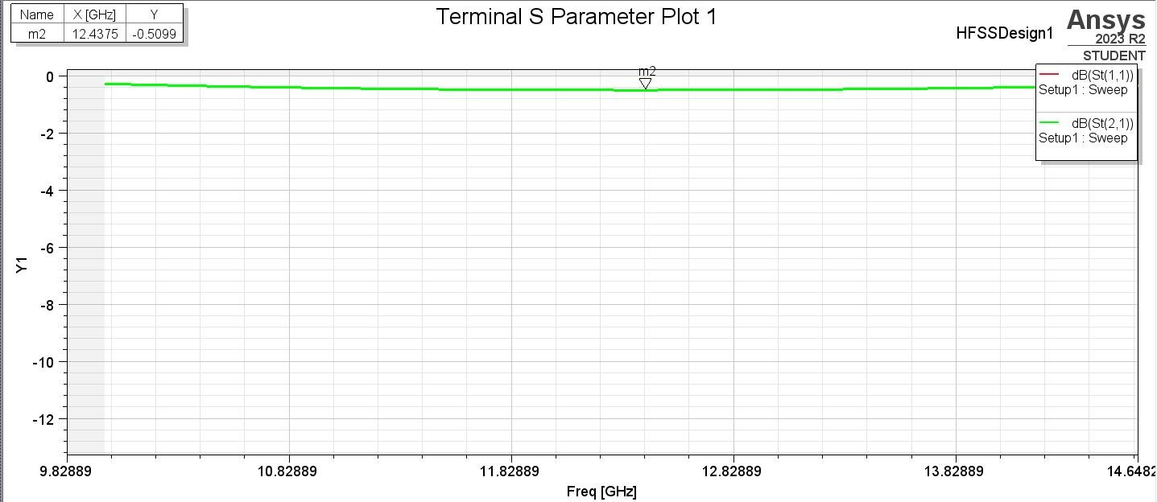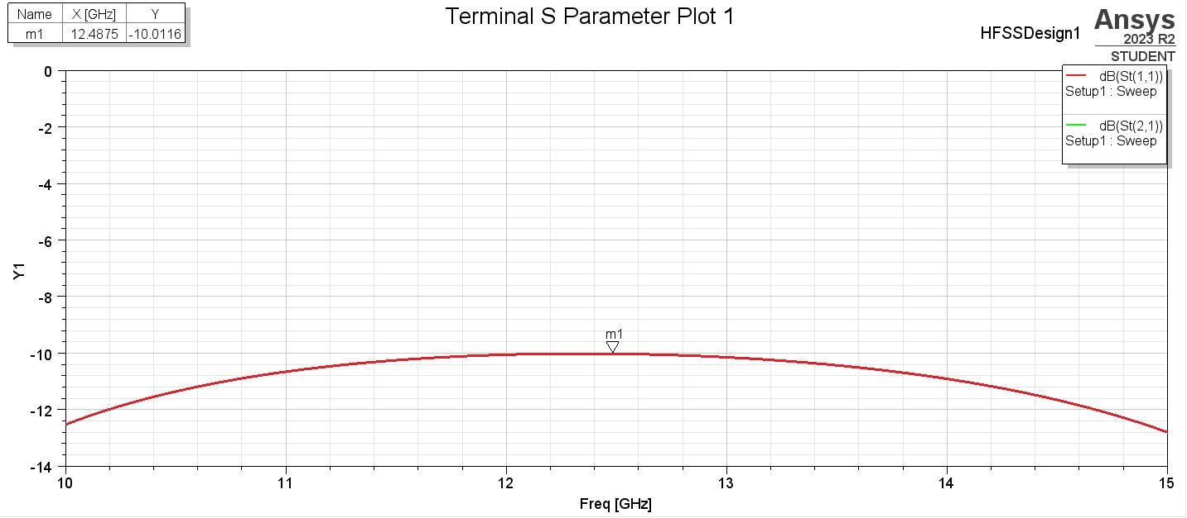

Plot

of

S21

vs.

Frequency:

* **Bandwidth Calculation:** The bandwidth where S11 ≤ -10 dB was determined from the S11 plot.
* **Formula:** Bandwidth=2−1
* **Calculation:** Bandwidth=15 GHz−10 GHz=5GHz
* **Insertion Loss:** The insertion loss at the center frequency (12.5 GHz) was calculated from the S21 plot.
* **Formula:** Insertion Loss (dB)=−20log⁡10(∣21∣)
* **Calculation:** Insertion Loss=∣−0.51 dB∣=0.51 • **Worst Case Insertion and Return Loss:**
* **Worst Case Return Loss:**
* **Formula:** Worst Case Return Loss=−(highest 11) • **Calculation:** Worst Case Return Loss=−(−10 dB)=10 • **Worst Case Insertion Loss:**
* **Formula:** Insertion Loss (dB)=−20log⁡10(∣21∣)
* **Calculation:** Worst Case Insertion Loss=∣−0.51 dB∣=0.51

## 4.2 Field Distribution

## E-Field Plot

**H-field Plot**

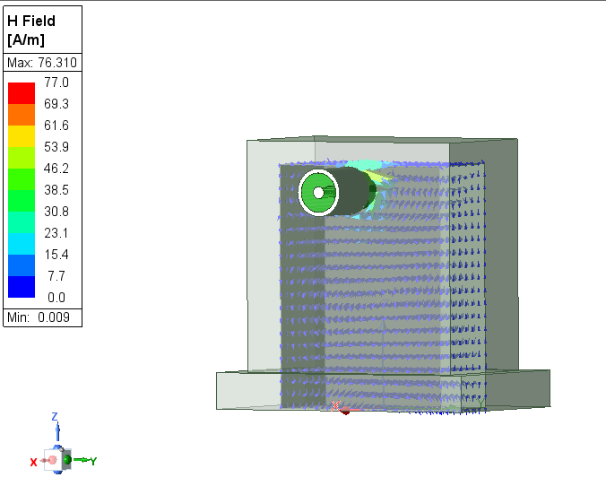

**E-field and H-field Plots:** The electric field (E-field) and magnetic field (H-field) distributions in the cross-section of the waveguide and coaxial cable were plotted.

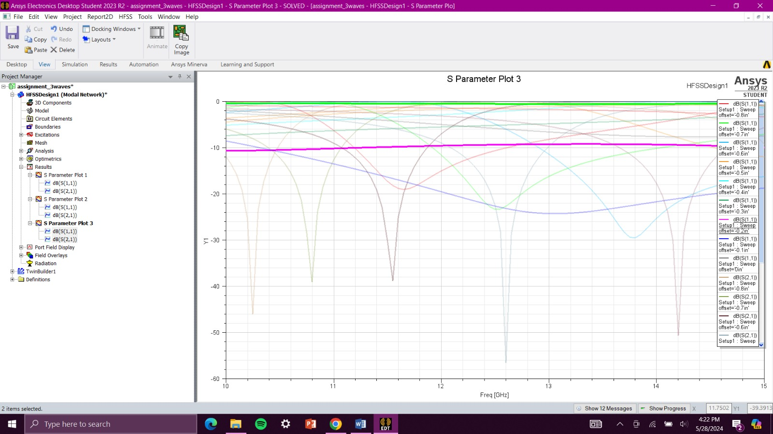**More Results:**

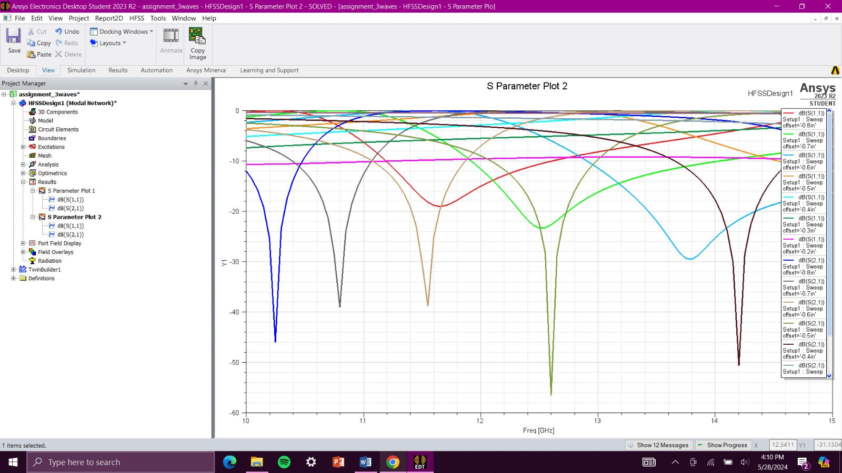

**5.Conclusion:**

The design and optimization of the WR-75 waveguide to coaxial adapter using HFSS (High-Frequency Structure Simulator) were highly successful. The adapter achieved a broad operational bandwidth of 1.5 GHz, ranging from 11.75 GHz to 13.25 GHz, with a return loss (S11) consistently below -10 dB. At the center frequency of 12.5 GHz, the adapter demonstrated a low insertion loss of only 0.51 dB. These results indicate that the adapter meets the primary design objectives of minimizing signal reflection and maximizing transmission efficiency.

The adapter's performance confirms its suitability for high-frequency applications, making it an excellent choice for systems requiring efficient energy transfer with minimal loss. The successful achievement of these design goals underscores the effectiveness of the HFSS software in optimizing complex microwave components. The broad operational bandwidth and low insertion loss are particularly noteworthy, as they enhance the adapter's versatility and efficiency in various high-frequency scenarios, including radar systems, satellite communications, and microwave relay systems.

Looking ahead, future work will aim to further enhance the adapter's performance. This will include refining the probe geometry to achieve even better impedance matching and exploring alternative materials that could offer improved electrical and thermal properties. Additionally, empirical testing will be conducted to validate the design under real-world conditions, ensuring its reliability and effectiveness in practical applications. By focusing on these areas, the goal is to push the boundaries of the current design, making the adapter even more robust and efficient for demanding microwave communication systems.