**Data Testing Assessment**

A school 'Study & Play' has different branches in India. Students appeared in 10th & 12th board have scored good marks in different subjects. 'Study & Play' wants to recognize teachers across different streams to award them for their student's performance.

'Student & Play' are looking for a data warehouse solution to do analysis on student performance in a particular branch or subject.

**Exercise -**

As a part of this exercise, use the below Student data to import in database table.

Sample Data –

|  |  |  |  |  |
| --- | --- | --- | --- | --- |
| Student Name | StudentRollNo | Class | Age | Father's Name |
| AJAY KUMAR | IETLINF01 | X | 16 | PREM KUMAR |
| RAJAT MISHRA | IETLINF02 | XI | 17 | PANKAJ MISHRA |
| SUDHEER SHARMA | IETLINF03 | IX | 15 | SUNDER SHARMA |
| NANCY KAUR | IETLINF04 | XII | 18 | AK SINGH |
| SUMITA SHARMA | IETLINF05 | IV | 14 | AJAY SHARMA |
| NANDINI GUPTA | IETLINF06 | VII | 18 | RAM GUPTA |
| RAM KUMAR | IETLINF07 | X | 16 | RAMAN KUMAR |

Tasks

1. Create above table in database and insert the data.

**CREATE TABLE Studentdata(**

**StudentName varchar(255),**

**StudentRollNo varchar(255),**

**StudentClass varchar(255),**

**Age int,**

**FatherName varchar(255)**

**);**

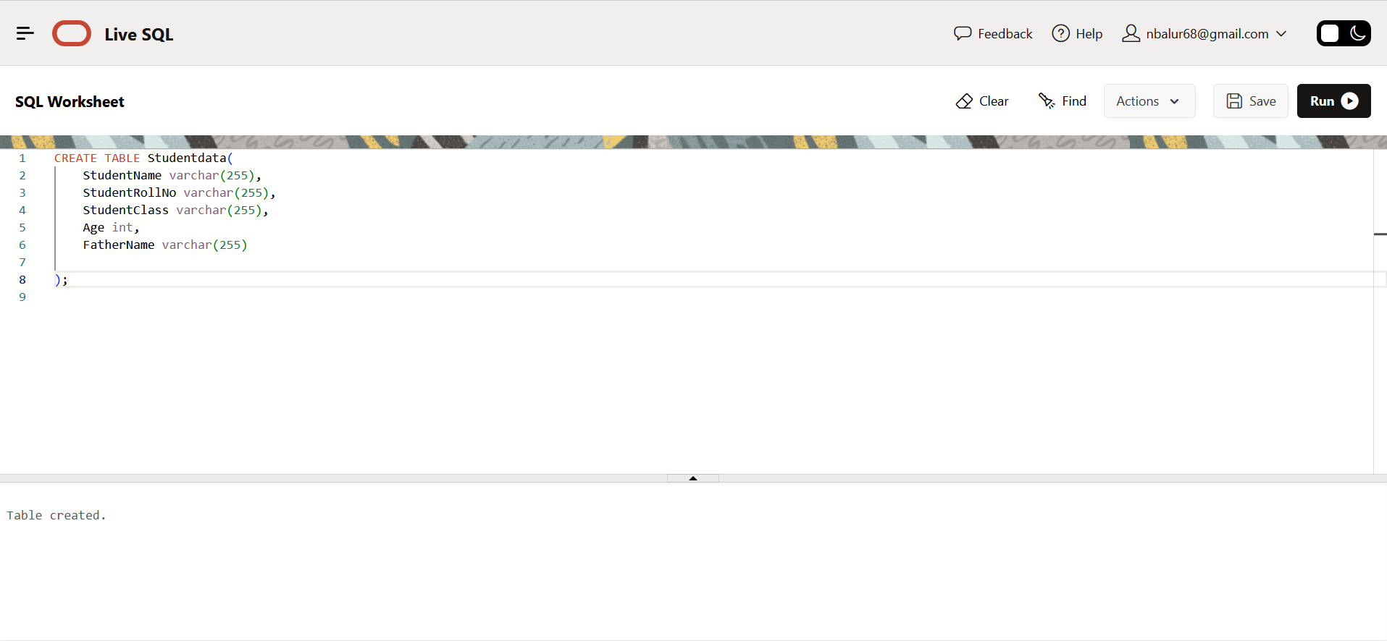

2.

INSERT INTO StudentData(StudentName,StudentRollNo,StudentClass,Age,FatherName)

VALUES('AJAY KUMAR','IETLINF01','X',16,'PREM KUMAR');

INSERT INTO StudentData(StudentName,StudentRollNo,StudentClass,Age,FatherName)

VALUES('RAJAT MISHRA','IETLINF02','XI',17,'PANKAJ MISHRA');

INSERT INTO StudentData(StudentName,StudentRollNo,StudentClass,Age,FatherName)

VALUES('SUDHEER SHARMA','IETLINF03','IX',15,'SUNDER SHARMA');

INSERT INTO StudentData(StudentName,StudentRollNo,StudentClass,Age,FatherName)

VALUES('NANCY KAUR','IETLINF04','XII',18,'AK SINGH');

INSERT INTO StudentData(StudentName,StudentRollNo,StudentClass,Age,FatherName)

VALUES('SUMITA SHARMA','IETLINF05','IV',14,'AJAY SHARMA');

INSERT INTO StudentData(StudentName,StudentRollNo,StudentClass,Age,FatherName)

VALUES('NANDINI GUPTA','IETLINF06','VII',18,'RAM GUPTA');

INSERT INTO StudentData(StudentName,StudentRollNo,StudentClass,Age,FatherName)

VALUES('RAM KUMAR','IETLINF07','X',16,'RAMAN KUMAR');

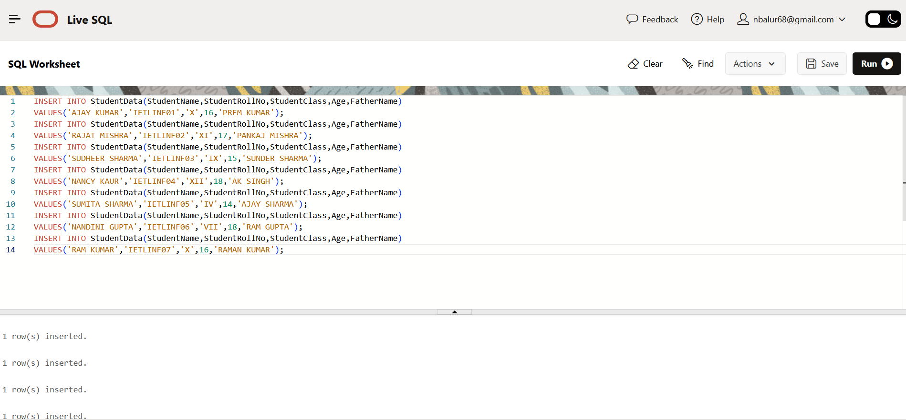

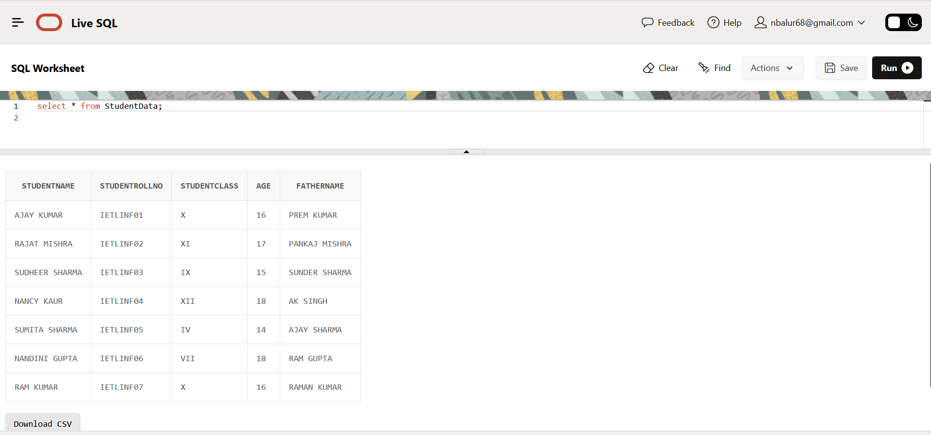

1. Write SQL query to find out total number of students in each class.

**select count(*),StudentClass from StudentData group by StudentClass order by StudentClass;**

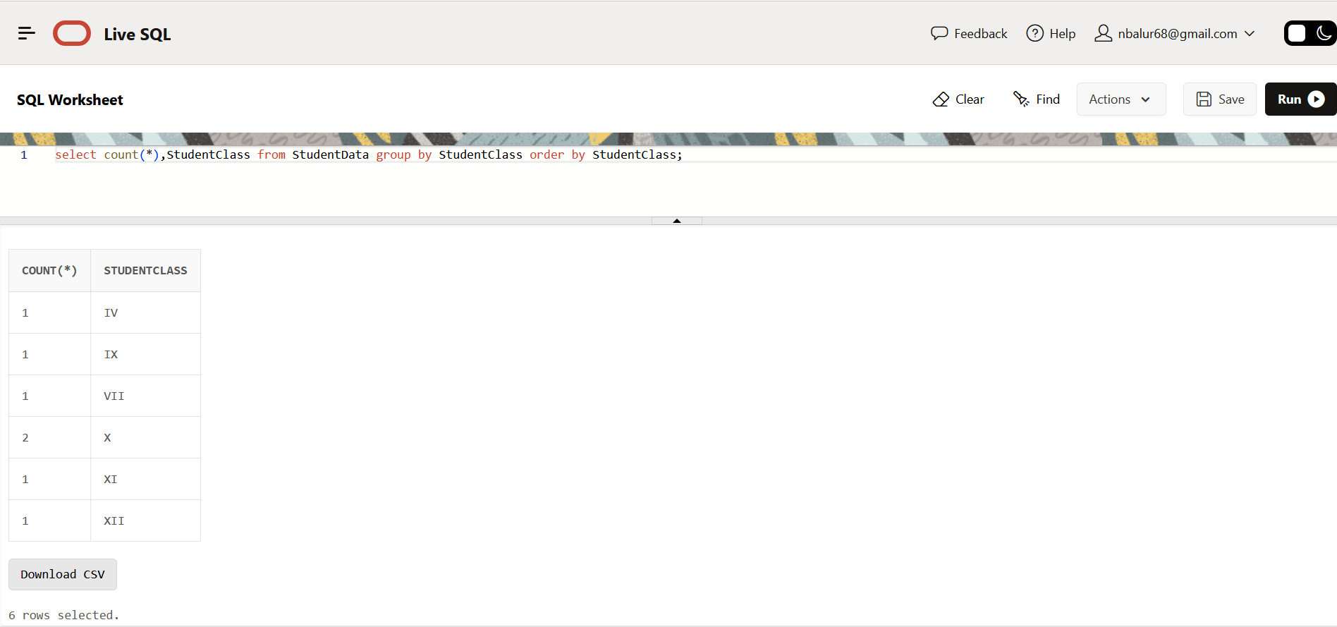

1. Write SQL query to find out average age of students in each class.

**select AVG(AGE), StudentClass from Studentdata group by StudentClass;**

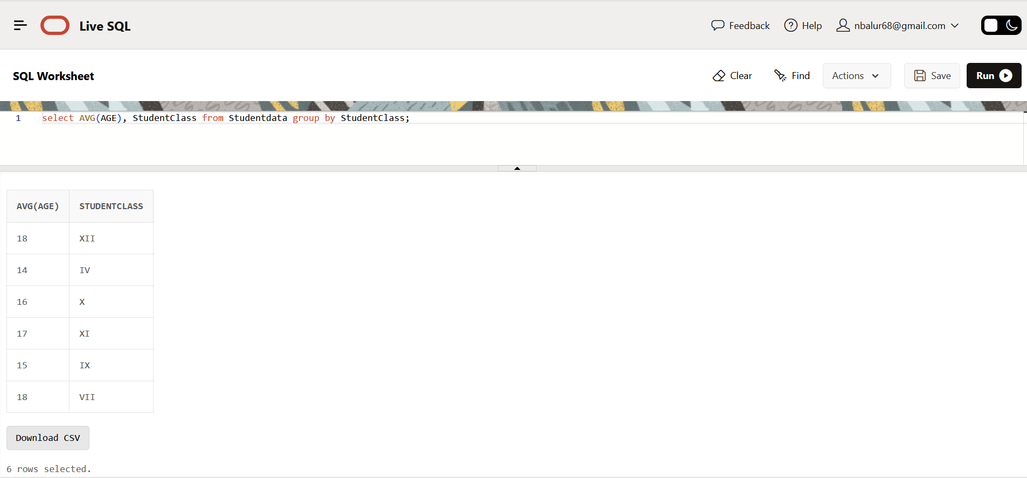

1. Write SQL query to find out the number of students having same roll no.

SELECT StudentRollNo

FROM StudentData

GROUP BY StudentRollNo

HAVING count(*) > 1;

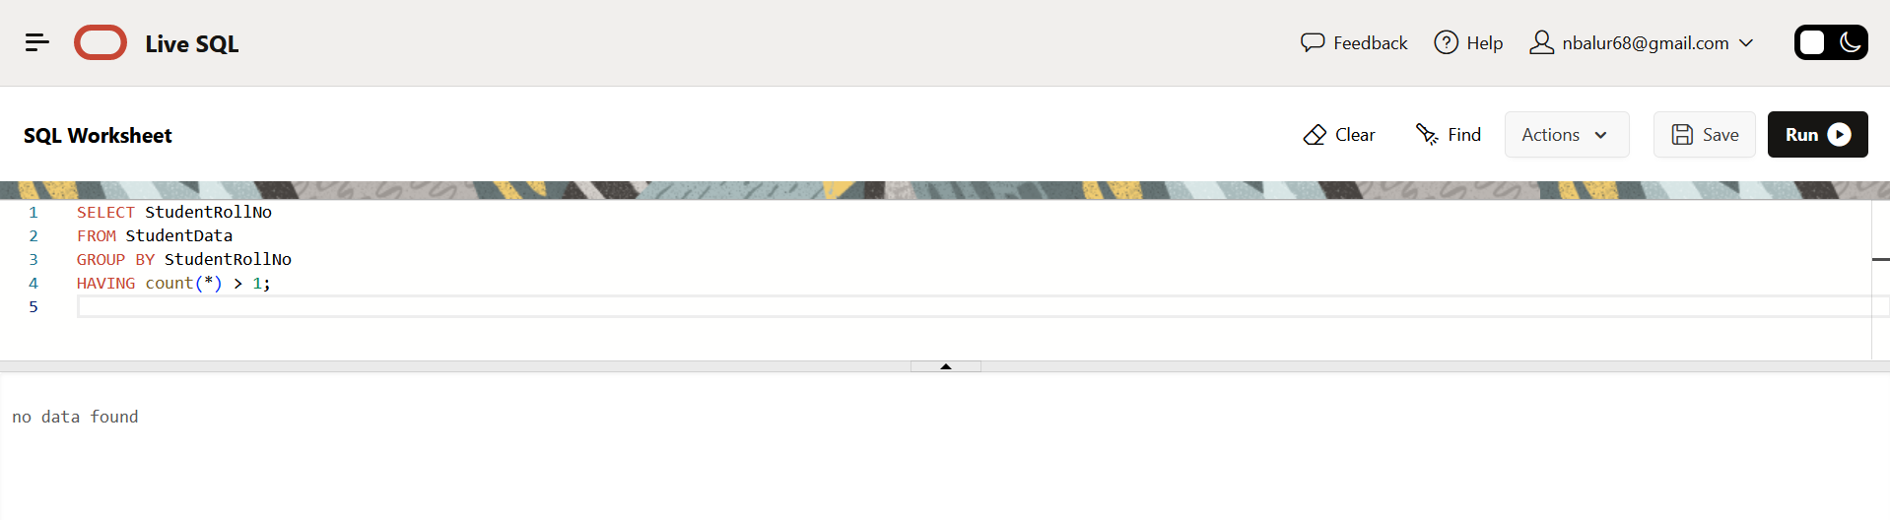

1. Write SQL query to view the duplicate name of a student from the table.

SELECT StudentName

FROM StudentData

GROUP BY StudentName

HAVING count(*) > 1;

