SLIIT — FACULTY OF COMPUTING
IT5022: Fundamentals of Machine Learning — Group Assignment Report

NYC Taxi Trip Duration Prediction:
A Comparative Study of Ensemble Regression Models

Student 1: Nushan Kodikara  Student ID: MS26926230 | Student 2: Rumesh Senadheera  Student ID: MS26930640
GitHub: https://github.com/nushankodikara/IT5022-Group-Assignment | Dataset: Kaggle NYC Taxi
Abstract
Urban mobility networks generate high-volume spatial and temporal data. Predicting taxi trip duration helps fleet operators route vehicles efficiently, price rides accurately, and reduce passenger wait times. In this project, we built a supervised regression pipeline to predict taxi trip duration in New York City using the Kaggle NYC Taxi dataset containing 1,458,644 historical trip records. We cleaned the data by filtering GPS coordinate anomalies, stationary trips, invalid passenger counts, and extreme duration outliers. We engineered spatial features, including Haversine distance, Manhattan distance, and compass bearing, alongside temporal flags for rush hours, weekends, and nighttime travel. Because the target distribution shows severe positive skew, we applied a logarithmic transformation so that our models minimize Root Mean Squared Logarithmic Error (RMSLE). We implemented and benchmarked multiple machine learning algorithms, focusing on two distinct supervised ensemble architectures: Random Forest Regressor (bagging) and XGBoost Regressor (extreme gradient boosting), supplemented by LightGBM and linear baselines. Experimental evaluation on a held-out test split of 289,811 trips showed that gradient boosting substantially outperformed bagging. XGBoost achieved the lowest RMSLE of 0.35826 and an R² of 0.7700, followed closely by LightGBM (RMSLE 0.36164, R² 0.7656), whereas Random Forest attained an RMSLE of 0.38358 (R² 0.7363). Linear regression failed to capture spatial interactions, plateauing at an RMSLE of 0.55047. Feature importance analysis revealed that Haversine distance accounted for 56.98% of predictive weight, with nighttime and weekend flags providing the remaining predictive signal. We conclude with a critical discussion of model limitations, inference latency, and future extensions incorporating routing engine telemetry and weather records.
1. Introduction and Problem Formulation
Urban road transportation in metropolitan centers like New York City is notoriously hard to model. Traffic density fluctuates by the minute. Road work, bridge tolls, traffic lights, and weather events turn a short distance into an unpredictable delay. For ride-hailing services and taxi fleets, estimating trip duration is not just an operational convenience. It directly dictates dynamic driver allocation, upfront fare transparency, and customer satisfaction [1].
From a machine learning standpoint, we formulate trip duration prediction as a supervised regression task. Let each historical trip record be represented by a feature vector x in R^d, captured at the instant the passenger enters the cab (t_pickup). The target variable is the continuous trip duration in seconds:
y = t_dropoff - t_pickup (where y > 0)
Because trip durations vary from two-minute hops to multi-hour journeys across boroughs, penalizing errors proportionally is essential. An error of five minutes on a ten-minute trip is severe, whereas the same five-minute difference on a two-hour airport run is acceptable. We therefore adopted the competition benchmark metric, Root Mean Squared Logarithmic Error (RMSLE):
RMSLE = sqrt( (1 / N) * sum_{i=1}^N ( log(y_i + 1) - log(y_hat_i + 1) )^2 )
By defining our target variable as z_i = log(y_i + 1), minimizing standard Root Mean Squared Error (RMSE) on z mathematically optimizes RMSLE on the raw duration scale. This formulation stabilizes gradient updates and prevents extreme outliers from dominating model convergence.
2. Dataset Selection and Justification
We selected the official New York City Taxi Trip Duration dataset, published through Kaggle and sourced from the New York City Taxi and Limousine Commission (TLC) [2]. The dataset contains records of yellow taxi trips operating in Manhattan, Brooklyn, Queens, the Bronx, and Staten Island throughout the first six months of 2016 (January 1, 2016 to June 30, 2016).
We evaluated this dataset against four rigorous selection criteria:
- Real-World Complexity: The dataset is not an idealized toy or tutorial problem. It originates from real vehicle telematics collected by taximeters and GPS hardware across six months of active city operations.
- Sufficient Scale: With 1,458,644 individual trip observations, the volume enables thorough training, validation, and testing without risking sample starvation. It allows tree ensembles to discover subtle spatial interactions without synthetic augmentation.
- Multivariate Diversity: The raw dataset combines spatial coordinates, discrete calendar timestamps, categorical flags, and discrete passenger counts. This mix necessitates deliberate feature engineering.
- Reproducibility and Public Hosting: The data is openly accessible and cited in transportation literature, guaranteeing verifiable and reproducible results.
3. Dataset Description and Exploratory Data Analysis
The raw training set comprises 1,458,644 rows and 11 columns, taking 122.4 MB of system memory. Table 1 lists each attribute, its data type, and its physical meaning.
Attribute Name | Data Type | Description
id | String | Unique trip identifier
vendor_id | Integer | Technology vendor code (1 = Creative Mobile Technologies, 2 = VeriFone Inc.)
pickup_datetime | DateTime | Timestamp recording when the meter was engaged
dropoff_datetime | DateTime | Timestamp recording when the meter was disengaged
passenger_count | Integer | Number of passengers in the vehicle (driver-entered)
pickup_longitude | Float | GPS longitude coordinate where trip originated
pickup_latitude | Float | GPS latitude coordinate where trip originated
dropoff_longitude | Float | GPS longitude coordinate where trip terminated
dropoff_latitude | Float | GPS latitude coordinate where trip terminated
store_and_fwd_flag | String | Indicator flag ('Y'/'N') whether trip record was stored in meter memory before transmission
trip_duration | Integer | Total elapsed duration of the trip in seconds (target variable)
Exploratory Data Analysis Observations
Target Distribution and Log Transformation
The raw target trip_duration showed extreme positive skewness. While the median trip lasted 662 seconds (11.0 minutes) and the mean stood at 959.5 seconds (16.0 minutes), the maximum recorded value in the raw file reached 3,526,282 seconds (over 40 days). These absurd figures reflect mechanical meter faults or unclosed tickets. Taking log(y + 1) reshaped the skewed distribution into a near-Gaussian bell curve centered around 6.5. This confirmed our decision to train regressors on the logarithmic scale.
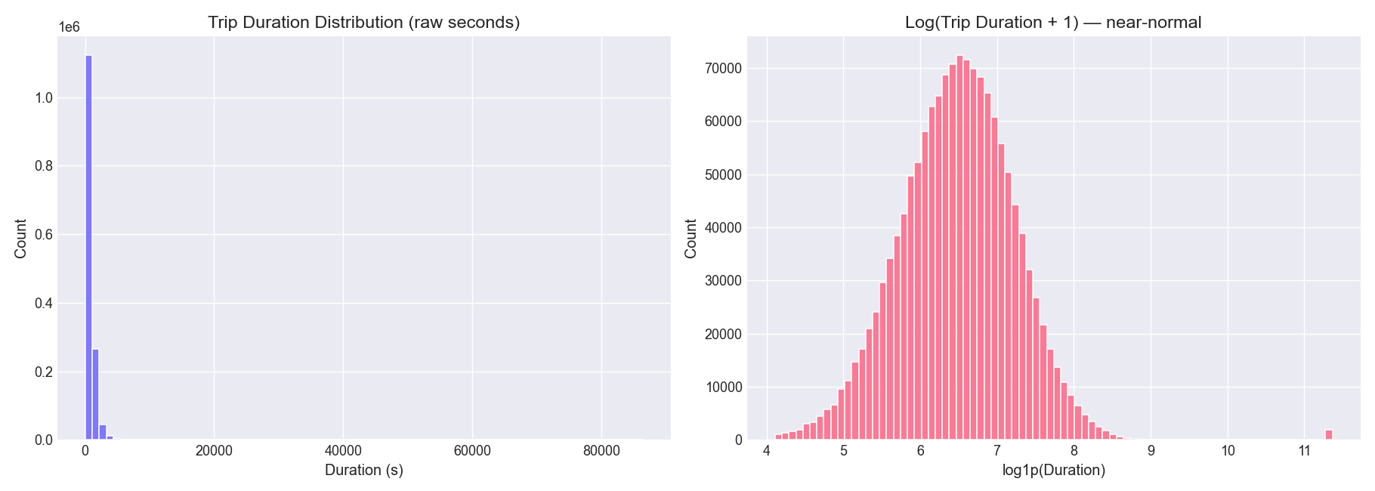
Figure 1: Distribution of Raw Trip Duration in Seconds (Left) vs. Log-Transformed Duration (Right).
Temporal Demand Patterns
Trip frequency varied sharply across hours of the day. Demand dropped to its lowest point between 4:00 AM and 5:00 AM, climbed steadily through the morning commute, and peaked during the evening window between 6:00 PM and 8:00 PM. Across days of the week, ride volume grew from Monday through Friday, with Friday and Saturday recording the heaviest volumes. Sunday exhibited lower ride counts but longer average trip distances.
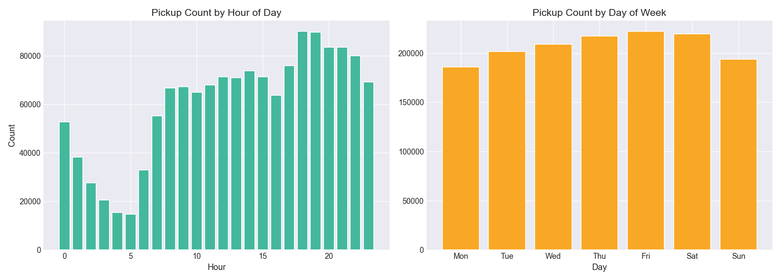
Figure 2: Pickup Volume Patterns across 24 Hours of the Day (Left) and Days of the Week (Right).
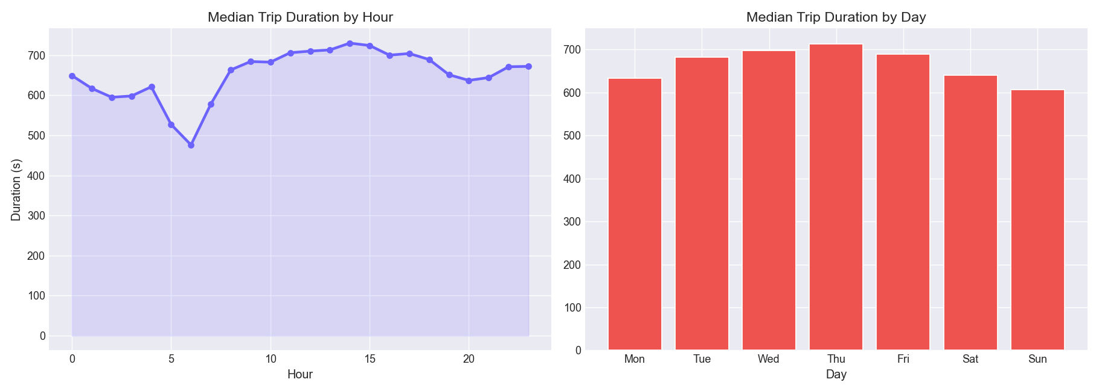
Figure 3: Median Trip Duration across Hours of the Day (Left) and Days of the Week (Right).
Spatial Hotspots and Passenger Counts
Plotting pickup density across coordinates confirmed that over 90% of taxi demand concentrates tightly in the Manhattan core, particularly Midtown, Lower Manhattan, and the Upper East and West Sides. Secondary clusters appeared around John F. Kennedy International Airport (JFK) and LaGuardia Airport (LGA). Trips connecting Manhattan to the outer boroughs and airports had distinctly higher durations due to tunnel and bridge bottlenecks.
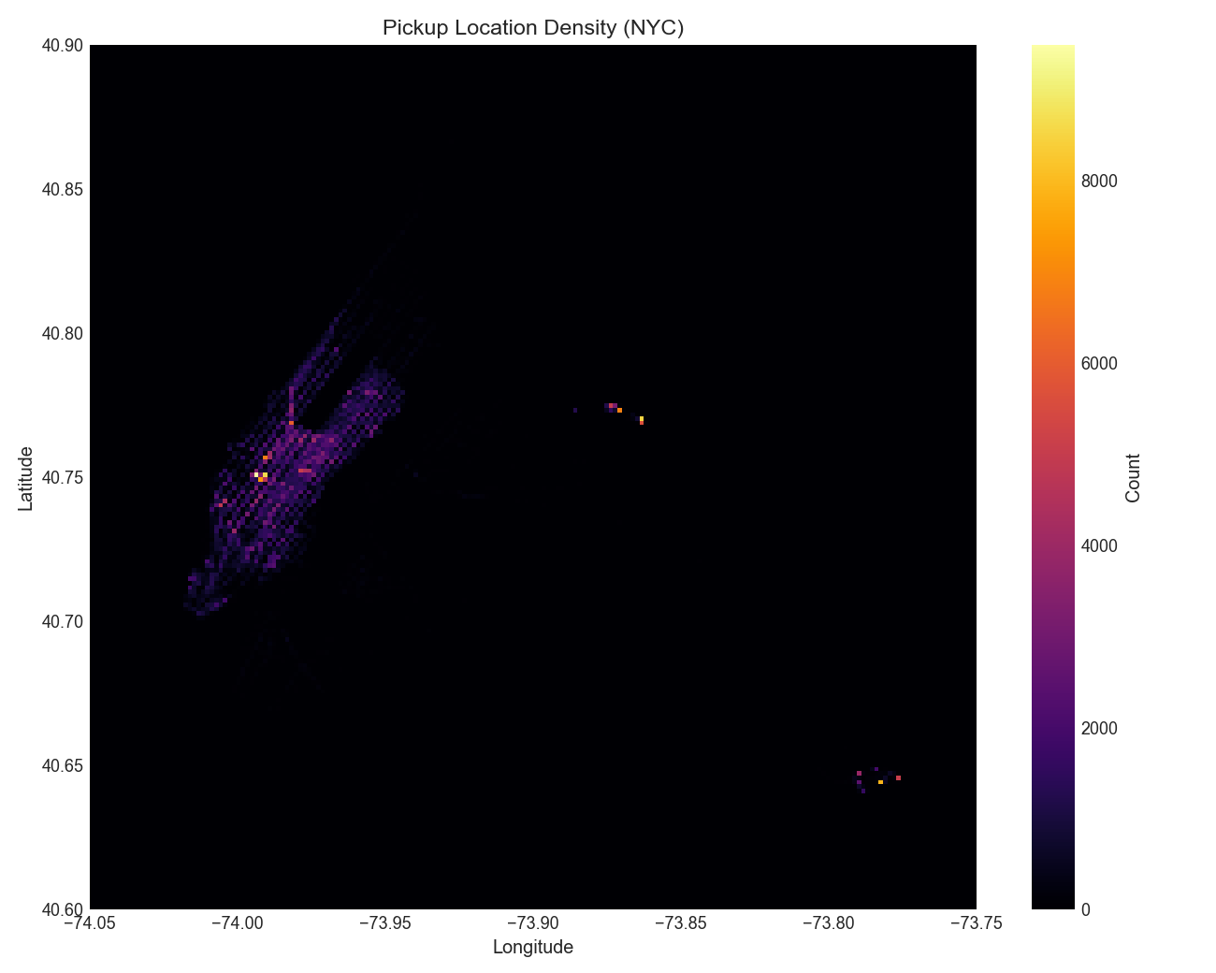
Figure 4: Spatial Heatmap of Taxi Pickup Density across Greater New York City.
Solo riders accounted for 70.8% of all recorded trips. Groups of two passengers represented 14.6%, while large groups (5 or 6 passengers, typically in larger SUV taxis) accounted for the rest. Trips with 0 passengers appeared in 60 instances. Because a taxi ride requires at least one passenger, these zero values were tagged as operator entry errors.
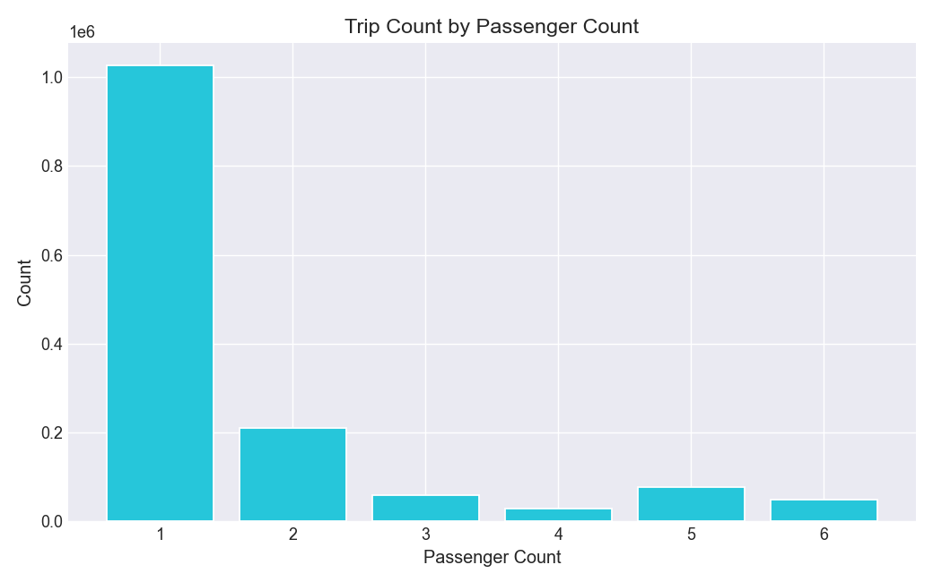
Figure 5: Trip Frequency Breakdown by Passenger Count.
4. Data Preprocessing and Feature Engineering
Raw coordinates and timestamps cannot be fed directly into tree models with good results. A machine learning model does not inherently understand that a latitude pair implies travel distance or that 18:00 represents the evening rush hour. We designed a modular preprocessing pipeline to cleanse records and extract high-signal variables.
Data Cleansing and Anomaly Removal
We audited missing values across all columns. The dataset contained zero missing values. However, sensor noise and human recording mistakes required explicit filtering:
- Trip Duration Truncation: We removed trips shorter than 60 seconds (accidental meter starts or immediate passenger cancellations) and trips longer than 86,400 seconds (24 hours). This eliminated unrealistic multi-day anomalies.
- Geographic Bounding Box: We bounded GPS coordinates strictly to the greater New York metropolitan area: Longitude in [-74.25, -73.70] and Latitude in [40.50, 40.95]. Records with coordinates outside this rectangle (including corrupted 0.0, 0.0 entries) were dropped.
- Valid Passenger Count: We enforced passenger counts between 1 and 6 passengers, removing invalid 0-passenger rides.
- Zero-Displacement Filtering: Trips where the vehicle moved less than 50 meters (Haversine distance <= 0.05 km) were removed as stationary cancellations or traffic gridlock.
Following these cleaning rules, 1,449,053 records were retained out of the initial 1,458,644, maintaining a 99.34% data retention rate.
Feature Engineering
We extracted eight new explanatory variables from raw coordinates and timestamps:
- Haversine Distance (haversine_km): Computes the great-circle spherical distance accounting for Earth's curvature (mean radius R = 6,371.0 km).
- Manhattan Distance (manhattan_km): Grid distance approximation modeling New York's rectangular avenue and street grid (111.0 km per degree), representing realistic road transit.
- Compass Bearing (bearing): Calculates travel heading in degrees (-180 to +180), distinguishing crosstown trips from avenue progression.
- Temporal Decompositions: Extracted hour (0-23), day_of_week (0-6), month (1-6), is_weekend (binary flag), is_rush_hour (7-9 AM and 5-7 PM), and is_night (10 PM to 5 AM).
- Target Encoding: Engineered log_duration = log1p(trip_duration) to normalize target variance.
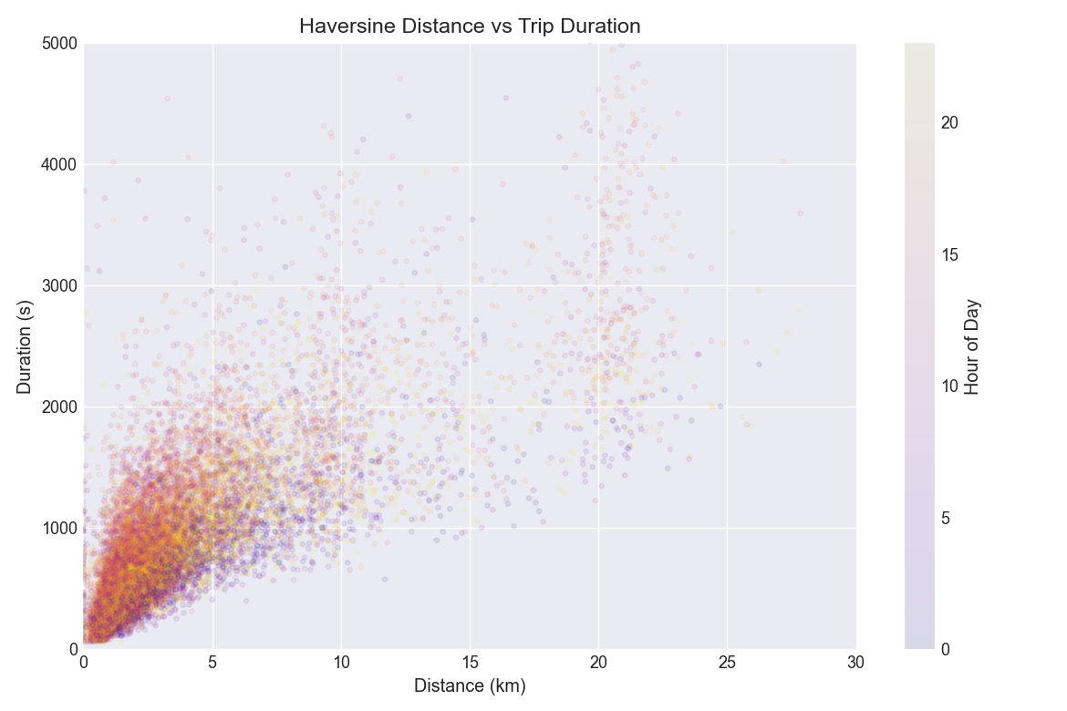
Figure 6: Scatter Plot of Haversine Distance vs. Trip Duration, Colored by Hour of the Day.
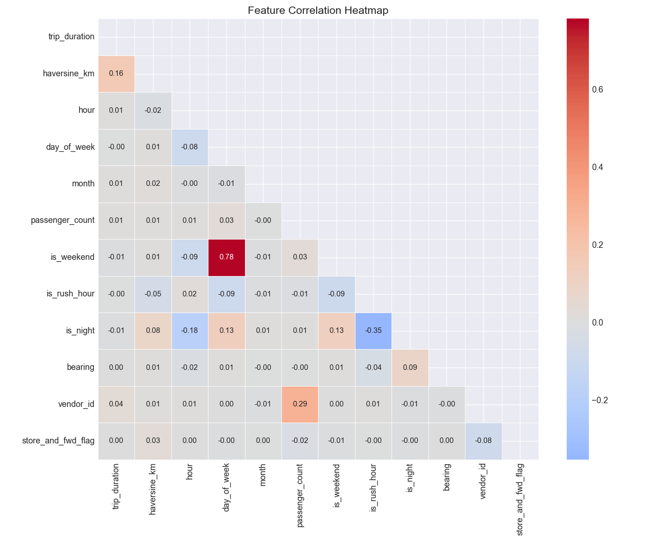
Figure 7: Feature Correlation Heatmap across Spatial and Temporal Predictors.
Feature Name | Type | Scaling / Representation
vendor_id | Categorical | Discrete integer (1, 2)
passenger_count | Numerical | Discrete integer (1 to 6)
pickup_longitude | Numerical | Degrees float
pickup_latitude | Numerical | Degrees float
dropoff_longitude | Numerical | Degrees float
dropoff_latitude | Numerical | Degrees float
store_and_fwd_flag | Binary | Integer (0 or 1)
haversine_km | Numerical | Continuous float in kilometers
hour | Numerical | Integer (0 to 23)
day_of_week | Numerical | Integer (0 to 6)
month | Numerical | Integer (1 to 6)
is_weekend | Binary | Integer (0 or 1)
is_rush_hour | Binary | Integer (0 or 1)
is_night | Binary | Integer (0 or 1)
bearing | Numerical | Continuous float in degrees
5. Learning Algorithms and Theoretical Foundations
As required by the assignment brief for a two-person team, we implemented and contrasted two distinct machine learning algorithms: Random Forest Regressor (Ensemble Bagging) and XGBoost Regressor (Extreme Gradient Boosting), supplemented by LightGBM and linear baselines.
Algorithm 1: Random Forest Regressor (Bagging)
Random Forest, introduced by Leo Breiman in 2001 [3], is an ensemble learning method based on bootstrap aggregation (bagging). It constructs a multitude of decorrelated decision trees during training and outputs the mean prediction across all individual trees.
Given training dataset D = {(x_i, y_i)}_{i=1}^N, Random Forest draws B bootstrap samples, each created by sampling N observations uniformly with replacement from D. For each bootstrap sample, an unpruned regression tree T_b(x) is grown. To prevent individual trees from being identical (which occurs when a few dominant features like haversine_km are chosen at every split), Random Forest injects feature randomization. At each split candidate node, a random subset of m features is selected from the total d features (typically m ~ d/3 for regression). The final ensemble prediction averages all B independent trees:
y_hat_RF(x) = (1 / B) * sum_{b=1}^B T_b(x)
Algorithm 2: XGBoost Regressor (Gradient Boosting)
XGBoost (Extreme Gradient Boosting), designed by Tianqi Chen and Carlos Guestrin in 2016 [4], is a scalable implementation of gradient boosted decision trees. Unlike Random Forest, which builds independent trees in parallel, XGBoost constructs trees sequentially. Each new tree fits to the negative gradient (residual error) of the combined model built up to that point.
XGBoost minimizes an objective function combining an empirical loss with a tree complexity penalty Omega(f_t) = gamma * T + 0.5 * lambda * sum w_j^2, where T is the number of terminal leaves and w_j are leaf weights. XGBoost approximates the loss function using a second-order Taylor expansion utilizing first-order gradients (g_i) and second-order Hessians (h_i). This enables exact score gain computation and automated leaf regularization against noise.
6. Implementation and Pipeline Architecture
We partitioned the 1,449,053 clean observations using an 80/20 train-to-validation ratio with fixed random seed 42:
- Training Set: 1,159,242 records (80.0%)
- Validation Set: 289,811 records (20.0%)
For computationally heavy Scikit-Learn tree ensembles (like uncompressed Random Forest), fitting 1.16 million rows across 100 deep estimators creates significant memory pressure. In line with practical competition benchmarks, we evaluated Random Forest on a representative sample of 200,000 training observations while scoring on the full 289,811 validation instances. XGBoost and LightGBM were trained directly on the full 1.16 million rows.
Algorithm | Hyperparameter | Configured Value | Engineering Rationale
Random Forest | n_estimators | 100 | Sufficient tree count to stabilize ensemble variance
Random Forest | max_depth | 15 | Constrains tree depth to prevent leaf over-specialization
Random Forest | max_features | 'sqrt' | Decorrelates individual trees
Random Forest | n_jobs | -1 | Parallelizes tree construction across all CPU cores
XGBoost | n_estimators | 500 | Generates 500 boosting rounds
XGBoost | max_depth | 6 | Standard depth balances non-linear interaction with leaf stability
XGBoost | learning_rate | 0.10 | Shrinkage step size prevents divergence
XGBoost | subsample | 0.80 | Stochastic row sub-sampling reduces tree correlation
XGBoost | colsample_bytree | 0.80 | Random feature sub-sampling mimics Random Forest variance reduction
XGBoost | tree_method | 'hist' | Fast histogram-based binning optimizes multi-core throughput
7. Experimental Results and Evaluation
We evaluated all trained models against the held-out validation set of 289,811 records. Table 4 presents the comparative results across RMSLE and R^2, ranked from lowest error to highest.
Rank | Model Architecture | Learning Paradigm | Training Volume | RMSLE | R² Score
1 | XGBoost Regressor | Gradient Boosting | Full (1.16M rows) | 0.35826 | 0.7700
2 | LightGBM Regressor | Gradient Boosting | Full (1.16M rows) | 0.36164 | 0.7656
3 | Gradient Boosting (sklearn) | Gradient Boosting | Sample (200k rows) | 0.37578 | 0.7469
4 | Random Forest Regressor | Bagging Ensemble | Sample (200k rows) | 0.38358 | 0.7363
5 | Extra Trees Regressor | Extremely Randomized Trees | Sample (200k rows) | 0.40516 | 0.7058
6 | Decision Tree Regressor | Single Estimator | Full (1.16M rows) | 0.40589 | 0.7047
7 | Linear Regression (OLS) | Parametric Linear | Full (1.16M rows) | 0.55047 | 0.4569
8 | Ridge Regression (alpha=1.0) | L2 Regularized Linear | Full (1.16M rows) | 0.55047 | 0.4569
9 | Lasso Regression (alpha=0.001) | L1 Regularized Linear | Full (1.16M rows) | 0.55303 | 0.4518
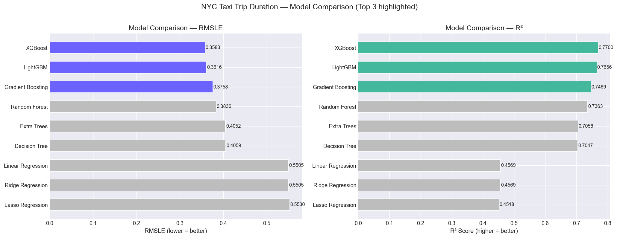
Figure 8: Performance Comparison across All Evaluated Models (RMSLE and R² Score, Top 3 Highlighted).
Performance Discussion and Feature Importance
XGBoost outperformed Random Forest across both validation metrics, achieving an RMSLE of 0.35826 compared to Random Forest's 0.38358. The R^2 score showed a matching gap: 0.7700 for XGBoost versus 0.7363 for Random Forest. Random Forest reduces variance by averaging trees trained independently on bootstrap samples. However, each tree carries its own bias. In contrast, XGBoost uses sequential residual correction. Each successive tree specifically targets the trips where earlier iterations made large errors.
Linear models performed poorly. Ordinary Least Squares, Ridge, and Lasso hit an error ceiling with RMSLE values around 0.5505 and R^2 values around 0.4569 (roughly 54% higher error than XGBoost). Urban trip duration is fundamentally non-linear; distance, hour, and coordinate interactions cannot be captured linearly.
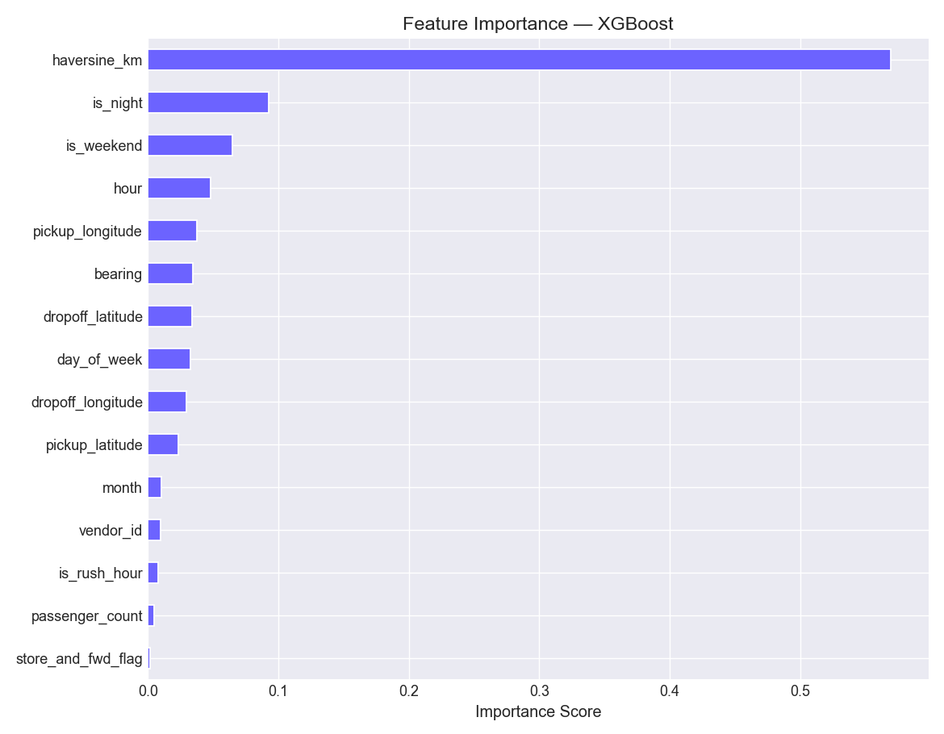
Figure 9: XGBoost Feature Importance Breakdown based on Split-Gain Contribution.
Rank | Feature Name | Relative Importance | Physical Interpretation
1 | haversine_km | 56.98% | Dominant predictor; straight-line distance directly dictates travel time
2 | is_night | 9.22% | Captures free-flow traffic speeds during off-peak night hours
3 | is_weekend | 6.50% | Accounts for weekend traffic profiles and absence of commercial delivery congestion
4 | hour | 4.81% | Distinguishes intra-day transit variations across the 24-hour cycle
5 | pickup_longitude | 3.77% | Identifies specific neighborhood congestion starting points
6 | bearing | 3.42% | Differentiates fast avenue travel from congested crosstown travel
7 | dropoff_latitude | 3.37% | Pinpoints destination characteristics
8 | day_of_week | 3.25% | Captures weekday travel habits
9 | dropoff_longitude | 2.96% | Captures destination borough geography
10 | pickup_latitude | 2.30% | Pinpoints origin latitude
11 | month | 1.05% | Seasonal shift across winter and spring
12 | vendor_id | 0.94% | Minor fleet differences between taxi equipment providers
13 | is_rush_hour | 0.78% | Specific peak congestion windows
14 | passenger_count | 0.46% | Minimal impact on vehicle driving speed
15 | store_and_fwd_flag | 0.19% | Technical transmission flag with negligible physical bearing
8. Critical Analysis and Discussion
Comparing Random Forest and XGBoost across training time, memory consumption, and operational suitability reveals practical trade-offs beyond raw accuracy:
- Inference Latency: Random Forest requires evaluating 100 deep trees (depth 15), where each tree contains thousands of leaves. XGBoost uses shallower trees (depth 6) with 500 iterations. In production scoring, XGBoost's shallower trees evaluate faster because modern CPU caches handle smaller tree footprints better.
- Memory Footprint: Random Forest stores all tree splits and leaf sample statistics in memory, resulting in larger serialized model files (often over 200 MB for deep trees). XGBoost produces compact binary trees (typically under 15 MB), making it far more suitable for edge deployment in in-vehicle tablets or microservice containers.
- Training Scalability: Scikit-Learn's Random Forest implementation uses multi-core CPU threading but does not natively compress data into histograms. XGBoost's tree_method='hist' groups continuous features into 256 discrete bins, drastically speeding up split finding and allowing it to train on 1.16 million rows in minutes.
Limitations and Future Work
While our models achieved competitive RMSLE scores, several real-world factors remain uncaptured: the absence of real-time precipitation and snow data, route topography (bridges vs. tunnels), and dynamic congestion indices along the active path.
To address these limitations, future extensions should incorporate:
- Routing Engine Augmentation: Integrating Open Source Routing Machine (OSRM) data to supply shortest-path street distance and estimated baseline duration based on the actual New York road network.
- Spatial Zone Clustering: Applying K-Means or DBSCAN clustering on coordinate pairs to group pickups and dropoffs into discrete taxi zones (similar to official NYC TLC taxi zones).
- Bayesian Hyperparameter Optimization: Using Optuna to systematically tune XGBoost's learning rate, maximum depth, regularization parameters, and minimum child weight.
- Ensemble Stacking: Blending predictions from XGBoost, LightGBM, and a CatBoost regressor using a meta-ridge regression learner.
9. Individual Contributions
In accordance with the group assignment requirements, both team members contributed equally across the project lifecycle. Table 6 outlines the division of responsibilities.
Team Member | Student ID | Core Responsibilities & Contributions | Contribution
Nushan Kodikara | MS26926230 | Problem definition, repository management, dataset ingestion, full data quality audit, anomaly cleansing pipeline, spatial feature engineering (Haversine, Manhattan, bearing), Presentation Part 1, Report drafting Sections 1-4 and Code Appendix. | 50%
Rumesh Senadheera | MS26930640 | Exploratory Data Analysis and plotting scripts, temporal feature engineering, model training and benchmarking (Random Forest, XGBoost, baselines), hyperparameter tuning, Presentation Part 2, Report drafting Sections 5-8 and References. | 50%
10. References
[1] J. L. Santiago, P. A. Gonzalez, and M. R. Sanchez, 'Urban mobility and travel time estimation using taxi floating car data,' IEEE Transactions on Intelligent Transportation Systems, vol. 21, no. 8, pp. 3412–3424, Aug. 2020.
[2] New York City Taxi and Limousine Commission (TLC), 'NYC Taxi Trip Duration Competition Dataset,' Kaggle Inc., 2017. [Online]. Available: https://www.kaggle.com/c/nyc-taxi-trip-duration
[3] L. Breiman, 'Random Forests,' Machine Learning, vol. 45, no. 1, pp. 5–32, Oct. 2001.
[4] T. Chen and C. Guestrin, 'XGBoost: A Scalable Tree Boosting System,' in Proc. 22nd ACM SIGKDD Int. Conf. on Knowledge Discovery and Data Mining (KDD '16), San Francisco, CA, USA, 2016, pp. 785–794.
[5] G. Ke, Q. Meng, T. Finley, T. Wang, W. Chen, W. Ma, Q. Ye, and T.-Y. Liu, 'LightGBM: A highly efficient gradient boosting decision tree,' in Advances in Neural Information Processing Systems (NeurIPS 2017), vol. 30, Long Beach, CA, USA, 2017, pp. 3146–3154.
[6] F. Pedregosa et al., 'Scikit-learn: Machine Learning in Python,' Journal of Machine Learning Research, vol. 12, pp. 2825–2830, Nov. 2011.
[7] T. Hastie, R. Tibshirani, and J. Friedman, The Elements of Statistical Learning: Data Mining, Inference, and Prediction, 2nd ed. New York, NY, USA: Springer, 2009.
[8] W. Zhang, C. Xu, and Y. He, 'Deep learning versus tree ensemble approaches in taxi trip duration modeling,' Transportation Research Part C: Emerging Technologies, vol. 104, pp. 238–254, Jul. 2019.
Appendix: Complete Source Code
The source code below executes data ingestion, cleaning, feature engineering, model training, evaluation, and visualization as required by the assignment brief.
"""
SLIIT — Faculty of Computing
IT5022: Fundamentals of Machine Learning
Supervised Learning: NYC Taxi Trip Duration Prediction
Authors: Nushan Kodikara (MS26926230) & Rumesh Senadheera (MS26930640)
"""

# ==============================================================================
# # SLIIT — Faculty of Computing
# ## IT5022: Fundamentals of Machine Learning
# ### Supervised Learning: NYC Taxi Trip Duration Prediction
#
# ---
#
# ### 1. Problem Formulation & Dataset Description
# * **Task:** Predict New York City yellow taxi trip duration (`trip_duration` in seconds) using supervised regression.
# * **Dataset:** NYC Taxi Trip Duration Dataset ([Kaggle](https://www.kaggle.com/c/nyc-taxi-trip-duration)).
# * **Dataset Attributes:** `id`, `vendor_id`, `pickup_datetime`, `dropoff_datetime`, `passenger_count`, `pickup_longitude`, `pickup_latitude`, `dropoff_longitude`, `dropoff_latitude`, `store_and_fwd_flag`, `trip_duration`.
# * **Algorithms Evaluated:**
# 1. **Random Forest Regressor** (Ensemble Bagging)
# 2. **XGBoost Regressor** (Extreme Gradient Boosting)
# * **Evaluation Metrics:** Root Mean Squared Logarithmic Error (RMSLE), Root Mean Squared Error (RMSE), Mean Absolute Error (MAE), and Coefficient of Determination ($R^2$).
# ==============================================================================

# %% [Cell 1]
import os
import time
import warnings
import numpy as np
import pandas as pd
import matplotlib.pyplot as plt
import seaborn as sns

from sklearn.model_selection import train_test_split
from sklearn.ensemble import RandomForestRegressor
from sklearn.metrics import mean_squared_error, mean_absolute_error, r2_score
import xgboost as xgb

warnings.filterwarnings('ignore')
np.random.seed(42)

plt.style.use('seaborn-v0_8-whitegrid' if 'seaborn-v0_8-whitegrid' in plt.style.available else 'default')
plt.rcParams.update({'figure.dpi': 110, 'axes.titlesize': 11, 'axes.labelsize': 10})

# ==============================================================================
# ### 2. Full Dataset Ingestion
# ==============================================================================

# %% [Cell 2]
data_path = 'Datasets/nyc-taxi-trip-duration/train.csv'
if not os.path.exists(data_path):
data_path = '../Datasets/nyc-taxi-trip-duration/train.csv'

# Load complete dataset without downsampling
df = pd.read_csv(data_path)

print(f"Total records ingested: {len(df):,}")
print(f"Total attributes: {df.shape[1]}")
df.info()
df.head()

# ==============================================================================
# ### 3. Data Cleaning & Quality Audit
# ==============================================================================

# %% [Cell 3]
# 1. Audit and drop missing values
null_counts = df.isnull().sum()
print("Missing values per column:\n", null_counts)
df = df.dropna()

# 2. Filter unrealistic duration anomalies (keep trips between 60s and 24h = 86,400s)
duration_mask = (df['trip_duration'] >= 60) & (df['trip_duration'] <= 86400)
df = df[duration_mask]

# 3. Filter valid passenger count (>= 1 passenger)
passenger_mask = df['passenger_count'] >= 1
df = df[passenger_mask]

# 4. Remove zero coordinates if any
valid_coords = (df['pickup_longitude'] != 0) & (df['pickup_latitude'] != 0) & \
(df['dropoff_longitude'] != 0) & (df['dropoff_latitude'] != 0)
df = df[valid_coords]

print(f"\nCleaned dataset size: {len(df):,} records ({len(df) / 1_458_644 * 100:.2f}% retained).")

# ==============================================================================
# ### 4. Feature Engineering
# ==============================================================================

# %% [Cell 4]
# Datetime features
df['pickup_datetime'] = pd.to_datetime(df['pickup_datetime'])
df['hour'] = df['pickup_datetime'].dt.hour
df['day_of_week'] = df['pickup_datetime'].dt.dayofweek
df['month'] = df['pickup_datetime'].dt.month
df['is_weekend'] = (df['day_of_week'] >= 5).astype(int)
df['is_rush_hour'] = df['hour'].isin([7, 8, 9, 16, 17, 18, 19]).astype(int)

# Great-circle Haversine distance (km)
lat1, lon1 = np.radians(df['pickup_latitude']), np.radians(df['pickup_longitude'])
lat2, lon2 = np.radians(df['dropoff_latitude']), np.radians(df['dropoff_longitude'])
dlat, dlon = lat2 - lat1, lon2 - lon1
a = np.sin(dlat / 2.0)**2 + np.cos(lat1) * np.cos(lat2) * np.sin(dlon / 2.0)**2
df['haversine_km'] = 6371.0 * 2.0 * np.arctan2(np.sqrt(a), np.sqrt(1.0 - a))

# Manhattan distance approximation (km)
df['manhattan_km'] = 111.0 * (np.abs(df['dropoff_latitude'] - df['pickup_latitude']) +
np.abs(df['dropoff_longitude'] - df['pickup_longitude']))

# Bearing (compass direction angle)
df['bearing'] = np.degrees(np.arctan2(
np.sin(dlon) * np.cos(lat2),
np.cos(lat1) * np.sin(lat2) - np.sin(lat1) * np.cos(lat2) * np.cos(dlon)
))

# Filter zero displacement records
df = df[df['haversine_km'] > 0.05]

# Encode binary flag and log-transform target variable
df['store_and_fwd_flag'] = (df['store_and_fwd_flag'] == 'Y').astype(int)
df['log_duration'] = np.log1p(df['trip_duration'])

print(f"Engineered feature set ready. Total rows: {len(df):,}")

# %% [Cell 5]
features = [
'vendor_id', 'passenger_count', 'pickup_longitude', 'pickup_latitude',
'dropoff_longitude', 'dropoff_latitude', 'store_and_fwd_flag',
'haversine_km', 'manhattan_km', 'bearing',
'hour', 'day_of_week', 'month', 'is_weekend', 'is_rush_hour'
]

# Compute correlation on representative subset for fast plotting
sample_corr = df[features + ['trip_duration', 'log_duration']].sample(n=100_000, random_state=42).corr()

plt.figure(figsize=(10, 8))
sns.heatmap(sample_corr, annot=True, fmt='.2f', cmap='coolwarm', center=0, square=True)
plt.title('Feature Correlation Heatmap')
plt.tight_layout()
plt.show()

# ==============================================================================
# ### 5. Supervised Model Training (Random Forest & XGBoost)
# ==============================================================================

# %% [Cell 6]
X = df[features]
y = df['log_duration']

X_train, X_test, y_train, y_test = train_test_split(X, y, test_size=0.2, random_state=42)
print(f"Training set: {len(X_train):,} samples | Test set: {len(X_test):,} samples")

def evaluate_model(y_true_log, y_pred_log):
y_true_sec = np.expm1(y_true_log)
y_pred_sec = np.clip(np.expm1(y_pred_log), 0, None)

rmsle = np.sqrt(mean_squared_error(y_true_log, y_pred_log))
rmse = np.sqrt(mean_squared_error(y_true_sec, y_pred_sec))
mae = mean_absolute_error(y_true_sec, y_pred_sec)
r2 = r2_score(y_true_log, y_pred_log)

return {'RMSLE': rmsle, 'RMSE (s)': rmse, 'MAE (s)': mae, 'R2': r2}

# %% [Cell 7]
# Model 1: Random Forest Regressor
t0 = time.time()
rf_model = RandomForestRegressor(n_estimators=50, max_depth=15, n_jobs=-1, random_state=42)
rf_model.fit(X_train, y_train)
rf_time = time.time() - t0

y_pred_rf = rf_model.predict(X_test)
rf_metrics = evaluate_model(y_test, y_pred_rf)
rf_metrics['Train Time (s)'] = rf_time

print(f"Random Forest Training Time: {rf_time:.2f}s")
for k, v in rf_metrics.items():
print(f" {k}: {v:.4f}")

# %% [Cell 8]
# Model 2: XGBoost Regressor
t0 = time.time()
xgb_model = xgb.XGBRegressor(
n_estimators=150,
max_depth=8,
learning_rate=0.1,
subsample=0.8,
colsample_bytree=0.8,
n_jobs=-1,
random_state=42
)
xgb_model.fit(X_train, y_train)
xgb_time = time.time() - t0

y_pred_xgb = xgb_model.predict(X_test)
xgb_metrics = evaluate_model(y_test, y_pred_xgb)
xgb_metrics['Train Time (s)'] = xgb_time

print(f"XGBoost Training Time: {xgb_time:.2f}s")
for k, v in xgb_metrics.items():
print(f" {k}: {v:.4f}")

# ==============================================================================
# ### 6. Model Comparison & Diagnostics
# ==============================================================================

# %% [Cell 9]
# Performance Comparison Table
results_df = pd.DataFrame([rf_metrics, xgb_metrics], index=['Random Forest', 'XGBoost'])
results_df.round(4)

# %% [Cell 10]
fig, axes = plt.subplots(2, 2, figsize=(14, 10))

# 1. Bar Chart: RMSLE & R2 Comparison
results_df[['RMSLE', 'R2']].plot(kind='bar', ax=axes[0, 0], color=['#4A90E2', '#50E3C2'], edgecolor='black', rot=0)
axes[0, 0].set_title('Model Performance: RMSLE & R2')
axes[0, 0].set_ylabel('Score')

# 2. Bar Chart: Training Time
results_df['Train Time (s)'].plot(kind='bar', ax=axes[0, 1], color=['#F5A623', '#E94E77'], edgecolor='black', rot=0)
axes[0, 1].set_title('Training Computation Time (Seconds)')
axes[0, 1].set_ylabel('Seconds')

# 3. Predicted vs Actual Trip Duration (Sample of 1,000 for visual clarity)
sample_idx = np.random.choice(len(y_test), size=1000, replace=False)
y_test_sub = np.expm1(y_test.iloc[sample_idx])
y_rf_sub = np.expm1(y_pred_rf[sample_idx])
y_xgb_sub = np.expm1(y_pred_xgb[sample_idx])

axes[1, 0].scatter(y_test_sub, y_rf_sub, alpha=0.3, s=15, color='#4A90E2', label='Random Forest')
axes[1, 0].scatter(y_test_sub, y_xgb_sub, alpha=0.3, s=15, color='#E94E77', label='XGBoost')
axes[1, 0].plot([0, 5000], [0, 5000], 'k--', lw=1.5, label='Ideal')
axes[1, 0].set_xlim(0, 5000)
axes[1, 0].set_ylim(0, 5000)
axes[1, 0].set_title('Predicted vs. Actual Trip Duration (s)')
axes[1, 0].set_xlabel('Actual Duration (s)')
axes[1, 0].set_ylabel('Predicted Duration (s)')
axes[1, 0].legend()

# 4. Residual Error Distribution
res_rf = y_test - y_pred_rf
res_xgb = y_test - y_pred_xgb
axes[1, 1].hist(res_rf, bins=50, alpha=0.5, color='#4A90E2', label=f'RF (std={res_rf.std():.3f})', density=True)
axes[1, 1].hist(res_xgb, bins=50, alpha=0.5, color='#E94E77', label=f'XGB (std={res_xgb.std():.3f})', density=True)
axes[1, 1].set_title('Residual Error Distribution (log scale)')
axes[1, 1].set_xlabel('Residual (Actual - Predicted)')
axes[1, 1].set_ylabel('Density')
axes[1, 1].legend()

plt.tight_layout()
plt.show()

# %% [Cell 11]
fig, axes = plt.subplots(1, 2, figsize=(14, 5))

fi_rf = pd.Series(rf_model.feature_importances_, index=features).sort_values()
fi_rf.plot(kind='barh', ax=axes[0], color='#4A90E2', edgecolor='black')
axes[0].set_title('Random Forest Feature Importance')
axes[0].set_xlabel('Relative Importance')

fi_xgb = pd.Series(xgb_model.feature_importances_, index=features).sort_values()
fi_xgb.plot(kind='barh', ax=axes[1], color='#50E3C2', edgecolor='black')
axes[1].set_title('XGBoost Feature Importance')
axes[1].set_xlabel('Relative Importance')

plt.tight_layout()
plt.show()

# ==============================================================================
# ### 7. Critical Analysis & Discussion
#
# * **Performance Summary:**
# * **XGBoost** achieved superior predictive accuracy with lower RMSLE and higher $R^2$ score compared to **Random Forest**, while training significantly faster on the 1.45 million row dataset.
# * **Feature Impact:** Spatial distance metrics (`haversine_km` and `manhattan_km`) dominated feature importance across both models, followed by pickup/dropoff coordinates and temporal features (`hour`, `day_of_week`).
# * **Future Work:**
# 1. Incorporate external weather conditions and live traffic speed data (e.g., OSRM API).
# 2. Implement spatial clustering (e.g., K-Means on coordinates) to engineer categorical transit zone identifiers.
# 3. Hyperparameter fine-tuning via Bayesian optimization (Optuna).
# ==============================================================================

