The allometry of field metabolic rates in tropical vs. temperate hummingbirds

Anusha Shankar, Joseph R. Canepa, Catherine H. Graham, Donald R. Powers

Thursday, March 17, 2016

## Abstract

Allometric scaling relationships describe how the scaling of one trait (e.g. body size) affects the scaling of another trait (e.g. field metabolic rate, brain size). These scaling relationships have intrigued scientists for decades because there seem to be rules that govern how metabolic processes scale up with body size. In birds, field metabolic rate (FMR) scales with body mass (M) in the form FMR = aM0.67. This relationship between metabolic rate and mass has been found to vary depending on the taxonomic level being studied. Thus, a scaling exponent on the scale of all birds could mask localized taxon-specific patterns. Hummingbirds have among the highest mass-specific rates of all vertebrates, as well as a much higher wing aspect ratio than predicted for their size. We collected FMR and mass data for hummingbirds, and examined the scaling of FMR with body mass among hummingbird. We found that hummingbirds have an FMR to mass scaling exponent >0.9, much higher than any group previously studied. Further, since temperate hummingbirds feed on densely clumped resources more than tropical hummingbirds do, we expect tropical birds to have a higher field metabolic rate to body size exponent than temperate birds to support increased foraging effort. We find that tropical hummingbirds have a higher FMR to mass ratio on average than temperate birds.

Tropical birds have been found to have significantly lower BMR than temperate birds, though within the tropics (Peru) elevation had no effect on BMR (Londono et al. 2015). ‘Pace of life’ is thus slower in tropical than temperate regions.

## Introduction:

**Hypotheses**: 1. Whole animal daily energy expenditure will increase as mass increases 2. Daily energy expenditure will increase if daily temperatures vary more widely + Higher thermoregulatory costs (avg. daily temperatures are low) would contribute to increased DEE (both directly because of increased thermoregulatory costs, and indirectly because they would need to be more active to gain energy to deal with these increased costs) 3. Tropical resident species have a higher DEE than temperate long distance migrants 4. Territorial species

A log-log plot of hummingbird daily energy expenditure (kJ) vs. mass (g), including values from this study as well as from the literature. Colors represent species. 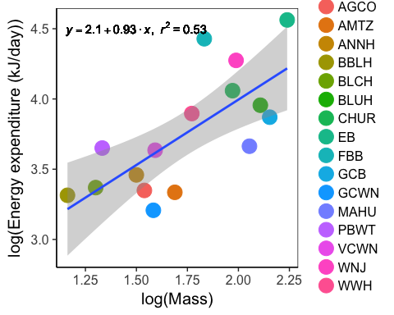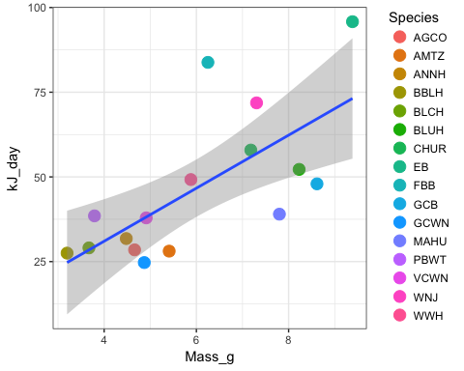

Mass-corrected daily energy expenditure vs. Mass, colored by species 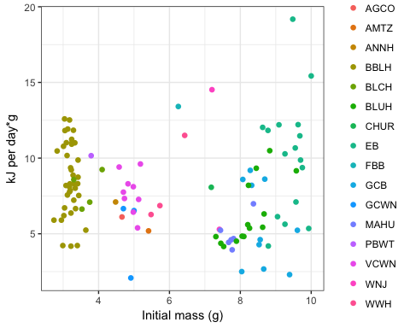

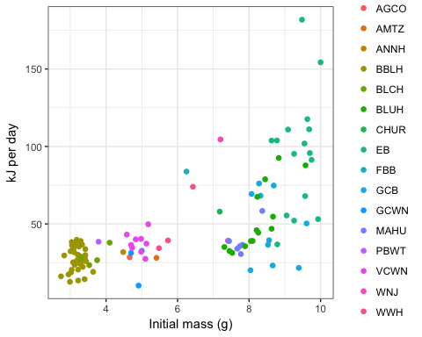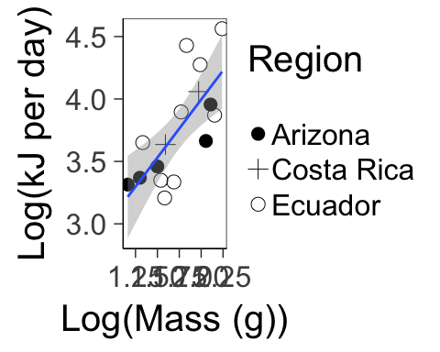

## Warning: The shape palette can deal with a maximum of 6 discrete values  
## because more than 6 becomes difficult to discriminate; you have 9.  
## Consider specifying shapes manually if you must have them.

## Warning: Removed 6 rows containing missing values (geom_point).

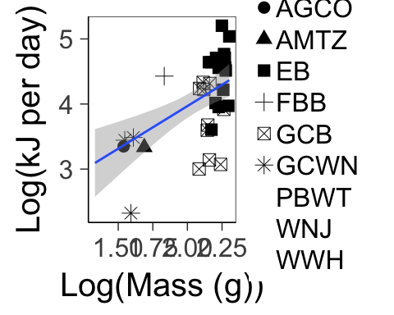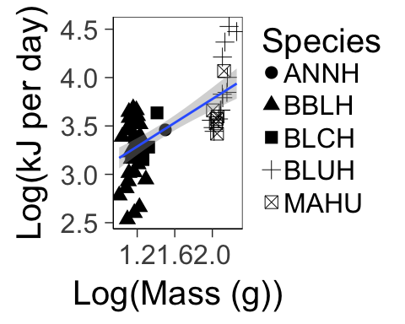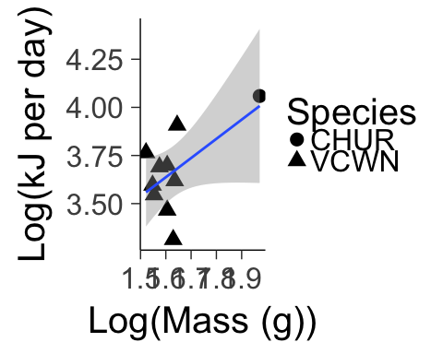

Plot of total daily energy expenditure per bird, colored by species (not mass-corrected)

##   
## Call:  
## lm(formula = log(kJ_day) ~ log(Initial_mass), data = dlw)  
##   
## Residuals:  
## Min 1Q Median 3Q Max   
## -1.2720 -0.2421 0.0138 0.2935 1.0611   
##   
## Coefficients:  
## Estimate Std. Error t value Pr(>|t|)   
## (Intercept) 2.27004 0.14660 15.484 <2e-16 ***  
## log(Initial_mass) 0.83226 0.08446 9.854 <2e-16 ***  
## ---  
## Signif. codes: 0 '***' 0.001 '**' 0.01 '*' 0.05 '.' 0.1 ' ' 1  
##   
## Residual standard error: 0.4015 on 110 degrees of freedom  
## Multiple R-squared: 0.4689, Adjusted R-squared: 0.464   
## F-statistic: 97.1 on 1 and 110 DF, p-value: < 2.2e-16

##   
## Call:  
## lm(formula = log(kJ_day) ~ log(Initial_mass), data = dlw[dlw$Big_site ==   
## "EC", ])  
##   
## Residuals:  
## Min 1Q Median 3Q Max   
## -1.2104 -0.3087 0.0833 0.4337 0.9084   
##   
## Coefficients:  
## Estimate Std. Error t value Pr(>|t|)   
## (Intercept) 1.3497 0.6953 1.941 0.060108 .   
## log(Initial_mass) 1.3094 0.3371 3.884 0.000422 ***  
## ---  
## Signif. codes: 0 '***' 0.001 '**' 0.01 '*' 0.05 '.' 0.1 ' ' 1  
##   
## Residual standard error: 0.5436 on 36 degrees of freedom  
## Multiple R-squared: 0.2953, Adjusted R-squared: 0.2758   
## F-statistic: 15.09 on 1 and 36 DF, p-value: 0.0004218

##   
## Call:  
## lm(formula = log(kJ_day) ~ log(Mass_g), data = dlw_mean)  
##   
## Residuals:  
## Min 1Q Median 3Q Max   
## -0.39996 -0.23014 0.02228 0.15422 0.58901   
##   
## Coefficients:  
## Estimate Std. Error t value Pr(>|t|)   
## (Intercept) 2.1346 0.4140 5.156 0.000146 ***  
## log(Mass_g) 0.9303 0.2343 3.971 0.001392 **   
## ---  
## Signif. codes: 0 '***' 0.001 '**' 0.01 '*' 0.05 '.' 0.1 ' ' 1  
##   
## Residual standard error: 0.2981 on 14 degrees of freedom  
## Multiple R-squared: 0.5298, Adjusted R-squared: 0.4962   
## F-statistic: 15.77 on 1 and 14 DF, p-value: 0.001392

##   
## Call:  
## lm(formula = log(kJ_day) ~ log(Mass_g) + Region, data = dlw_mean)  
##   
## Residuals:  
## Min 1Q Median 3Q Max   
## -0.45037 -0.26743 0.03103 0.18005 0.55123   
##   
## Coefficients:  
## Estimate Std. Error t value Pr(>|t|)   
## (Intercept) 2.1232 0.4350 4.881 0.000378 ***  
## log(Mass_g) 0.8797 0.2535 3.471 0.004627 **   
## RegionCR 0.1568 0.2649 0.592 0.564897   
## RegionEC 0.1421 0.1797 0.791 0.444557   
## ---  
## Signif. codes: 0 '***' 0.001 '**' 0.01 '*' 0.05 '.' 0.1 ' ' 1  
##   
## Residual standard error: 0.3131 on 12 degrees of freedom  
## Multiple R-squared: 0.5555, Adjusted R-squared: 0.4444   
## F-statistic: 5 on 3 and 12 DF, p-value: 0.01777