Back4App

Signup with [nushrat.tuli666@gmail.com](mailto:nushrat.tuli666@gmail.com)

Build new app

App name-AC-TwitterClone

Server settings

Core settings-settings

Google-android studio archive

Agree terms and condition

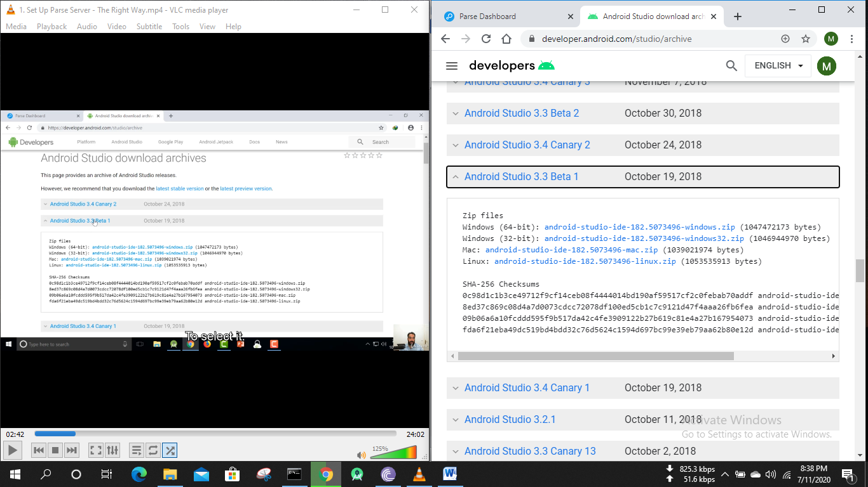

Android studio- new project- AC_TwitterClone

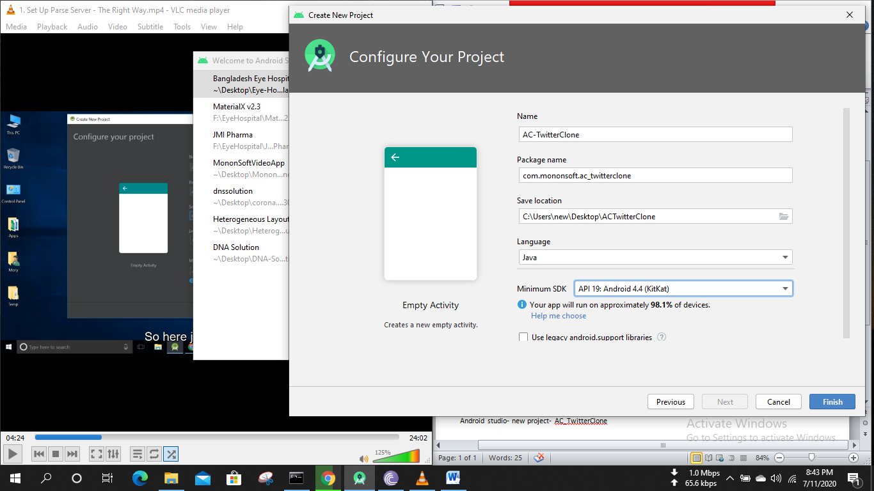

Back4App- helps- guide  
android- install parse sdk

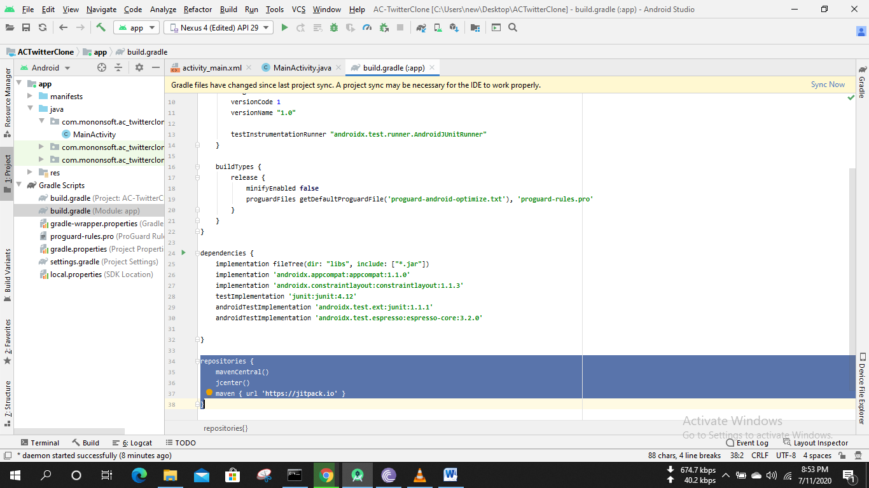

repositories **{** mavenCentral()  
 jcenter()  
 maven **{** url **'https://jitpack.io' }  
}**

sync now

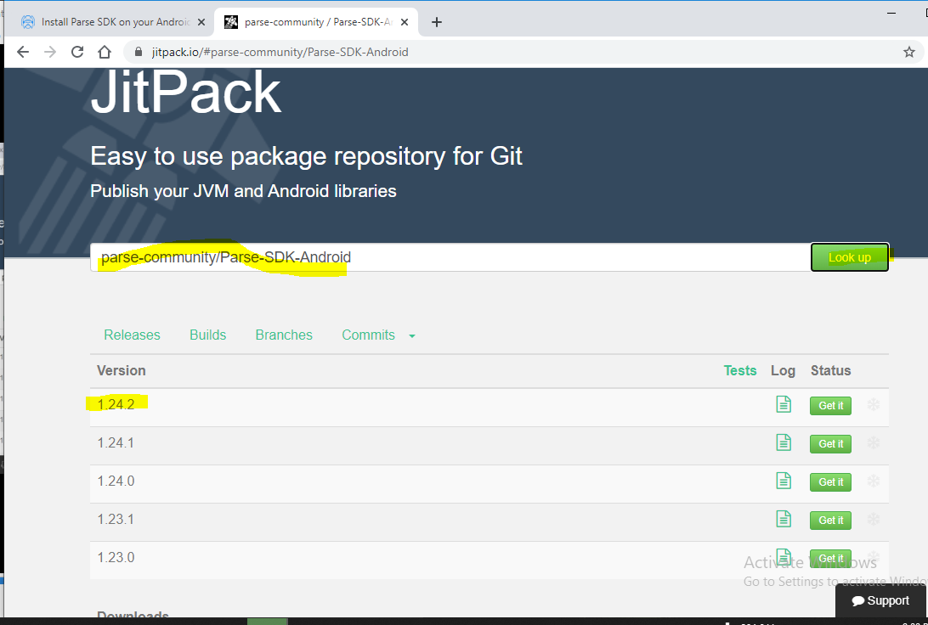

implementation **"com.github.parse-community.Parse-SDK-Android:parse:1.24.2"**

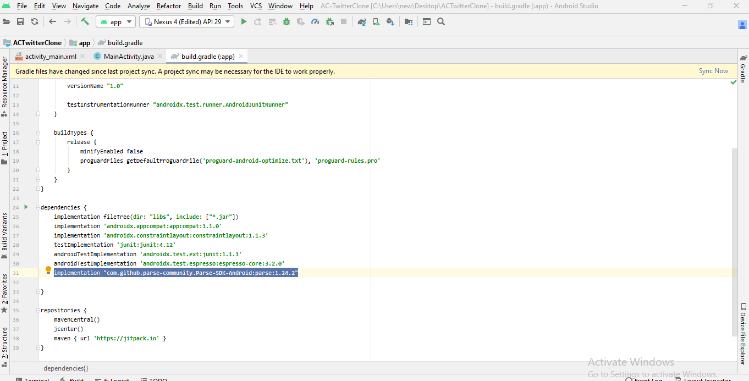

Sync now

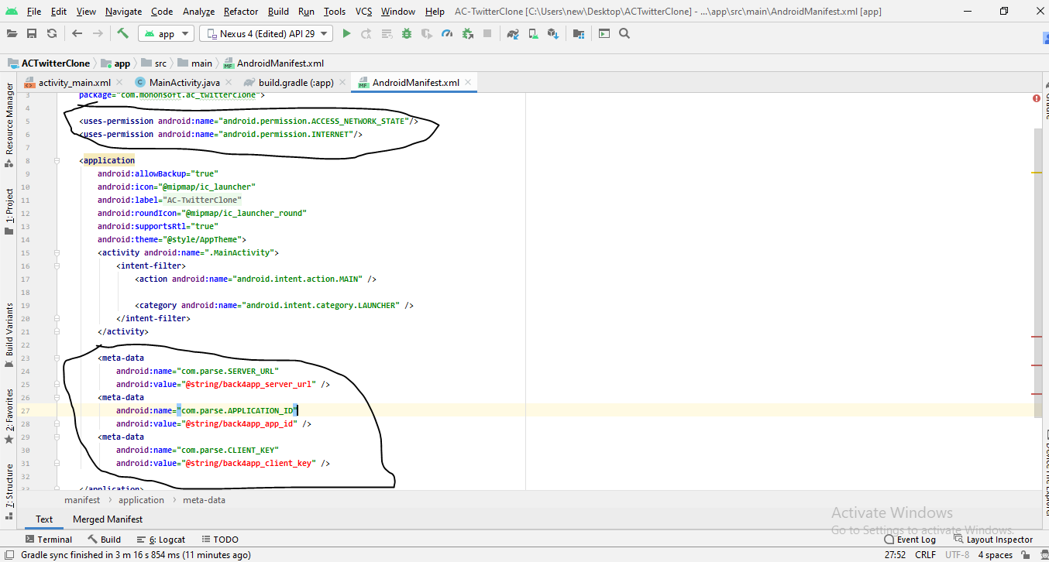

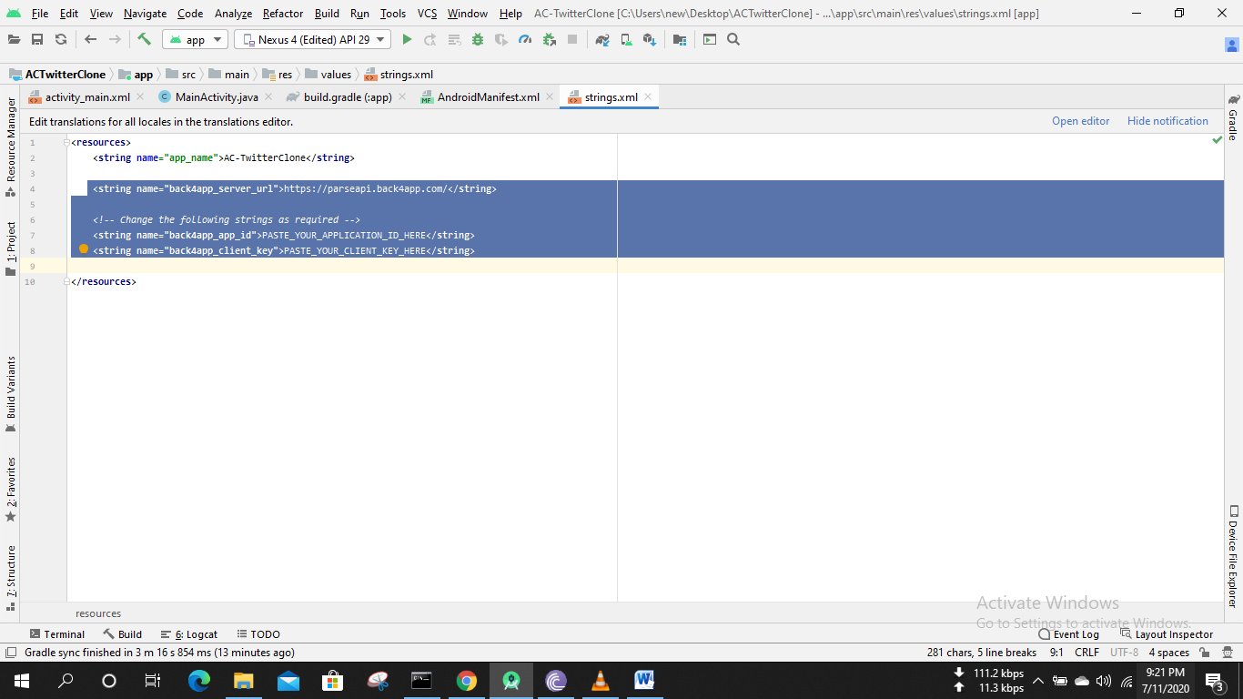

Back4app- myapp- serversetting-core setting

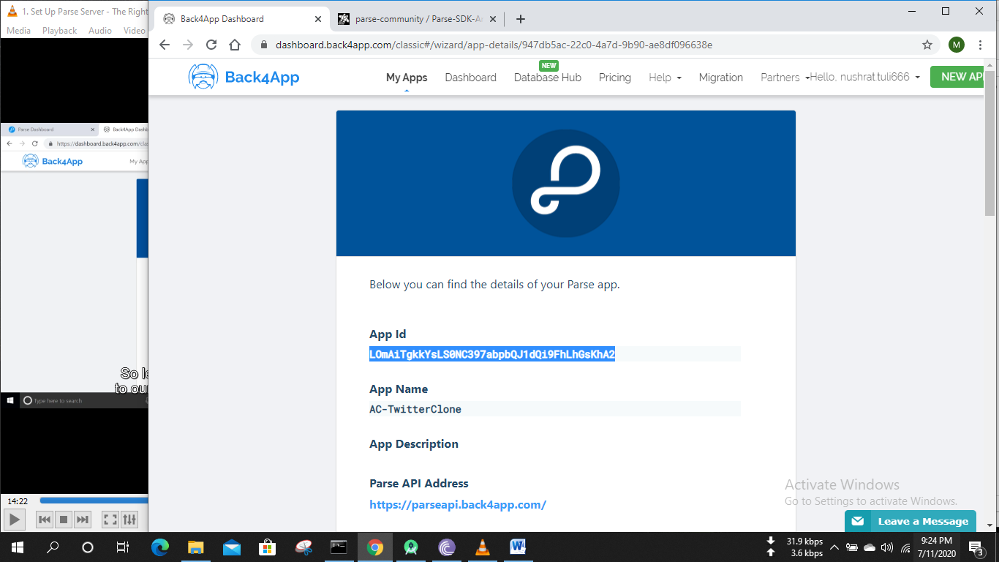

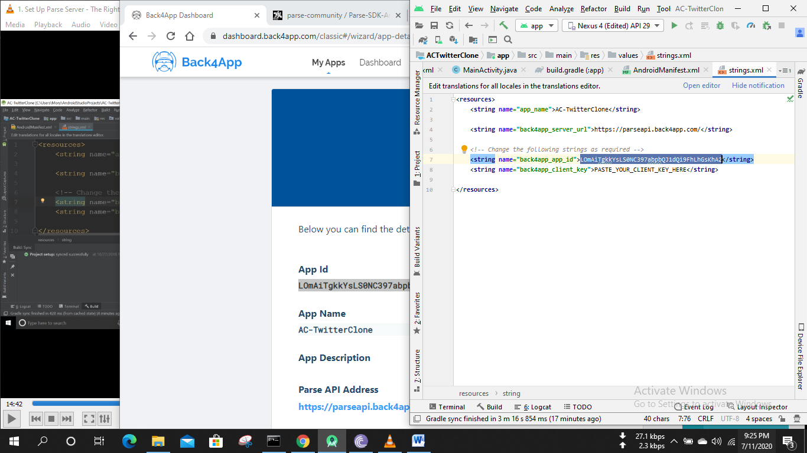

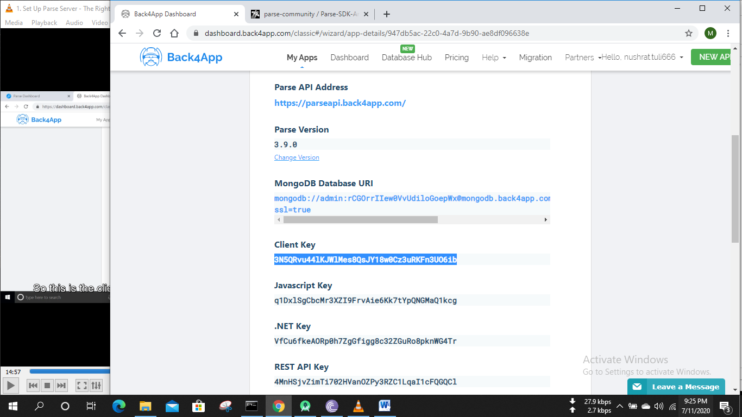

Build – rebuild project

Java class-App

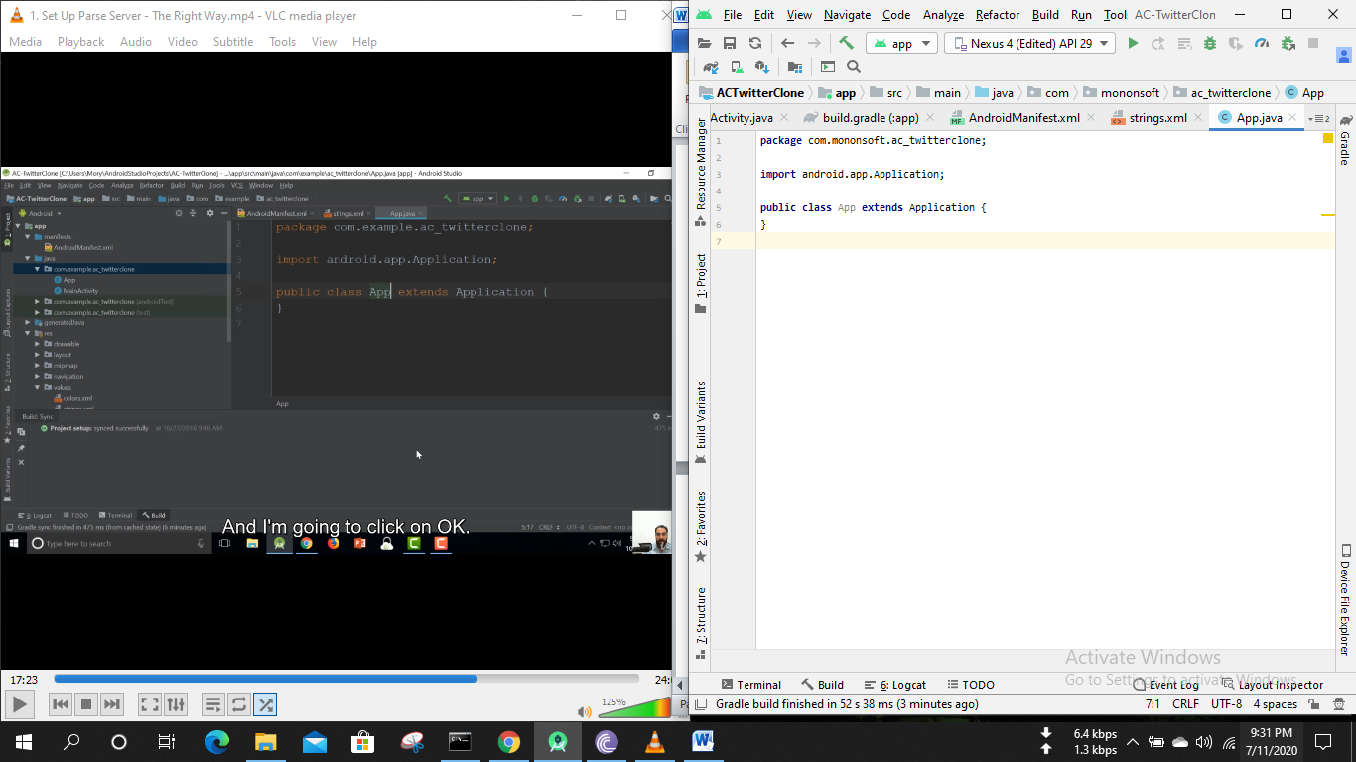

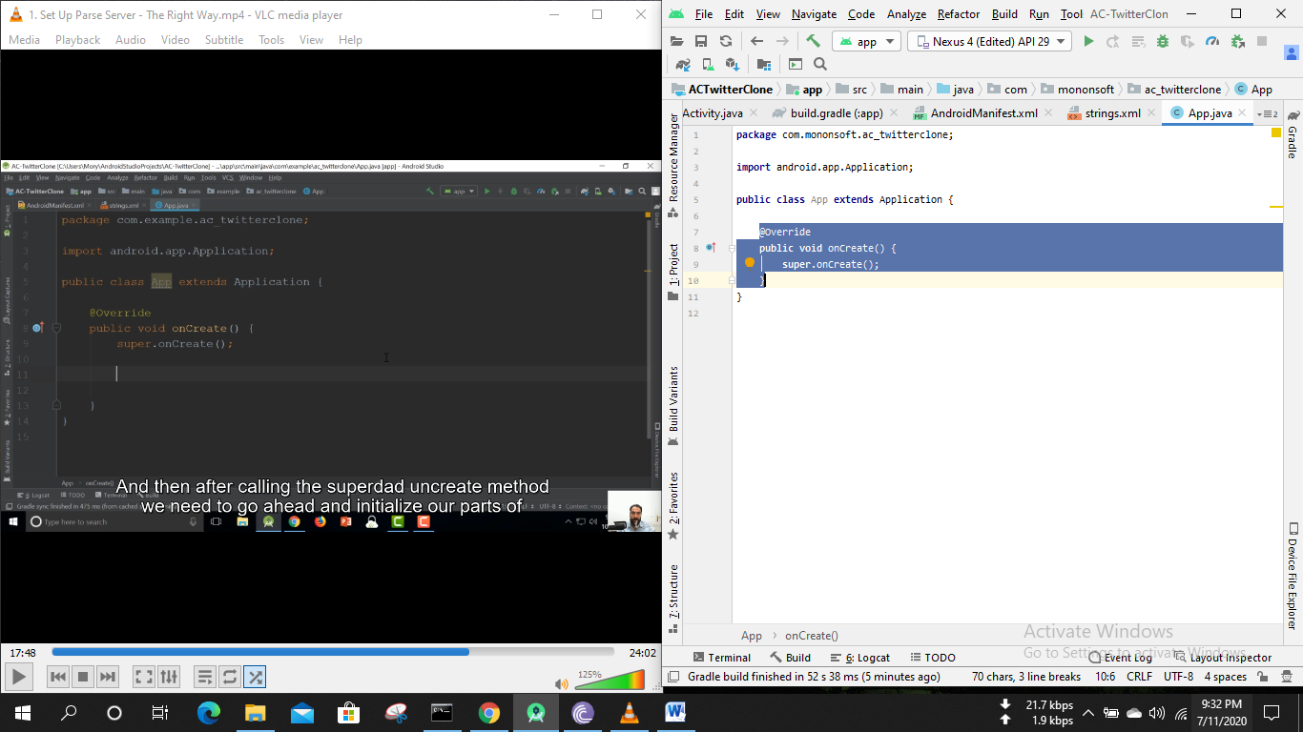

**Parse.**initialize**(new** **Parse.**Configuration**.**Builder**(this)**

**.**applicationId**(**getString**(**R**.**string**.**back4app_app_id**))**

*// if defined*

**.**clientKey**(**getString**(**R**.**string**.**back4app_client_key**))**

**.**server**(**getString**(**R**.**string**.**back4app_server_url**))**

**.**build**()**

**);**

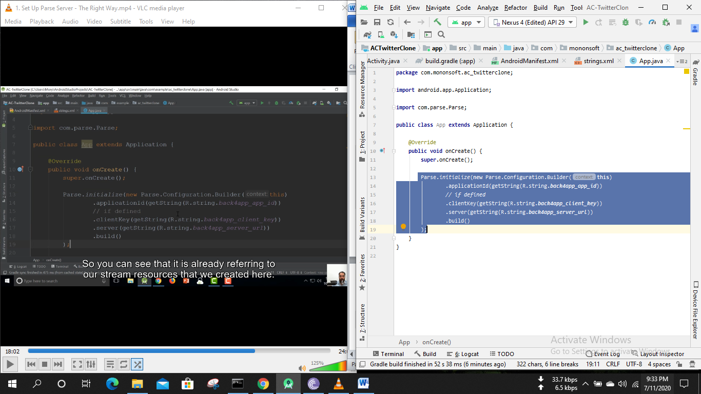

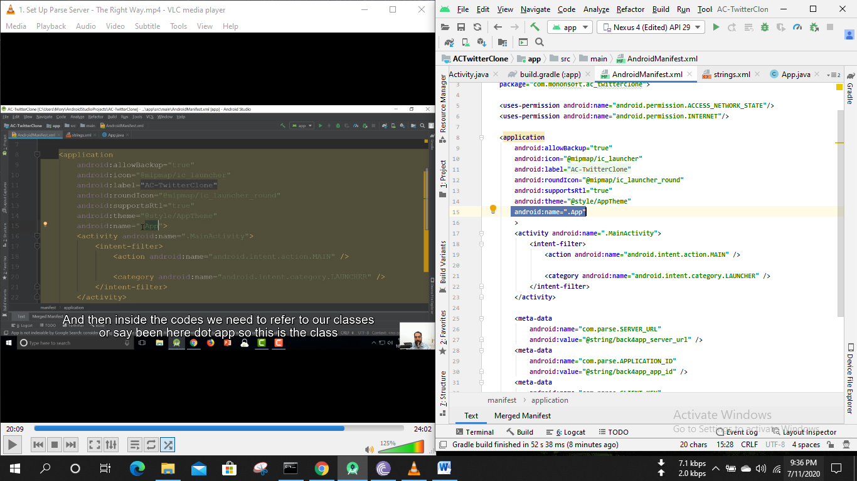

ParseInstallation.*getCurrentInstallation*().saveInBackground();

File-settings-editor-general-auto import

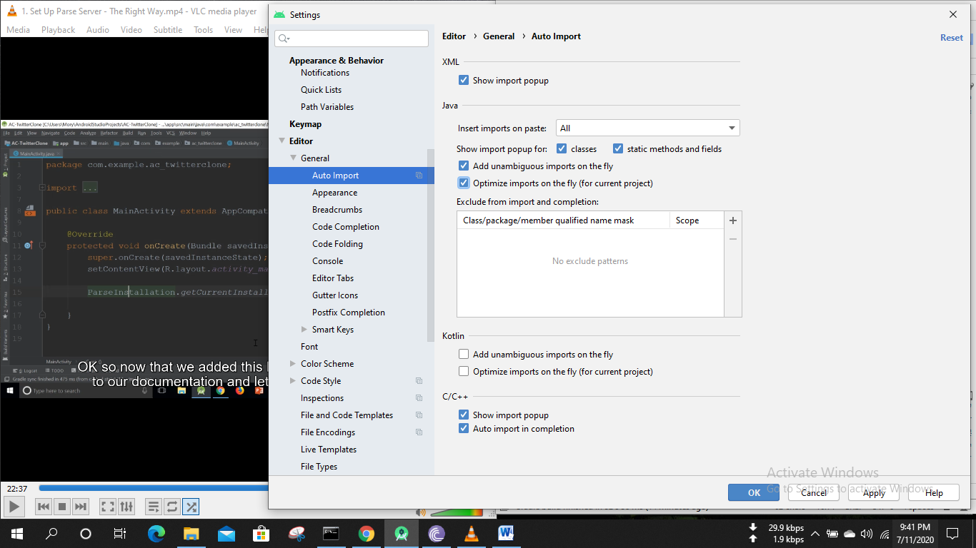

Run App

