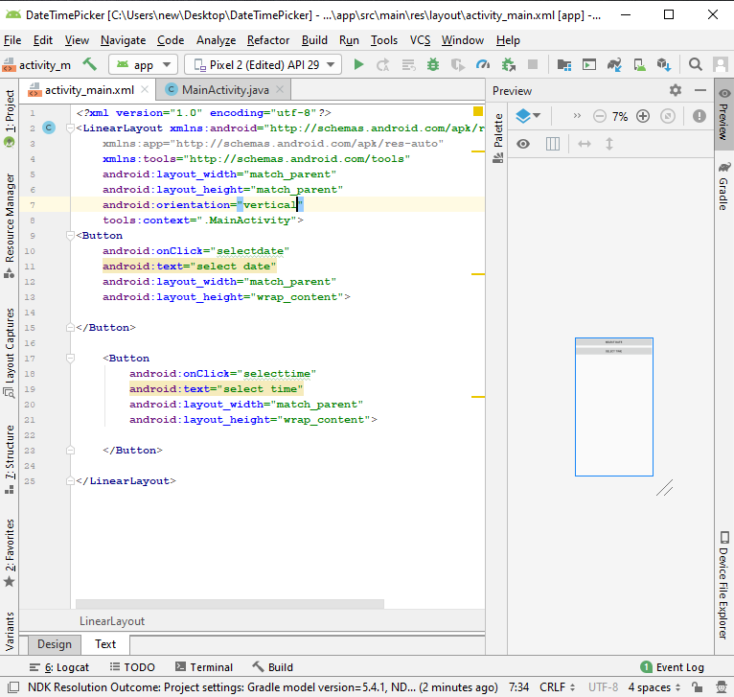

*<?***xml version="1.0" encoding="utf-8"***?>*<**LinearLayout xmlns:android="http://schemas.android.com/apk/res/android"  
 xmlns:app="http://schemas.android.com/apk/res-auto"  
 xmlns:tools="http://schemas.android.com/tools"  
 android:layout_width="match_parent"  
 android:layout_height="match_parent"  
 android:orientation="vertical"  
 android:gravity="center"  
 tools:context=".MainActivity"**>  
<**Button  
 android:onClick="selectdate"  
 android:text="select date"  
 android:layout_width="match_parent"  
 android:layout_height="wrap_content"**>  
  
</**Button**>  
  
 <**Button  
 android:onClick="selecttime"  
 android:text="select time"  
 android:layout_width="match_parent"  
 android:layout_height="wrap_content"**>  
  
 </**Button**>  
  
</**LinearLayout**>

