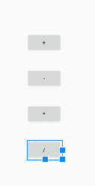

*<?***xml version="1.0" encoding="utf-8"***?>*<**LinearLayout xmlns:android="http://schemas.android.com/apk/res/android"  
 xmlns:app="http://schemas.android.com/apk/res-auto"  
 xmlns:tools="http://schemas.android.com/tools"  
 android:layout_width="match_parent"  
 android:layout_height="match_parent"  
 android:orientation="vertical"  
 android:gravity="center"  
 tools:context=".MainActivity"**>  
  
 <**Button  
 android:layout_margin="20dp"  
 android:id="@+id/button1"  
 android:layout_width="wrap_content"  
 android:layout_height="wrap_content"  
 android:text="+"  
 app:layout_constraintBottom_toBottomOf="parent"  
 app:layout_constraintLeft_toLeftOf="parent"  
 app:layout_constraintRight_toRightOf="parent"  
 app:layout_constraintTop_toTopOf="parent"** />  
  
 <**Button  
 android:layout_margin="20dp"  
 android:id="@+id/button2"  
 android:layout_width="wrap_content"  
 android:layout_height="wrap_content"  
 android:text="-"  
 app:layout_constraintBottom_toBottomOf="parent"  
 app:layout_constraintLeft_toLeftOf="parent"  
 app:layout_constraintRight_toRightOf="parent"  
 app:layout_constraintTop_toTopOf="parent"** />  
 <**Button  
 android:layout_margin="20dp"  
 android:id="@+id/button3"  
 android:layout_width="wrap_content"  
 android:layout_height="wrap_content"  
 android:text="*"  
 app:layout_constraintBottom_toBottomOf="parent"  
 app:layout_constraintLeft_toLeftOf="parent"  
 app:layout_constraintRight_toRightOf="parent"  
 app:layout_constraintTop_toTopOf="parent"** />  
 <**Button  
 android:layout_margin="20dp"  
 android:id="@+id/button4"  
 android:layout_width="wrap_content"  
 android:layout_height="wrap_content"  
 android:text="/"  
 app:layout_constraintBottom_toBottomOf="parent"  
 app:layout_constraintLeft_toLeftOf="parent"  
 app:layout_constraintRight_toRightOf="parent"  
 app:layout_constraintTop_toTopOf="parent"** />  
  
</**LinearLayout**>

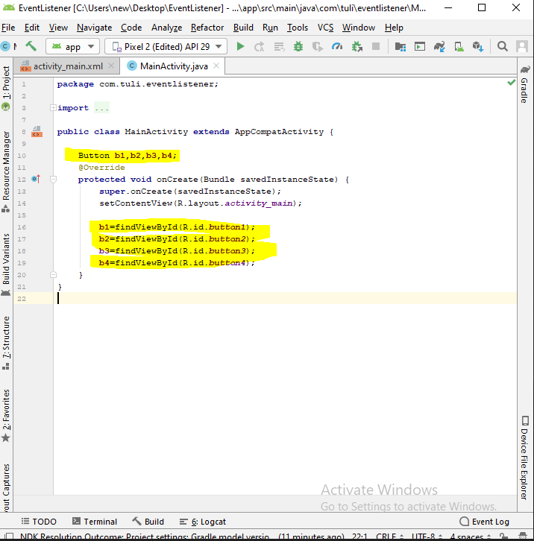

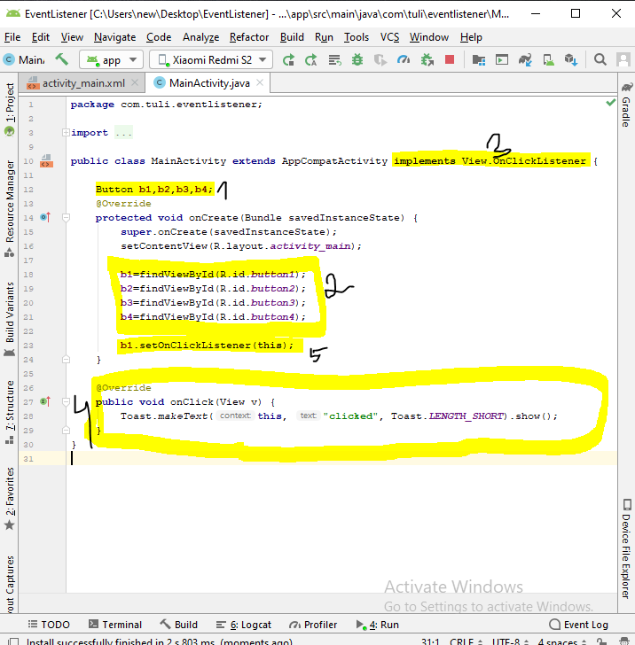

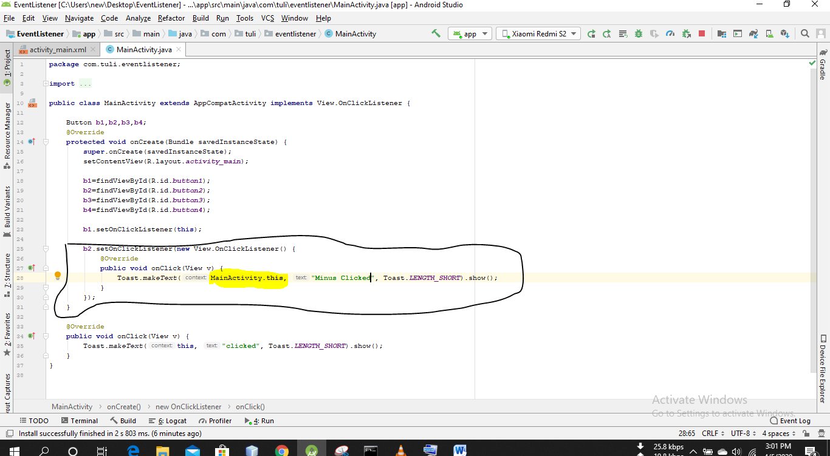

Implement –Toast(this)

new viewOnclicklistener-Toast(Mainactivity.this)- annonymas class

context-abstract class- not create object

