Alignparentright- rightcorner on the screen

Alignparent bottom- right corner+bottom on the screen

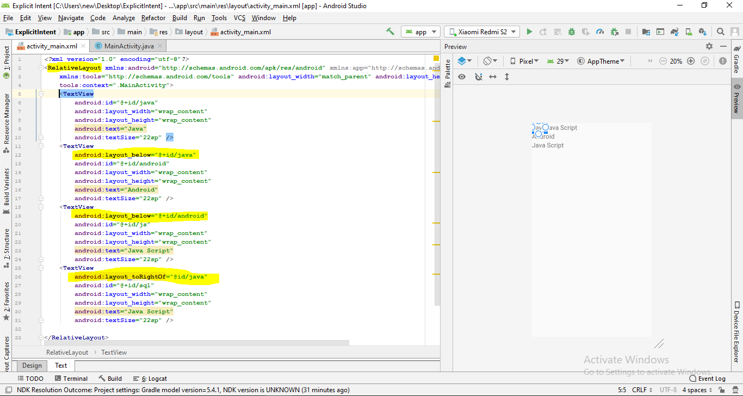

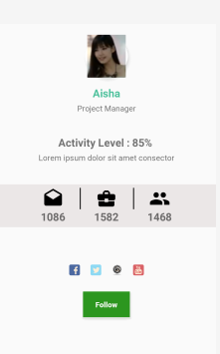

*<?***xml version="1.0" encoding="utf-8"***?>*<**RelativeLayout xmlns:android="http://schemas.android.com/apk/res/android"  
 xmlns:app="http://schemas.android.com/apk/res-auto"  
 android:layout_width="match_parent"  
 android:layout_height="match_parent"  
 android:orientation="vertical"**>  
  
 <**RelativeLayout  
 android:id="@+id/rel1"  
 android:layout_width="wrap_content"  
 android:layout_height="wrap_content"  
 android:layout_centerHorizontal="true"  
 android:layout_marginTop="20dp"**>  
  
 <**androidx.cardview.widget.CardView  
 android:id="@+id/cardview"  
 android:layout_width="80dp"  
 android:layout_height="80dp"  
 android:layout_centerHorizontal="true"  
 android:elevation="12dp"  
 android:innerRadius="0dp"  
 android:shape="ring"  
 android:thicknessRatio="1.9"  
 app:cardCornerRadius="40dp"**>  
  
 <**ImageView  
  
 android:id="@+id/imageView1"  
 android:layout_width="match_parent"  
 android:layout_height="80dp"  
 android:layout_alignParentTop="true"  
 android:layout_centerHorizontal="true"  
 android:src="@drawable/p"**></**ImageView**>  
  
 </**androidx.cardview.widget.CardView**>  
  
 <**TextView  
 android:id="@+id/t1"  
 android:layout_width="match_parent"  
 android:layout_height="wrap_content"  
 android:layout_below="@+id/cardview"  
 android:layout_marginTop="15dp"  
 android:gravity="center"  
 android:text="Aisha"  
 android:textColor="#4CC09B"  
 android:textSize="20sp"  
 android:textStyle="bold"**>  
  
 </**TextView**>  
  
 <**TextView  
 android:id="@+id/t2"  
 android:layout_width="match_parent"  
 android:layout_height="wrap_content"  
 android:layout_below="@+id/t1"  
 android:layout_marginTop="5dp"  
 android:gravity="center"  
 android:text="Project Manager"  
 android:textSize="15sp"**>  
  
 </**TextView**>  
  
 <**TextView  
  
 android:id="@+id/t4"  
 android:layout_width="match_parent"  
 android:layout_height="wrap_content"  
  
 android:layout_below="@+id/t2"  
 android:layout_marginTop="40dp"  
 android:gravity="center"  
 android:text="Activity Level : 85% "  
 android:textSize="20sp"  
 android:textStyle="bold"**>  
  
 </**TextView**>  
  
 <**TextView  
 android:layout_width="match_parent"  
 android:layout_height="wrap_content"  
 android:layout_below="@+id/t4"  
 android:layout_marginTop="5dp"  
 android:gravity="center"  
 android:text="Lorem ipsum dolor sit amet consector"  
 android:textSize="15sp"**>  
  
 </**TextView**>  
 </**RelativeLayout**>  
  
  
 <**RelativeLayout  
 android:id="@+id/rel2"  
 android:layout_width="match_parent"  
 android:layout_height="80dp"  
 android:layout_below="@+id/rel1"  
 android:layout_centerHorizontal="true"  
 android:layout_marginTop="40dp"  
 android:background="#EBE7E7"  
 android:gravity="center"**>  
  
 <**LinearLayout  
 android:id="@+id/l1"  
 android:layout_width="wrap_content"  
 android:layout_height="wrap_content"  
 android:orientation="vertical"**>  
  
 <**ImageView  
 android:id="@+id/i1"  
 android:layout_width="100dp"  
 android:layout_height="40dp"  
 android:src="@drawable/ic_drafts_black_24dp"**>  
  
 </**ImageView**>  
  
 <**TextView  
 android:layout_width="wrap_content"  
 android:layout_height="wrap_content"  
 android:layout_gravity="center"  
 android:text="1086"  
 android:textSize="20sp"  
 android:textStyle="bold"**>  
  
 </**TextView**>  
 </**LinearLayout**>  
  
 <**View  
 android:id="@+id/i2"  
 android:layout_width="2dp"  
 android:layout_height="40dp"  
 android:layout_toRightOf="@+id/l1"  
 android:background="#0F0F0F"**>  
  
 </**View**>  
  
  
 <**LinearLayout  
 android:id="@+id/l2"  
 android:layout_width="wrap_content"  
 android:layout_height="wrap_content"  
 android:layout_toRightOf="@+id/l1"  
 android:orientation="vertical"**>  
  
 <**ImageView  
 android:id="@+id/i3"  
 android:layout_width="100dp"  
 android:layout_height="40dp"  
 android:layout_toRightOf="@+id/i2"  
 android:src="@drawable/ic_business_center_black_24dp"**>  
  
 </**ImageView**>  
  
 <**TextView  
 android:layout_width="wrap_content"  
 android:layout_height="wrap_content"  
 android:layout_gravity="center"  
 android:text="1582"  
 android:textSize="20sp"  
 android:textStyle="bold"**>  
  
 </**TextView**>  
 </**LinearLayout**>  
  
 <**View  
 android:id="@+id/i4"  
 android:layout_width="2dp"  
 android:layout_height="40dp"  
 android:layout_toRightOf="@+id/l2"  
 android:background="#0F0F0F"**>  
  
 </**View**>  
  
 <**LinearLayout  
 android:id="@+id/l3"  
 android:layout_width="wrap_content"  
 android:layout_height="wrap_content"  
 android:layout_toRightOf="@+id/l2"  
 android:orientation="vertical"**>  
  
 <**ImageView  
 android:layout_width="100dp"  
 android:layout_height="40dp"  
 android:layout_toRightOf="@+id/i4"  
 android:src="@drawable/ic_people_black_24dp"**>  
  
 </**ImageView**>  
  
 <**TextView  
 android:layout_width="wrap_content"  
 android:layout_height="wrap_content"  
 android:layout_gravity="center"  
 android:text="1468"  
 android:textSize="20sp"  
 android:textStyle="bold"**>  
  
 </**TextView**>  
 </**LinearLayout**>  
  
  
 </**RelativeLayout**>  
  
 <**RelativeLayout  
  
 android:id="@+id/rel3"  
 android:layout_width="match_parent"  
 android:layout_height="80dp"  
 android:layout_below="@+id/rel2"  
 android:layout_centerHorizontal="true"  
 android:layout_marginTop="40dp"  
 android:gravity="center"**>  
  
 <**ImageView  
 android:id="@+id/i5"  
 android:layout_width="40dp"  
 android:layout_height="20dp"  
 android:src="@drawable/facebook"**>  
  
 </**ImageView**>  
  
 <**ImageView  
 android:id="@+id/i6"  
 android:layout_width="40dp"  
 android:layout_height="20dp"  
 android:layout_toRightOf="@+id/i5"  
 android:src="@drawable/twitter"**>  
  
 </**ImageView**>  
  
 <**ImageView  
 android:id="@+id/i7"  
 android:layout_width="40dp"  
 android:layout_height="20dp"  
 android:layout_toRightOf="@+id/i6"  
 android:src="@drawable/linkedin"**>  
  
 </**ImageView**>  
  
 <**ImageView  
 android:id="@+id/i8"  
 android:layout_width="40dp"  
 android:layout_height="20dp"  
 android:layout_toRightOf="@+id/i7"  
 android:src="@drawable/youtube"**>  
  
 </**ImageView**>  
 </**RelativeLayout**>  
  
  
 <**Button  
 android:layout_width="wrap_content"  
 android:layout_height="wrap_content"  
 android:layout_below="@+id/rel3"  
 android:layout_centerHorizontal="true"  
 android:background="#2C961F"  
 android:gravity="center"  
 android:padding="10dp"  
 android:text="Follow"  
  
 android:textAllCaps="false"  
 android:textColor="#F5F7F5"  
 android:textStyle="bold"**>  
  
 </**Button**>  
</**RelativeLayout**>

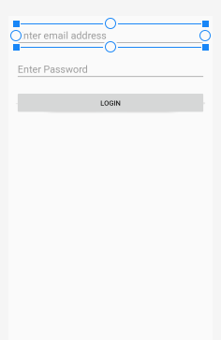

*<?***xml version="1.0" encoding="utf-8"***?>*<**RelativeLayout xmlns:android="http://schemas.android.com/apk/res/android"  
 android:layout_width="match_parent"  
 android:layout_height="match_parent"  
 android:padding="15dp"**>  
  
 <**EditText  
 android:id="@+id/emailValue"  
 android:layout_width="match_parent"  
 android:layout_height="wrap_content"  
 android:hint="Enter email address"  
 android:inputType="textEmailAddress"  
 android:textSize="20sp"**>  
  
 </**EditText**>  
  
 <**EditText  
 android:id="@+id/passwordValue"  
 android:layout_width="match_parent"  
 android:layout_height="wrap_content"  
 android:layout_below="@id/emailValue"  
 android:layout_marginTop="20sp"  
 android:hint="Enter Password"  
 android:inputType="textPassword"  
 android:textSize="20sp"**>  
  
 </**EditText**>  
  
 <**Button  
 android:id="@+id/loginBtn"  
 android:layout_width="match_parent"  
 android:layout_height="wrap_content"  
 android:layout_below="@+id/passwordValue"  
 android:layout_centerHorizontal="true"  
 android:layout_marginTop="20sp"  
 android:text="login"**>  
  
 </**Button**>  
  
</**RelativeLayout**>

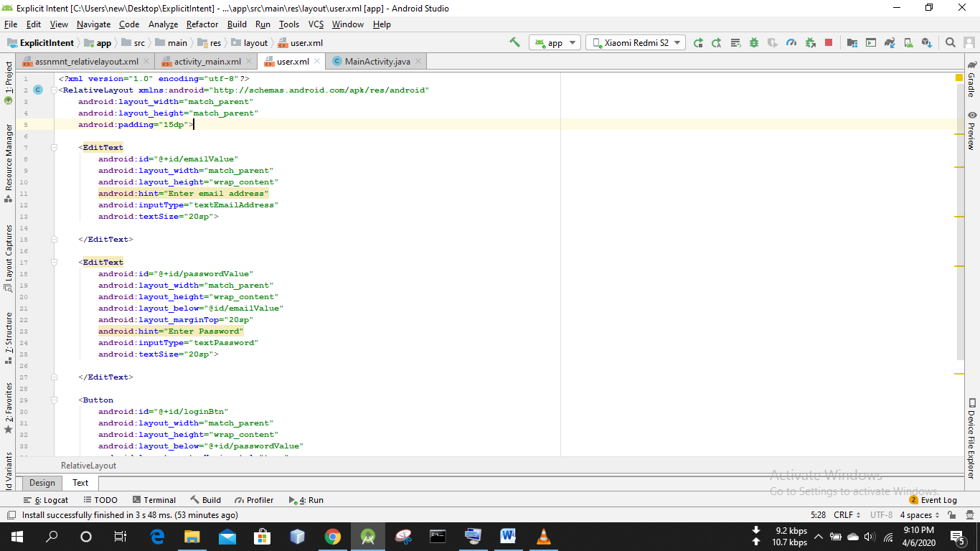

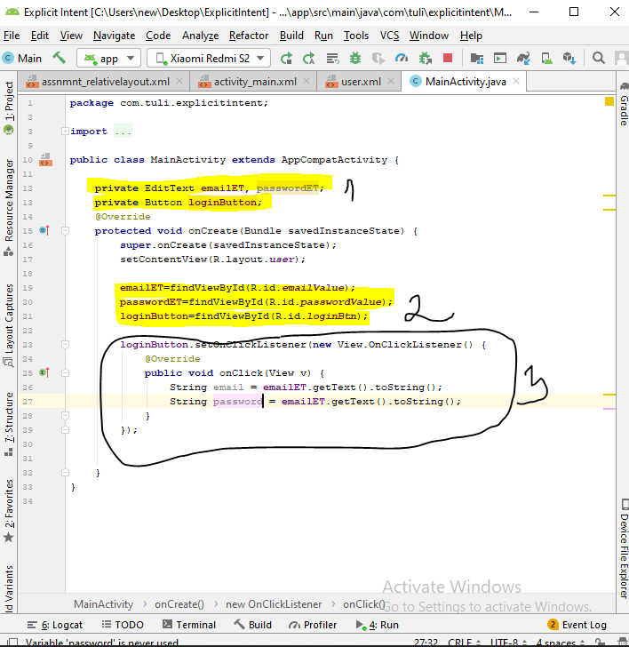

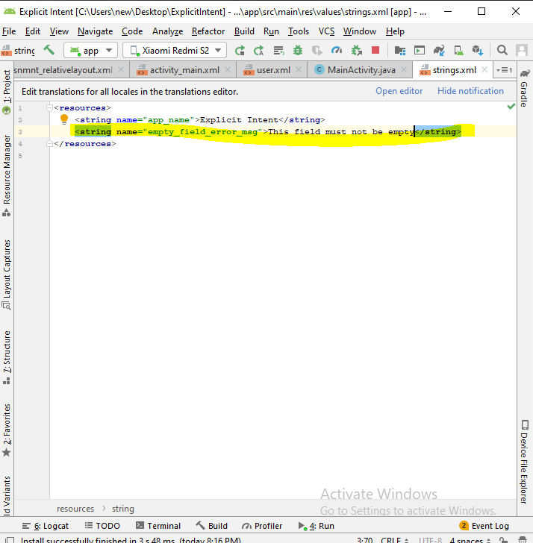

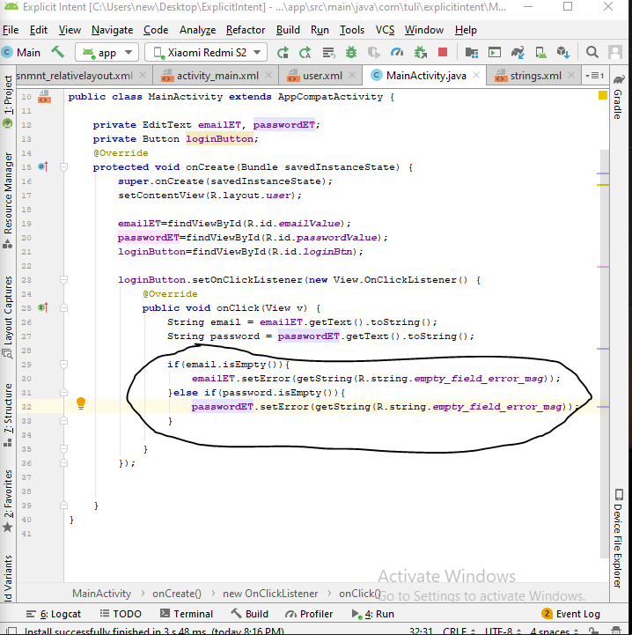

New empty activity create

Called it second activity

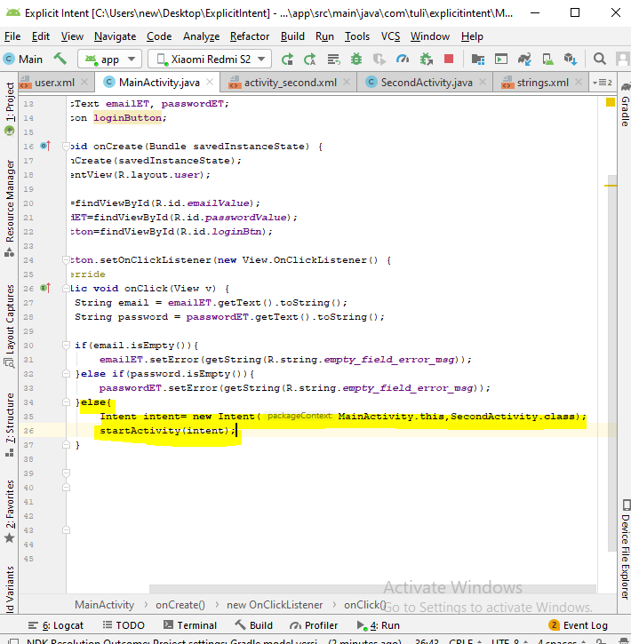

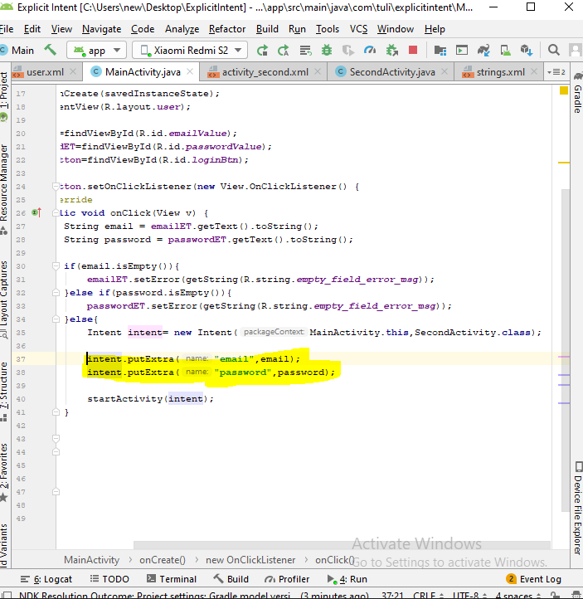

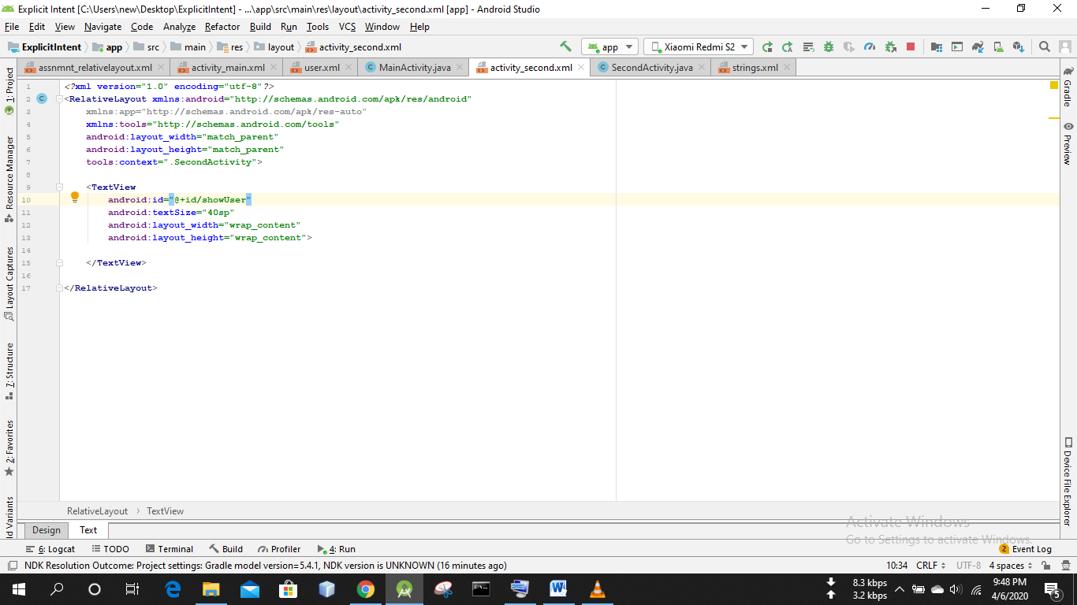

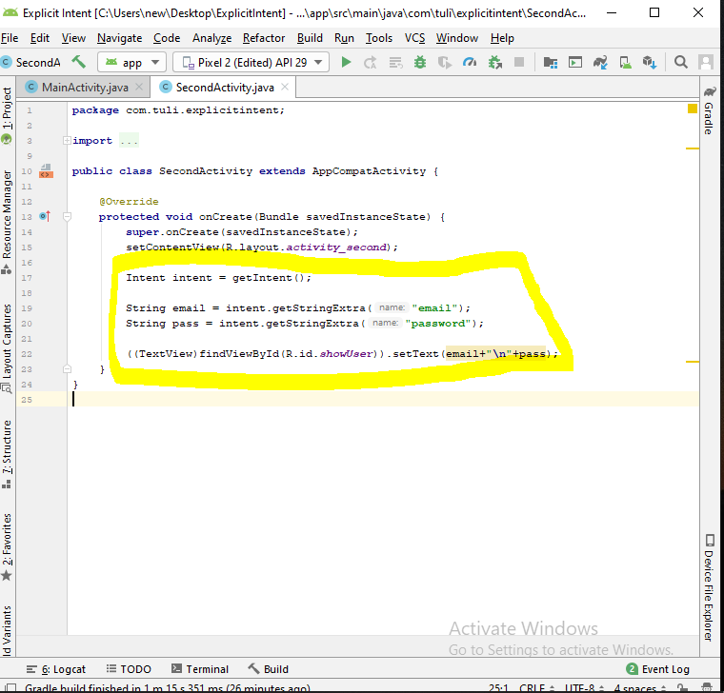

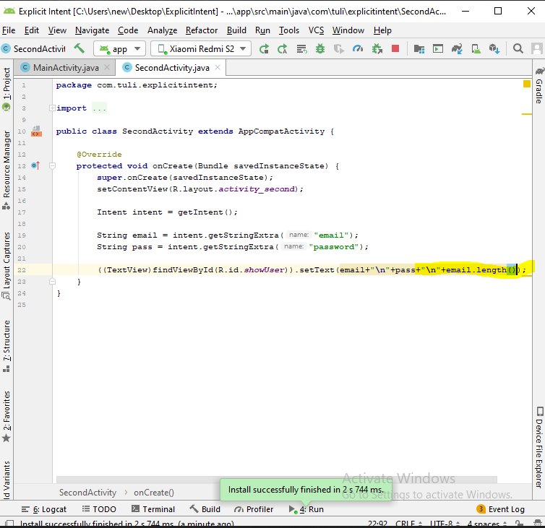

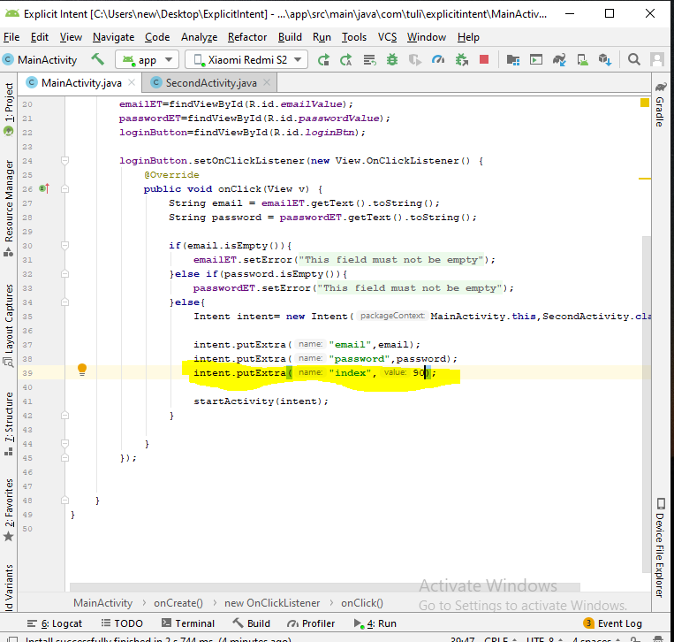

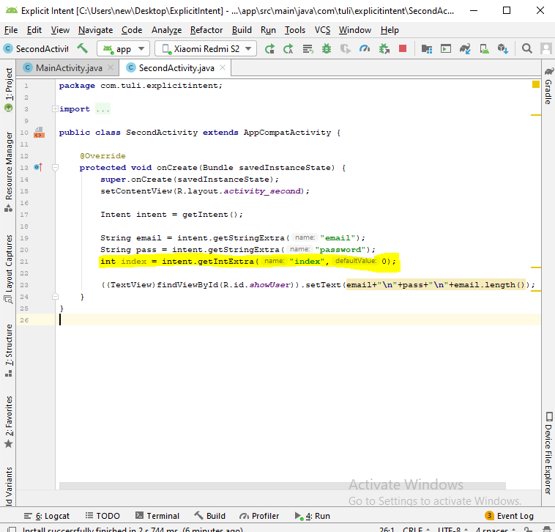

Create Java class – Student

