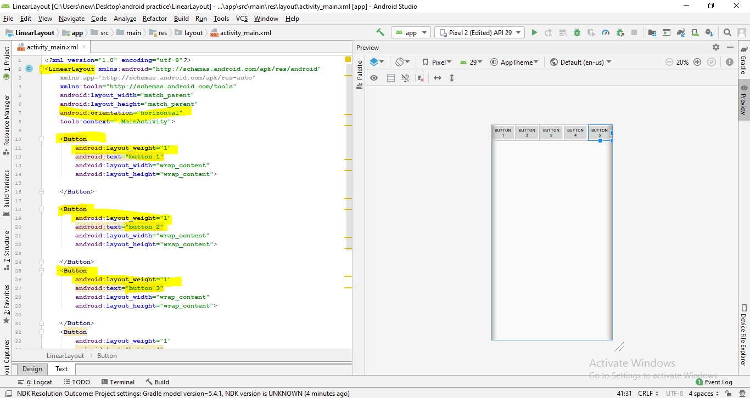

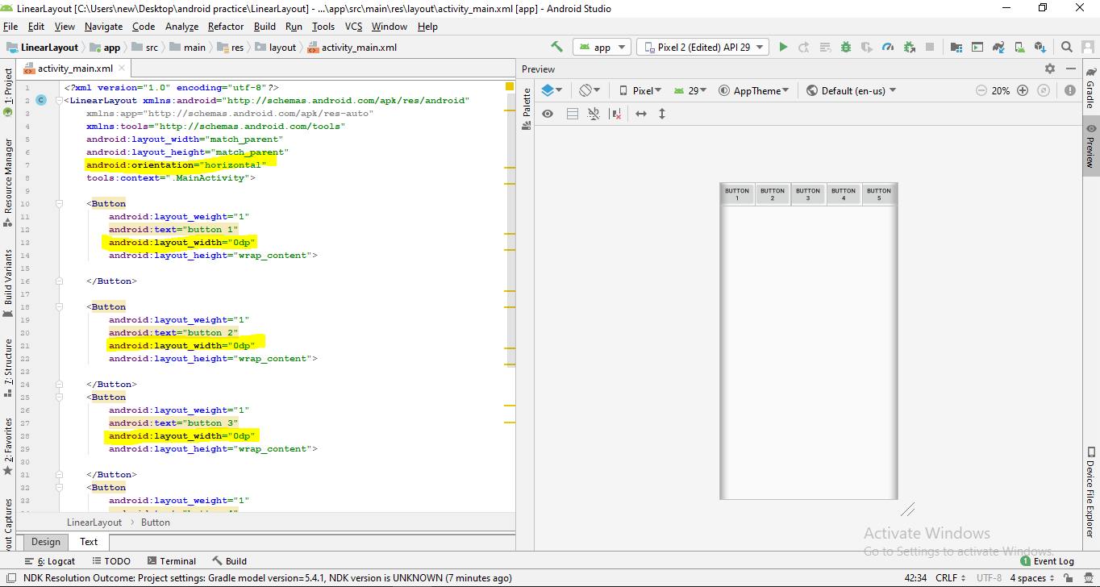

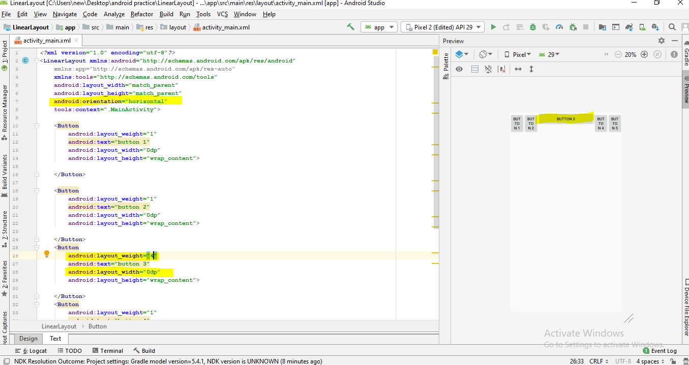

For vertical—height=0dp

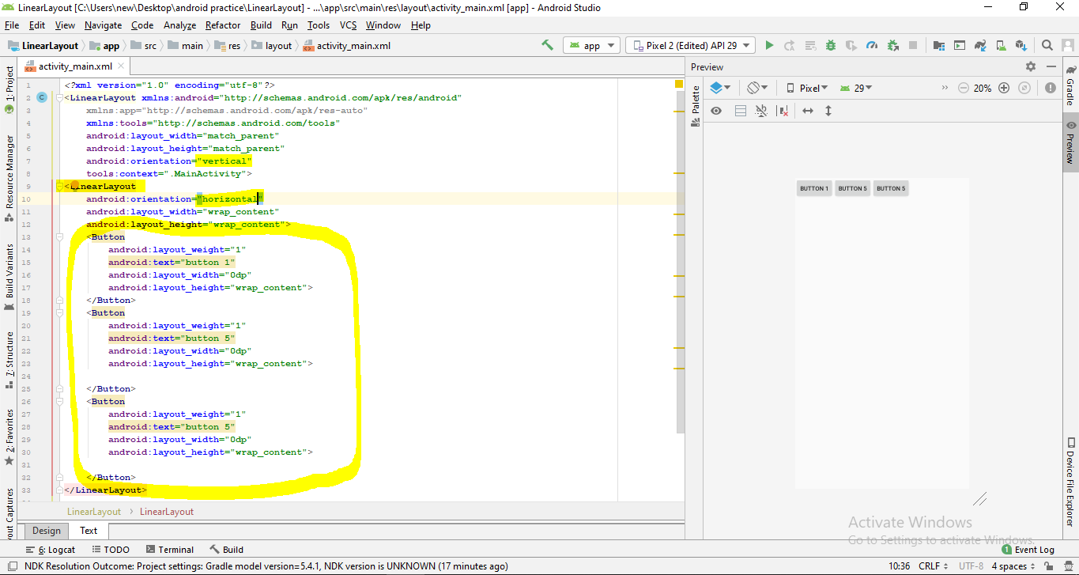

View move- layout gravity

Content move –gravity

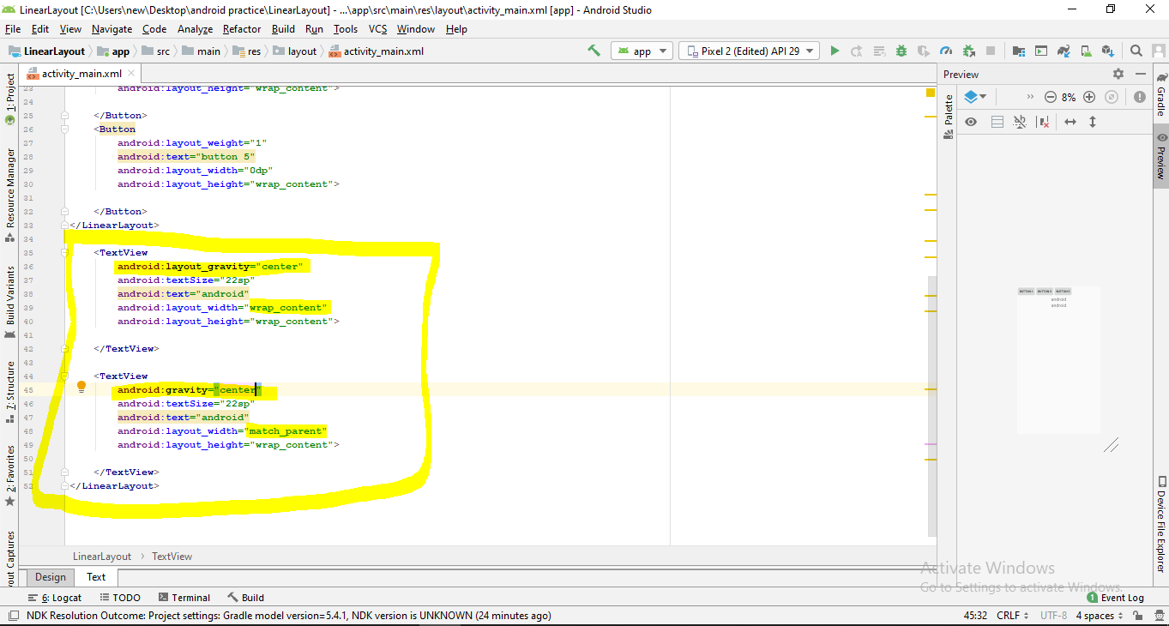

New activity- weightExampleActivity

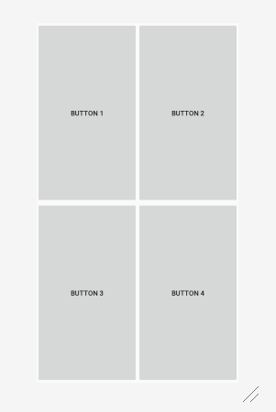

*<?***xml version="1.0" encoding="utf-8"***?>*<**LinearLayout xmlns:android="http://schemas.android.com/apk/res/android"  
 xmlns:app="http://schemas.android.com/apk/res-auto"  
 xmlns:tools="http://schemas.android.com/tools"  
 android:layout_width="match_parent"  
 android:layout_height="match_parent"  
 android:orientation="vertical"  
 tools:context=".weightExampleActvity"**>  
  
 <**LinearLayout  
 android:layout_weight="1"  
 android:orientation="horizontal"  
 android:layout_width="match_parent"  
 android:layout_height="0dp"**>  
 <**Button  
 android:text="Button 1"  
 android:layout_weight="1"  
 android:layout_width="0dp"  
 android:layout_height="match_parent"**>  
  
 </**Button**>  
 <**Button  
 android:text="Button 2"  
 android:layout_weight="1"  
 android:layout_width="0dp"  
 android:layout_height="match_parent"**>  
  
 </**Button**>  
 </**LinearLayout**>  
  
 <**LinearLayout  
 android:layout_weight="1"  
 android:orientation="horizontal"  
 android:layout_width="match_parent"  
 android:layout_height="0dp"**>  
 <**Button  
 android:text="Button 3"  
 android:layout_weight="1"  
 android:layout_width="0dp"  
 android:layout_height="match_parent"**>  
  
 </**Button**>  
 <**Button  
 android:text="Button 4"  
 android:layout_weight="1"  
 android:layout_width="0dp"  
 android:layout_height="match_parent"**>  
  
  
 </**Button**>  
 </**LinearLayout**>  
  
</**LinearLayout**>

