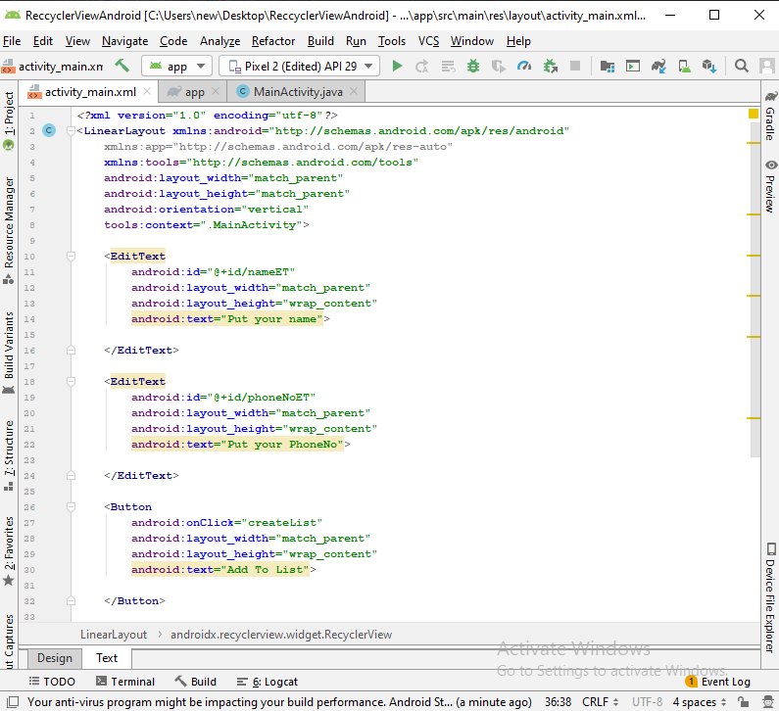

*<?***xml version="1.0" encoding="utf-8"***?>*<**LinearLayout xmlns:android="http://schemas.android.com/apk/res/android"  
 xmlns:app="http://schemas.android.com/apk/res-auto"  
 xmlns:tools="http://schemas.android.com/tools"  
 android:layout_width="match_parent"  
 android:layout_height="match_parent"  
 android:orientation="vertical"  
 tools:context=".MainActivity"**>  
  
 <**EditText  
 android:id="@+id/nameET"  
 android:layout_width="match_parent"  
 android:layout_height="wrap_content"  
 android:text="Put your name"**>  
  
 </**EditText**>  
  
 <**EditText  
 android:id="@+id/phoneNoET"  
 android:layout_width="match_parent"  
 android:layout_height="wrap_content"  
 android: hint="Put your PhoneNo"**>  
  
 </**EditText**>  
  
 <**Button  
 android:onClick="createList"  
 android:layout_width="match_parent"  
 android:layout_height="wrap_content"  
 android: hint="Add To List"**>  
  
 </**Button**>  
  
 <**androidx.recyclerview.widget.RecyclerView  
 android:id="@+id/recycler_view"  
 android:scrollbars="vertical"  
 android:layout_width="match_parent"  
 android:layout_height="wrap_content"**>  
  
 </**androidx.recyclerview.widget.RecyclerView**>  
  
  
  
</**LinearLayout**>

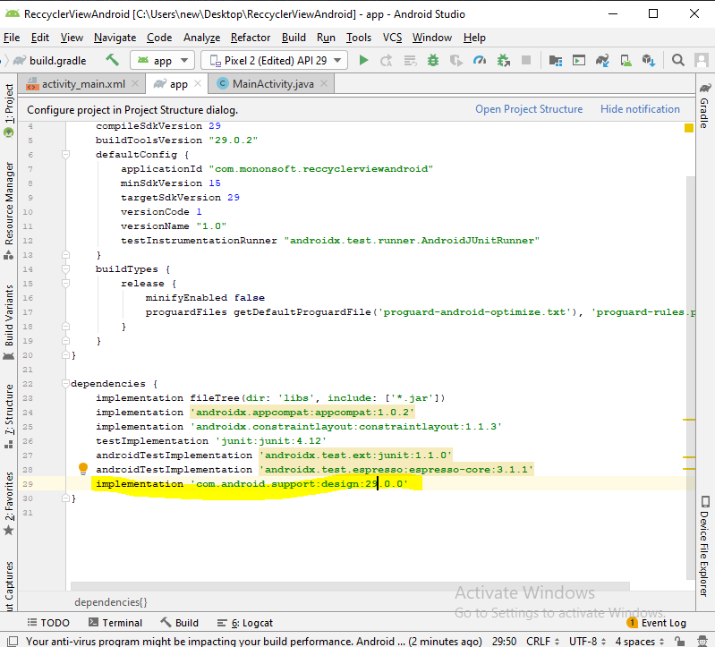

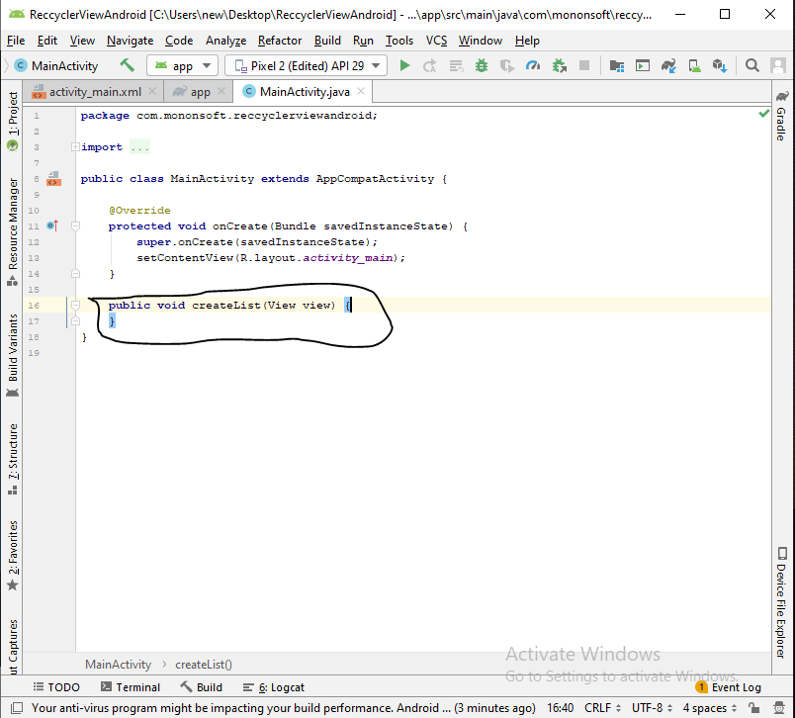

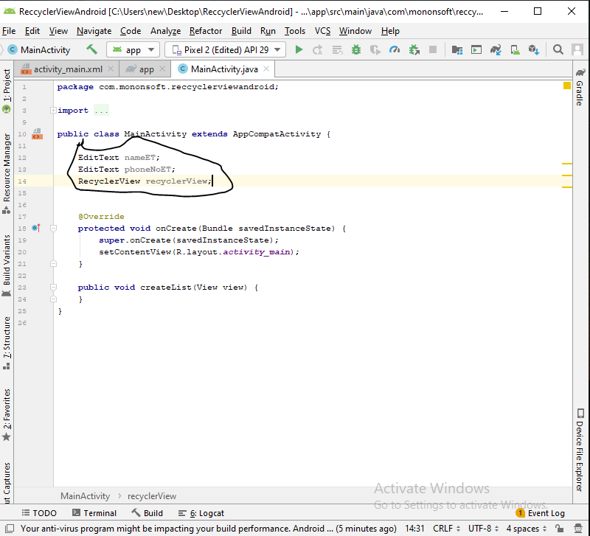

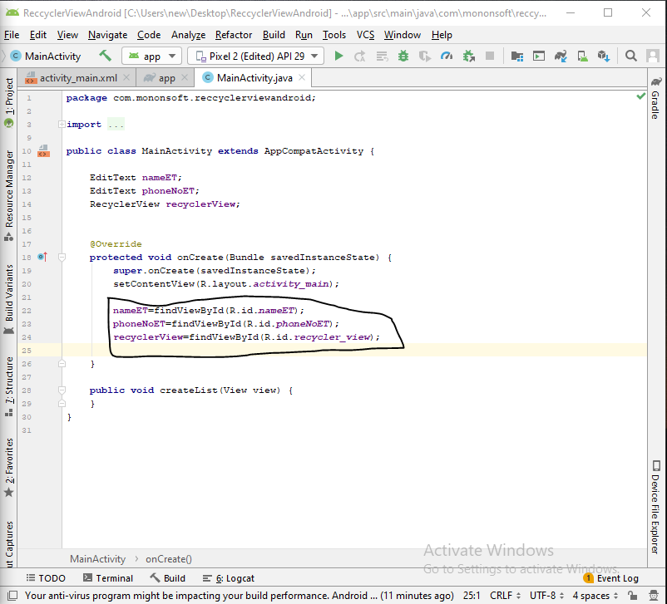

Create Java class- ContactAdapter

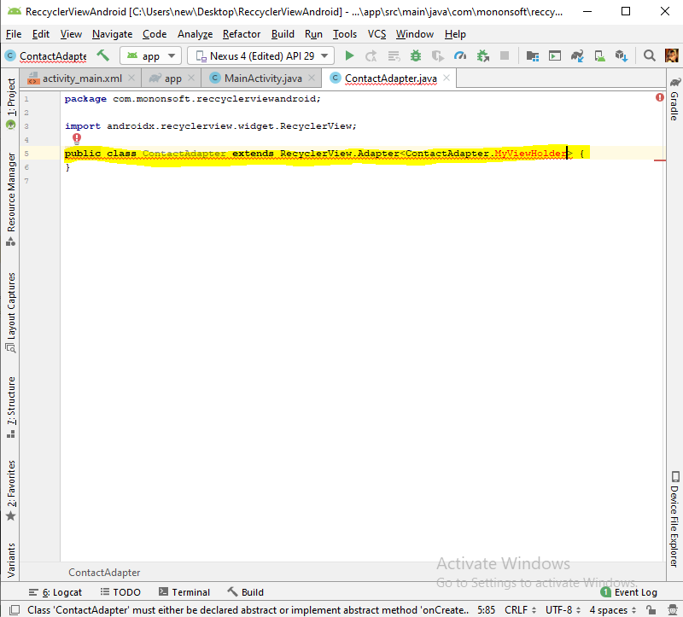

Continuously click alt+ent till error not found

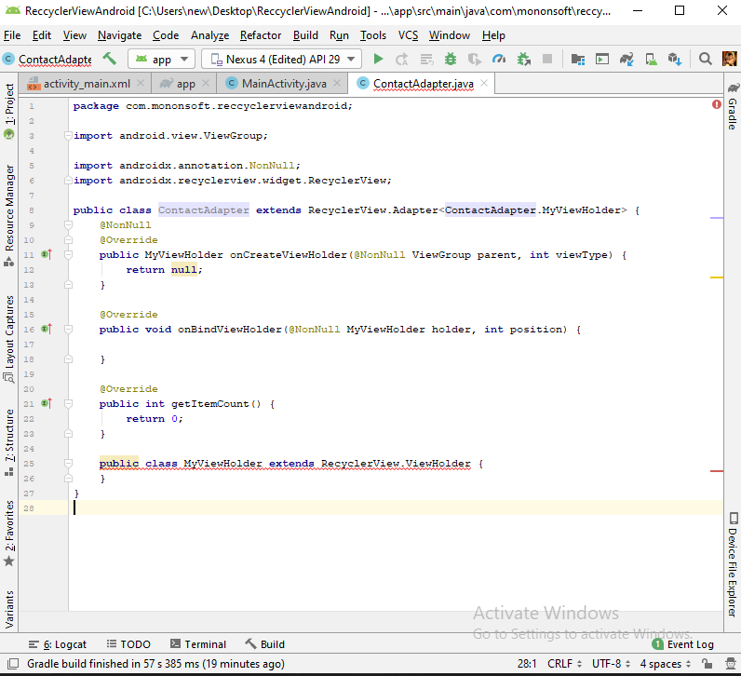

Alt+ent in error

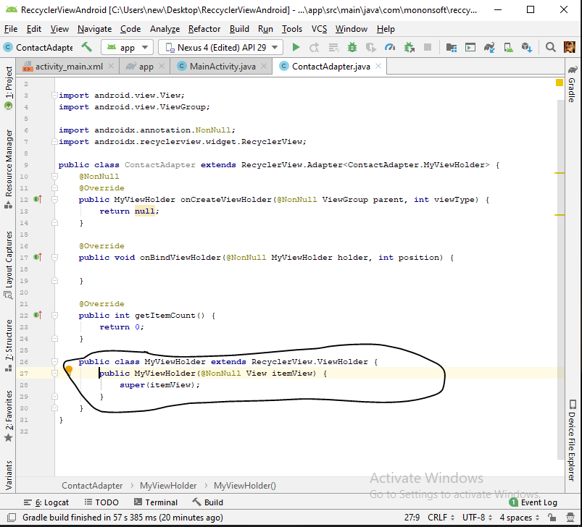

Row_layout design

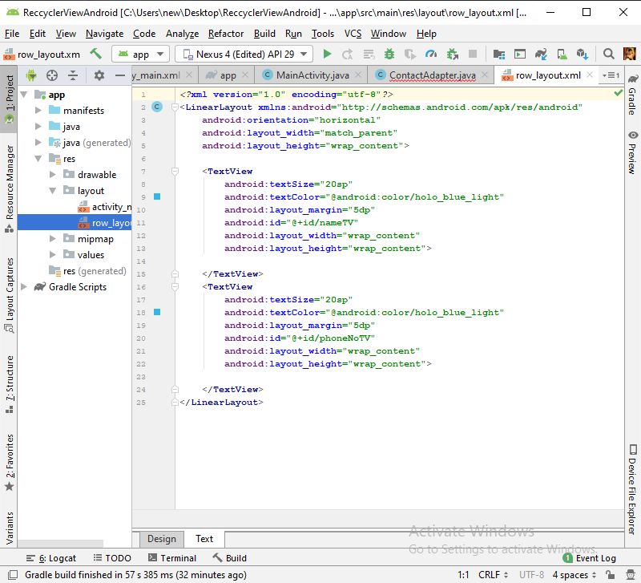

*<?***xml version="1.0" encoding="utf-8"***?>*<**LinearLayout xmlns:android="http://schemas.android.com/apk/res/android"  
 android:orientation="horizontal"  
 android:layout_width="match_parent"  
 android:layout_height="wrap_content"**>  
  
 <**TextView  
 android:textSize="20sp"  
 android:textColor="@android:color/holo_blue_light"  
 android:layout_margin="5dp"  
 android:id="@+id/nameTV"  
 android:layout_width="wrap_content"  
 android:layout_height="wrap_content"**>  
  
 </**TextView**>  
 <**TextView  
 android:textSize="20sp"  
 android:textColor="@android:color/holo_blue_light"  
 android:layout_margin="5dp"  
 android:id="@+id/phoneNoTV"  
 android:layout_width="wrap_content"  
 android:layout_height="wrap_content"**>  
  
 </**TextView**>  
</**LinearLayout**>

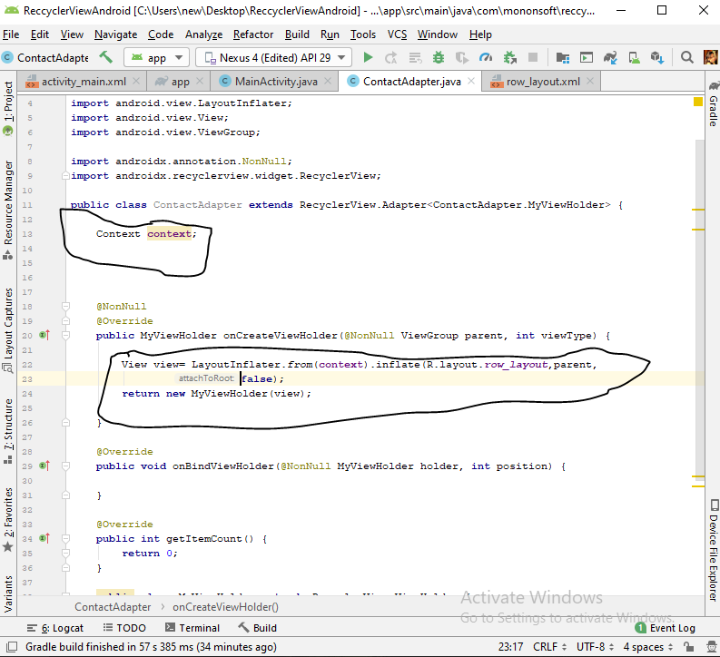

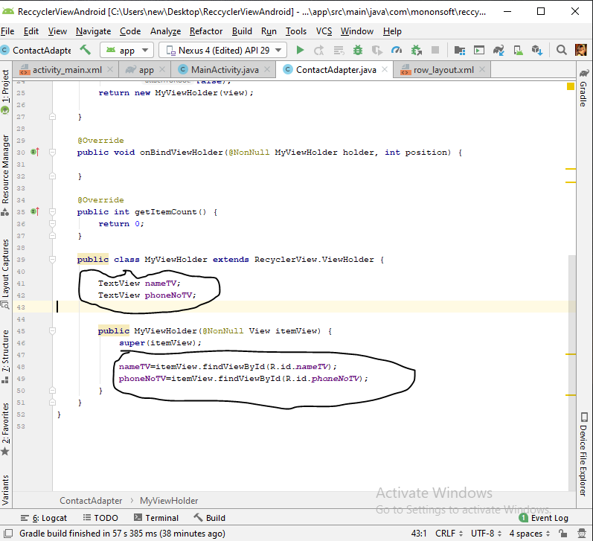

Create new java class- Contact

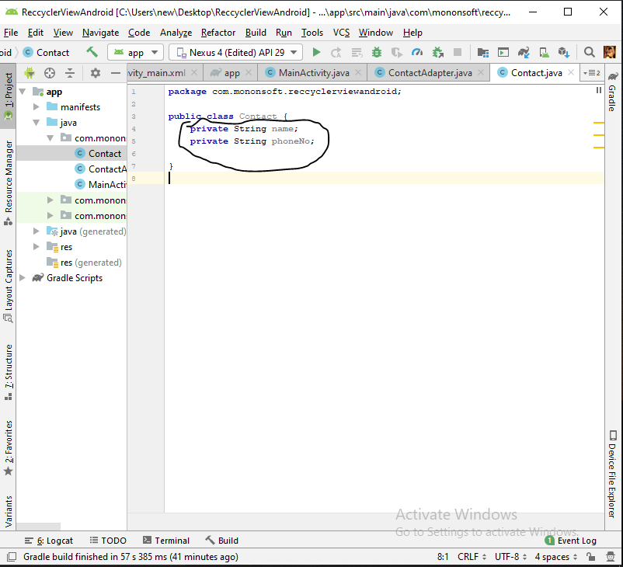

Getter setter

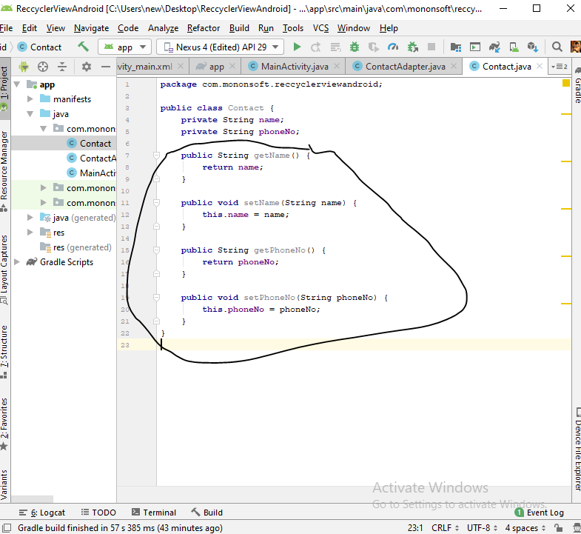

Constructor

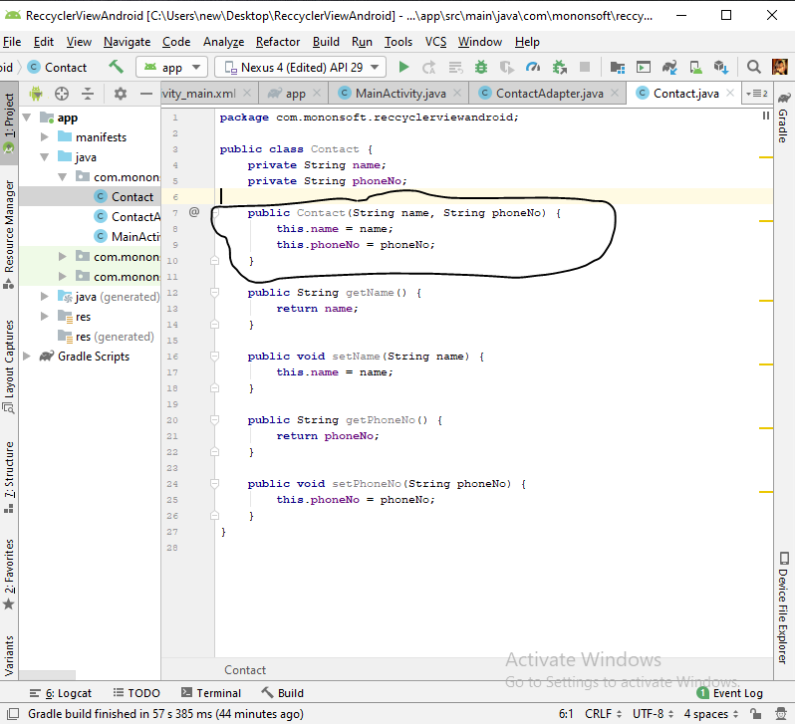

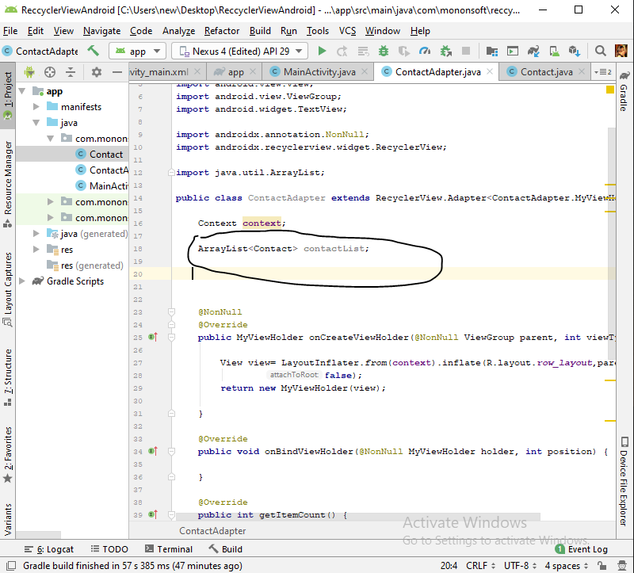

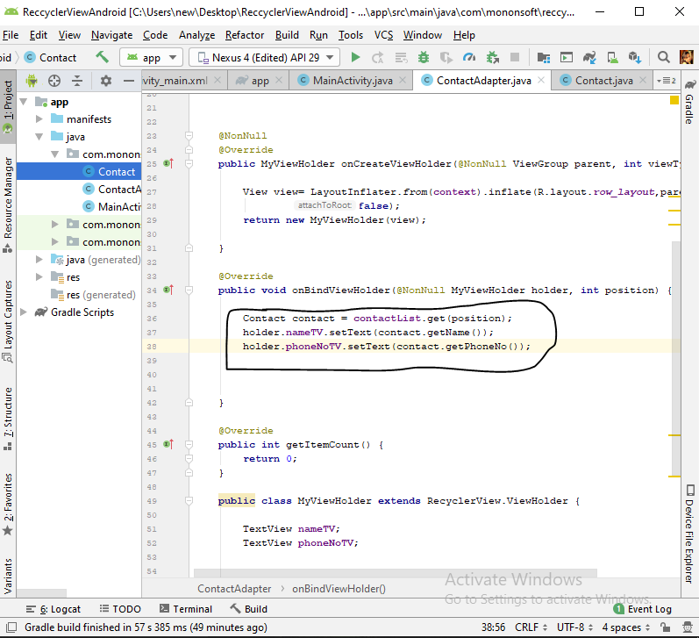

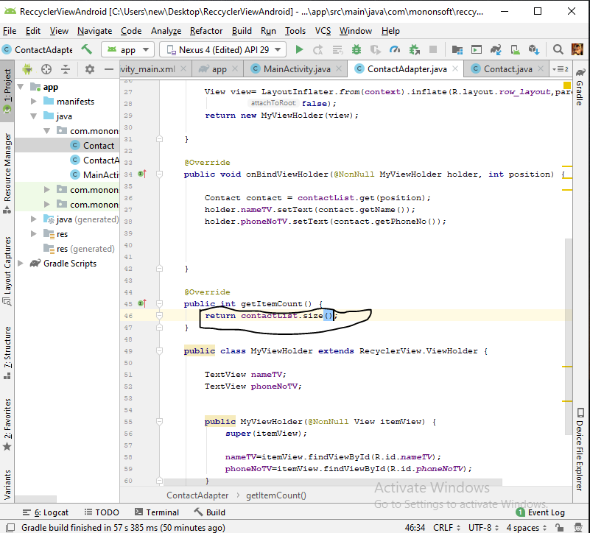

Constructor set

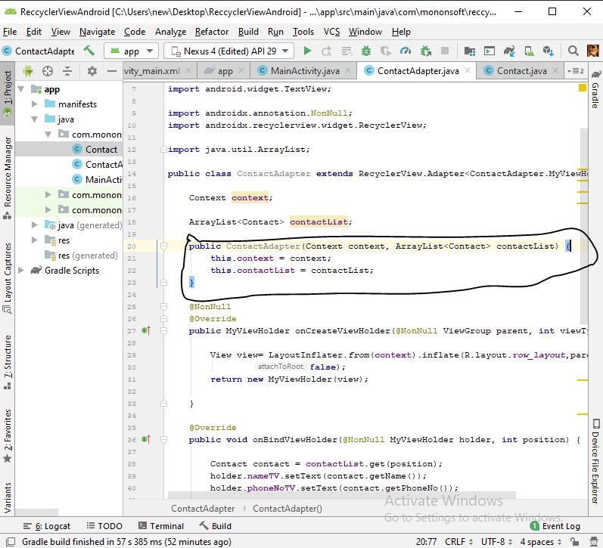

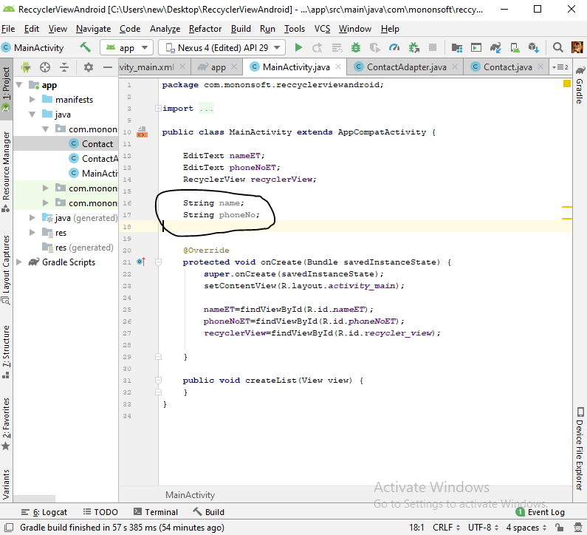

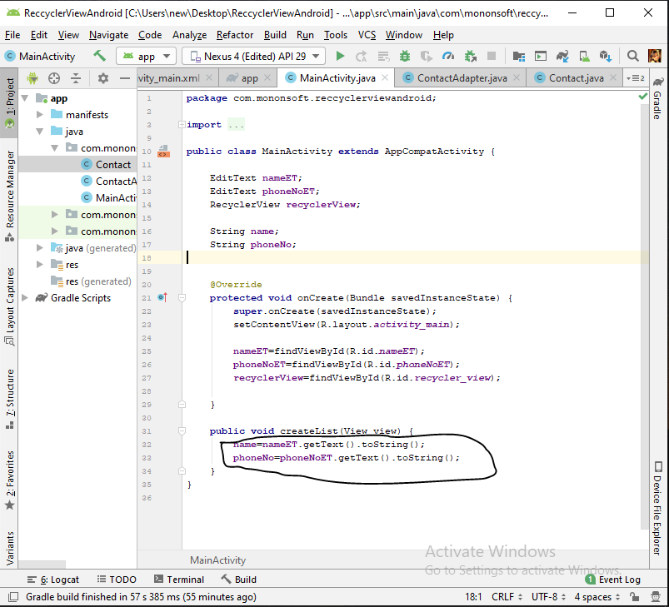

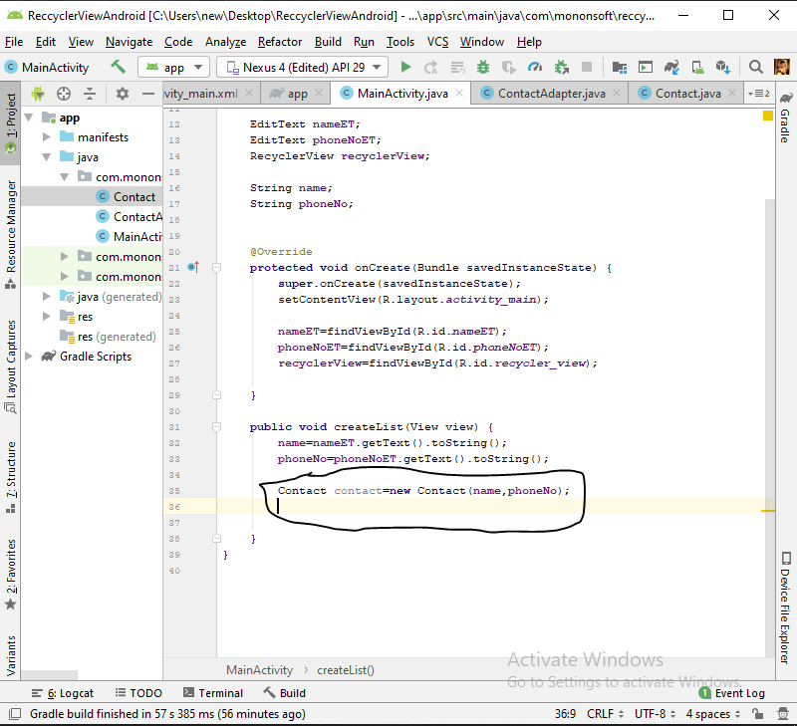

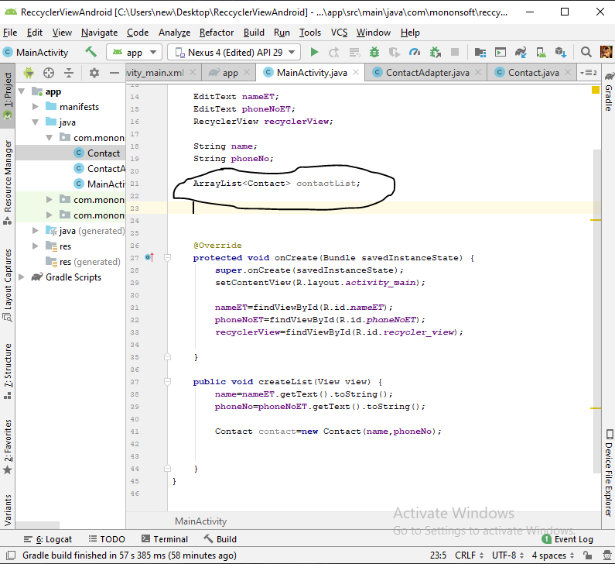

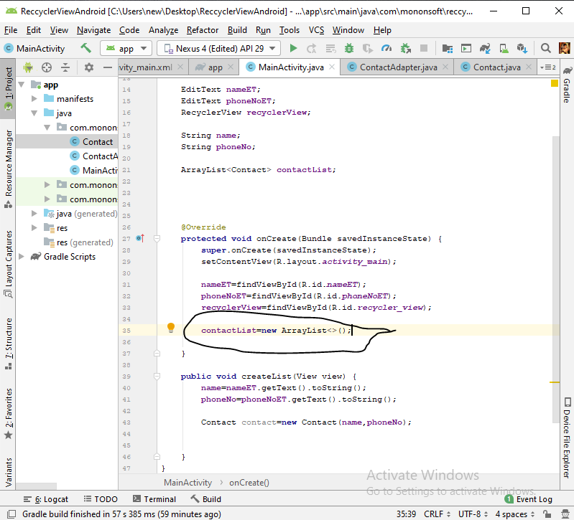

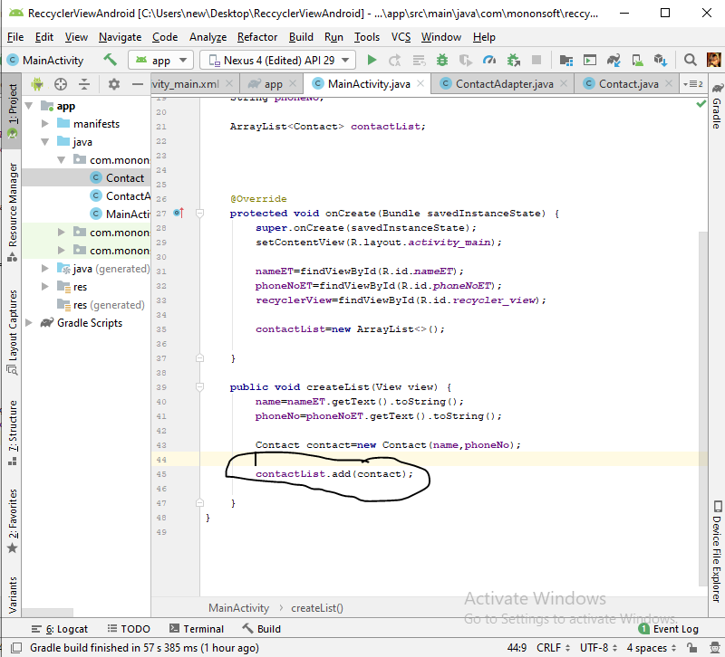

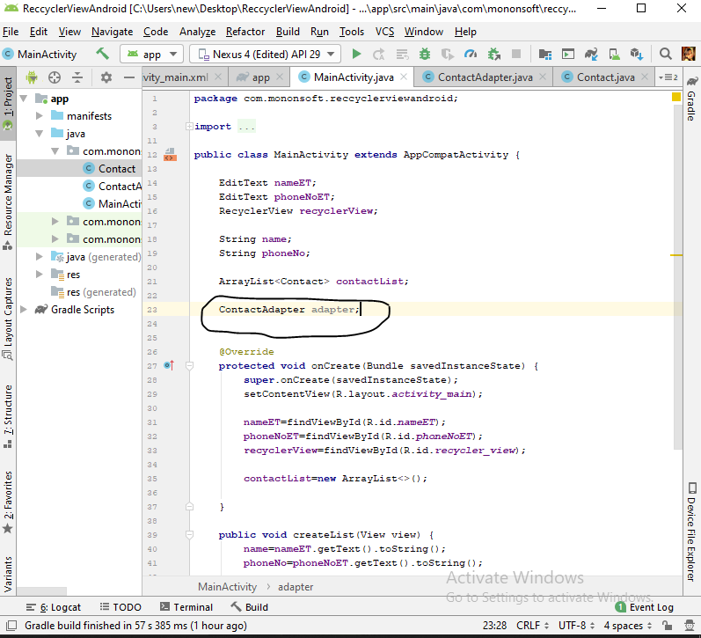

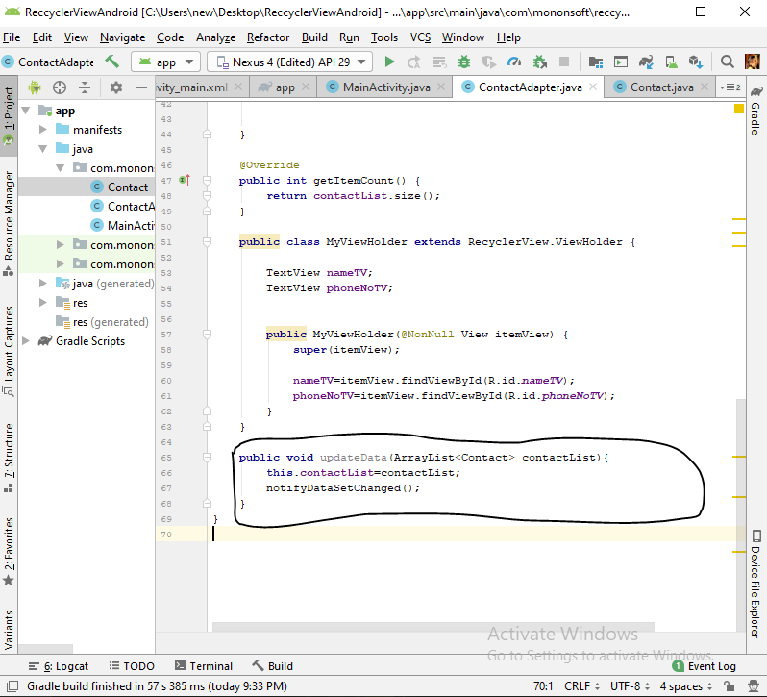

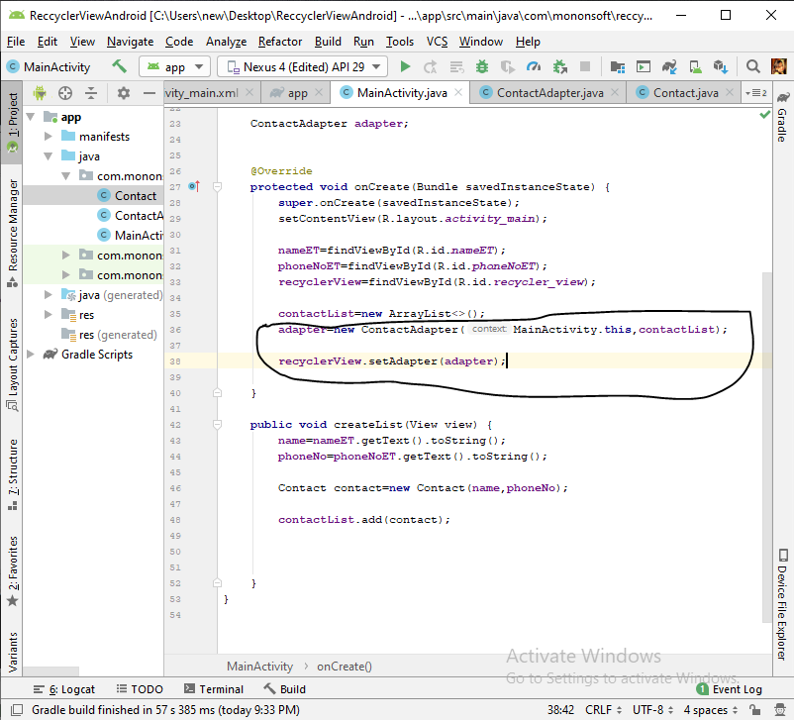

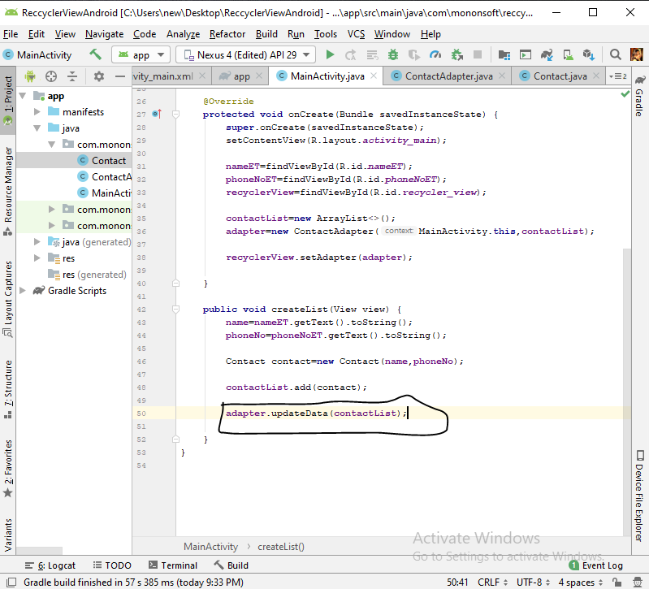

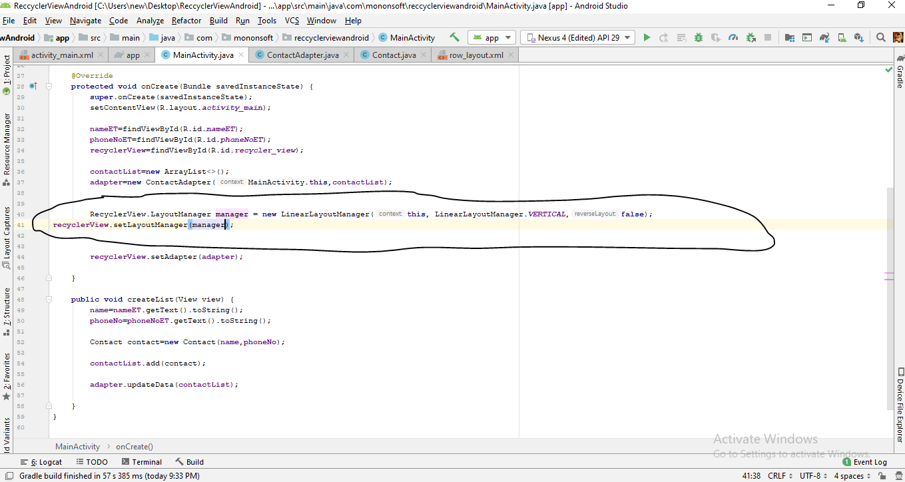

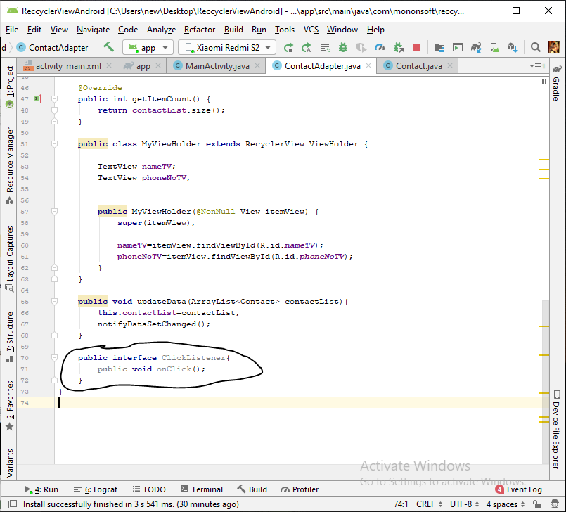

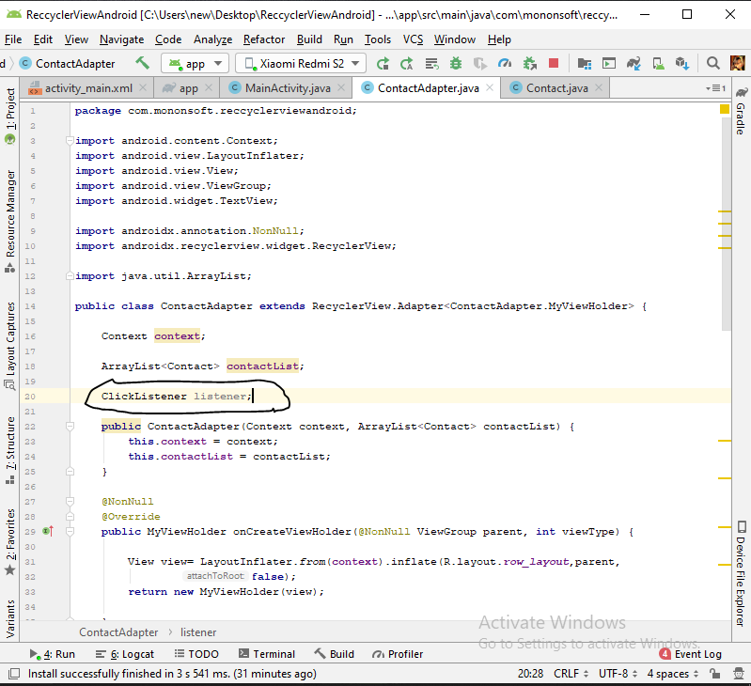

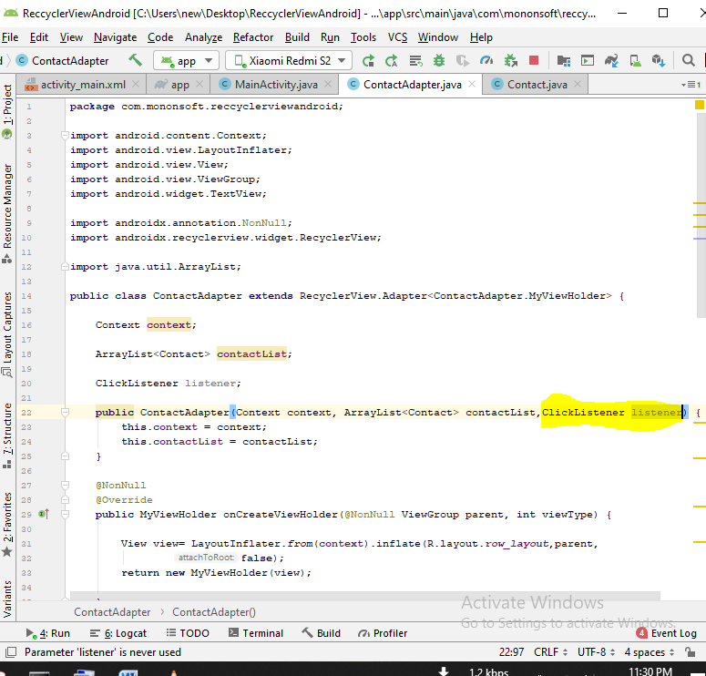

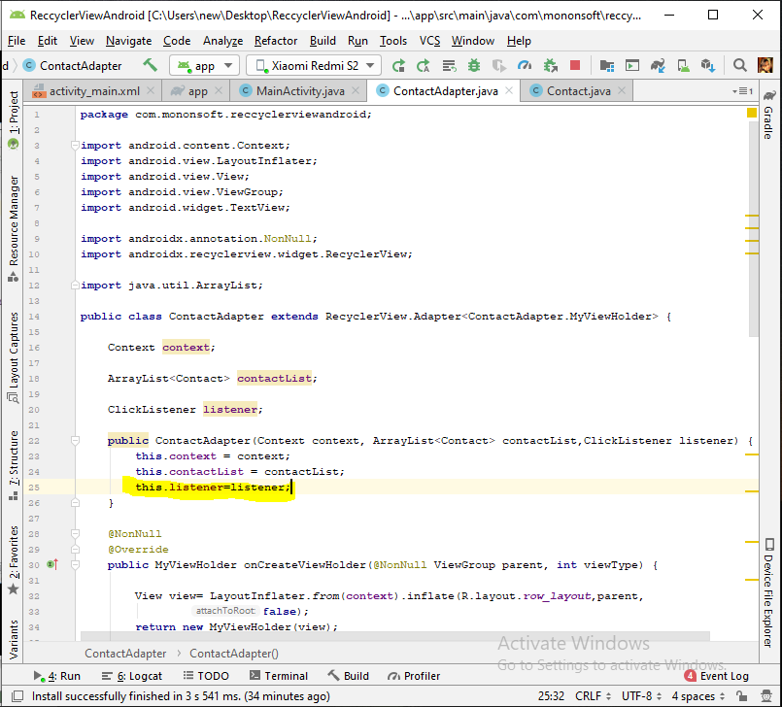

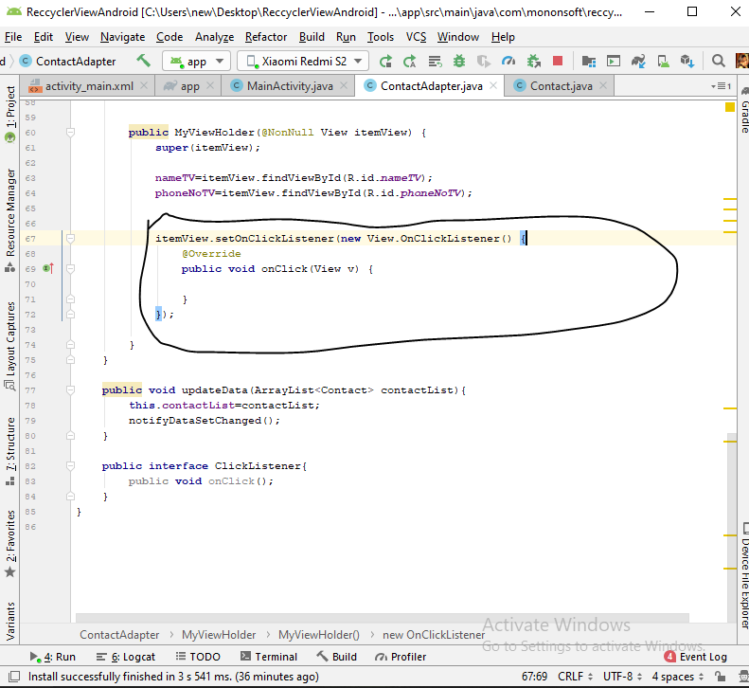

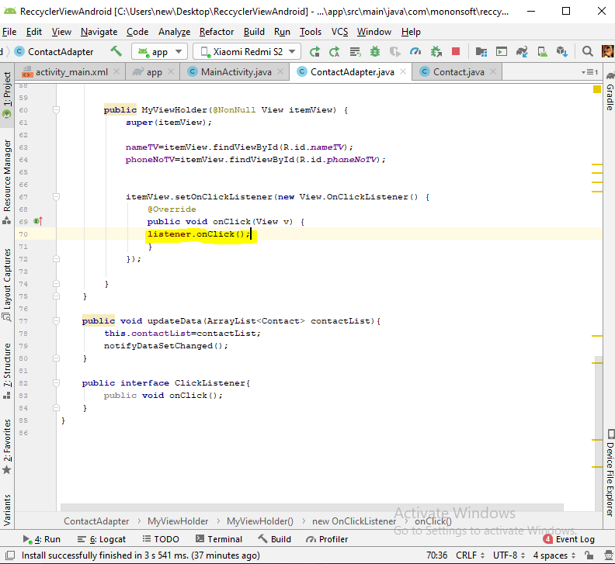

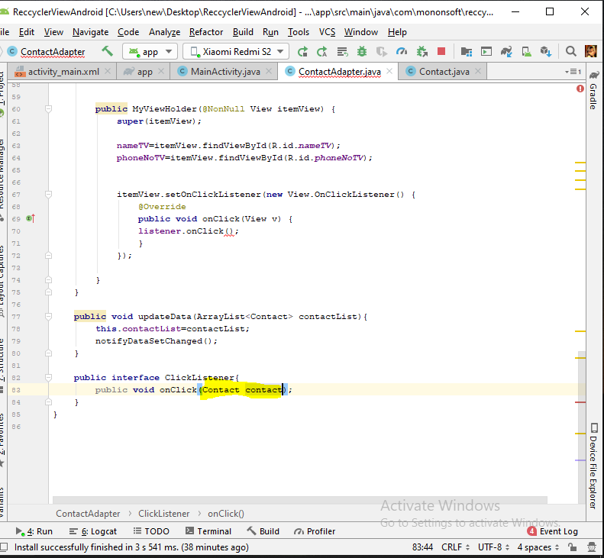

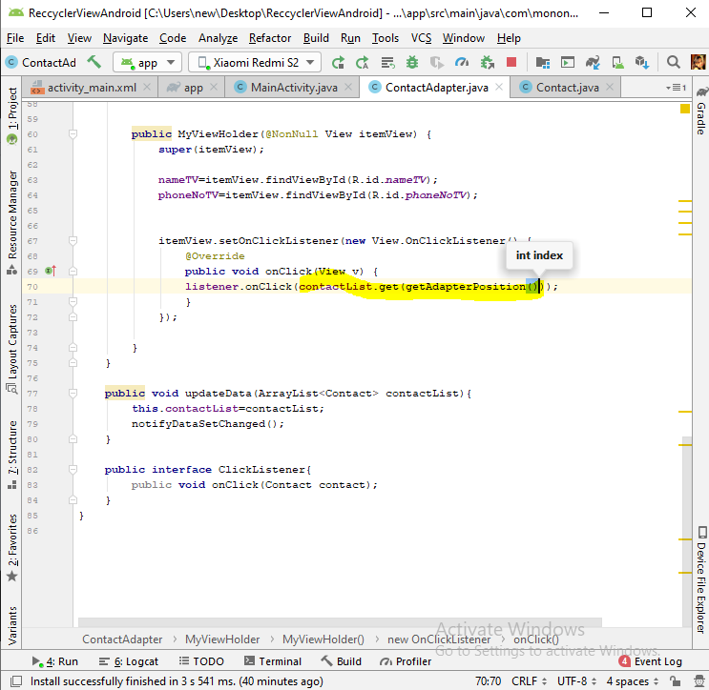

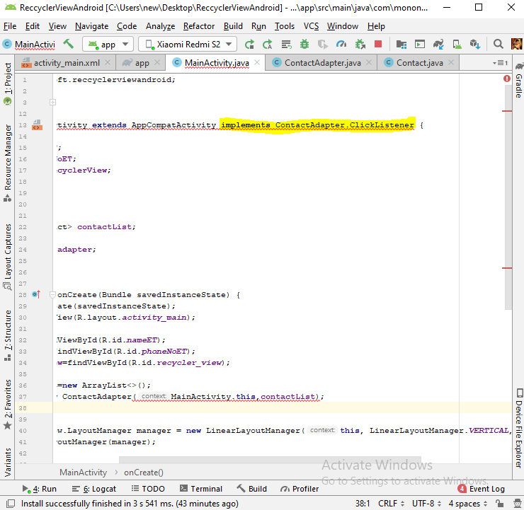

Alt+ent

