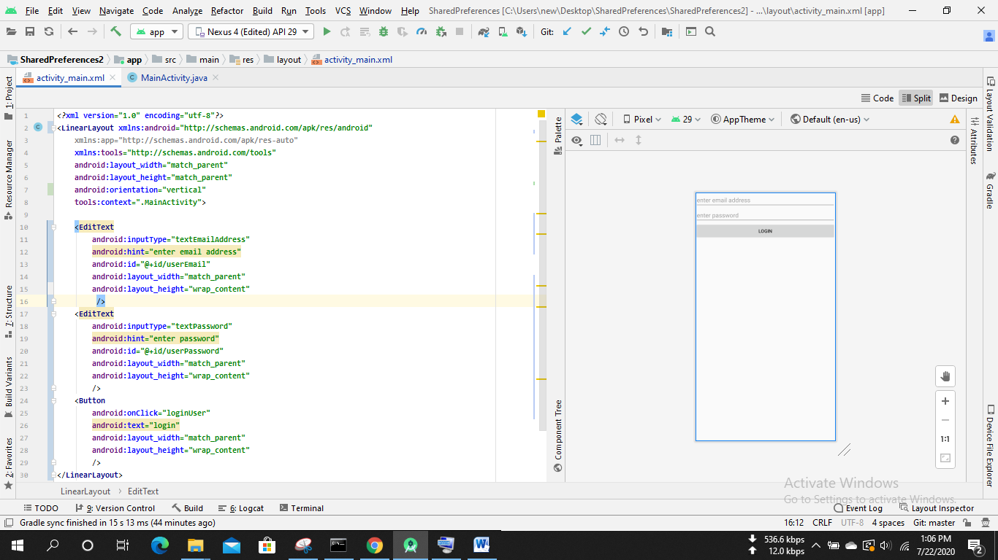

*<?***xml version="1.0" encoding="utf-8"***?>*<**LinearLayout xmlns:android="http://schemas.android.com/apk/res/android"  
 xmlns:app="http://schemas.android.com/apk/res-auto"  
 xmlns:tools="http://schemas.android.com/tools"  
 android:layout_width="match_parent"  
 android:layout_height="match_parent"  
 android:orientation="vertical"  
 tools:context=".MainActivity"**>  
  
 <**EditText  
 android:inputType="textEmailAddress"  
 android:hint="enter email address"  
 android:id="@+id/userEmail"  
 android:layout_width="match_parent"  
 android:layout_height="wrap_content"** />  
 <**EditText  
 android:inputType="textPassword"  
 android:hint="enter password"  
 android:id="@+id/userPassword"  
 android:layout_width="match_parent"  
 android:layout_height="wrap_content"** />  
 <**Button  
 android:onClick="loginUser"  
 android:text="login"  
 android:layout_width="match_parent"  
 android:layout_height="wrap_content"** />  
</**LinearLayout**>

