Key Word in Context (Pipe and filter) Report

A0162485Y

1. Introductory

This is KWIC implemented with pipe and filter architecture with multithread optimization.

1. Architecture:

there are four filters: input, shift, alphabetize, and output. Each filter processes the data and sends it to the next filter. Data sharing between filters is strictly limited to

that transmitted on pipes.



Following is the class diagram.

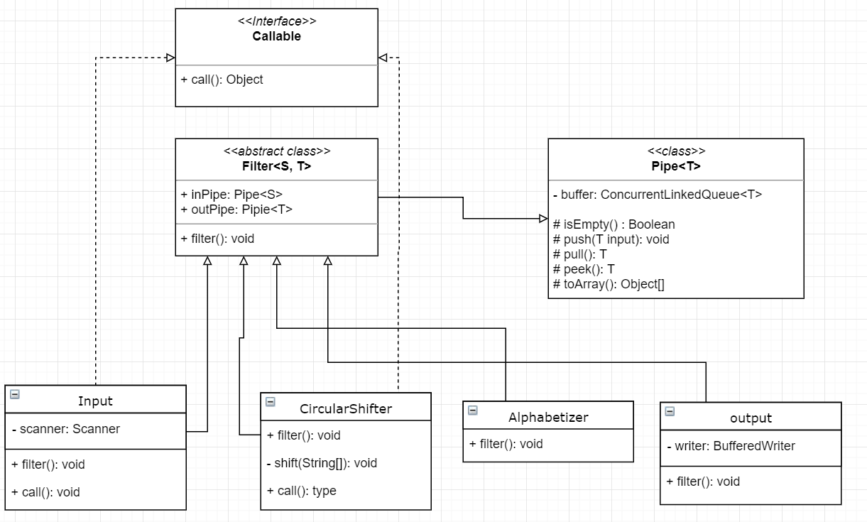

Concurrent can only be done for input and circularShifter, so they both implements Callable interface, and put into a executor service’s cachedThreadPool. And process concurrently.

I’m using Callable instead of runnable because u can only join the thread when the task are Callable by calling the invokeAll, which will wait all tasks finished.

1. Test:
2. Open eclipse
3. Create a project
4. Copy the source file in the src folder
5. Create a input.txt(or use the default) Input should be a file consisting lines of words, which ended with the special character “`”,
6. then run the program, you can get the output.txt in your project folder.