**Kairos**

**USER GUIDE**

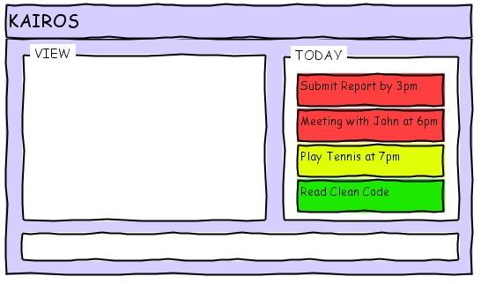

|  |  |  |  |
| --- | --- | --- | --- |
| Nguyen Hoang Thanh Duc, David | Hari Krishna Vetharenian | Karthik Rajasekaran | Bathini Yatish |
| Team Leader + Task, TaskList implementation | Repo Manager + UI implementation | Architect + Logic implementation | Tester, Debugger + Controller implementation |

**INTRODUCTION**

Kairos is a open-source tool that helps you keep track and stay ahead of all of life’s happenings all in one interactive app that is both easy-to-use and packed with features. It helps you meet deadlines, finish work and lets you achieve greater productivity. Kairos is designed to put user experience at the forefront during task handling through the ease of Text Command Line Interface. So let Kairos help you make every second count.

Let’s get started.

*Autostart* - Boot up your system and Kairos is there waiting for you to start the tasks for the day.

*Shortcut* – Hit **Ctrl+Alt+T** at any point to open the task menu at any point in time to view the Kairos console.

**FEATURES**

**1. SimpleAdd:**

Just type in what you would normally write down and voila! Kairos understands and updates your task list.kairos have an exhaustive add command which is capable of handling all events possible with a few short keywords. It’s as intuitive as it can get.

*Intelligent* - Auto complete helps you save typing a few more keystrokes. The text also is colored based on the priority of the task, highlighting to you various parts of the input.

Task with time happening on the same day

**_add meeting with John at 5pm**

Task with time happening on tomorrow

**_add submit report by 10am tomorrow**

Task with start and end time

**_add play tennis from 2pm to 6pm this Saturday**

Recurrent task

**_add visit Anny every sun and tues at 6pm**

Task on specific date with time

**_add attend ABC conference on 29 Oct 2012 10am**

Task with priority

**_add attend CS2103 lecture on 14 Sep 2012 2pm -h (high priority)**

**_add attend ECE sharing session 10 Sep 2012 (medium priority date/time specified)**

**_add re-organize room (floating tasks low priority)**

Task with start and end date, and location

**_add camping at Nation Park from 10 Oct 2012 10am to 11 Oct 2012 5pm**

**_add camping at Nation Park from 10/10 10am to 11/10 5pm**

**_add camping at Nation Park from 10/10 1000 to 11/10 1700**

Floating task

**_add reading The Mythical Man Month**

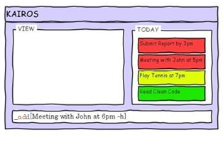

**2. SimpleEdit:**

Need to change some details of a task? The edit command has got you covered. It’s able to quickly find the task you need to modify and enable you to change it’s description.

*Use Case:*

Scenario - User wants to modify a meeting with John, postpone it from 5 to 6pm

Actor - Jim

Pre-Condition : User is on the CLI of Kairos

1. User enters the following command:

**_edit John**.

This shows a list of all his tasks involving “John”.

2. User adds another keyword “meeting” to refine his search:

**_edit John meeting**

This lists down all his meetings scheduled with John. Since there is only one meeting, he can select the task by pressing **TAB**.

3. The task details appear on the command line and the user can edit it now.

4. User can now postpone his meeting with John by changing the time of the meeting to 6pm in the task details. The user presses **ENTER** to confirm this change.

Extensions:

2. (a) There are no tasks with John and meeting. Displays <none found> and waits for user to change command.

3. (a) Incorrect values: If user enters incorrect time, inform user about time error and go to 3.

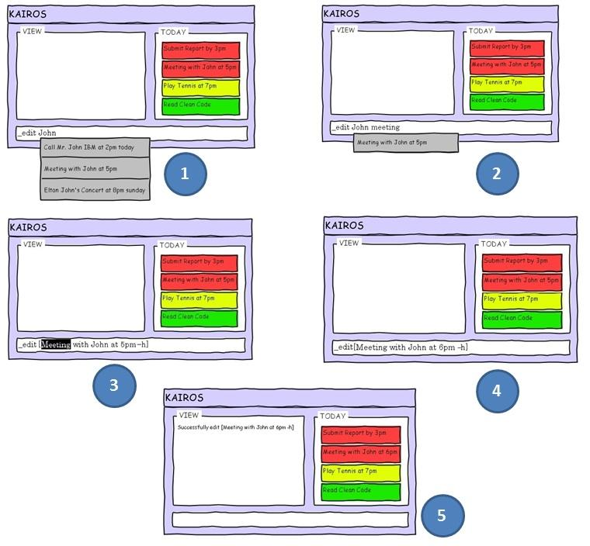

**3. SimpleView**

Zip through your tasks with view. It can find tasks based on any parameter, listing them in an easy to read format. It even allows you to create lists for different priorities, places and people, making it incredibly friendly.

All tasks with John. Works similarly for place, date

**_view John**

All high priority tasks of the day.

**_view -h**

All the done tasks of the day

**_view done**

Also each of the view statements can be appended by an **all** keyword which will display all the tasks matching with it in the entire database of tasks to be done/already done.

eg: **_view -h all**

**_view done all**

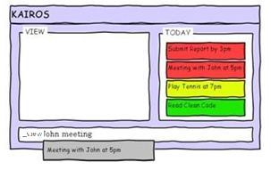

**4.Undo**

Made a mistake? No need to fret. With undo, you can remove the changes you may have previously edited or added.

**_undo**

or use the hotkey as follows

**Ctrl + Z**

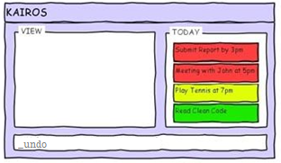

**5.SimpleComplete**

When you are all done with the tasks for the day, just complete them. Strike them off the task list or if you’d like a back up, archive them to a log file.

Complete the task that is present at the index for the day’s task

**_done [index]**

Complete with all the tasks for the day

**_done all**

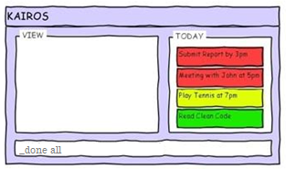

**6. SimpleRemainders**

You might in the rush of things forget about certain events and tasks. Which is why Kairos has SimpleRemainders. It allows to set notifications to pop up in the System Tray and in the task menu. By default alerts are sent just before the task starts. Kairos also have other alert features like an alert 30mins before the task.

Alerts are not sent for low priority tasks as there isn’t a to-do by time for them.

**7. Help!?**

Stuck? Forgot syntax? Worry not because Kairos has an inbuilt help feature.

**_help**

This will enlist all the user commands available

**_help [command_name]**

This will display all options for the [command_name] command

Thank you for choosing Kairos to be your daily task manager!

Make every second count.

**Kairos**

**DEVELOPER GUIDE**

1. **Design and implementation:**

There are 7 main classes which are:

* Controller: plays a role as a container which will create objects of other classes and passing parameter between functions and objects.
* UI: interacts with User such as taking User command and display message to User.
* Logic: interprets the command from User. It also analyzes and provides necessary information to Kairos. It also creates a dummy Task which will contain information from user’s input.
* TaskList: acts as a buffer which contains a list of Task. It also has 2 Log stack for Undo and Redo feature.
* Task: is the fundamental object of Kairos. It contains all the information of a task which User is trying to manage.
* Autocomplete: (to be implemented) is inherited from TaskList. This will work concurrently with UI to provide a user-friendly feature.
* Storage: (to be implemented) is the main database which will store all the task even when the application is closed or terminated.

1. **Descriptive Diagrams**

*Patterns and Principles applied:*

1. Façade: Controller class sits between users and internal classes. All the actions access only via Controller class.
2. Model-View-Control (MVC):
   * Model: TaskList class which stores data buffer.
   * Controller: Logic and Controller class which will interpret user command and change the model accordingly.
   * View: UI Class will interact with users to get the command and to display outputs to users.

*Architecture Diagram*

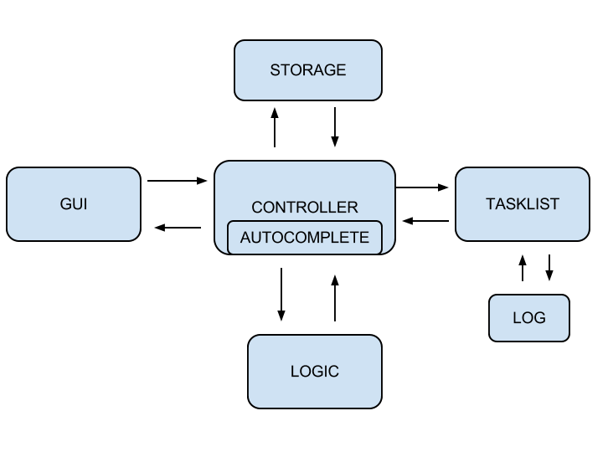

*Class Diagram*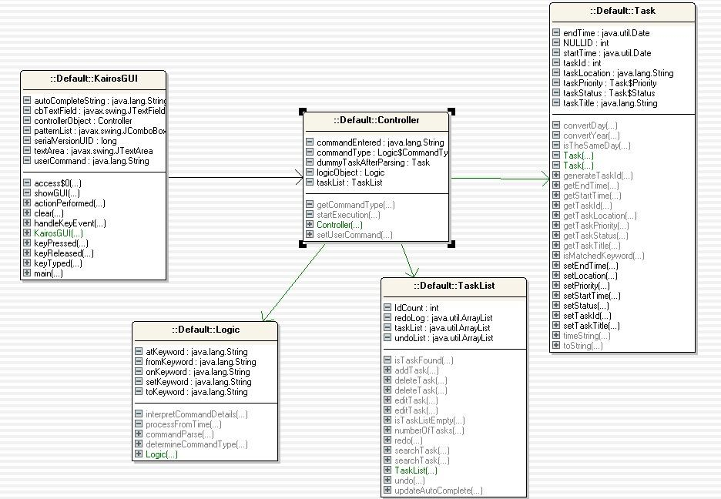

1. 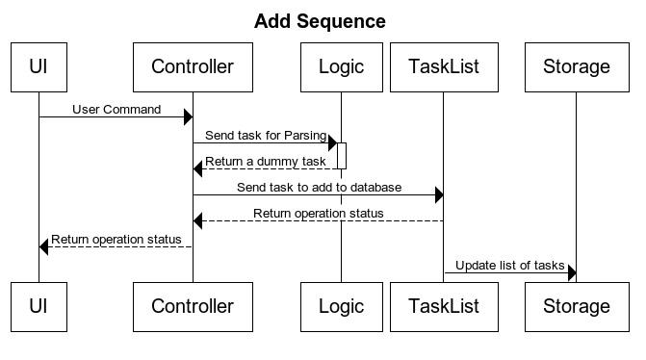**Sequence Diagrams:**

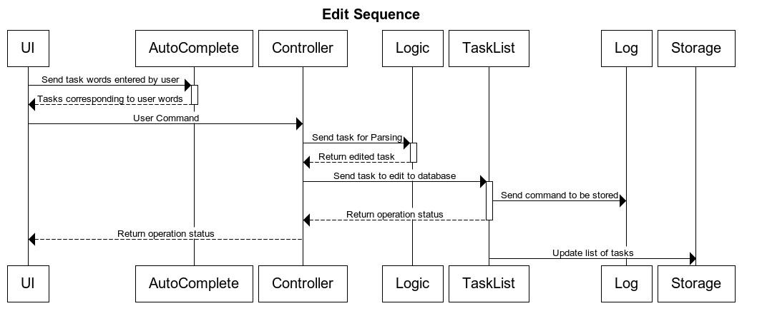

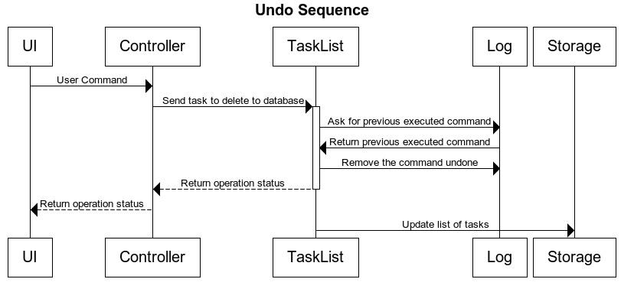

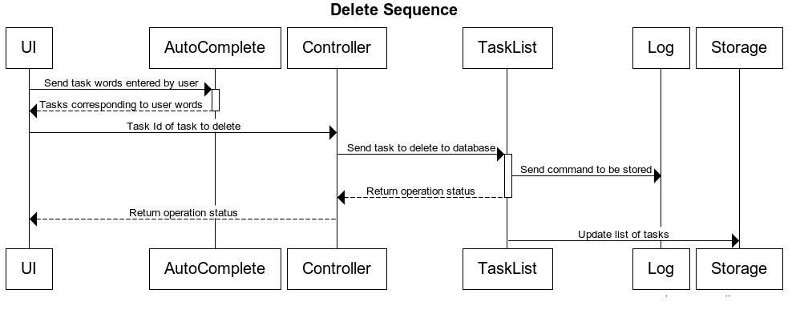

4. **Important APIs:**

* 1. *Controller:*

|  |  |
| --- | --- |
| boolean setUserCommand(String userCommand) | Function that interacts with the GUI and calls the corresponding functions to perform the operations relevant to the commands entered by the user |
| String[] getTodayTask() | Returns an array containing the tasks pertaining to that day to be displayed on a separate frame by the GUI |

* 1. *GUI:*

|  |  |
| --- | --- |
| void invokeGUI() | Sets up the GUI frame and starts it. |

* 1. *Logic:*

|  |  |
| --- | --- |
| Task parseCommand(String command) | splits up the command into respective fields then combines them into one Task object which it then returns to the Controller |
| CommandType determineCommandType(String command) | returns the CommandType of the command entered. |
| Date processFromTime(String fromTime) | returns the parsed date to be added to the Task generated by the parseCommand function |

* 1. *Task*

|  |  |
| --- | --- |
| bool setTaskId(int id); | assign ID of a task |
| bool setTaskTitle(String title); | assign Title of a task |
| bool setTaskStartTime(Date startTime); | assign start time of a task |
| bool setTaskEndTime(Date endTime); | assign end time of a task |
| bool setTaskLocation(String location); | assign location details of a task |
| bool setTaskStatus(int status); | update status of a task |
| bool setTaskPriority(int priority); | assign priority of a task |
| int getTaskId(); | return ID of a task |
| String getTaskTitle(); | return the title of a task |
| Date getTaskStartTime(); | return the start time of a task |
| Date getTaskEndTime(); | return the end time of a task |
| String getTaskLocation(); | return the location of a task |
| int getTaskStatus(); | return the status of a task |
| int getTaskPriority(); | return the priority of a task |
| int generateTaskId(); | generate a unique id based on the date and time of creation of the task (**to be implemented**) |
| String toString(); | return a string with all data of a task collated together |
| boolean isMatchedKeyword(String keyword) | check if a task contains the input keyword |

* 1. *TaskList:*

|  |  |
| --- | --- |
| bool addTask(Task task); | add a task into the data structure |
| bool deleteTask(Task task); | delete a task from the data structure |
| bool deleteTask(int taskId); (**overloading**) | delete a task with the input ID from the data structure |
| bool editTask(int taskId, Task updatedTask); | edit a task with the input ID by the updatedTask from the data structure |
| Task searchTask(task Id); | search a task by ID (return a unique task) |
| List<Task> searchTask(String keyword); (**overloading**) | search tasks by their info, return a list of results |
| int totalNumberOfTasks(); | return total number of tasks |
| bool isTaskListEmpty(); | return TRUE if empty, else return FALSE |
| bool updateAutoComplete(); | **to be implemented in future** |

f. *Storage: (to be implemeted)*

|  |  |
| --- | --- |
| void writeToFile(ArrayList<Task>) | writes the entire stored list of tasks onto an xml file |
| ArrayList<Task> readFromFile() | returns an arraylist of task objects that are stored in the file |

Create a local copy of our code : <https://code.google.com/p/cs2103aug12-f12-3j/>

5. **Changes made in V0.2:**

* Completing design UI with autocomplete feature for “edit” command
* Implement Storage which stores all the tasks into a xml file
* Improve the command parsing in Logic class