SOFTWARE CHANGE IMPLEMENTATION REPORT
CR-008: Server-Side Search, Filtering and Pagination for Admin Enrollments
Field | Details
Change Request ID | CR-008
Change Request Title | Server-Side Search, Filtering and Pagination for Admin Enrollments
Student Name | Not provided
Student ID | Not provided
Implementation Status | Implemented; frontend production build verified; backend/live database and end-to-end verification pending
Date | 21 October 2026

1. Change Request Summary

1.1 Business Requirement
Administrators need to manage large enrollment lists efficiently. The system must search, filter, sort, and paginate enrollment records on the server, return accurate pagination information, and keep student accounts from accessing the administrator listing.

1.2 Existing Behaviour
- The administrator enrollment listing loaded all enrollment rows in one request.
- Search by student, combined filters, date-range filtering, and pagination controls were unavailable.
- The dashboard displayed counts derived from the loaded enrollment collection rather than a paginated response.
- Admin authorization was already applied to the enrollment listing route and must remain enforced.

1.3 Requested Change
- Implement server-side student search, course and date filtering, sorting, and page retrieval.
- Validate query parameters and return pagination totals using a separate count query.
- Add result range and First, Previous, Next, and Last controls to the admin page.
- Keep deletion behavior, filter state, admin authorization, and existing student enrollment behavior compatible.

2. Implementation

2.1 Implementation Summary
The GET /api/enrollments handler now validates q, courseId, from, to, sort, order, page, and limit. Defaults are page 1 and 20 rows; the maximum page size is 100. It counts matching rows separately, then retrieves only the requested page. Student full name and username searches, course/date filters, and allowlisted sorting are applied server-side. The admin page sends the selected criteria and displays the returned records, total, result range, and navigation controls. Deletion refreshes the list and moves back one page when its last row is removed. The route continues to require an authenticated administrator.

2.2 Affected Files
File | Change / Purpose
backend/controllers/enrollmentController.js | Validates supported query parameters and returns filtered paginated results with metadata.
backend/models/enrollmentModel.js | Adds shared filter construction, escaped search, separate count and paginated queries, stable sorting, and distinct enrolled-student count.
backend/controllers/courseController.js | Adds enrolledStudentCount to the dashboard statistics response.
frontend/src/pages/ManageEnrollments.jsx | Adds search, filters, sort, page size, result range, pagination controls, and deletion page correction.
frontend/src/pages/AdminDashboard.jsx | Requests six recent enrollments and reads total counts from server responses.
frontend/src/App.css | Styles the enrollment filters and pagination bar.

2.3 Technical Changes
API validation and response
- Rejects malformed values, repeated query parameters, invalid dates and date ranges, unsupported sort fields/directions, page values below 1, and limits outside 1–100 with HTTP 400.
- Defaults to date descending, page 1, and limit 20. Returns HTTP 200 and an empty array for a valid search with no matches.
- Returns pagination.page, limit, total, and totalPages; an out-of-range requested page is represented by an empty array rather than a 404.
Database query safety
- Search matches student full name or username. User-entered %, _, and ! characters are escaped for literal LIKE matching.
- Search and filter values use bound parameters. Sort columns and sort direction are selected from validated allowlists. LIMIT and OFFSET are parameterized.
- The count and page queries share the same WHERE builder. Results use enrollment id as a stable secondary sort.
Admin interface and dashboard
- The admin page debounces text search, combines filters, resets page to 1 when criteria, sorting, or page size changes, and shows loading, error, and empty states.
- First, Previous, Next, and Last controls are disabled at their respective boundaries. Result ranges are calculated from returned rows.
- After removing the only row on a page, the UI navigates to the previous page; active filters remain in state.
- The admin dashboard now requests six recent records and obtains totals from response metadata; the public course statistics endpoint supplies a distinct enrolled-student count.
Database and authorization
- No schema change or migration was introduced. Existing enrollment relationships and schema indexes remain in place.
- GET /api/enrollments remains behind JWT authentication and the admin role middleware. The frontend admin route remains protected as well.

2.4 Implementation Logic
- An administrator opens the protected enrollment management page.
- The page requests course options and requests the current enrollment page with the active query criteria.
- The controller validates all supported query values before querying for enrollment results.
- The model builds the shared search/filter conditions and runs a separate matching-row count query.
- The model retrieves one page with allowlisted ordering, stable id tie-breaking, LIMIT, and OFFSET.
- The API returns enrollment rows and pagination metadata; the UI updates the table, totals, result range, and button states.
- When an administrator removes a row, the page reloads or moves to the previous page if the removed row was the only row displayed.

2.5 Error and Data Handling
- Invalid query values receive HTTP 400 with a parameter-specific message; database failures receive HTTP 500.
- Valid filters with no matching rows return HTTP 200 with enrollments: [] and total/totalPages equal to zero.
- The UI presents invalid date ranges locally and displays server errors separately from empty search results.
- Enrollment records are not changed by search, filtering, sorting, or pagination.

3. Testing and Verification

3.1 Testing Approach
The frontend production build was executed successfully. git diff --check completed without reporting whitespace errors. No automated backend test suite is defined in package.json, and no live database-backed API, browser interaction, authorization bypass, or deletion scenario was run for this report. Implemented behavior is distinguished below from behavior directly verified.

3.2 Test Cases and Results
Test ID | Test Case | Expected Result | Actual Result | Status
TC-001 | Build frontend for production | Build completes without compilation errors. | npm.cmd run build completed; Vite transformed 102 modules and emitted production assets. | Passed
TC-002 | Check changed-file whitespace | No whitespace errors are reported. | git diff --check completed without output. | Passed
TC-003 | Request default enrollment page | HTTP 200; page 1, limit 20; only requested rows returned. | Implementation present; not run against live backend/database. | Pending
TC-004 | Reject invalid page, limit, date, course, sort, or order | HTTP 400 before enrollment queries. | Validation implementation present; API cases not executed. | Pending
TC-005 | Search name/username and escape %, _, ! | Only matching records returned with literal wildcard handling. | Query implementation present; database behavior not exercised. | Pending
TC-006 | Combine filters and verify count and page rows | Both queries use same filters; metadata is accurate. | Shared filter builder and separate count implemented; not database-verified. | Pending
TC-007 | Navigate page boundaries and change criteria | Controls navigate correctly; criteria changes reset page to 1. | Frontend code implemented; browser interaction not performed. | Pending
TC-008 | Delete only row on a later page | Previous page is displayed and totals refresh. | Deletion behavior implemented; not tested through browser/API. | Pending
TC-009 | Attempt student access to admin listing | Student receives HTTP 403; admin remains authorized. | Route middleware confirms admin role; role-specific API request not executed. | Pending
TC-010 | Run backend/database regression checks | Existing enrollment, dashboard, and database behavior remains functional. | No live database or backend regression run. | Pending

3.3 Test Summary
Test Result | Count / Result
Total defined test cases | 10
Passed | 2
Pending verification | 8
Failed | 0
Execution coverage | 2 of 10 (20%)
Pass rate among executed cases | 2 of 2 (100%)
Overall test result | Partially verified; database-backed and end-to-end checks remain pending

4. Acceptance Criteria Verification
ID | Acceptance Criterion | Verification / Status
AC-001 | Server returns only requested page and defaults page=1, limit=20. | LIMIT/OFFSET and defaults implemented; live API verification pending.
AC-002 | Reject invalid page/limit values; enforce limit maximum 100. | Validation implemented; API cases pending.
AC-003 | Search full name and username; safely handle wildcard input. | Parameterized LIKE search and escaping implemented; database verification pending.
AC-004 | Filter by course and inclusive date range; combine filters. | Shared filter builder implemented; live query verification pending.
AC-005 | Support date/student/course sorting and asc/desc safely. | Allowlisted sorting implemented with stable id tie-break; API verification pending.
AC-006 | Return separate total count and accurate pagination metadata. | Separate COUNT(*) and page queries implemented with common filters; live data verification pending.
AC-007 | Return HTTP 200 with empty list for no matches/out-of-range page. | Controller behavior implemented; API verification pending.
AC-008 | Show current page, total pages/records, result range, and four navigation controls. | Implemented in ManageEnrollments.jsx; browser verification pending.
AC-009 | Reset page when search, filters, page size, or sorting changes. | Handlers and debounced search reset page; browser verification pending.
AC-010 | Correct page after deleting final row and refresh totals. | Implemented; browser/API verification pending.
AC-011 | Restrict admin listing to authorized administrators. | Existing auth and admin role middleware retained; role-based API test pending.
AC-012 | Keep dashboard totals compatible with paginated endpoint. | Dashboard now uses pagination total and stats endpoint returns enrolledStudentCount; runtime verification pending.
AC-013 | Avoid unnecessary schema changes and preserve existing enrollment behavior. | No schema or migration changes made; regression verification pending.

5. Evidence
Evidence files and screenshots were not embedded. The frontend build output and clean diff check were observed during implementation. Capture and attach the following before formal submission:
- Evidence 01 - Admin enrollment page showing search, course/date filters, sorting, page size, and result range.
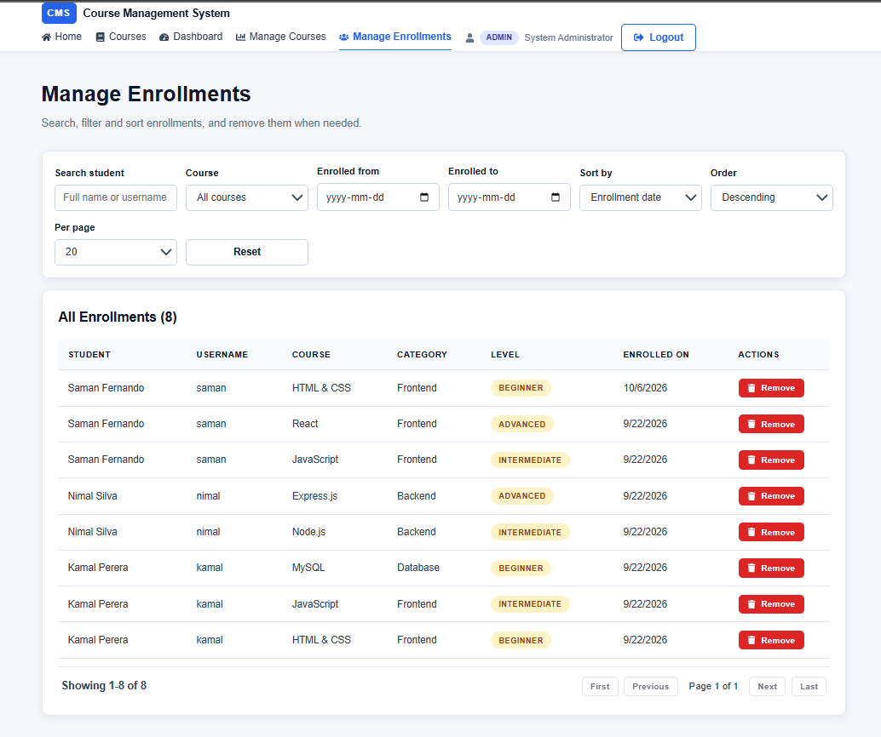

6. Final Result
Item | Result
Requirements | CR-008 server-side enrollment search, filtering, sorting, pagination, and admin UI changes are implemented in the working tree.
Implementation | API validation and queries, pagination metadata, admin controls, deletion page correction, dashboard integration, and styles are present.
Testing | Frontend production build and diff whitespace check passed.
End-to-end status | Live database behavior, API validation/security cases, browser pagination/deletion, and regression checks remain unverified.
Acceptance criteria | Implemented but partially verified; see section 4.
Final status | Implemented; pending database-backed end-to-end verification and formal review.

6.1 Final Summary
CR-008 updates administrator enrollment management to retrieve a server-selected page and apply student search, course/date filters, and allowlisted sorting. The response includes accurate pagination fields by design, and the interface displays result ranges and four navigation controls. The frontend build passed. API and database behavior, authorization requests, and interactive deletion/navigation scenarios still require execution before the implementation can be considered fully acceptance-tested.

6.2 Issues / Limitations
- Student name and student ID were not supplied; placeholders are shown in the report. Replace them before submission.
- No backend automated test suite or live database-backed API tests were run for this report.
- Screenshots and API/database evidence have not been attached.
- No schema/index migration was added because no schema change was necessary for the implemented query patterns.
- The date range logic uses the existing enrolled_at timestamp and inclusive calendar-day boundaries; verify it against the deployment database timezone before formal sign-off.
Student Name: AAM. Nusky
Student ID: JF/ICT/24/01
Date: 21 October 2026
Signature: ____________________________________
~ END OF REPORT ~

