# MongoDB Lab Assignments -Day 1

**MongoDB Exercise in mongo shell**

Connect to a running mongo instance, use a database named **mongo_practice**. Document all your queries in a javascript file to use as a reference.

# Insert Documents

Insert the following documents into a **movies** collection.

title : Fight Club

writer : Chuck Palahniuko year : 1999

actors : [ Brad Pitt

Edward Norton

]

title : Pulp Fiction

writer : Quentin Tarantino year : 1994

actors : [

John Travolta Uma Thurman

]

title : Inglorious Basterds writer : Quentin Tarantino year : 2009

actors : [ Brad Pitt

Diane Kruger Eli Roth

]

title : The Hobbit: An Unexpected Journey writer : J.R.R. Tolkein

year : 2012

franchise : The Hobbit

title : The Hobbit: The Desolation of Smaug writer : J.R.R. Tolkein

year : 2013

franchise : The Hobbit

title : The Hobbit: The Battle of the Five Armies writer : J.R.R. Tolkein

year : 2012

franchise : The Hobbit

synopsis : Bilbo and Company are forced to engage in a war against an array of combatants and keep the Lonely Mountain from falling into the hands of a rising darkness.

title : Pee Wee Herman's Big Adventure title : Avatar

Reference https[://ww](http://www.tutorialspoint.com/mongodb/mongodb_insert_document.htm)w.t[utorialspoint.com/mongodb/mongodb_insert_document.htm](http://www.tutorialspoint.com/mongodb/mongodb_insert_document.htm)

# Query / Find Documents

query the **movies** collection to

1. get all documents

**db.movies.find()**

1. get all documents with writer set to "Quentin Tarantino"

**db.movies.find({writer:”Quentien Tarantino”})**

1. get all documents where actors include "Brad Pitt"

**db.movies.find({actors:”Brad Pitt”})**

1. get all documents with franchise set to "The Hobbit"

**db.movies.find({franchise:”The Hobbit”})**

1. get all movies released in the 90s

**db.movies.find({year:{$gt:”1990”,$lt:”2000”}})**

1. get all movies released before the year 2000 or after 2010

**db.movies.find({$or:[{year:{$lt:”2000”}},{$gt:”2010”}}]})**

Reference: https[://ww](http://www.tutorialspoint.com/mongodb/mongodb_query_document.htm)w.t[utorialspoint.com/mongodb/mongodb_query_document.htm](http://www.tutorialspoint.com/mongodb/mongodb_query_document.htm)

# Update Documents

1. add a synopsis to "The Hobbit: An Unexpected Journey" : "A reluctant hobbit, Bilbo Baggins, sets out to the Lonely Mountain with a spirited group of dwarves to reclaim their mountain home - and the gold within it - from the dragon Smaug."



1. add a synopsis to "The Hobbit: The Desolation of Smaug" : "The dwarves, along with Bilbo Baggins and Gandalf the Grey, continue their quest to reclaim Erebor, their homeland, from Smaug. Bilbo Baggins is in possession of a mysterious and magical ring."



1. add an actor named "Samuel L. Jackson" to the movie "Pulp Fiction"

C:\Users\lonovo\Desktop\ss2\ques3.png

Reference: https[://ww](http://www.tutorialspoint.com/mongodb/mongodb_update_document.htm)w.t[utorialspoint.com/mongodb/mongodb_update_document.htm](http://www.tutorialspoint.com/mongodb/mongodb_update_document.htm)

# Text Search

1. find all movies that have a synopsis that contains the word "Bilbo"

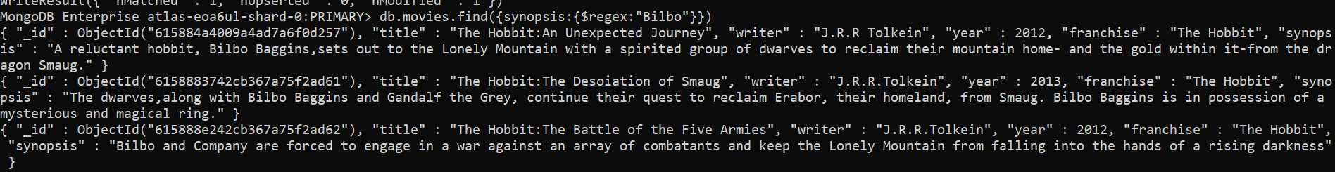

1. find all movies that have a synopsis that contains the word "Gandalf"



1. find all movies that have a synopsis that contains the word "Bilbo" and not the word "Gandalf"



1. find all movies that have a synopsis that contains the word "dwarves" or "hobbit"



1. find all movies that have a synopsis that contains the word "gold" and "dragon"



Reference: https[://w](http://www.tutorialspoint.com/mongodb/mongodb_text_search.htm)ww[.t](http://www.tutorialspoint.com/mongodb/mongodb_text_search.htm)u[torialspoint.com/mongodb/mongodb_text_search.htm](http://www.tutorialspoint.com/mongodb/mongodb_text_search.htm)

# Delete Documents

1. delete the movie "Pee Wee Herman's Big Adventure"

**db.movies.remove({_id:ObjectId(“61158893342cb367a75f2ad63”)})**

1. delete the movie "Avatar"

**db.movies.remove({_id:ObjectId(“6158893342cb367a75f2ad64”)})**

Reference: https[://ww](http://www.tutorialspoint.com/mongodb/mongodb_delete_document.htm)w.t[utorialspoint.com/mongodb/mongodb_delete_document.htm](http://www.tutorialspoint.com/mongodb/mongodb_delete_document.htm)

# Relationships

Insert the following documents into a **users** collection

username : GoodGuyGreg first_name : "Good Guy" last_name : "Greg" username : ScumbagSteve full_name :

first : "Scumbag" last : "Steve"

Insert the following documents into a **posts** collection

username : GoodGuyGreg title : Passes out at party

body : Wakes up early and cleans house

username : GoodGuyGreg title : Steals your identity

body : Raises your credit score

username : GoodGuyGreg

title : Reports a bug in your code body : Sends you a Pull Request

username : ScumbagSteve title : Borrows something body : Sells it

username : ScumbagSteve title : Borrows everything body : The end

username : ScumbagSteve

title : Forks your repo on github body : Sets to private

Insert the following documents into a **comments** collection

username : GoodGuyGreg

comment : Hope you got a good deal! post : [post_obj_id]

where [post_obj_id] is the ObjectId of the posts document: "Borrows something"

username : GoodGuyGreg comment : What's mine is yours! post : [post_obj_id]

where [post_obj_id] is the ObjectId of the posts document: "Borrows everything"

username : GoodGuyGreg

comment : Don't violate the licensing agreement! post : [post_obj_id]

where [post_obj_id] is the ObjectId of the posts document: "Forks your repo on github

username : ScumbagSteve comment : It still isn't clean post : [post_obj_id]

where [post_obj_id] is the ObjectId of the posts document: "Passes out at party"

username : ScumbagSteve

comment : Denied your PR cause I found a hack post : [post_obj_id]

where [post_obj_id] is the ObjectId of the posts document: "Reports a bug in your

code"

# Querying related collections

1. find all users

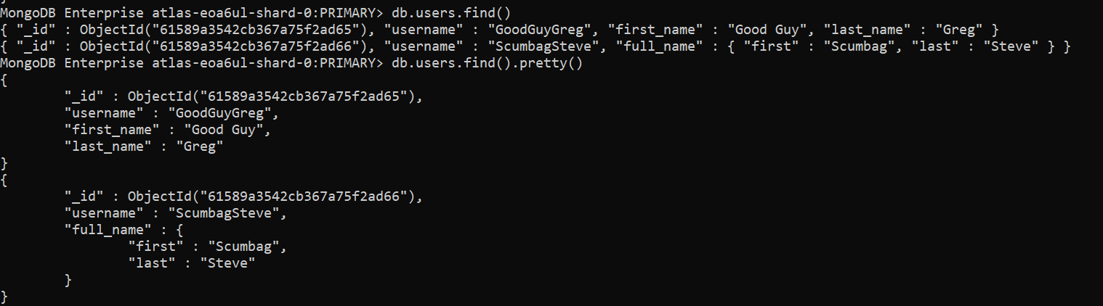

1. find all posts

**db.posts.find().pretty**

1. find all posts that was authored by "GoodGuyGreg"

**db.posts.find({username:”GoodGuyGreg”}).pretty()**

1. find all posts that was authored by "ScumbagSteve"

**db.posts.find({username:”ScumbagSteve”}).pretty()**

1. find all comments

**db.comments.find().pretty()**

1. find all comments that was authored by "GoodGuyGreg"

**db.comments.find({username:”GoodGuyGreg”}).pretty()**

1. find all comments that was authored by "ScumbagSteve"

**db.comments.find({username:”ScumbagSteve”}).pretty()**

1. find all comments belonging to the post "Reports a bug in your code"

**db.comments.find({**

References: <https://docs.mongodb.com/manual/reference/method/db.collection.find/>

@@@@@@@@@@@@@@@@@@@@@@@@@@@@@@@@@@@@@@@