**Install GIT & make sure it is added into PATH.**

**Section 0 -Use GIT as local VCS. Steps to follow:**

1 Create a directory ‘project_dir’ & cd to ‘project_dir’.

Ans: lonovo@LAPTOP-7172MF3G MINGW64 ~

$ mkdir project_dir

lonovo@LAPTOP-7172MF3G MINGW64 ~

$ cd project_dir

2. Initialize git git version database.(git init)

lonovo@LAPTOP-7172MF3G MINGW64 ~/project_dir

$ git init

Initialized empty Git repository in C:/Users/lonovo/project_dir/.git/

3.Create a new file index.html.

lonovo@LAPTOP-7172MF3G MINGW64 ~/project_dir (master)

$ touch index.html

4. Check the git status. You should find index.html as untracked file.

lonovo@LAPTOP-7172MF3G MINGW64 ~/project_dir (master)

$ git status

On branch master

No commits yet

nothing to commit (create/copy files and use "git add" to track)

5. Stage the index.html file.

lonovo@LAPTOP-7172MF3G MINGW64 ~/project_dir (master)

$ git add index.html

6. Commit index.html

lonovo@LAPTOP-7172MF3G MINGW64 ~/project_dir (master)

$ git commit -m "commiting index file"

[master (root-commit) e659f1b] commiting index file

1 file changed, 0 insertions(+), 0 deletions(-)

create mode 100644 index.html

7. Make few changes in index.html & create a new file info.txt file.

lonovo@LAPTOP-7172MF3G MINGW64 ~/project_dir (master)

$ vi index.html

lonovo@LAPTOP-7172MF3G MINGW64 ~/project_dir (master)

$ touch info.txt

8.Check git status. You should find index.html &info.txt as untracked files.

$ git status

On branch master

Changes not staged for commit:

(use "git add <file>..." to update what will be committed)

(use "git restore <file>..." to discard changes in working directory)

modified: index.html

Untracked files:

(use "git add <file>..." to include in what will be committed)

info.txt

no changes added to commit (use "git add" and/or "git commit -a")

9. Configure GIT to ignore all txt files.

lonovo@LAPTOP-7172MF3G MINGW64 ~/project_dir (master)

$ touch .gitignore

after this we write *.txt in gitignore file.

10.Again check the git status. You should find only index.html as untracked file.

lonovo@LAPTOP-7172MF3G MINGW64 ~/project_dir (master)

$ git status

On branch master

Changes not staged for commit:

(use "git add <file>..." to update what will be committed)

(use "git restore <file>..." to discard changes in working directory)

modified: index.html

Untracked files:

(use "git add <file>..." to include in what will be committed)

.gitignore

no changes added to commit (use "git add" and/or "git commit -a")

11. State & commit index.html

lonovo@LAPTOP-7172MF3G MINGW64 ~/project_dir (master)

$ git add .

lonovo@LAPTOP-7172MF3G MINGW64 ~/project_dir (master)

$ git commit -m "commiting again"

[master de9b714] commiting again

2 files changed, 3 insertions(+)

create mode 100644 .gitignore

12.Log all your comments so far.

lonovo@LAPTOP-7172MF3G MINGW64 ~/project_dir (master)

$ git log

commit de9b714d6bea1ccc8d35a9d3cf1ed96c236078c3 (HEAD -> master)

Author: nusrat937 <nusratfaim100@gmail.com>

Date: Wed Sep 29 18:27:48 2021 +0530

commiting again

commit 285346fb4d40731e6afb60b5681ed296a5639808

Author: nusrat937 <nusratfaim100@gmail.com>

Date: Wed Sep 29 18:22:55 2021 +0530

commiting index file

13. Make some changes in index.html.

lonovo@LAPTOP-7172MF3G MINGW64 ~/project_dir (master)

$ vi index.html

14. Revert the change made in the previous step using git command.

lonovo@LAPTOP-7172MF3G MINGW64 ~/project_dir (master)

$ git revert HEAD

[master 7458389] Revert "msg"

1 file changed, 2 deletions(-)

15.Again change index.html.

lonovo@LAPTOP-7172MF3G MINGW64 ~/project_dir (master)

$ vi index.html

16 Stage index.html

lonovo@LAPTOP-7172MF3G MINGW64 ~/project_dir (master)

$ git add index.html

17. Revert back the last stage.

$ git revert HEAD

[master 4c01935] Revert "changed again"

1 file changed, 1 insertion(+), 1 deletion(-)

18. Rename ‘add’ command to ‘my-add’.

lonovo@LAPTOP-7172MF3G MINGW64 ~/project_dir (master)

$ git config --global alias.my-add add

19. Using my_add command Stage index.html again & commit the changes.

lonovo@LAPTOP-7172MF3G MINGW64 ~/project_dir (master)

$ git my-add index.html

lonovo@LAPTOP-7172MF3G MINGW64 ~/project_dir (master)

$ git commit -m "last change"

On branch master

nothing to commit, working tree clean

20.Revert the last commit

lonovo@LAPTOP-7172MF3G MINGW64 ~/project_dir (master)

$ git revert HEAD

[master ba0d0d8] Revert "Revert "changed again""

1 file changed, 1 insertion(+), 1 deletion(-)

*GIT Branching*

**Objective: Commit HTML, CSS & JavaScript assignments into GIT.**

**SECTION-1 (HTML assignments) - Steps to follow:**

21. First take a backup of your assignments & projects. This is required because due to incorrect GIT operation you may lose your files.

22.Create an empty directory ‘Assignments’ & cd to ‘Assignments’.

lonovo@LAPTOP-7172MF3G MINGW64 ~

$ mkdir Assignments

lonovo@LAPTOP-7172MF3G MINGW64 ~

$ cd Assignments

23. Create a file README.txt inside ‘Assignments’ & write few lines about the contents of ‘Assignments’ folder.

lonovo@LAPTOP-7172MF3G MINGW64 ~/Assignments (master)

$ touch README.txt

lonovo@LAPTOP-7172MF3G MINGW64 ~/Assignments (master)

$ vi README.txt

24. Commit README.txt file.

lonovo@LAPTOP-7172MF3G MINGW64 ~/Assignments (master)

$ git commit -m "first change"

[master (root-commit) f81a07d] first change

1 file changed, 1 insertion(+)

create mode 100644 README.txt

25. Now create a new branch ‘html-assignments’.

lonovo@LAPTOP-7172MF3G MINGW64 ~/Assignments (master)

$ git branch html_assignment

26. Switch to ‘html-assignments’ branch.

lonovo@LAPTOP-7172MF3G MINGW64 ~/Assignments (master)

$ git checkout html_assignment

Switched to branch 'html_assignment'

27. Copy all HTML assignments inside ‘Assignments’ folder.

lonovo@LAPTOP-7172MF3G MINGW64 ~/Assignment (html_assignment)

$ touch fil.html

lonovo@LAPTOP-7172MF3G MINGW64 ~/Assignment (html_assignment)

$ git add .

28. Commit HTML assignments into ‘html-assignments’ branch.

lonovo@LAPTOP-7172MF3G MINGW64 ~/Assignment (html_assignment)

$ git commit -m "second commit"

[html_assignment 229bbc8] second commit

1 file changed, 0 insertions(+), 0 deletions(-)

create mode 100644 fil.html

29. Make minor changes into few files belonging to ‘html-assignments’ branch.

lonovo@LAPTOP-7172MF3G MINGW64 ~/Assignment (html_assignment)

$ vi fil.html

30. Commit those changed files.

lonovo@LAPTOP-7172MF3G MINGW64 ~/Assignment (html_assignment)

$ git commit -m "third change"

[html_assignment 8e7e543] third change

1 file changed, 1 insertion(+)

31. Switch to master branch.

lonovo@LAPTOP-7172MF3G MINGW64 ~/Assignment (html_assignment)

$ git checkout master

Switched to branch 'master'

32. Make minor changes into README.txt file & commit those changes into master.

lonovo@LAPTOP-7172MF3G MINGW64 ~/Assignment (master)

$ vi README.txt

lonovo@LAPTOP-7172MF3G MINGW64 ~/Assignment (master)

$ git add README.txt

lonovo@LAPTOP-7172MF3G MINGW64 ~/Assignment (master)

$ git commit -m "fourth change"

[master eccbbaa] fourth change

1 file changed, 1 insertion(+)

33. Again switch to ‘html-assignments’ branch.

lonovo@LAPTOP-7172MF3G MINGW64 ~/Assignments (master)

$ git checkout html_assignment

Switched to branch 'html_assignment'

34. Make minor changes into few files belonging to ‘html-assignments’ branch.

lonovo@LAPTOP-7172MF3G MINGW64 ~/Assignment (html_assignment)

$ vi fil.html

lonovo@LAPTOP-7172MF3G MINGW64 ~/Assignment (html_assignment)

$ git add fil.html

35. Commit those changes.

lonovo@LAPTOP-7172MF3G MINGW64 ~/Assignment (html_assignment)

$ git commit -m "fifth change"

[html_assignment 99471a8] fifth change

1 file changed, 3 insertions(+)

36. Switch to master.

lonovo@LAPTOP-7172MF3G MINGW64 ~/Assignments (html_assignment)

$ git checkout master

Switched to branch 'master'

37. Merge ‘html-assignments’ branch into master. Confirm all html assignments are shown in master.

lonovo@LAPTOP-7172MF3G MINGW64 ~/Assignment (master)

$ git merge html_assignment

Merge made by the 'recursive' strategy.

fil.html | 4 ++++

1 file changed, 4 insertions(+)

create mode 100644 fil.html

38. Finally delete the ‘html-assignments’ branch.

lonovo@LAPTOP-7172MF3G MINGW64 ~/Assignments (master)

$ git branch -d html_assignment

Deleted branch html_assignment (was 6f0997b).

**SECTION-2 - (CSS assignments) Steps to follow:**

1. Create a new branch ‘css-assignments

lonovo@LAPTOP-7172MF3G MINGW64 ~/Assignment (master)

$ git branch css_assignment

2. Switch to ‘css-assignments’ branch.

lonovo@LAPTOP-7172MF3G MINGW64 ~/Assignment (master)

$ git checkout css_assignment

Switched to branch 'css_assignment'

3. Copy all CSS assignments inside ‘Assignments’ folder.

lonovo@LAPTOP-7172MF3G MINGW64 ~/Assignment (css_assignment)

$ touch fil.css

lonovo@LAPTOP-7172MF3G MINGW64 ~/Assignment (css_assignment)

$ git add fil.css

4. Commit CSS assignments into ‘css-assignments’ branch.

lonovo@LAPTOP-7172MF3G MINGW64 ~/Assignment (css_assignment)

$ git commit -m "second"

[css_assignment 32e6f1e] second

1 file changed, 0 insertions(+), 0 deletions(-)

create mode 100644 fil.css

5. Make minor changes into README.txt file on line 1 belonging to ‘css-assignments’ branch.

lonovo@LAPTOP-7172MF3G MINGW64 ~/Assignment (css_assignment)

$ vi README.txt

6. Commit those changed files.

lonovo@LAPTOP-7172MF3G MINGW64 ~/Assignment (css_assignment)

git commit -m "third change"

[css_assignment 32e6f1e] third change

1 file changed, 0 insertions(+), 0 deletions(-)

create mode 100644 fil.css

7. Switch to master branch.

lonovo@LAPTOP-7172MF3G MINGW64 ~/Assignment (css_assignment)

$ git checkout master

Switched to branch 'master'

8. Make minor changes into README.txt file on line 3 & commit those changes into master.

lonovo@LAPTOP-7172MF3G MINGW64 ~/Assignment (master)

$ vi README.txt

lonovo@LAPTOP-7172MF3G MINGW64 ~/Assignment (master)

$ git add README.txt

lonovo@LAPTOP-7172MF3G MINGW64 ~/Assignment (master)

$ git commit -m "third"

[master 2541900] third

1 file changed, 1 insertion(+)

9. Again switch to ‘css-assignments’ branch.

lonovo@LAPTOP-7172MF3G MINGW64 ~/Assignment (master)

$ git checkout css_assignment

Switched to branch 'css_assignment'

10. Make minor changes into few files belonging to ‘css-assignments’ branch.

lonovo@LAPTOP-7172MF3G MINGW64 ~/Assignment (css_assignment)

$ vi fil.css

11. Commit those changes.

lonovo@LAPTOP-7172MF3G MINGW64 ~/Assignment (css_assignment)

$ git commit -m "fourth"

[css_assignment 15ed3cc] fourth

1 file changed, 1 insertion(+)

12. Switch to master.

lonovo@LAPTOP-7172MF3G MINGW64 ~/Assignment (css_assignment)

$ git checkout master

Switched to branch 'master'

13. Merge ‘css-assignments’ branch into master. Confirm all css assignments are shown in master.

lonovo@LAPTOP-7172MF3G MINGW64 ~/Assignment (master)

$ git merge css_assignment

Merge made by the 'recursive' strategy.

fil.css | 1 +

1 file changed, 1 insertion(+)

create mode 100644 fil.css

14. Finally delete the ‘css-assignments’ branch.

lonovo@LAPTOP-7172MF3G MINGW64 ~/Assignment (master)

$ git branch -d css_assignment

Deleted branch css_assignment (was 15ed3cc).

**SECTION-3 - (JavaScript assignments) Steps to follow:**

1. Create a new branch ‘js-assignments’.

lonovo@LAPTOP-7172MF3G MINGW64 ~/Assignment (master)

$ git branch js-assignment

2. Switch to ‘js-assignments’ branch.

lonovo@LAPTOP-7172MF3G MINGW64 ~/Assignment (master)

$ git checkout js-assignment

Switched to branch 'js-assignment

3. Copy all JavaScript assignments inside ‘Assignments’ folder.

lonovo@LAPTOP-7172MF3G MINGW64 ~/Assignment (js-assignment)

$ touch fd.txt

4. Commit JavaScript assignments into ‘js-assignments’ branch.

lonovo@LAPTOP-7172MF3G MINGW64 ~/Assignment (js-assignment)

$ git add fd.txt

lonovo@LAPTOP-7172MF3G MINGW64 ~/Assignment (js-assignment)

$ git commit -m "first"

[js-assignment 30a1dfb] first

1 file changed, 0 insertions(+), 0 deletions(-)

create mode 100644 fd.txt

5. Make minor changes into README.txt file on line 1 belonging to ‘js-assignments’ branch.

lonovo@LAPTOP-7172MF3G MINGW64 ~/Assignment (js-assignment)

$ vi README.txt

6. Commit those changed files.

lonovo@LAPTOP-7172MF3G MINGW64 ~/Assignment (js-assignment)

$ git add .

lonovo@LAPTOP-7172MF3G MINGW64 ~/Assignment (js-assignment)

$ git commit -m "second"

[js-assignment 04f102b] second

1 file changed, 2 insertions(+)

7. Switch to master branch.

lonovo@LAPTOP-7172MF3G MINGW64 ~/Assignment (js-assignment)

$ git checkout master

Switched to branch 'master'

8. Make minor changes into README.txt file on line 1 & commit those changes into master.

lonovo@LAPTOP-7172MF3G MINGW64 ~/Assignment (master)

$ vi README.txt

lonovo@LAPTOP-7172MF3G MINGW64 ~/Assignment (master)

$ git add .

lonovo@LAPTOP-7172MF3G MINGW64 ~/Assignment (master)

$ git commit -m "third"

[master 4111713] third

1 file changed, 1 insertion(+)

9. Again switch to ‘js-assignments’ branch.

lonovo@LAPTOP-7172MF3G MINGW64 ~/Assignment (master)

$ git checkout js-assignment

Switched to branch 'js-assignment'

10. Make minor changes into few files belonging to ‘js-assignments’ branch.

lonovo@LAPTOP-7172MF3G MINGW64 ~/Assignment (js-assignment)

$ vi fd.js

11. Commit those changes.

lonovo@LAPTOP-7172MF3G MINGW64 ~/Assignment (js-assignment)

$ git add fd.js

lonovo@LAPTOP-7172MF3G MINGW64 ~/Assignment (js-assignment)

$ git commit -m "fourth"

[js-assignment 7565daf] fourth

1 file changed, 1 insertion(+)

12. Switch to master.

lonovo@LAPTOP-7172MF3G MINGW64 ~/Assignment (js-assignment)

$ git checkout master

Switched to branch 'master'

13. Merge ‘js-assignments’ branch into master. Confirm all JavaScript assignments are shown in master.

lonovo@LAPTOP-7172MF3G MINGW64 ~/Assignment (master)

$ git merge js-assignment

Auto-merging README.txt

Merge made by the 'recursive' strategy.

README.txt | 2 ++

fd.js | 1 +

2 files changed, 3 insertions(+)

create mode 100644 fd.js

14. Finally delete the ‘js-assignments’ branch.

lonovo@LAPTOP-7172MF3G MINGW64 ~/Assignment (master)

$ git branch -d js-assignment

Deleted branch js-assignment (was 7565daf).

*GIT Remoting*

**Objective: Pushing source code into GITHUB & collaborate team members.**

**SECTION-3 (Pushing assignments to remote repository) - Steps to follow:**

1. Create a github account if you do not have already.

created

2. Login on into github account.

done

3. Create new public repository ‘freshersbatch-oct16’.

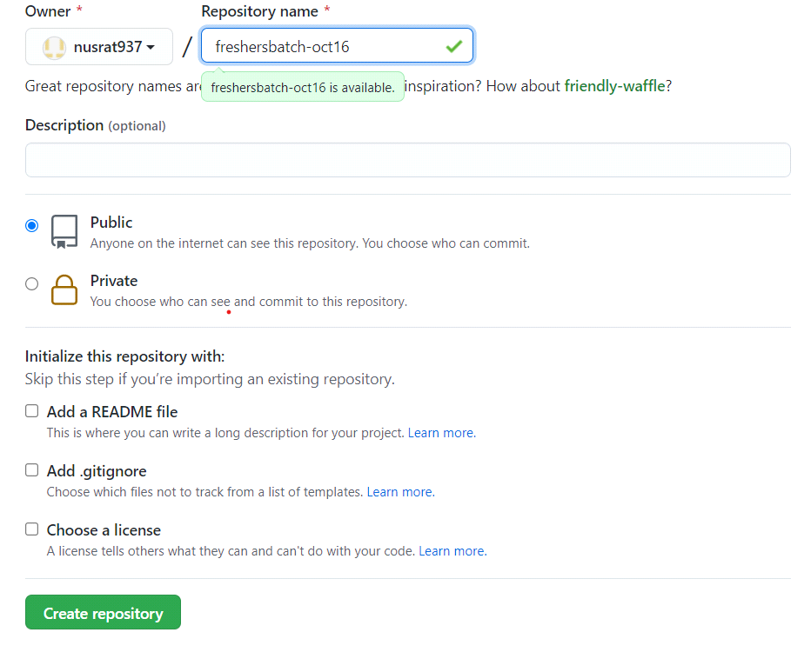

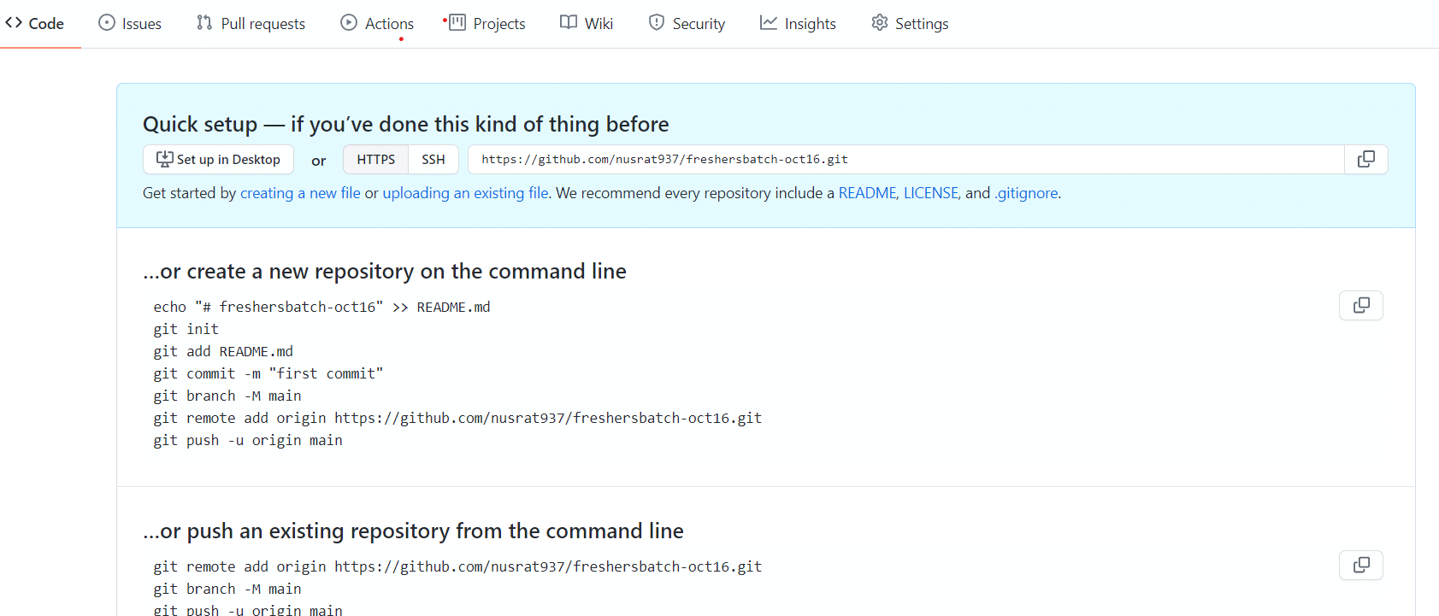

4. Commit & push any sample file to this repository under ‘Assignments’ directory.

lonovo@LAPTOP-7172MF3G MINGW64 ~/Assignment (master)

$ git remote add origin <https://github.com/nusrat937/freshersbatch-oct16.git>

lonovo@LAPTOP-7172MF3G MINGW64 ~/Assignment (master)

$ git push -u origin master

Enumerating objects: 27, done.

Counting objects: 100% (27/27), done.

Delta compression using up to 4 threads

Compressing objects: 100% (19/19), done.

Writing objects: 100% (27/27), 2.46 KiB | 157.00 KiB/s, done.

Total 27 (delta 2), reused 0 (delta 0), pack-reused 0

remote: Resolving deltas: 100% (2/2), done.

To <https://github.com/nusrat937/freshersbatch-oct16.git>

* [new branch] master -> master

Branch 'master' set up to track remote branch 'master' from 'origin'.

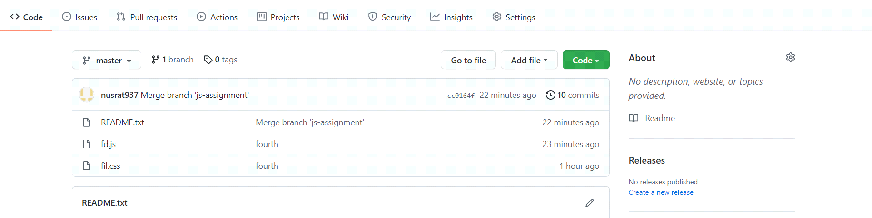

SECTION-4 (Pushing source code to remote repository using Eclipse GIT plugin) - Steps to follow:

1. One developer from project team will create eclipse projects ‘SampleProj’ & add sample source code files. Then commit all files through eclipse GIT plugin.
2. Collaborate other team members with your github account so that they can also modify the committed files.
3. Other developers from same team will checkout all files from remote repository. This might get conflicts since certain files fail to merge. In such case, merge it manually.
4. Commit & push the ‘SampleProj’ project.