Data Wizardry in Hogwarts
Forecasting a Canadian retail buy before the December 2026 wizarding revival
PROJECT BUILD BRIEF
A complete specification for an autonomous coding agent
Author: Nusrat Jahan
Programme: Master of Business Analytics and AI, Ontario Tech University
Repository: data-wizardry-in-hogwarts
Document version 1.6, sources verified 1 September 2026

1. How to use this document
This document is written for a coding agent such as Claude Code or Cowork. It is a build brief, not a report. The agent should be able to open this file, read it once, and begin work without asking the human for missing details.

Rules for the agent
- Read the whole document before writing any code. Several later sections change decisions made in earlier ones.
- Build in the order given in section 16. Do not start with the dashboard, however tempting it is.
- Every script must run on its own from the command line and must save its output to disk. No step may depend on data that only exists in memory from a previous step.
- If a data source fails or returns nothing, stop, write the failure into logs/data_issues.md, and continue with the next source. Never invent numbers to fill a gap.
- Where this document marks an item as a human decision, do not decide it alone. Write the question into docs/open_questions.md and carry on with the stated default.
- Commit after each completed module with a plain message naming the module.

What done means
Each module below ends with an acceptance test. A module is finished only when its acceptance test passes, its output files exist on disk, and a short note has been added to docs/build_log.md saying what was produced and what was skipped.

2. Project overview
The wizarding franchise returns to screens with a new eight episode television season premiering on 25 December 2026. The franchise has been commercially quiet for several years, so retailers have no recent sales history to plan against. This project builds a data driven buying recommendation for a Canadian book and lifestyle retailer that must commit its holiday category order months before the premiere.
The project is deliberately built as nine modules so that it covers business intelligence, data analysis, machine learning, big data tooling, supply chain reasoning and data ethics. All nine modules answer parts of a single business question, so the finished work reads as one piece of consulting, not as nine separate exercises.

Naming and theme
Hogwarts in the title stands for the fictional world as a whole, not for the school. Data Wizardry signals that this is analytics work carried out by someone who knows and loves the source material. Report sections are named after locations in the castle. The theme is presentation only. It must never change how any calculation is performed.
Section name | Meaning | Module
The Great Hall | Overview and headline findings | Module 2
The Library | Data sources, collection and analysis | Modules 1 and 3
The Houses | Audience segmentation | Module 4
Potions | Modelling and forecasting | Module 5
Gringotts | Money, the retail buy and supply chain | Module 6
The Chamber | Large scale text processing | Module 7
The Ministry | Ethics, privacy and governance | Module 8

How the nine modules fit together
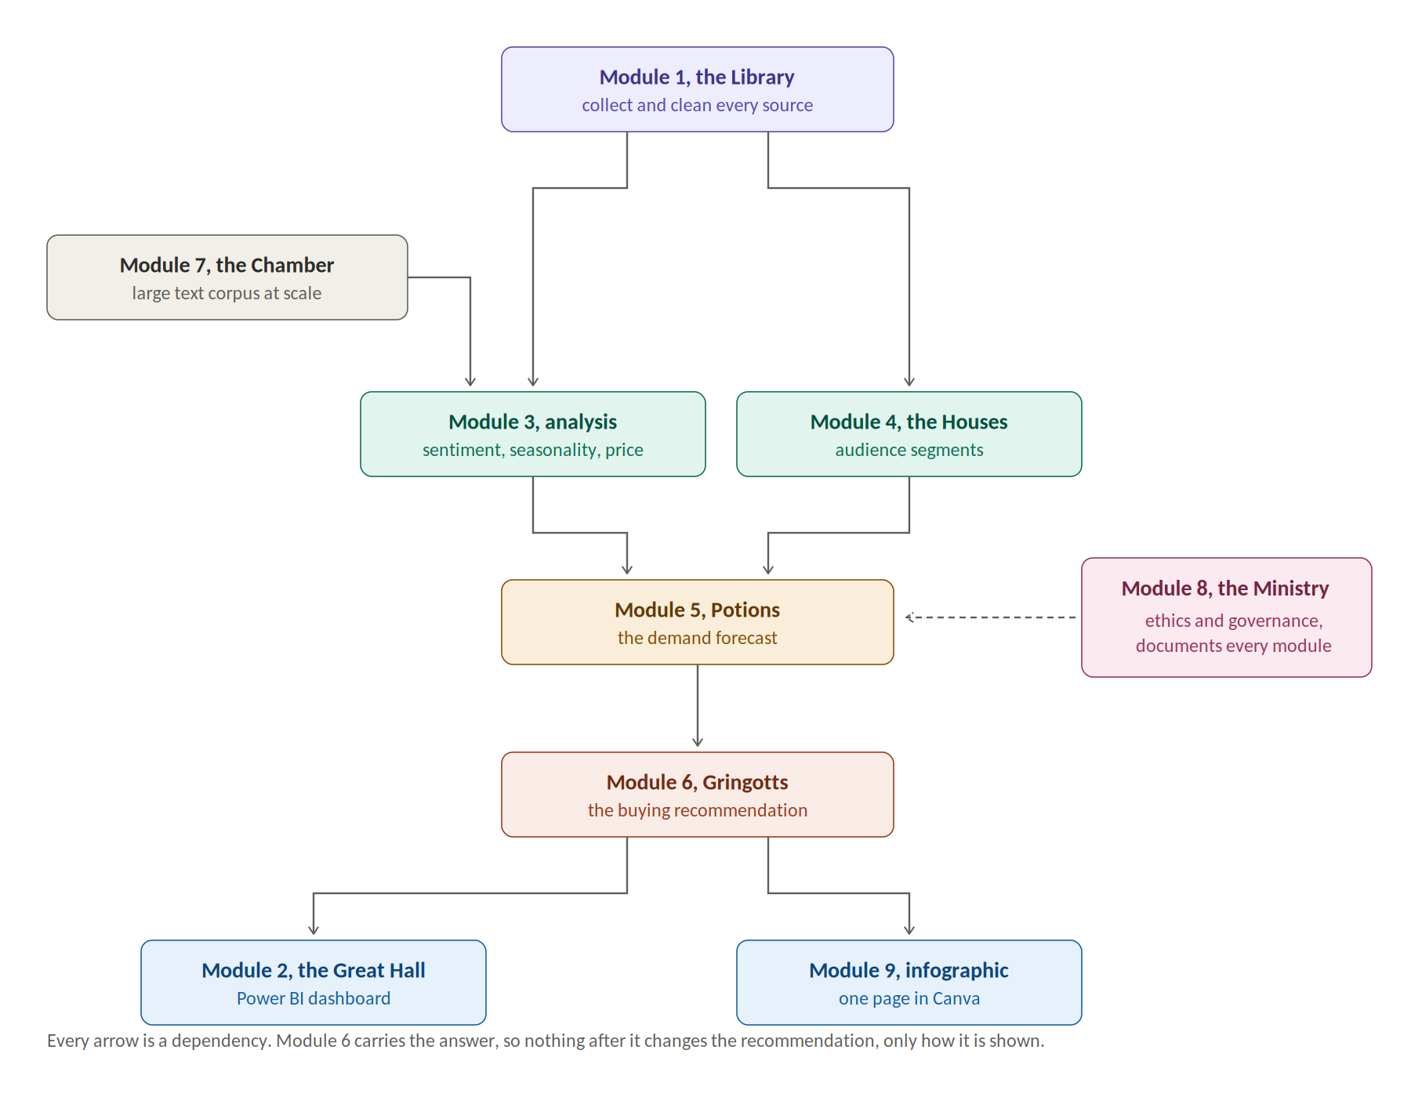
Figure 1. Module dependency map. Every arrow is something the next module needs.

3. The business question

Client
A Canadian book and lifestyle retailer. Treat the client as a realistic composite rather than naming a specific listed company, because the obvious Canadian comparison was taken private and no longer publishes financial statements. If a financial benchmark is needed, use a listed retailer as a proxy and say so plainly in the methods section. Naming a data limitation earns credit. Hiding one does not.

Decision statement
A Canadian book and lifestyle retailer must commit its holiday 2026 category buy well before the season starts. Given a premiere date of 25 December 2026, how large should the wizarding category buy be, which products and characters should it favour, and when should stock arrive in stores.

The finding the project is built to test
The premiere date falls after the gift buying window closes, not during it. Interest and buzz build through October and November while shoppers are choosing gifts, but the show itself arrives on the day buying stops. The resulting viewing driven demand spike is therefore expected to land in late December and January, during gift card redemption and markdown season, when seasonal stock has normally already been cleared.
The agent must test this claim against the data rather than assume it. If the evidence does not support it, report that instead. A disproved hypothesis honestly reported is a stronger result than a confirmed one that was never tested.
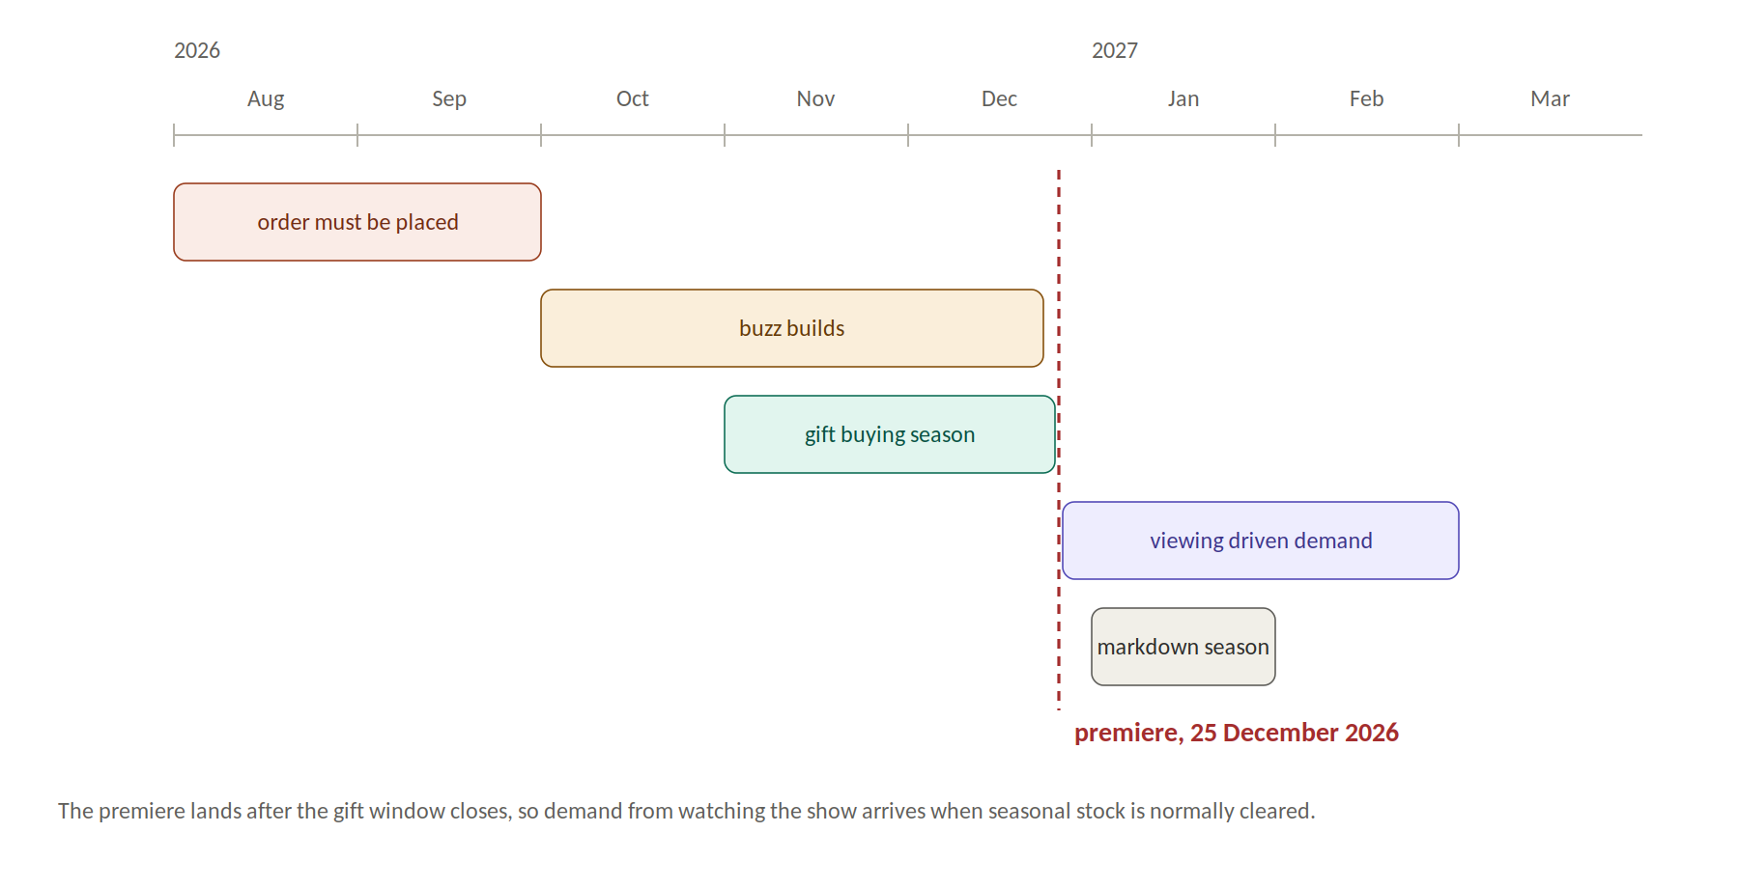
Figure 2. The calendar problem the project exists to solve.

Three questions every module must serve
- How big is the coming demand spike.
- What shape does it have, meaning which products, which characters and which audience segments.
- When does it arrive, and what does that mean for order timing.

4. Repository structure and file placement rules
Create this structure exactly. Every file has one correct home and the agent must not improvise a new location. Scripts are numbered so that running them in filename order reproduces the whole project.

The tree
data-wizardry-in-hogwarts/
data/ ALL downloaded data lands here, nowhere else
raw/ untouched source pulls, never edited
potterdb/ json from the book, chapter, character and movie endpoints
pageviews/ json from the article view endpoint, one file per article
trends/ csv or json of weekly search interest by keyword group
statcan/ csv and compressed table downloads
toys/ json from the product catalogue and the price source
reddit/ json or parquet of posts and comments
parks/ pdf reports before extraction
cleaned/ one folder per source again, same names as raw
potterdb/ cleaned but still only PotterDB data
pageviews/
trends/
statcan/
toys/
reddit/
parks/
processed/ joined analysis ready tables, no source folders
external/ manually entered files, see section 6
images/ ALL images, of any kind, live here
figures/ charts generated by scripts
dashboard/ exported dashboard screenshots
source/ images downloaded from a source
infographic/ exports of the finished one page design
src/
collect/ 01 to 09, one script per source
clean/ 10 to 19
analysis/ 20 to 29
models/ 30 to 39
retail/ 40 to 49
bigdata/ 50 to 59
utils/ shared helpers, config loader, logging
web/ any HTML deliverable, see the rules below
index.html markup only
css/ one stylesheet per concern, never inline
js/ one script per concern, never inline
assets/ fonts, icons and other static files
notebooks/ exploration only, never the source of truth
outputs/
tables/ csv summaries for the report
models/ saved model objects and metrics
dashboard/ Power BI file and a star schema note
infographic/ Canva working files and the asset pack
docs/ proposal, methods, ethics, open questions, build log
logs/ run logs and data issues
tests/ pytest checks on the processed tables
config.yaml all paths, dates and parameters
requirements.txt
.env.example names of API keys, never real keys
README.md written last

How data moves through the folders
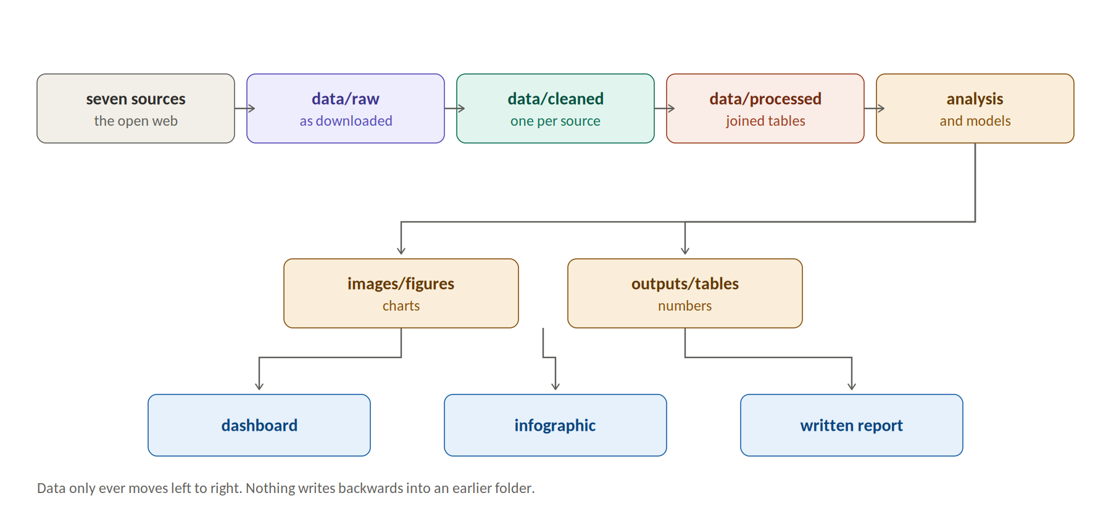
Figure 3. End to end flow. Data only ever moves left to right.

The data folder in picture form
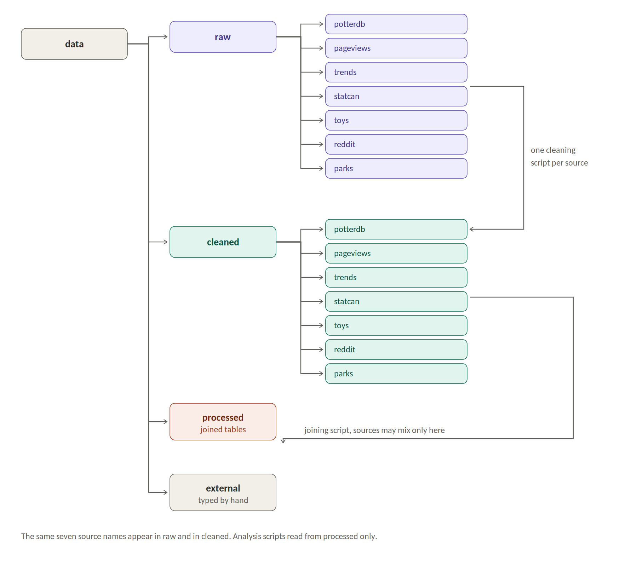
Figure 4. The data folder. Raw and cleaned hold the same seven source names.

The images folder in picture form
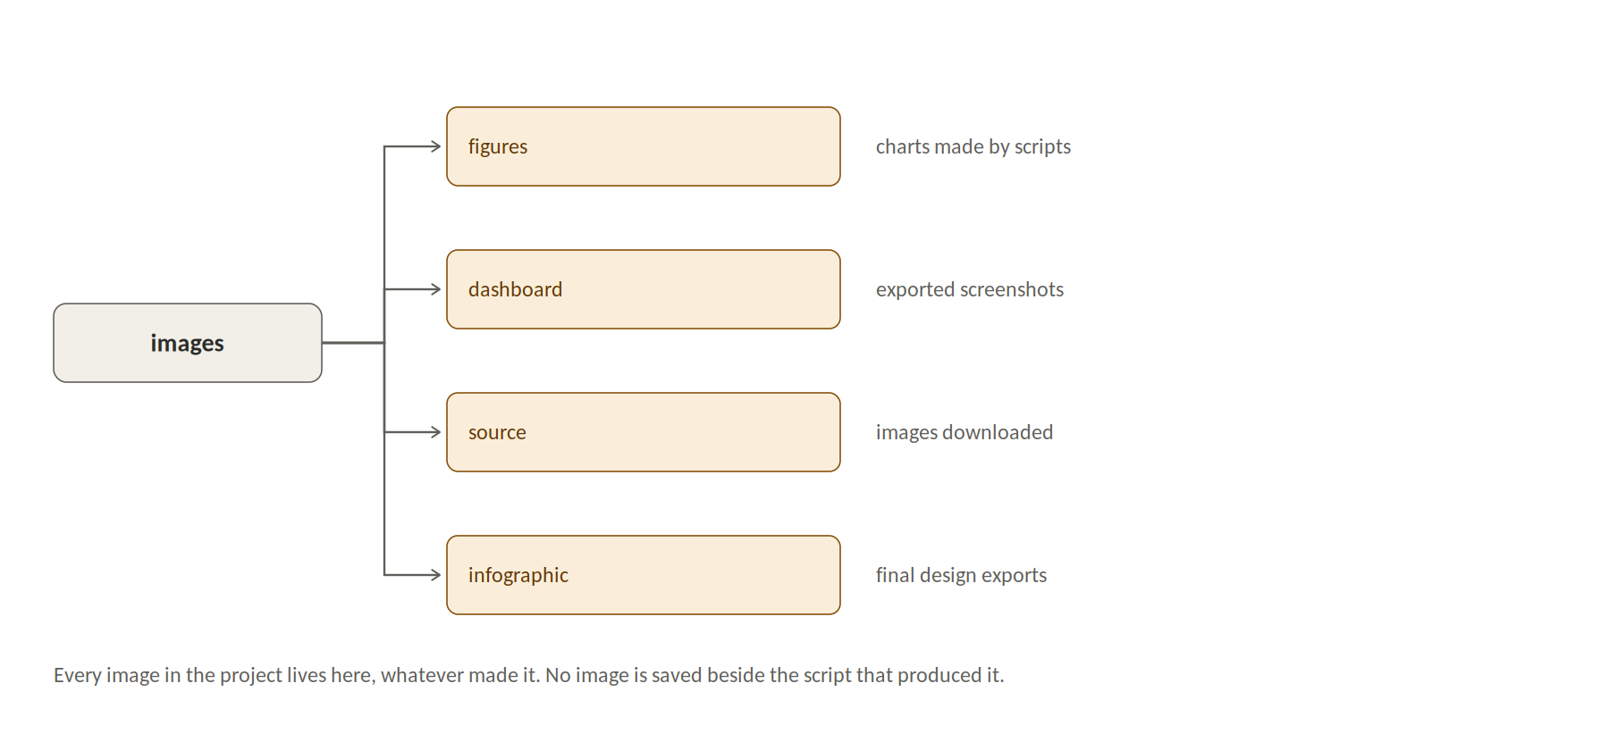
Figure 5. The images folder. Every picture in the project lives here.

The src folder in picture form
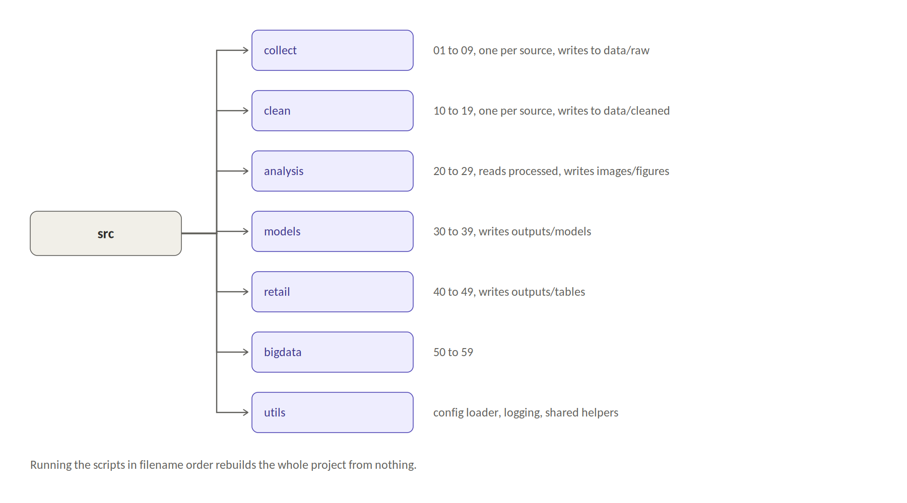
Figure 6. The src folder. Numbered so that filename order is run order.

Placement rules
- Anything downloaded from anywhere goes under data. No script may save a download into src, into the repository root, into a notebook directory, or into a temporary path outside the tree.
- Sort raw downloads by their source first. Every source in section 6 gets exactly one folder under data/raw named after it, and the collection script for that source writes only into that folder. One script, one folder, so a broken source can be deleted and pulled again on its own.
- Keep files in the format they arrived in. Do not convert during collection. If a single source returns more than one format, add format subfolders inside that source folder, for example data/raw/statcan/csv and data/raw/statcan/pdf. Do not add format subfolders when a source returns only one format.
- A source folder holds nothing but that source. Never mix two sources in one folder, and never write a cleaned file into data/raw.
- The cleaned folder mirrors the raw folder exactly. The same seven source names appear in both, so data/raw/statcan is cleaned into data/cleaned/statcan and nowhere else. A reader can then compare any cleaned file against the download it came from by changing one word in the path.
- The processed folder has no source subfolders, because the tables in it combine several sources and belong to none of them. That is the only place a join is allowed to happen, and it is the only folder the analysis scripts are allowed to read.
- Every image in the project goes under images, whether it was downloaded, generated by a chart script, exported from the dashboard, or exported from the design tool. No image is ever saved beside the script that made it.
- Chart scripts write to images/figures and nowhere else. Numeric summaries that accompany a chart go to outputs/tables. The two are separate on purpose, because the report needs the numbers and the design work needs the picture.
- No analysis script reads from data/raw or data/cleaned. Analysis reads only from data/processed.
- File names are lower case with underscores, no spaces, no capitals and no special characters. Dates inside file names use the year month day format so that names sort correctly.
- Every saved file carries the date of collection either in its name or in an accompanying small metadata file, so that a stale pull can be recognised later.

Rules for any HTML, CSS or JavaScript
Some parts of this project may end up as a web page, for example a portfolio version of the data story or an interactive chart. Whenever that happens the following rules apply, with no exceptions.
- Never put everything in one file. Markup, styling and behaviour are three separate concerns and live in three separate places.
- HTML files contain markup only. No style block, no script block containing code, and no inline style attribute on an element.
- All styling lives in files under web/css and is linked from the HTML. Split by concern rather than writing one enormous stylesheet, for example a base file, a layout file and a chart file.
- All behaviour lives in files under web/js and is linked from the HTML. One file per concern, for example one for chart drawing and one for page interaction.
- Colours, fonts and spacing values are declared once as variables at the top of the base stylesheet and referenced everywhere else. Never repeat a colour value in several places, because the palette must match the dashboard and the infographic exactly.
- Images referenced by a web page are read from the images folder using a relative path. Do not copy an image into the web folder.
- No build tool, no bundler and no framework unless the human asks for one. Plain HTML, plain CSS and plain JavaScript keep the work readable by a marker.
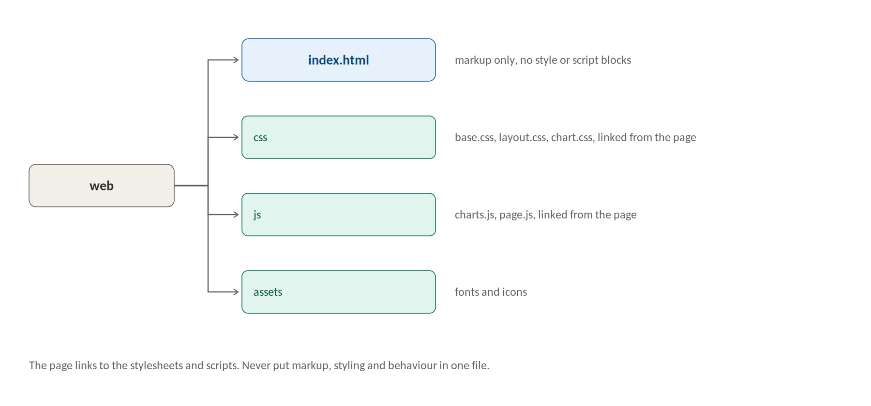
Figure 7. The web folder. Markup, styling and behaviour kept in three separate places.

Why this matters here
This is not tidiness for its own sake. A reviewer opening the repository should be able to find any file within a few seconds without reading a single script, and the person marking the work should be able to see at a glance which files were downloaded, which were generated and which were written by hand. Naming the raw folders after the sources also makes the collection layer self documenting, because the folder list and the script list match one for one. A single page with the styling and behaviour buried inside it also hides how much work was actually done, which is the opposite of what a portfolio piece should do.
Note. The README is deliberately written at the very end, once the real findings exist. Do not draft it early.

5. Environment and setup
Python 3.11 or newer. Create a virtual environment in the repository root and record every package version in requirements.txt.

Core packages
pandas numpy requests pyyaml python-dotenv tqdm
matplotlib seaborn plotly
scikit-learn statsmodels prophet
trendspy nltk vaderSentiment networkx
pyspark dask[complete] pyarrow
pytest ruff

Secrets
Some sources need a free API key. Keys go in a .env file that is listed in .gitignore. Commit only .env.example with the key names and no values. If a key is missing, the collection script must log a clear message naming the key and skip that source cleanly rather than crash.
REBRICKABLE_API_KEY=
REDDIT_CLIENT_ID=
REDDIT_CLIENT_SECRET=
REDDIT_USER_AGENT=

Configuration
Every date, path, threshold and parameter lives in config.yaml. No hard coded values inside scripts. At minimum the config holds the premiere date of 2026-12-25, the analysis start date of 2004-01-01, the list of film titles, the retail lead time assumptions and the random seed.

6. Data sources
All sources below are free. The agent should attempt them in the order listed and record in logs/data_issues.md any that fail, change shape, or return less than expected.

Primary sources
Source | What it gives | How to get it | Saves to
PotterDB API | Books, chapters, characters, films, spells, potions as structured JSON | REST calls to api.potterdb.com, paginated, no key needed | data/raw/potterdb/
HP API | Character attributes including house, species, wand, patronus | Single JSON call to hp-api.onrender.com | data/raw/hpapi/
Wikipedia pageviews | Daily views per article since 1 July 2015 for the franchise, films, characters and the new series, worldwide and by access type | Wikimedia analytics REST endpoint, no key needed, one call per article | data/raw/pageviews/
Google Trends | Weekly worldwide and Canadian search interest since 2004, plus related queries and regional breakdown | trendspy library, not pytrends, see the note below and appendix A | data/raw/trends/
Statistics Canada | Monthly Canadian retail trade sales by store type, and consumer price index for inflation adjustment | StatCan web data service REST endpoints, no key needed | data/raw/statcan/
Rebrickable | 213 branded construction toy sets from 2001 to 2026 with year, piece count and theme, but no retail price | REST API, free key required | data/raw/toys/
Brickset | The same product line with retail prices in Canadian, United States and United Kingdom currency | REST API, free key required, this is the price source | data/raw/toys/
Reddit | Fan discussion posts and comments across several years | praw library, free application credentials | data/raw/reddit/
Film performance | Budget, opening weekend, domestic gross, worldwide gross, release date for eleven films | Manual entry, see below | data/external/films.csv
Critical reception | Critic and audience scores per film | Manual entry alongside the film table | data/external/films.csv
Theme park attendance | Annual attendance for the relevant parks | Published industry index reports as PDF, manual extraction | data/external/parks.csv

Warning on the search interest source
The pytrends library named in most tutorials was archived by its owner in April 2025 and its last release was in April 2023. Its session handling is stale, so it commonly fails on the first call with a rate limit error even from a clean address. Do not build stage one on it. Use the maintained successor trendspy, or a short hand written request against the same endpoint. The official Google trends interface exists but is still an application gated alpha, so assume it is unavailable.
Because that source is fragile, Wikipedia pageviews has been added as a second and independent attention series. It is an official endpoint, needs no key, has no meaningful rate limit and serves daily article level data from 1 July 2015. It is more reliable than search interest and is granular enough to measure attention per character and per film. Collect both. If the search interest series cannot be obtained, pageviews becomes the primary attention series and the analysis start date moves from 2004 to 2015. Record that substitution in the methods note if it happens.

Why some data is entered by hand
There are only eleven films and a handful of park figures. Writing a scraper for eleven rows is slower, more fragile and more likely to breach a website term of use than typing them. Enter them once into a CSV in data/external, add a source column giving the origin of each figure, and add a retrieved date column. Hand entered data is acceptable in professional work as long as it is sourced and dated.

Google Trends keyword groups
Trends comparisons are relative within a group of at most five terms, so use a fixed anchor term in every group to make groups comparable. Suggested groups follow. Pull each group for worldwide and for Canada separately.
- Group A, franchise level terms covering the brand name, the new series and the streaming service.
- Group B, product intent terms such as gift, book set, costume and toy variants of the brand name.
- Group C, character level terms for the main characters.
- Group D, comparison franchises used as a control so that a general seasonal rise is not mistaken for a franchise specific one.

Sources deliberately excluded
Do not collect, store or commit the text of the novels or the film scripts. They are copyrighted. Text analysis in this project uses fan written reviews and discussion posts, which are collected under the conditions set out in module 8. Where derived features such as sentiment scores or word counts are needed, store only the derived features, never the source text of a copyrighted work.

7. Module 1. The Library. Data collection and preparation
Objective. Produce clean, documented, analysis ready tables from every source in section 6.

Steps
- Write one collection script per source in src/collect, numbered 01 upward. Each script pulls, saves raw output unchanged to data/raw, and logs row counts and the time of the pull.
- Write one cleaning script per source in src/clean. Each reads from data/raw under its source name and writes to data/cleaned under the same source name, standardising column names to lower case with underscores, parsing all dates to ISO format, and coercing numeric columns to numeric types.
- Convert all monetary values to a single currency and state the conversion approach in docs/methods.md. Adjust historic money to current dollars using the consumer price index series and keep both the nominal and the real column.
- Only after every source is cleaned, build the joined tables in data/processed. At minimum a film table, a character table, a weekly interest table, a monthly retail sales table and a product table.
- Write a data dictionary to docs/data_dictionary.md listing every column in every processed table with its type, units, source and any known gap.

Acceptance test
- Deleting the whole data folder and running the collect and clean scripts in filename order rebuilds every cleaned and processed table without manual help, apart from the files in data/external.
- tests/test_processed.py passes. It checks that no processed table is empty, that no date is after the run date, that no monetary column is negative, and that primary keys are unique.
- The data dictionary covers every column with no blank entries.

8. Module 2. The Great Hall. Business intelligence
Objective. A Power BI dashboard that lets a category buyer explore the franchise commercially in under five minutes.

Model design
Build a star schema, not a pile of flat tables. Fact tables hold film performance, weekly search interest, monthly retail sales and product releases. Dimension tables hold date, film, character, product theme and country. Write the schema to dashboard/model_notes.md so a reader can rebuild it.

Pages
- Overview. Franchise revenue across films and products over time, with the headline finding stated in text on the page.
- Return on investment. Scatter plot of production budget against worldwide gross, bubble size showing profit, colour showing era.
- Reception. Critic score against audience score per film, so the gap between the two can be read at a glance.
- Geography. Map of search interest by country, with Canada highlighted.
- Product line. Price per piece across release years for the construction toy line, with a trend line and an inflation adjusted comparison.
- Timing. Weekly search interest with the premiere date marked, and the retail season overlaid, which is the page that carries the central argument.

Measures to write in DAX
- Profit and profit margin per film.
- Cumulative franchise revenue.
- Year over year change in average search interest.
- Seasonality index by month, meaning each month against the annual average.
- Price per piece and inflation adjusted price per piece.

Interaction
Add slicers for era, covering the original film years, the middle years and the streaming revival years, and for country. Every page must respond to both.

Acceptance test
- The file opens with no broken relationships and no error visuals.
- Every page has a one line title stating what the page shows, written as a finding rather than a label.
- Screenshots of all six pages are exported to images/figures for use in the report and infographic.

9. Module 3. The Library. Data analysis
Objective. Four analyses that produce findings the retail recommendation can rest on.

3.1 Sentiment over time
Score fan reviews and discussion posts for sentiment using a lexicon method first, then a trained classifier as a check. Plot mean sentiment by month against a timeline of major franchise announcements. The question is whether announcements move sentiment, and for how long the movement lasts. Report effect size, not only direction.

3.2 Character network
The chapter records available from the structured source carry only an order number, a title and a summary. They do not carry a list of characters present, so a true chapter level co appearance network cannot be built directly. Two workarounds are acceptable. First, match character names from the character table against the chapter summary text, which gives an approximate network and must be described as approximate. Second, and better for the business question, build the network from attention data instead, using daily article view series per character and measuring which characters rise and fall together.
Compute degree, betweenness and eigenvector centrality on whichever network is built. The output feeds the product recommendation, because the characters that carry the story are the ones worth stocking. Compare the network ranking against measured fan attention and report where the two disagree, since disagreement is the interesting part.
If neither approach produces a defensible network, drop this analysis rather than publish a weak one. It is the least important of the four.

3.3 Seasonality
Decompose the weekly search interest series into trend, seasonal and residual components. Measure the size and timing of the recurring autumn and December peaks. Do the same for the Canadian retail sales series. State clearly whether the franchise peak leads, lags or coincides with the general retail peak, because the whole timing argument depends on this.

3.4 Product pricing
Analyse price per piece across the construction toy line over time, adjusted for inflation. Test whether the branded line is priced above comparable unbranded lines, which is a licensing premium and is directly relevant to a buyer choosing margin.

Acceptance test
- Each analysis writes a figure to images/figures and a summary table to outputs/tables.
- Each analysis ends with a written finding of at most three sentences saved to docs/findings.md.
- Every statistical claim states its sample size and its uncertainty.

10. Module 4. The Houses. Audience segmentation
Objective. Identify distinct fan segments from behaviour and size each one.

Method
- Build a feature table from the fan discussion data. Suggested features include posting frequency, account age band, topics engaged with, whether the user references the books or the films, sentiment level, and whether activity is seasonal or year round.
- Standardise features, reduce dimensions if needed, then cluster with k means. Choose k using the silhouette score and the elbow method together, and report both.
- Profile each cluster on its features and give it a plain descriptive name first, for example nostalgic adult rewatcher, new young viewer, collector, seasonal casual buyer.
- Only after the clusters exist and are profiled, add a house name to each as a presentation label.

Generation comparison
The younger audience question is answered here. Use platform mix, account age and language markers as proxies for age band, and state openly that they are proxies rather than confirmed ages. Compare which characters, products and formats each band engages with. This is the part of the analysis that tells the buyer whether to stock for nostalgic parents or for new young viewers, and the answer is likely to be both in different proportions.

Rule that must not be broken
Clusters come from the data. House labels are applied afterwards for communication only. Never sort users into houses first and then analyse them, and write that sentence into the methods section so no reader can mistake the order.

Acceptance test
- The number of clusters is justified with two independent measures.
- Each cluster has a size, a profile and at least one distinguishing feature with a number attached.
- The methods note states plainly that the house labels are cosmetic.

11. Module 5. Potions. Forecasting and modelling
Objective. Produce the demand forecast that every later module depends on.

5.1 Interest forecast, the core model
Forecast weekly search interest from the last observed week through to at least twelve months after the premiere. Fit at least three approaches, for example seasonal naive as a baseline, exponential smoothing or SARIMA, and Prophet with the premiere date added as a known event. Compare them on a held out period using mean absolute error and mean absolute percentage error, and pick a winner on evidence.
Validate against a real world check. The trailer release created an observable spike in the historical data. A model that cannot reproduce that behaviour should not be trusted to predict the premiere.
Produce three scenarios, low, central and high, rather than a single line, and carry all three into the retail module. A buyer needs a range, not a point.

5.2 Interest to sales link
Model the relationship between franchise search interest and the relevant Canadian monthly retail sales series, controlling for the general retail seasonal pattern. Test lags of zero to three months to find where the relationship is strongest. This is the bridge that turns attention into an order quantity, so document its weakness honestly. The link is correlational, category level rather than product level, and must be presented as an estimate with error bounds.

5.3 Product price model
Regression predicting product retail price from piece count, minifigure count, release year and theme. Take piece and theme data from Rebrickable and price from Brickset, because Rebrickable does not carry retail price. The line holds roughly two hundred and thirteen sets from 2001 to 2026, which is enough for a regression but small enough that the model must be reported with confidence intervals and not oversold. Report the coefficients in plain language, not only as a table.

5.4 Sentiment classifier
Train a classifier on labelled review text to predict sentiment class. Report accuracy, precision, recall and a confusion matrix. Compare it against the lexicon baseline from module 3 and say which one is used downstream and why.

Modelling rules
- Never fit a model on the eleven film rows and present it as a forecast. Eleven rows is a description, not a model. Film level analysis stays descriptive.
- Always split time series data by time, never at random.
- Report a naive baseline beside every model. A model that cannot beat a naive baseline must be reported as such.
- Fix the random seed from config.yaml so results reproduce.

Acceptance test
- Every model has a baseline, a held out evaluation and a written statement of its limits.
- The three demand scenarios are saved to outputs/tables as numbers the retail module can read directly.
- Model objects and metrics are saved to outputs/models.

12. Module 6. Gringotts. Retail and supply chain
Objective. Turn the forecast into a specific buying recommendation with quantities and dates.

Steps
- Convert each of the three demand scenarios into an expected category sales value for the Canadian retailer, showing the assumptions used at every step. Show the arithmetic in the report so a reader can disagree with an assumption rather than with a black box.
- Build a monthly demand profile from November 2026 through March 2027, distributing the spike using the seasonality findings from module 3 and the timing of the premiere.
- Apply lead times. Set out separate assumptions for imported product, domestic product and reprinted books. Work backwards from the required in store date to the required order date for each.
- Calculate safety stock and reorder points for the central scenario, stating the service level chosen and why.
- Model the cost of being wrong in both directions. Understocking costs lost margin and lost customers. Overstocking costs markdown and holding cost. Show which error is more expensive here, because that determines whether the buyer should lean optimistic or cautious.
- State the recommendation in one paragraph a buyer could act on, with a number and a date in it.

The timing argument
This module carries the central finding. Lay out the calendar clearly. Gift buying peaks in the weeks before 25 December. The premiere is on 25 December. Viewing driven demand therefore begins on the day the gift season ends and builds through January. Standard retail practice is to clear seasonal stock in early January. If the analysis supports it, the recommendation is that a portion of the buy should be held for a January position rather than committed entirely to the pre Christmas window. Quantify that portion. Do not leave it as an opinion.

Acceptance test
- Every assumption sits in config.yaml and is listed in a single assumptions table in the report.
- Changing one assumption in the config and rerunning changes the recommendation, proving the chain is live rather than hard coded.
- The recommendation contains a quantity, a date and a stated confidence range.

13. Module 7. The Chamber. Big data
Objective. Demonstrate genuine large scale processing, not the vocabulary of it.

Method
Assemble a text corpus large enough that single machine tools become uncomfortable. Fan discussion archives and fan fiction metadata are the realistic sources at this scale. Process the corpus twice, once with pandas and once with PySpark or Dask, on the same machine and the same task.
The deliverable is the comparison. Report runtime, peak memory and the point at which the pandas approach fails or becomes impractical. A chart of runtime against corpus size, with both approaches on it, is the single most valuable output of this module.

Suggested processing task
Token frequency and sentiment scoring by month across the whole corpus, producing a long run attention series that extends further back than the review data alone allows. That series then feeds module 3, so this module produces something the project actually uses rather than a standalone demonstration.

Acceptance test
- Corpus size is stated in rows and in gigabytes.
- The runtime comparison chart exists and covers at least three corpus sizes.
- The output series is consumed by at least one other module.

14. Module 8. The Ministry. Ethics, security and trust
Objective. A written governance section covering how the data was obtained, protected and interpreted.

Topics to cover
- Terms of use. For every source, record whether automated collection is permitted, what rate limits apply, and what was done to comply. Put this in a table.
- Privacy of fan data. Public posts were not written for research. Hash or drop usernames at the point of collection, never store them in processed tables, aggregate before reporting, and quote no individual post.
- Young audiences. The franchise reaches minors, so set out the obligations under Canadian privacy law and the equivalent United States rules for online data about children, and explain how the project avoids collecting data about identifiable young users.
- Security. How credentials are handled, why keys never enter the repository, and what the .gitignore prevents.
- Brand and reputational risk. Public controversy attached to the franchise is a measurable influence on sentiment and therefore on demand. Treat it as a risk variable with evidence. Report what the sentiment data shows, note the uncertainty, and do not argue a personal position either way. A retailer needs the size of the risk, not an opinion about it.
- Machine generated content. A growing share of online fan text is written by language models. This contaminates sentiment measures because it reflects no human opinion. Describe the detection attempted, the limits of that detection, and the effect on confidence in the results.
- Bias in the analysis. English language sources, a small number of platforms and search data that only covers people who search all skew the picture. Name each bias and say which conclusion it threatens.

Acceptance test
- docs/ethics.md covers all seven topics with specific reference to this project rather than general statements.
- No username, email address or direct quotation from an individual user appears anywhere in the repository.
- A scan of the repository history finds no credentials.

15. Module 9. The infographic
Objective. One page in Canva that carries the whole argument to a reader who will not open the dashboard.

Requirements
- One headline number, taken from the module 6 recommendation.
- Three or four charts only, exported from images/figures so the numbers match the analysis exactly.
- A calendar strip showing the gift season, the premiere date and the projected demand spike. This is the visual that carries the finding.
- The same colour palette as the dashboard, so the two deliverables clearly belong together.
- A source line and a date at the foot.

Palette guidance
Use one restrained palette across both the dashboard and the infographic, for example a deep neutral with one accent colour drawn from the franchise. Do not use all four house colours as the chart palette. Four saturated colours competing on one page make charts hard to read. Keep the house colours for the segmentation page only, where they carry meaning.

Acceptance test
- Every number on the page traces to a file in outputs/tables.
- A reader who sees only this page can state the recommendation correctly.

16. Build order and milestones
Do not build in module number order. Build in dependency order. The purpose of this sequence is to discover early whether the project is viable.
Stage | Work | Why it comes here | Gate before moving on
1 | Collect from PotterDB and Wikipedia pageviews, then attempt search interest | These decide whether the project is viable at all | An attention series exists at weekly or better granularity
2 | Collect Statistics Canada retail and price index series | The retail argument cannot exist without them | Monthly series covering at least fifteen years
3 | Enter the film and park tables by hand | Small, quick, unblocks the BI work | Sourced and dated CSV files exist
4 | Clean and build processed tables, write the data dictionary | Everything downstream reads these | Module 1 acceptance test passes
5 | Rough version of the interest forecast | Every later module needs a number from it | Three scenarios exist, even if crude
6 | Retail and supply chain module | Confirms the central finding early | A recommendation with a number and a date
7 | Remaining collection, then analysis and segmentation | Enriches an argument that already stands | Findings file has at least six findings
8 | Refine the forecast and the models properly | Now worth the effort, the shape is proven | Every model beats its baseline or is reported as not beating it
9 | Build the dashboard | Presentation of settled findings | Six pages, no error visuals
10 | Big data module | Sits on top of existing work | Runtime comparison chart exists
11 | Ethics section | Documents what has actually been done | All seven topics covered
12 | Infographic, then the README last | Communication of a finished result | Numbers trace to outputs
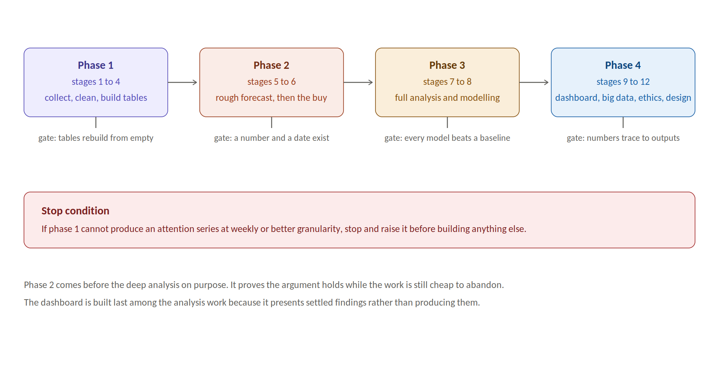
Figure 8. The twelve stages grouped into four phases, each with a gate.

Stop conditions
If stage 1 fails, meaning no attention series can be obtained at weekly or better granularity from either source, stop and raise it with the human before building anything else. The entire forecast rests on that series. If stage 2 fails, the retail argument must fall back to a stated assumption rather than measured seasonality, and that fallback must be declared prominently in the report.

17. Coding standards
- One purpose per script. If a file does two things, split it.
- Every script starts with a short docstring saying what it reads, what it writes and roughly how long it takes.
- No hard coded paths. Read everything from config.yaml through a single helper in src/utils.
- Log to logs with a timestamp, the script name and the row counts in and out.
- Raw data in data/raw is never modified. Cleaning always writes a new file.
- Charts are produced by scripts, never by hand, so that a data change updates every figure.
- Notebooks are for exploration only. Anything that matters is moved into src before the module is called finished.
- Run ruff before every commit.
- Commit messages name the module, for example module 5 forecasting, add Prophet baseline comparison.

18. Guardrails the agent must not break
- Never invent data. If a source fails, record the failure and continue. A gap that is documented is a limitation. A gap that is filled with an invented number is misconduct.
- Never commit the text of the novels or the film scripts. Store derived features only.
- Never commit credentials, and never write a real key into any file that is not .env.
- Never store usernames or personal identifiers in processed data, and never quote an individual user.
- Never fit a predictive model on the eleven film rows.
- Never present a correlation as a cause. The interest to sales link is correlational and must be described that way everywhere it appears.
- Never let the castle theme change a calculation. It is naming only.
- Never take a personal position on public controversy attached to the franchise. Report measured sentiment and its effect on risk.
- Never save a downloaded file anywhere except under data, and never save an image anywhere except under images.
- Never put HTML, CSS and JavaScript in one file, and never use an inline style attribute or an inline script block.
- Never write the README before the findings exist.

19. Deliverables checklist
Deliverable | Location | Done when
Collection and cleaning scripts | src/collect, src/clean | A full rebuild runs from empty
Processed tables and data dictionary | data/processed, docs/ | Tests pass, no blank dictionary entries
Analysis figures and tables | images/figures, outputs/tables | Each has a written finding
Models and metrics | outputs/models | Each has a baseline and a limits note
Demand scenarios | outputs/tables | Low, central and high with intervals
Retail recommendation | docs/findings.md | Contains a quantity, a date and a range
Power BI dashboard | dashboard/ | Six pages, screenshots exported
Big data runtime comparison | images/figures | Three or more corpus sizes
Ethics and governance note | docs/ethics.md | Seven topics, project specific
Methods and assumptions note | docs/methods.md | Every assumption listed once
Canva infographic | infographic/ | Every number traces to outputs
Build log and open questions | docs/ | Updated at the end of each module
README | repository root | Written last, finding stated in the first lines

20. Decisions reserved for the human
The agent should proceed using the stated default and write the question into docs/open_questions.md rather than settling these alone.
Question | Default to use meanwhile
Should the client be an unnamed composite retailer or a named proxy company | Unnamed composite, with a listed proxy used only for benchmarking
Which service level should the safety stock calculation target | Ninety five percent, stated as an assumption
How much of the buy should be reserved for the January position | Model several proportions and present the trade off rather than choosing one
Should the segmentation use four clusters to match the four houses | No. Choose the number the data supports, then label whatever number results
Which currency should be the reporting currency | Canadian dollars, since the client is Canadian
How far back should the fan text corpus reach | As far as the archive allows, with a stated cut off

Closing note for the agent
The value of this project is not that it involves a famous franchise. It is that a real buying decision has to be made before a known date under genuine uncertainty. Every module either helps size that decision, shape it, time it, or state its risk. If a piece of work does none of those four things, it does not belong in this project, however interesting it is.

Appendix A. Source verification log
Every source in section 6 was checked on 1 September 2026 before this brief was issued. This appendix records what was confirmed working, what was found to be broken, and what remains unverified. The agent should re verify anything marked unverified before relying on it, and should re run these checks if a source fails during the build.
Source | Status on 1 September 2026 | Detail confirmed
PotterDB REST API | Live and working | Returned 5410 character records across 217 pages at 25 per page, in JSON API format, with no key required
PotterDB rate limit | Confirmed | 900 requests per hour per address, so 15 per minute, which the collection script must respect
PotterDB movies | Live | Carries release date, budget, box office, running time, rating and cast credits, all as strings needing parsing
PotterDB chapters | Live but limited | Only order, slug, title and summary. No character list, which is why the network analysis was rewritten
Rebrickable | Live | 213 branded sets from 2001 to 2026 confirmed in the catalogue, with piece counts but no retail price
Brickset | Live | Carries retail prices and set metadata, free key required, added as the price source
Wikipedia pageviews | Documented and stable, not directly tested | Official endpoint serving daily article data from 1 July 2015, no key, per article and per project
Google Trends via pytrends | Broken | Library archived April 2025, last release April 2023, fails with a rate limit error on first call due to stale session handling
Google Trends via trendspy | Reported working, not directly tested | Maintained successor library, verify first before building on it
Statistics Canada web data service | Live | Public REST endpoints, no key, plus a full table download in compressed CSV for bulk pulls, which is the easier route
Statistics Canada retail table | Needs care | At least one retail trade table is archived and inactive. Confirm the active product identifier before collecting
Reddit | Not tested | Requires free application credentials, verify before relying on the corpus
Theme park attendance | Not tested | Published as annual PDF reports, manual extraction expected

Why this appendix exists
Four items in the first version of this brief were wrong, and all four would have cost days if discovered mid build. The search interest library was dead. The chapter records could not support the network analysis as written. The toy source had no prices in it. One government table was archived. Checking sources before writing code is cheaper than checking them after, and a brief that names its own uncertainty is more useful to an agent than one that sounds confident about everything.
If a source in this table is found to have changed, update this appendix rather than silently working around it, and note the change in the build log.

